Parallel Programming Exercise 10 – 4

Author: | 林子傑 (r10525069@ntu.edu.tw)
Student ID | R10525069
Department | Engineering Science and Ocean Engineering
(If you and your team member contribute equally, you can use (co-first author), after each name.)
r09525059 黃仙惠 r10525068林怡萱

Problem and Proposed Approach
(Brief your problem, and give your idea or concept of how you design your program.)
Problem: 一個立方體內部有球體，請算出立方體扣去球體的體積。

Proposed Approach：使用 Monte Carlo Methods 推估體積，假設要隨機生成 n 個點，每個 process 負責隨機生成 ⌈n/p⌉ 個點，計算在球體外部的個數 cnt，最後將 每個 process 計算的cnt reduction 到 global_cnt，最終推估體積為 global_cnt/N。

Theoretical Analysis Model
(Try to give the time complexity of the algorithm, and analyze your program with iso-efficiency metrics)
Sequential algorithm complexity：Θ(n)
Parallel computational complexity：Θ(n/p)
Parallel communication complexity：Θ(log p)
Parallel overhead：To(n, p) =Θ(p log p)
Iso-efficiency relation：p>=Cp log p
M(n)=1
M(Cp log p)/p=1/p

Performance Benchmark
(Give your idea or concept of how you design your program.)
The time to generate point：χ
Sequential execution time：nχ
Parallel：
The computation time for each process: ⌈n/p⌉χ
A reduction of p values distributed among p tasks can be preformed in ⌈log p⌉ communication steps.
Parallel execution time：(⌈n/p⌉)χ+ ⌈log p⌉ λ
Table 1. The execution time
Processors | 1 | 2 | 3 | 4 | 5 | 6 | 7 | 8
Real execution time | 114.6491 | 110.4272 | 37.3637 | 28.3306 | 22.7218 | 21.4782 | 33.154 | 29.0298
Estimate execution  time | 114 | 57 | 38 | 28.5 | 22.8 | 19 | 16.28571 | 14.25
Speedup |  | 1.038232 | 3.068462 | 4.046829 | 5.045775 | 3.458077 | 3.949359 | 3.949359
Karp-flatt metrics |  | 0.926351 | -0.011156 | -0.003857 | -0.002268 | 0.147014 | 0.12874 | 0.146521

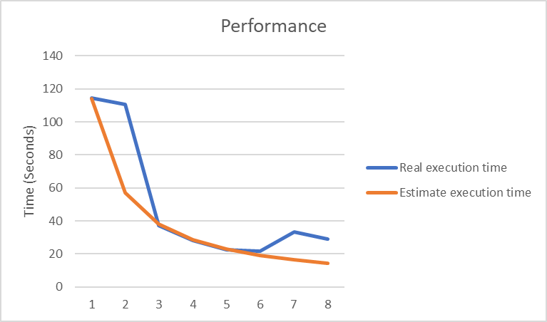
Figure 1. The performance of diagram

Conclusion and Discussion
(Discuss the following issues of your program
- What is the speedup respect to the number of processors used?
- How can you improve your program further more
- How does the communication and cache affect the performance of your program?
- How does the Karp-Flatt metrics and Iso-efficiency metrics reveal?
)
從speedup 的數據來看，當processor增加，speedup 的數據也會增加，本問題適合用平行計算。
從 Iso-efficiency metrics 顯示出這個程式有很好的 Scalability。

Appendix(optional):
(If something else you want to append in this file, like picture of life game)

