Parallel Programming Exercise 8 – 10

Author: | 林子傑 (r10525069@ntu.edu.tw)
Student ID | R10525069
Department | Engineering Science and Ocean Engineering
(If you and your team member contribute equally, you can use (co-first author), after each name.)

Problem and Proposed Approach
(Brief your problem, and give your idea or concept of how you design your program.)
Problem: 利用 checkerboard block decomposition 實作 matrix-vector multiplication。

Proposed Approach:先將 vector 分散到 first row，由 first row broadcast 到其他 column，算好值後再利用 reduction 合併答案。

Theoretical Analysis Model
(Try to give the time complexity of the algorithm, and analyze your program with iso-efficiency metrics)
Sequential algorithm complexity：Θ(n²)
Parallel computational complexity：Θ(n²/p)
Parallel communication complexity：Θ(n log p / √p)
Parallel overhead：To(n, p) =Θ(np log p / √p)
Iso-efficiency relation：n>=C√p log p
M(n)=n^2
M(C√p log p)/p= C² p log² p/p = C²log² p

Performance Benchmark
(Give your idea or concept of how you design your program.)
The time to perform calculate：χ
The time to perform sending：λ
Sequential execution time：n²χ
Parallel：
The computation time for each process: (⌈n /√p⌉)²χ
Redistribution of b requires time：√p(λ+8⌈n /√p⌉/β)
Columnwise broadcast requires time：√p(λ+8⌈n /√p⌉/β)
Parallel execution time：(⌈n /√p⌉)²χ+√p(λ+8⌈n /√p⌉/β)
Table 1. The execution time
Processors | 1 | 2 | 3 | 4 | 5 | 6 | 7 | 8
Real execution time | 0.288328 | 0.144052 | 0.098903 | 0.074405 | 0.05953 | 0.049791 | 0.042718 | 0.037545
Estimate execution  time | 0.28 | 0.14 | 0.093333 | 0.07 | 0.056 | 0.046667 | 0.04 | 0.035
Speedup |  | 2.001555 | 2.91526 | 3.875116 | 4.843407 | 5.790765 | 6.749567 | 7.679531
Karp-flatt metrics |  | -0.000777 | 0.014534 | 0.010742 | 0.008083 | 0.007226 | 0.006184 | 0.005961

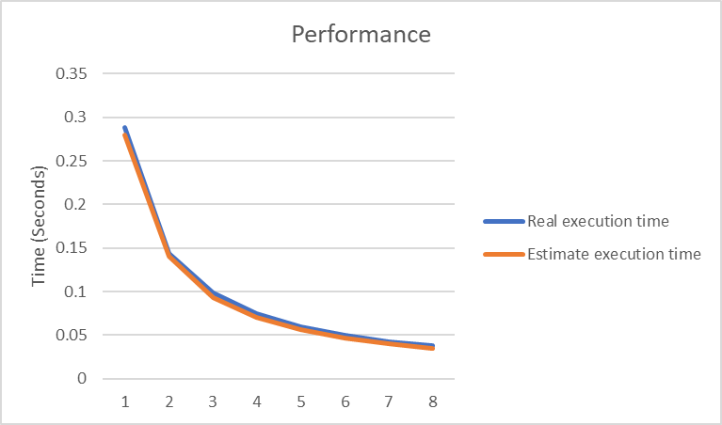
Figure 1. The performance of diagram

Conclusion and Discussion
(Discuss the following issues of your program
- What is the speedup respect to the number of processors used?
- How can you improve your program further more
- How does the communication and cache affect the performance of your program?
- How does the Karp-Flatt metrics and Iso-efficiency metrics reveal?
)
從speedup 的數據來看，當processor增加，speedup 的數據也會增加，本問題適合用平行計算。
從 Iso-efficiency metrics 顯示出這個程式有很好的 Scalability。

Appendix(optional):
(If something else you want to append in this file, like picture of life game)

