Parallel Programming Exercise 9

Author: | 林子傑 (r10525069@ntu.edu.tw)
Student ID | R10525069
Department | Engineering Science and Ocean Engineering
(If you and your team member contribute equally, you can use (co-first author), after each name.)

1.
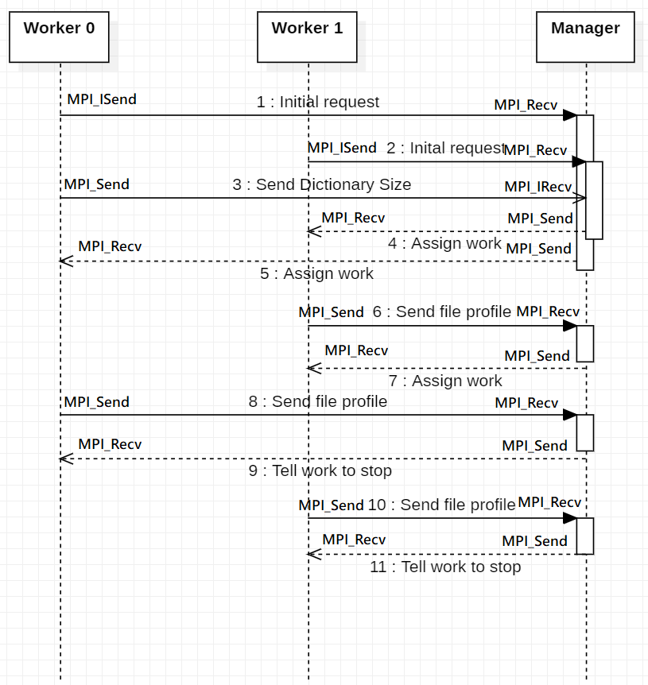

2. Explain why the program uses non-blocking send/receive MPI functions. Explain why there is no dead-lock problem
1) 使用non-blocking send/receive MPI function 可以在 communication 的時候進行其他工作，提高平行計算的效率。
2) 因為 worker 0 初始化的請求和傳送 buffer size 給 manager 不會互相阻擋，因此不會產生 dead-lock 問題。

