Parallel Programming Exercise 9 – 10

Author: | 林子傑 (r10525069@ntu.edu.tw)
Student ID | R10525069
Department | Engineering Science and Ocean Engineering
(If you and your team member contribute equally, you can use (co-first author), after each name.)
r09525059 黃仙惠 r10525068林怡萱

Problem and Proposed Approach
(Brief your problem, and give your idea or concept of how you design your program.)
Problem: 找出前八個完全數。

Proposed Approach: 設立一個 manager process，其他 process 當 worker，worker 每次都和 manager 拿一個數字 n去判斷是否 2^{n}-1為質數，如果是質數，就直接回傳該數字，否則回傳 0。Manager 一次給一個數字，如果找到八個答案，就會傳送 0 給每個 worker，表示要停止搜尋。
(一個偶數是完美數，若且唯若它具有如下形式：2^{n-1}*(2^{n}-1)，其中2^{n}-1 是質數)

Theoretical Analysis Model
(Try to give the time complexity of the algorithm, and analyze your program with iso-efficiency metrics)
Sequential algorithm complexity：Θ(n)
Parallel computational complexity：Θ(n/p)
Parallel communication complexity：Θ(n)
Parallel overhead：To(n, p) =Θ(np)
Iso-efficiency relation：n>=Cpn
M(n)=1
M(Cpn)/p= Cpn/p=Cn

Performance Benchmark
(Give your idea or concept of how you design your program.)
The time to perform determine if it is a perfect number：χ
Sequential execution time：nχ
Parallel：
The computation time for each process:χ(⌈n/p⌉)
Need to send a number 2n times.
Sending a number requires time：λ
Parallel execution time：χ(⌈n/p⌉)+2nλ
Table 1. The execution time
Processors | 2 | 3 | 4 | 5 | 6 | 7 | 8
Real execution time | 0.000538 | 0.000505 | 0.000501 | 0.001579 | 0.000503 | 0.000585 | 0.000489
Estimate execution  time | 0.0005 | 0.00025 | 0.00016667 | 0.000125 | 0.0001 | 8.3333E-05 | 7.1429E-05
Speedup |  | 1.06534653 | 1.0738523 | 1.0695825 | 0.91965812 | 1.1002045 | 1.1002045
Karp-flatt metrics |  | 0.87732342 | 0.89684015 | 0.91325898 | 1.10920074 | 0.89070632 | 0.89374226
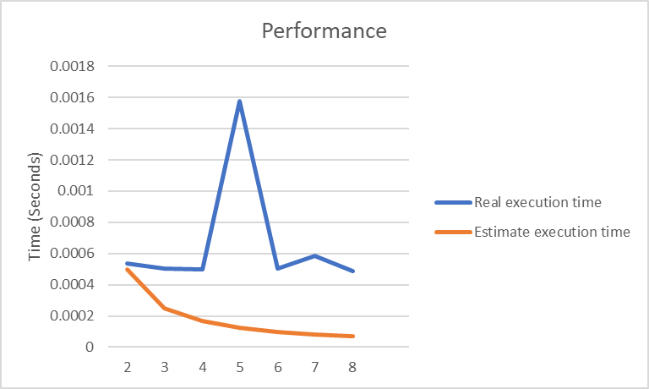

Conclusion and Discussion
(Discuss the following issues of your program
- What is the speedup respect to the number of processors used?
- How can you improve your program further more
- How does the communication and cache affect the performance of your program?
- How does the Karp-Flatt metrics and Iso-efficiency metrics reveal?
)
從speedup 的數據來看，當processor增加，speedup 效果有限，本問題不適合用平行計算。
從 Iso-efficiency metrics 顯示出這個程式有不錯的 Scalability。

Appendix(optional):
(If something else you want to append in this file, like picture of life game)

