Parallel Programming Exercise 4 – 12

Author: | 林子傑 (r10525069@ntu.edu.tw)
Student ID | R10525069
Department | Engineering Science and Ocean Engineering
(If you and your team member contribute equally, you can use (co-first author), after each name.)

Problem and Proposed Approach
(Brief your problem, and give your idea or concept of how you design your program.)
Problem:利用 Simpson's Rule 計算 PI。

Proposed Approach:每個 processor 用迴圈將 f 函數的第 in/p 到 (i+1)n/p-1 項的結果加總，再用 reduction 將所有 processor的和在進行加總。為了測試平行運算的效能，將 n 設為 1000000。

Theoretical Analysis Model
(Try to give the time complexity of the algorithm, and analyze your program with iso-efficiency metrics)
Sequential algorithm complexity：Θ(n)
Parallel computational complexity：Θ(n/p)
Parallel communication complexity：Θ(log p)
Parallel overhead：To(n, p) =Θ(p log p)
Iso-efficiency relation：p>=Cp log p
M(n)=1
M(Cp log p)/p= C log p /p

Performance Benchmark
(Give your idea or concept of how you design your program.)
時間分析：
The time to perform add：χ
Sequential execution time：(n-1)χ
Parallel：
The computation time for each process:χ(⌈n/p⌉-1)
A reduction of p values distributed among p tasks can be preformed in ⌈log p⌉ communication steps.
Each reduction stop requires time：λ+χ
Parallel execution time：(⌈n/p⌉-1)χ+ ⌈log p⌉ (λ+χ)

Table 1. The execution time
Processors | 1 | 2 | 3 | 4 | 5 | 6 | 7 | 8
Real execution time | 0.017284 | 0.008892 | 0.005917 | 0.004464 | 0.003593 | 0.003019 | 0.002566 | 0.002324
Estimate execution  time | 0.015 | 0.0075 | 0.005 | 0.00375 | 0.003 | 0.0025 | 0.002143 | 0.001875
Speedup |  | 1.94377 | 2.921075 | 3.871864 | 4.810465 | 5.725075 | 6.735776 | 7.437177
Karp-flatt metrics |  | 0.028928 | 0.01351 | 0.011031 | 0.00985 | 0.009604 | 0.006538 | 0.010811

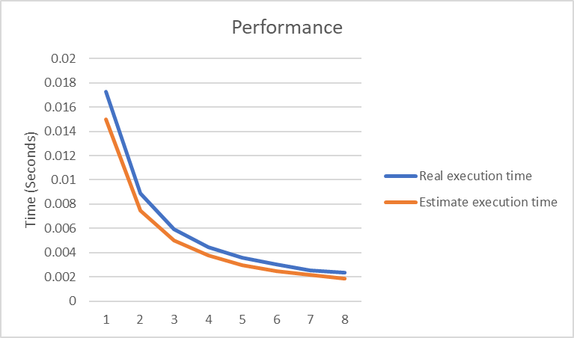
Figure 1. The performance of diagram

Conclusion and Discussion
(Discuss the following issues of your program
- What is the speedup respect to the number of processors used?
- How can you improve your program further more
- How does the communication and cache affect the performance of your program?
- How does the Karp-Flatt metrics and Iso-efficiency metrics reveal?
)
從speedup 的數據來看，當processor增加，speedup 的數據也會增加，本問題適合用平行計算。
從 Iso-efficiency metrics 顯示出這個程式有很好的 Scalability。

Appendix(optional):
(If something else you want to append in this file, like picture of life game)

