Parallel Programming Exercise 5 – 11

Author: | 林子傑 (r10525069@ntu.edu.tw)
Student ID | R10525069
Department | Engineering Science and Ocean Engineering
(If you and your team member contribute equally, you can use (co-first author), after each name.)

Problem and Proposed Approach
(Brief your problem, and give your idea or concept of how you design your program.)
Problem: 計算 1/1+1/2+1/3+…+1/n。

Proposed Approach:每個 processor 負責 in/p 到 (i+1)n/p-1 的範圍，如果邊界是偶數，就往外 +1 或 -1。每個 processor 維護一個變數 sum，加總區間內所有 I 的倒數，最後用 reduction 將所有 processor的 sum 加總。

Theoretical Analysis Model
(Try to give the time complexity of the algorithm, and analyze your program with iso-efficiency metrics)
Sequential algorithm complexity：Θ(n)
Parallel computational complexity：Θ(n/p)
Parallel communication complexity：Θ(log p)
Parallel overhead：To(n, p) =Θ(p log p)
Iso-efficiency relation：p>=Cp log p
M(n)=n
M(Cp log p)/p= Cp log p/p= C log p

Performance Benchmark
(Give your idea or concept of how you design your program.)
The time to perform add：χ
Sequential execution time：(n-1)χ
Parallel：
The computation time for each process:χ(⌈n/p⌉-1)
A reduction of p values distributed among p tasks can be preformed in ⌈log p⌉ communication steps.
Each reduction stop requires time：λ+χ
Parallel execution time：(⌈n/p⌉-1)χ+ ⌈log p⌉ (λ+χ)
Table 1. The execution time
Processors | 1 | 2 | 3 | 4 | 5 | 6 | 7 | 8
Real execution time | 0.607344 | 0.301069 | 0.208903 | 0.149901 | 0.125805 | 0.104973 | 0.090546 | 0.079043
Estimate execution  time | 0.6 | 0.3 | 0.2 | 0.15 | 0.12 | 0.1 | 0.085714 | 0.075
Speedup |  | 2.017292 | 2.907301 | 4.051634 | 4.827662 | 5.785716 | 6.707574 | 7.683716
Karp-flatt metrics |  | -0.008572 | 0.015942 | -0.004248 | 0.008925 | 0.007407 | 0.007266 | 0.00588

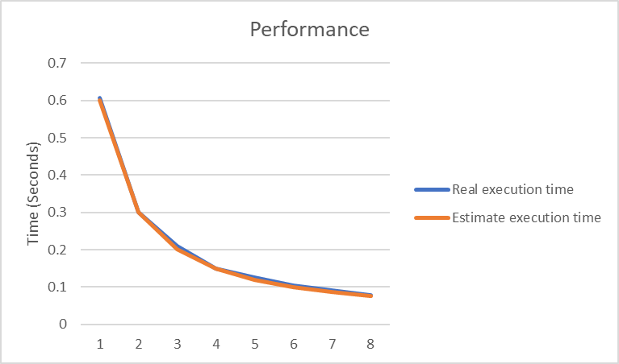
Figure 1. The performance of diagram

Conclusion and Discussion
(Discuss the following issues of your program
- What is the speedup respect to the number of processors used?
- How can you improve your program further more
- How does the communication and cache affect the performance of your program?
- How does the Karp-Flatt metrics and Iso-efficiency metrics reveal?
)
從speedup 的數據來看，當processor增加，speedup 的數據也會增加，本問題適合用平行計算。
從 Iso-efficiency metrics 顯示出這個程式有很好的 Scalability。

Appendix(optional):
(If something else you want to append in this file, like picture of life game)

