Parallel Programming Exercise 6 – 13

Author: | 林子傑 (r10525069@ntu.edu.tw)
Student ID | R10525069
Department | Engineering Science and Ocean Engineering
(If you and your team member contribute equally, you can use (co-first author), after each name.)

Problem and Proposed Approach
(Brief your problem, and give your idea or concept of how you design your program.)
Problem: M x N 的方格中的每一個都有一個細胞，細胞有兩種狀態死細胞和活細胞，如果一個死細胞周圍有三個活細胞，下一代會轉成活細胞，如果一個活細胞周圍有小於三個或大於三個活細胞，下一代會轉成死細胞，總共經過 J 代，每 K 代輸出一次結果。

Proposed Approach:每個 processor 負責計算第 in/p 到 (i+1)n/p-1 row，計算好之後，因為每個細胞要參考八個方位鄰居，因此要第一列傳給前一個 process，最後一列傳給下一個 process，再計算下一代。要輸出的時候，讓每一個 process 把負責計算的 rows 傳給 process 0，process 0 負責輸出。

Theoretical Analysis Model
(Try to give the time complexity of the algorithm, and analyze your program with iso-efficiency metrics)
Sequential algorithm complexity：Θ(JMN)
Parallel computational complexity：Θ(JMN/p)
Parallel communication complexity：Θ(J)
Parallel overhead：To(n, p) =Θ(Jp)
Iso-efficiency relation：p>=Cp
M(n)=n^2
M(Cp)/p= (Cp)^2 /p= C^2 p= C₂ p

Performance Benchmark
(Give your idea or concept of how you design your program.)
The time to perform calculate a cell：χ
Sequential execution time：JMNχ
Parallel：
The computation time for each process:χ(JN⌈M /p⌉)
Every iteration a process need to send a 1D-array at most 2+ ⌈M /p⌉ times.
Send a 1D-array requires time：λ
Parallel execution time：χ(JN⌈M /p⌉)+ λJ(2+ ⌈M /p⌉)
Table 1. The execution time
Processors | 1 | 2 | 3 | 4 | 5 | 6 | 7 | 8
Real execution time | 21.414555 | 15.79338 | 12.416672 | 10.743042 | 10.989637 | 9.716124 | 9.509998 | 8.73947
Estimate execution  time | 22 | 11 | 7.333333 | 5.5 | 4.4 | 3.666666 | 3.142857 | 2.75
Speedup |  | 1.355919 | 1.724661 | 1.993341 | 1.948613 | 2.204022 | 2.251793 | 2.450326
Karp-flatt metrics |  | 0.475013 | 0.369735 | 0.335560 | 0.391481 | 0.344459 | 0.351438 | 0.323553

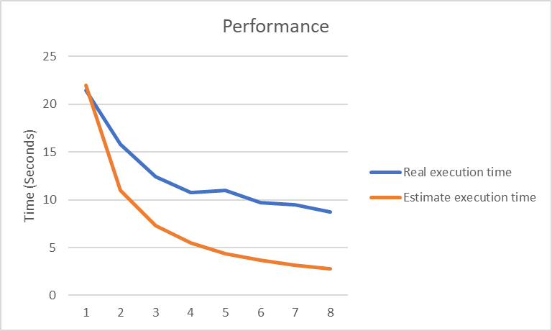
Figure 1. The performance of diagram

Conclusion and Discussion
(Discuss the following issues of your program
- What is the speedup respect to the number of processors used?
- How can you improve your program further more
- How does the communication and cache affect the performance of your program?
- How does the Karp-Flatt metrics and Iso-efficiency metrics reveal?
)
從speedup 的數據來看，當processor增加，speedup 的數據也會增加，本問題適合用平行計算，但受到資料傳輸大小影響，能夠提升的空間有限。
從 Iso-efficiency metrics 顯示出這個程式並沒有很好的 Scalability。

Appendix(optional):
(If something else you want to append in this file, like picture of life game)

