Parallel Programming Exercise 4 – 7

Author: | 林子傑 (r10525069@ntu.edu.tw)
Student ID | R10525069
Department | Engineering Science and Ocean Engineering
(If you and your team member contribute equally, you can use (co-first author), after each name.)

Problem and Proposed Approach
(Brief your problem, and give your idea or concept of how you design your program.)
Problem: 輸出 1+2+3+…+n。

Proposed Approach:每個 processor 用迴圈把 in/p 到 (i+1)n/p-1 的數字加總，在用 reduction 將所有 procseeor 的和在進行加總。

Theoretical Analysis Model
(Try to give the time complexity of the algorithm, and analyze your program with iso-efficiency metrics)
Sequential algorithm complexity：Θ(n)
Parallel computational complexity：Θ(n/p)
Parallel communication complexity：Θ(log p)
Parallel overhead：To(n, p) =Θ(n/p)
Iso-efficiency relation：p>=Cn/p
M(n)=1
M(Cn/p)/p= Cn/p*p

Performance Benchmark
(Give your idea or concept of how you design your program.)
令 n=1000000，分別利用 1~8 個 processor 算出答案。
Table 1. The execution time
Processors | 1 | 2 | 3 | 4 | 5 | 6 | 7 | 8
Real execution time | 0.003274 | 0.001698 | 0.001212 | 0.00083 | 0.000724 | 0.000587 | 0.000653 | 0.000466
Estimate execution  time | 0.003 | 0.0015 | 0.001 | 0.00075 | 0.0006 | 0.0005 | 0.000428 | 0.000375
Speedup |  | 1.928151 | 2.70132 | 3.944578 | 4.522099 | 5.577513 | 5.013783 | 7.025751
Karp-flatt metrics |  | 0.037263 | 0.055284 | 0.004683 | 0.02642 | 0.01515 | 0.066025 | 0.01981

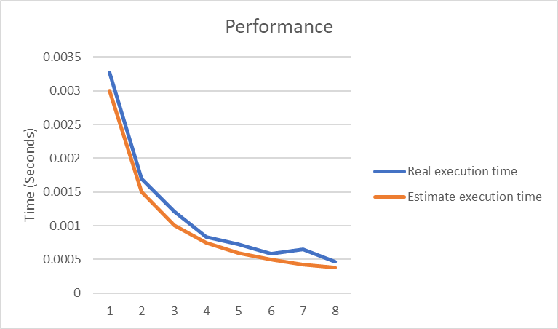
Figure 1. The performance of diagram

Conclusion and Discussion
(Discuss the following issues of your program
- What is the speedup respect to the number of processors used?
- How can you improve your program further more
- How does the communication and cache affect the performance of your program?
- How does the Karp-Flatt metrics and Iso-efficiency metrics reveal?
)
當 process 的數量增加，speedup 大致上也會增加，本問題適合用平行計算。
這題可以改用公式解來加快速度，這種作法不用平行運算。

Appendix(optional):
(If something else you want to append in this file, like picture of life game)

