Parallel Programming Exercise 4 – 9

Author: | 林子傑 (r10525069@ntu.edu.tw)
Student ID | R10525069
Department | Engineering Science and Ocean Engineering
(If you and your team member contribute equally, you can use (co-first author), after each name.)

Problem and Proposed Approach
(Brief your problem, and give your idea or concept of how you design your program.)
Problem: 找出 1到 n 所有相鄰兩質數的最大差距。

Proposed Approach:每個 processor 負責 in/p 到 (i+1)n/p-1 的範圍，如果邊界是偶數，就往外 +1 或 -1。每個 processor 維護一個變數 mx，記錄區間內兩質數的最大差距，利用迴圈判斷每個奇數是不是質數，如果是質數就記錄起來，並計算該質數和前一個質數差距 d，如果 d 大於 mx 就更新 mx，最後用 reduction 將所有 procseeor 的 mx 取最大值。

Theoretical Analysis Model
(Try to give the time complexity of the algorithm, and analyze your program with iso-efficiency metrics)
Sequential algorithm complexity：Θ(n√n)
Parallel computational complexity：Θ(n√n/p)
Parallel communication complexity：Θ(log p)
Parallel overhead：To(n, p) =Θ(n√n/p)
Iso-efficiency relation：p>=Cn√n/p
M(n)=1
M(Cn√n/p)/p= Cn√n/p*p

Performance Benchmark
(Give your idea or concept of how you design your program.)
令 n=1000000，分別利用 1~8 個 processor 算出答案。
Table 1. The execution time
Processors | 1 | 2 | 3 | 4 | 5 | 6 | 7 | 8
Real execution time | 0.271133 | 0.164764 | 0.114376 | 0.087554 | 0.070798 | 0.059411 | 0.051196 | 0.044979
Estimate execution  time | 0.27 | 0.135 | 0.09 | 0.0675 | 0.054 | 0.045 | 0.038571 | 0.03375
Speedup |  | 1.645584 | 2.370541 | 3.096752 | 3.82967 | 4.563683 | 5.29598 | 6.027991
Karp-flatt metrics |  | 0.215374 | 0.132767 | 0.097225 | 0.076399 | 0.062945 | 0.053626 | 0.046735

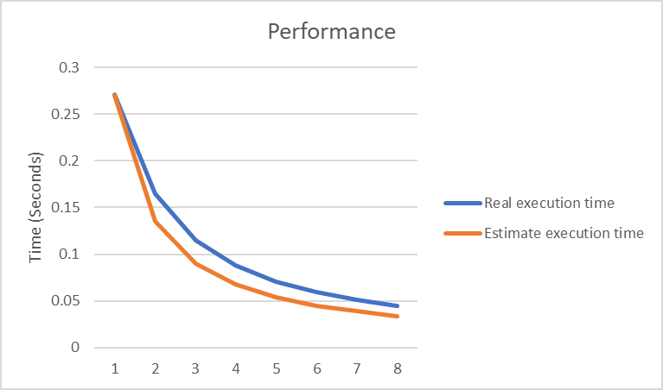
Figure 1. The performance of diagram

Conclusion and Discussion
(Discuss the following issues of your program
- What is the speedup respect to the number of processors used?
- How can you improve your program further more
- How does the communication and cache affect the performance of your program?
- How does the Karp-Flatt metrics and Iso-efficiency metrics reveal?
)
當 process 的數量增加，speedup 大致上也會增加，本問題適合用平行計算。

Appendix(optional):
(If something else you want to append in this file, like picture of life game)

