Parallel Programming Exercise 6 – 8

Author: | 林子傑 (r10525069@ntu.edu.tw)
Student ID | R10525069
Department | Engineering Science and Ocean Engineering
(If you and your team member contribute equally, you can use (co-first author), after each name.)

Problem and Proposed Approach
(Brief your problem, and give your idea or concept of how you design your program.)
Problem: processor 0 傳送資料依序到其他 processor，計算。

Proposed Approach:用迴圈依序將 processor 0 的訊息傳給其他 process。

Theoretical Analysis Model
(Try to give the time complexity of the algorithm, and analyze your program with iso-efficiency metrics)

Performance Benchmark
(Give your idea or concept of how you design your program.)

Table 1. The execution time
Processors | 1 | 2 | 3 | 4 | 5 | 6 | 7 | 8
Real execution time | 0.000005 | 0.000029 | 0.000045 | 0.000081 | 0.000082 | 0.000109 | 0.000124 | 0.000145
Estimate execution  time | 0.000005 | 0.00001 | 0.000015 | 0.00002 | 0.000025 | 0.00003 | 0.000035 | 0.00004
Speedup |  | 0.172414 | 0.111111 | 0.061728 | 0.060976 | 0.045872 | 0.040323 | 0.034483
Karp-flatt metrics |  | 10.6 | 13 | 21.26667 | 20.25 | 25.96 | 28.76667 | 33

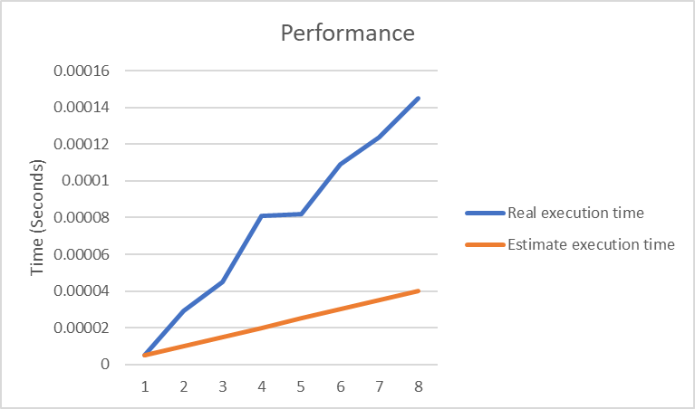
Figure 1. The performance of diagram

Conclusion and Discussion
(Discuss the following issues of your program
- What is the speedup respect to the number of processors used?
- How can you improve your program further more
- How does the communication and cache affect the performance of your program?
- How does the Karp-Flatt metrics and Iso-efficiency metrics reveal?
)

Appendix(optional):
(If something else you want to append in this file, like picture of life game)

