Discrete Fourier Transform on AMD GPU

Background
DFT transforms signal from time domain to frequency domain requiring O(n*n) operations, requiring O() with FFT butterfly algorithm.

DFT algorithm, require O(NxN)
This example shows the method of DFT calculation, given 4 points (N=4) from a sample of periodic discrete points over time(in time domain)
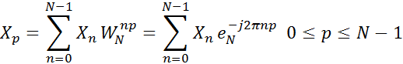
Eg. N=4
P=0, :
X₀=X₀ +X₁+ X₂ + X₃ = X₀+X₁+X₂+X₃
P=1, :
X₁=X₀ +X₁+ X₂ + X₃
X₁=X₀+X₁+X₂+X₃
X₁=X₀+X₁-X₂+X₃
X₁=X₀+X₁-X₂-X₃
P=2, :
X₂=X₀ +X₁+ X₂ + X₃
X₂=X₀+X₁+X₂+X₃
X₂=X₀₋ X₁+X₂₋ X₃
P=3, :
X₃=X₀ +X₁+ X₂ + X₃
X₃=X₀+X₁+X₂+X₃
X₃=X₀+X₁-X₂-X₃
_{Therefore,}
X₀=(X₀+X₂)+ (X₁+X₃)
X₁=(X₀-X₂)+ (X₁-X₃)
X₂=(X₀+X₂)+ (X₁+X₃)
X₃=(X₀-X₂)+ (X₁-X₃)
So,
For N = 4
X₀=(X₀+ ) + (X₁+X₃)
X₁=(X₀- ) + (X₁-X₃)
X₂=(X₀+ ) - (X₁+X₃)
X₃=(X₀- ) - (X₁-X₃)
W=
_{Its Butterfly Diagram:}
x_{0-----+------→} _{-----------+-------→} X₀
x_{2------_-----→} _{-----------+-------→} X₀
x_{1------+-----→} X₀
x_{3------_-----→} X₀
x_{0-----+------→} X₀
x_{2------_-----→} X₀
x1------+-----→ -----------+-------→ X₀
x_{3------_-----→} X₀

Butterfly Diagram, require O(log₂N)
Eg. N=2
X₀=X₀ + X₁ X₁=X₀ - X₁
x₀ X₁ x₀ X₁
x₁ X₁ x₁ X₁
Conclusion:
= 1 X₀=X₀ + X₁ X₁=X₀ - X₁
Eg. N=4
x₀ X₀
1
3
x₁ X₁
2
x₂ X₂
x₃ X₃
x₀ X₀
4
6
x₁ X₁
x₂ X₂
5
x₃ X₃
x₀ X₀
7
9
x₁ X₁
8
x₂ X₂
x₃ X₃
10000
x₀ X₀
x₁ X₁
11
12
x₂ X₂
x₃ X₃
Conclusion:
X₀ ₌ (x₀+ x₂)+ (x₁+ x₃)
1
2
3

X₁ ₌ (x₀- x₂)+ (x₁- x₃)
4
5
6

X₂ ₌ (x₀+ x₂)- (x₁+ x₃)
7
8
9

X₃ ₌ (x₀- x₂)- (x₁- x₃)
10
11
12

= 1 = -j = 1
For x₀=0, x₁=1, x₂=0, x₃=-1
X₀=0+0+(1-1)=0, X₁=0-0-j(1+1)=-2j, X₂=0+0-(1-1)=0, X₃=0-0+j(1+1)=2j

In place algorithm, bit reverse

N=4 Bit Reversed Bit Reversed Decimal
0 00 00 0
1 01 10 2
2 10 01 1
3 11 11 3
Eg. N = {0, 1, 0, -1} -> N = {0, 0, 1, -1}

N=8 Bit Reversed Bit Reversed Decimal
0 000 000 0
1 001 100 4
2 010 010 2
3 011 110 6
4 100 001 1
5 101 101 5
6 110 011 3
7 111 111 7
Eg. N={2,1,-1,-3,0,1,2,1} -> N{2,0,-1,2,1,1,-3,1}

Butterfly Algorithm

X[8] = {2,1,-1,-3,0,1,2,1}
2 2+0 2 2+1 3 3+0
0 2-0 2 2-3(-j) 2+3j 2+3j+4j()
-1 -1+2 1 2-1 1 1+4(-j)
2 -1-2 3 2+(-3)j 2-3j 2-3j+(-4j)(
1 1+1 2 2+(-2) 0 3
1 1-1 0 0-4(-j) 4j 2+3j-4j()
-3 -3+1 -2 2-(-2) 4 1+4j
1 -3-1 -4 0+(-4)j -4j 2-3j-4j()
1/8 =

One Complete Example
One time domain signal discrete periodic wave decomposed to several Sin and Cos curves
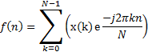
f(x) = Sin(x)
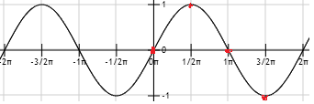
f(x) = Cos(x)
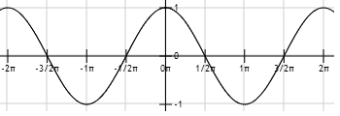
Time Domain Wave:
N=4 T=0.1s T/N=0.1/4=0.025 f=1/T=40Hz 40 samples per second
f(k)=sin(k)
k=0, f(0) = 0 k=1, f(1) = 1
k=2, f(2) = 0 k=3, f(3) = -1
Time Domain: N=(0,1,0,-1)
= 1 = 1 = -j = -1 = j
DFT:
=0+1+0-1=0
=0-j+0-j=-2j
=0-1+0+1=0
=0+j+0+j=2j
F(0)=0, F(1)=-2j,F(2)=0,F(3)=2j
FFT:
Because of:
X₀ ₌ (x₀+ x₂)+ (x₁+ x₃)
X₁ ₌ (x₀- x₂)+ (x₁- x₃)
X₂ ₌ (x₀+ x₂)- (x₁+ x₃)
X₃ ₌ (x₀- x₂)- (x₁- x₃)
Therefore:
X₀=0+0+(1-1)=0 X₁=0-0-j(1+1)=-2j
X₂=0+0-(1-1)=0 X₃=0-0+j(1+1)=2j
F(0)=0, F(1)=-2j,F(2)=0,F(3)=2j
Frequency function:
Phase: real + j * imaginary Magnitude = F(n) = n * 10Hz
F(0) = 0Hz F(1) = 10Hz F(2) = 20Hz F(3) = 30Hz
M(0) = 0 M(1) = 2 M(2) = 0 M(3) = 2
F(n) -> M(n)
Valid Frequency: 40/2 = 20Hz Any spikes above 20Hz is invalid
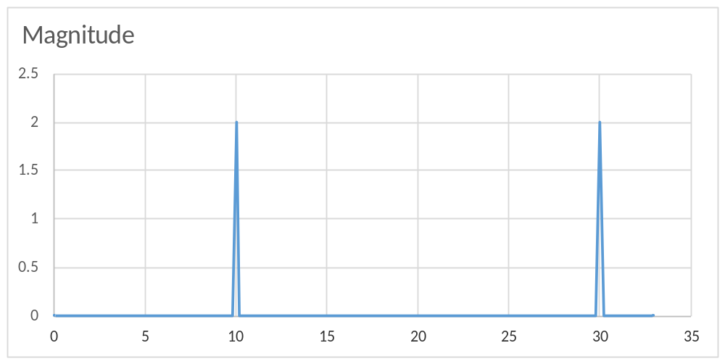Frequency Domain:

Lucas Lehmer Test using FFT (CPU)
- Given cl_int P, calculate MP = 2^P
- isPM function: (define m as an arbitrary big integer number)
//The key is to use BigInteger(C# .Net 4.0 System.Numerics.BigInterger, C++ BigIntegerLibrary.hh)
bool isMP() (cl_int p)//c++
{
const BigInteger base = 2;
if(p%2==0) return (p==2);
else
{
for(cl_int i = 3; i<= sqrt(p);i += 2)
if(p % i == 0) return false;
BigInteger m = BigIntegerPow(base,p)-1;
BigInteger s = 4;
for(cl_int i = 3; i<= p; i++)
s = (s*s -2) % m; //Multiplication Step
return s==0;
}
};
- Use FFT and Schönhage–Strassen_algorithm on Multiplication Step reduce Big O complexity
from O(N*N) to O(N logN log log N)
Steps:
- Input A: 1234 Input B: 5678
- PadA: 43210000 PadB: 87650000
- fA: FFT(PadA) fB:FFT(PadB)
- PointeweiseMultiplication: fA * fB
- InverseFFT(PointeweiseMultiplication) * N
- Difficulties of implementation on GPU is OpenCL does not natively support BigInteger type
- AMD FFT(GPU) can be used to calculate massive integer multiplication
- Other methods for massive integer multiplication:
Toom Cook: (C# .NET V4.0)

public static BigInteger ToomCook_2_Multiply(BigInteger a, BigInteger b)
{
String m = a.ToString();
String n = b.ToString();
//Splitting 2
int mlength = m.Length;
int nlength = n.Length;
String m1 = m.Substring(0, mlength / 2);
String m0 = m.Substring(mlength / 2, mlength % 2 == 0 ? mlength / 2 : mlength / 2 + 1);
String n1 = n.Substring(0, nlength / 2);
String n0 = n.Substring(nlength / 2, nlength % 2 == 0 ? nlength / 2 : nlength / 2 + 1);
BigInteger[] PP = new BigInteger[3];
BigInteger[] qq = new BigInteger[3];
// Fast Evaluation
PP[0] = Utility.BigIntegerFromString(m0);
qq[0] = Utility.BigIntegerFromString(n0);
PP[1] = Utility.BigIntegerFromString(m1) + Utility.BigIntegerFromString(m0);
qq[1] = Utility.BigIntegerFromString(n1) + Utility.BigIntegerFromString(n0);
PP[2] = Utility.BigIntegerFromString(m1);
qq[2] = Utility.BigIntegerFromString(n1);
// Posintwise Multiplication
BigInteger[] rr = new BigInteger[3];
for (int i = 0; i < 3; i++)
{
rr[i] = PP[i] * qq[i];
}
// Interpolation
rr[1] = rr[1] - rr[0] - rr[2];
//Console.WriteLine("rr[1]"+rr[1]);
// Recomposition
BigInteger tmp = BigInteger.Pow(10, m0.Length);
BigInteger result = rr[0] + rr[1] * tmp + rr[2] * tmp * tmp;
Console.WriteLine("ToomCook 2 Result: " + result);
return result;
}

public static BigInteger ToomCook_3_Multiply(BigInteger a, BigInteger b)
{
// warning: a and b must be the same length
BigInteger result = 0;
Console.WriteLine("Toom Cook 3:");
String m = a.ToString();
String n = b.ToString();
int mlength = m.Length;
int nlength = n.Length;
int d = 3;
int v = d * 2 - 1;
// Splitting 3
int inc = 0;
int num = mlength / d + inc;
while (!Utility.IsPowerOfTwo(num))
{
inc = inc + 1;
num = mlength / d + inc;
}
int ind = 0;
int mun = nlength / d + ind;
while (!Utility.IsPowerOfTwo(mun))
{
ind = ind + 1;
mun = nlength / d + ind;
}
int simbol = nlength / mun;

if (simbol == 2)
{
String m2 = m.Substring(0, mlength - num - num);
String m1 = m.Substring(mlength - num - num, num);
String m0 = m.Substring(mlength - num, num);
String n2 = n.Substring(0, nlength - mun - mun);
String n1 = n.Substring(nlength - mun - mun, mun);
String n0 = n.Substring(nlength - mun, mun);
//Console.WriteLine("Splitting:");
// Fast Evaluation
BigInteger[] PP = new BigInteger[v];
BigInteger[] qq = new BigInteger[v];
BigInteger tmpP = Utility.BigIntegerFromString(m0) + Utility.BigIntegerFromString(m2);
BigInteger tmpQ = Utility.BigIntegerFromString(n0) + Utility.BigIntegerFromString(n2);
PP[0] = Utility.BigIntegerFromString(m0);
qq[0] = Utility.BigIntegerFromString(n0);
PP[1] = tmpP + Utility.BigIntegerFromString(m1);
qq[1] = tmpQ + Utility.BigIntegerFromString(n1);
PP[2] = tmpP - Utility.BigIntegerFromString(m1);
qq[2] = tmpQ - Utility.BigIntegerFromString(n1);
PP[3] = (PP[2] + Utility.BigIntegerFromString(m2)) * 2 - Utility.BigIntegerFromString(m0);
qq[3] = (qq[2] + Utility.BigIntegerFromString(n2)) * 2 - Utility.BigIntegerFromString(n0);
PP[4] = Utility.BigIntegerFromString(m2);
qq[4] = Utility.BigIntegerFromString(n2);
// Posintwise Multiplication
BigInteger[] rr = new BigInteger[v];
// Console.WriteLine("Fast Evaluation:");
for (int i = 0; i < v; i++)
{
rr[i] = PP[i] * qq[i];//most expensive mutiplication
}
// Interpolation
BigInteger r0 = rr[0];
BigInteger r4 = rr[4];
BigInteger r3 = (rr[3] - rr[1]) / 3;
BigInteger r1 = (rr[1] - rr[2]) / 2;
BigInteger r2 = rr[2] - rr[0];
r3 = (r2 - r3) / 2 + 2 * rr[4];
r2 = r2 + r1 - r4;
r1 = r1 - r3;
// save the value to rr[]
rr[0] = r0;
rr[1] = r1;
rr[2] = r2;
rr[3] = r3;
rr[4] = r4;
// Recomposition
BigInteger tmp = BigInteger.Pow(10, m0.Length);
result = rr[0] + rr[1] * tmp + rr[2] * tmp * tmp + rr[3] * tmp * tmp * tmp + rr[4] * tmp * tmp * tmp * tmp;
Console.WriteLine("ToomCook 3 Result: " + result);
}
else if (simbol == 1)
{
result = ToomCook_2_Multiply(a, b);
}
return result;
}
Schonhage Strassen with FFT: (C# .NET V4.0 AForge.Math Library)
static public BigInteger Schonhage_Strassen_Fast_Fourier_Transform(AForge.Math.Complex[] ldata, AForge.Math.Complex[] rdata)
{
AForge.Math.Complex[] redata = new AForge.Math.Complex[ldata.Length];
FourierTransform.FFT(ldata, FourierTransform.Direction.Forward);
FourierTransform.FFT(rdata, FourierTransform.Direction.Forward);
for (int i = 0; i < ldata.Length; i++)
{
redata[i] = AForge.Math.Complex.Multiply(ldata[i] * ldata.Length, rdata[i] * rdata.Length);
}
FourierTransform.FFT(redata, FourierTransform.Direction.Backward);
// clean up 0 errors
for (int i = 0; i < redata.Length; i++)
{
redata[i].Re = Math.Round(redata[i].Re);
redata[i].Im = Math.Round(redata[i].Im);
}
BigInteger result = 0;
for (int i = 0; i < redata.Length; i++)
{
result += (BigInteger)redata[i].Re * BigInteger.Pow(10, i);
}
result = result / redata.Length;
Console.WriteLine("Schonhage_Strassen_FFT Answer:" + result);
return result;
}

Lucas Lehmer Test using AMD FFT(GPU)

References:
http://www.youtube.com/watch?v=D5ueRUyCP58
http://www.youtube.com/watch?v=vlFdVYAXIxg
http://www.dspguide.com/ch8/4.htm
http://en.wikipedia.org/wiki/Fast_Fourier_transform
http://en.wikipedia.org/wiki/Butterfly_diagram
http://www.alwayslearn.com/dft%20and%20fft%20tutorial/DFTandFFT_TheDFT.html
http://developer.amd.com/resources/documentation-articles/articles-whitepapers/opencl-optimization-case-study-fast-fourier-transform-part-1/
http://en.wikipedia.org/wiki/Lucas%E2%80%93Lehmer_primality_test
http://web.cecs.pdx.edu/~maier/cs584/Lectures/lect07b-11-MG.pdf
http://en.wikipedia.org/wiki/Toom%E2%80%93Cook_multiplication
http://en.wikipedia.org/wiki/Sch%C3%B6nhage%E2%80%93Strassen_algorithm
http://www.bealto.com/mp-opencl_ssa.html
http://www.mpi-inf.mpg.de/~csaha/intMult.pdf
https://mattmccutchen.net/bigint/
http://developer.amd.com/tools-and-sdks/heterogeneous-computing/amd-accelerated-parallel-processing-app-sdk/bolt-c-template-library/
http://hsa-libraries.github.io/Bolt/html/index.html

