Content-Based Video Retrival
Using Video Segment Analysis

Rahul Pandita
Department of Computer and Information Science
University Of Florida
Gainesville, FL
rahulpandita@ufl.edu
Vikram Menon
Department of Computer and Information Science
University Of Florida
Gainesville, FL
vikmenon@ufl.edu
David Ojika
Department of Computer and Electrical Engineering
University Of Florida
Gainesville, FL
davido@ufl.edu
Allen Starke
Department of Computer and Electrical Engineering
University Of Florida
Gainesville, FL
allen1.starke@ufl.edu

Abstract— Video retrieval is an important technology used in video search/retrieve engines. The main idea behind this project is to have an efficient content-based video retrieval system that can retrieve desired videos based on an input video or an image from the video.

Introduction and Motivation

Content-based video retrieval (CBVR) is a growing topic in the field of computer technology because of the growing number of huge quantities of video data being placed on internet media sites such as YouTube, Facebook, Netflix, etc. CBVR has two main components, which are spatial scene analysis and temporal analysis, used for extracting detailed features from frames in a movie/video. Spatial scene analysis recovers all features of a frame such as color, texture, object detection, text annotation, etc. The temporal analysis will evaluate information that induces the concept of motion for the objects present in the frames. With the use of CBVR on a Cloud Server, images or query video clips can be quickly, and efficiently matched to a corresponding movie.

Potential applications for this type of technology include quick browsing of video folders, analysis of visual electronic commerce, video surveillance, historical archive, forensic documents, DNA matching, etc. In this case, the technology possibly can be applicable to creating a game of matching an image to a particular movie, or used as a tool for video recording and storage.
For this project raw video recordings are analyzed and segmented based on abrupt changes of features. The team will try to store as minimal segment images in the database as possible. Video segments are classified, indexed and stored in corresponding database. When a user wants to browse the video samples in the database, he may put an image from the video or a query video into the computer. The search engine will then find the best-matched videos and present them to the user. The user may also refine the query to get more video material relevant to his interest

Related Work
Content based video retrieval systems by B V Patel and B B Meshram Shah has tried to solve a similar problem but by using an entirely different approach. They divide a video in to segments and then the segments into frames and maintain this in a tree based data structure. This basically indexes and ranks the videos and its frames and performs a content based matching of these frames and video segments using various available video and image processing algorithms [].
Content-based video retrieval by M. Petkovic has tried to solve the problem by analyzing video attributes like format, frame rate, quality etc. After this analysis of video characteristics the author tries to use visual features like color, shapes and textures to identify videos [].
An Effective Content Based Video Retrieval Utilizing Texture, Color and Optimal Key Frame Features by S.Padmakala, Dr.G.S.AnandhaMala and M.Shalini first segments the video and then uses a combination of - (1) Video Segment Representation (VSR) which computes a feature vector of objects from the raw video i.e. extracting the background image and the object in the foreground using texture analysis and color moments; and (2) Optimal key frame representation which is selected based on the probability of occurrence of pixel intensity values for each location and over all frames. The features of the query video are compared to the database of stored video features using a feature weighted distance measure.
Packing and Padding: Coupled Multi-index for Accurate Image Retrieval by Liang Zheng, Shengjin Wang, Ziqiong Liu, and Qi Tian addresses the limitation of SIFT of only describing local gradient distribution using a coupled Multi-Index to couple complementary features into a composite index in an inverted-index scheme. This reduced the occurrence of false negatives in a purely SIFT based scheme. []
The content-based video retrieval system developed by the authors S. Megrhi, W. Souidene, and A. Beghdadi utilizes mostly spatio information, such as color, text, etc., retrieved from an single image to conduct the matching of the CBVR system. They proposed that the spatio information contains enough information to make a correct distinction between the input video and the video stored in database. They conduct their matching using Hausdorff distance matching [].

High-level Design AND ARCHITECTURE

The design of our CBVR system follows a modular approach in order to allow for a more efficient development, testing and integration amongst members of our team. With a modular design of this nature, each unit will be individually tested and thereafter integrated with other parts upon the units passing of verification and validations tests.
The proposed design of Sincre is a three-tier, mixed framework architecture consisting of a front-end, a back-end and a middle-layer, each representing a sub-system of Sincre as shown in Figure 1. The three-tier architecture is important as it encapsulates the differences in sub-system implementations frameworks, allowing each sub-system to be individually implemented in its most efficient environment and with the right tools. This design will ensure that changes in the source video (such as video length, resolution, encoding, etc.), or changes in user requirements (for example, refining a search query) will only have minimal impact on the stability of, or need to redesign the whole system. The actual video storage, as well as processing is performed on cloud infrastructure with compute nodes and storage. Any change to this back-end layer is also expected to have minimal impact on the overall system design.
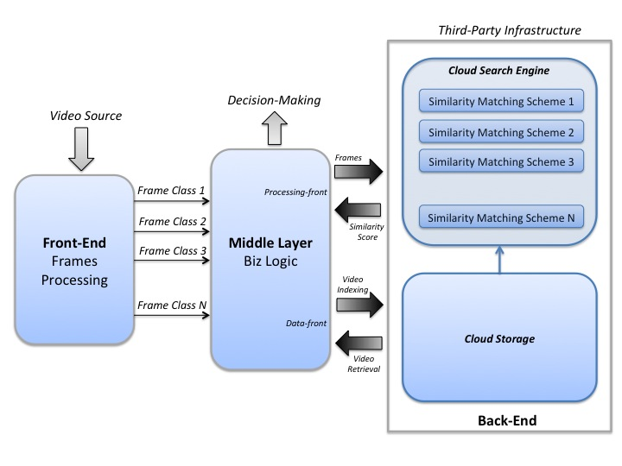
Figure 1: Modular Architecture
Within the three separate modules, the project has been separated into four major components that must be integrated together to provide a working CBVR system. These major components include:
- Key Frame Segmentation – Front Layer
- Key Feature Extraction – Front Layer
- Matching and Indexing Features – Middle Layer
- Cloud Storage & Engine Search – Back Layer
The above components will be elaborated on more in detail in the next section. These components will be utilized for the processing of the videos stored in the cloud database, and will also be utilized for the video or image the user will input into the CBVR system.
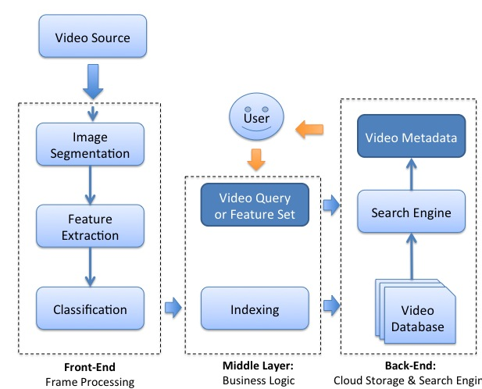

Figure 2: Individual Components in Modules
The user interface for our project would be based on Jquery and angular.js. The User Interface (UI) components would be taken from angular UI and the data binding would be done by angular js. It will be a stateless web interface where we would give our user the option to upload an image or a video as an input and then present our matching results in the form of a carousel which the user can easily browse. We would implement our project as a restful web service where we would use rest api’s to interact with the servers. The user interface would be styled using CSS3 and themes from libraries like Twitter bootstrap.css

Separate Modules & Components Functionality

In this section we describe the components and functionality of Sincre in more details. As described in section III, Sincre adopts a three-tier architecture, namely:
- Front-End: pre-processes frames from a source video sequence
- Middle-Layer: Business-logic that guides decision-making. Also in charge of video indexing and retrieval
- Back-end: processes search query. Also contains database of video archives
Figure 2 depicts our proposed modular design and individual components of Sincre. The Front-End is responsible for processing frames from an input video clip. The steps involved in this stage are standard image processing techniques involved in extracting and classifying the features of an image after segmentation. The backend has a database that stores already indexed videos and their metadata. It is also responsible for performing highly parallel query on the video database using a similarity-matching algorithm implemented on cloud infrastructure.
The Middle-layer, also called the Business Logic, interfaces with the front-end and the back-end. It is the cloud middleware of Sincre. At its front-end interface, it receives frames of a pre-processed video in form of templates that are grouped into classes depending on the frame’s content (i.e. features). At the back-end interface of the Middle-Layer, Data-front sub-unit responsible for video indexing and retrieval with the cloud database. Processing-front on the other hand is responsible for sending pre-processed frames (templates) and receiving similarity score - together with metadata of matched templates - to and from the cloud search engine. A third-party cloud infrastructure will be used to host both the front-end and middle-layers (video preprocessing) and the back-end consisting of the database and similarity matching layers.

Front – End : Frames Processing
This layer as stated before, is responsible for processing of the input/query video. This process will segment a key frame from the video and performs image processing to extract the videos metadata (pixels, histogram, etc.) to develop a feature vector of important information regarding that frame. This information will be used to compare to other video metadata, which will be located in cloud storage, to check for major similarities. Two major components that are incorporated with the front – end of this project are the key frame extraction, and the image processing/segmentation.

Key Frame Extraction
This component of the front –end layer extracts frames from a video to be processed. The term ‘key frames’ meaning that only the frames of the video that contain major changes will be extracted from the video. This will be useful for freeing memory for other processes to be handled. There would be no point in keeping duplicate frames that will produce the same feature vectors after being image processed. For this project, OpenCV can be utilized in conducting the key frame extraction. OpenCV operates with its own, and various other libraries like ffmpeg, which contains functions that allow users to read videos from a file on a local machine, and write images to a file in a specified directory (either local, or third-party). The algorithm developed in OpenCV will be similar to a basic for loop that will allow the capture of a single frame from every 5 frames presented. This will give a sequence of different frames for processing.
We could also use java based Xuggler library which provides easy api’s to record framed from a video based on the frame extraction frequency specified to the program. These frames can then easily undergo duplicate frame elimination using simple image comparisons libraries like OpenCV or RGB histogram difference comparison. For this method the students simply followed the frames extraction as represented in the figure above, and the later method we just compare the RGB histograms of pre specified section of the images and based on the results we decide how similar the images are to each other and thus eliminate the images with up to 90% similarity.
There are also a plethora of other applications developed to accomplish key frame extraction for this project such as VLC media player, GOM media player, AV Cutty, etc. These platforms can be configured to extract specific frames from a video, and will be utilized if previous key frame extraction technique does not provide the wanted results.

Key Feature Extraction
This component of the front – end layer will extract the needed metadata from each frame. Again OpenCV will be useful for this component, because it contains libraries for extracting a vast amount of information from an image.
A preliminary Hue Histogram based filter will form the first step in the image processing pipeline and will quickly return a set of possible matches by correlating the color frequencies of key frames from the query video to those we have in our database of videos. This approach allows us to reject non-matches up front without incurring the penalty of more expensive similarity matching algorithms.
Following this, the primary approach used for extracting information from an image is called scale-invariant feature transform (SIFT) and is used to describe local feature in images. The SIFT features are local and based on the appearance of the object at particular interest points, and are invariant to image scale and rotation. They are also robust to changes in illumination, noise, and minor changes in viewpoint. In addition to these properties, they are highly distinctive, relatively easy to extract and allow for correct object identification with low probability of mismatch. They are relatively easy to match against a (large) database of local features. Object description by set of SIFT features is also robust to partial occlusion; as few as 3 SIFT features from an object are enough to compute its location and pose.
Other options for image processing have been researched such as Java LIRE and will be developed further for a comparison between itself and the OpenCV SIFT extraction technique explained previously.

Middle-Layer : Business Logic
This layer is responsible for the matching algorithm and indexing of image metadata. For this layer a similarity measurement will be used of the query images SIFT metadata and the video databases SIFT metadata. A data structure that will be utilized for matching features on a cloud scale is kd-trees, which organizes points in a k-dimensional space.
Using a kd-tree allows us to find the nearest neighbor to a vector in O(log n) time complexity. This is useful to our SIFT implementation because it is observed that a single image may generate hundreds of features of where each is a 128-vector of 32-bit floating point numbers. This makes it impossible for us to store it in a conventional relational or NoSQL database and quickly index into it to find the nearest neighbor.
The kd-tree may be stored either in memory, on the file system, or on a managed key-value store such as Redis which has the following advantages:
- Point-in-time snapshots of the data may be saved to disk
- It is atomic and can be configured to be log-structured. This makes the data more reliable.
Storing the data on the file system allows us to store data about a larger number of images since memory is limited.
To compare histograms, OpenCV offers us some inbuilt methods – Correlation, Chi-Square, Intersection, and Bhattacharyya distance – of which it is found that Correlation gives the best discrimination between matches and rejections
Other options for a similarity measure could be flanning index that will be evaluated more if the previous data structure does not meet needed requirements as expected.
Students will also be experimenting with Java Lire library implementation for image comparisons. Lucene Image Retrieval (LIRe) is a lightweight java open source library for content-based image comparison. Lire also allows us to index large sets of images which makes handling them quite fast since the images are pre indexed on a tree based data structure. This might eliminate the need for us to have a database to store information since index based data structures would make the retrieval faster.

Back – End : Cloud Storage & Search Engine
This layer is responsible for holding all the metadata/feature vectors generated from the videos located in the video database. For this project we are planning to store the videos, frames and frame metadata in the AWS buckets and retrieve them programmatically whenever needed. For the retrieval of the relevant results we are considering two approaches one where we would be storing some meta-data related to frames in the dynamo DB and later on use these database tuples to filter content. Since dynamo DB and other databased have limitations on the sizes of these tuples and on the result retrieval efficiency in the case these frame metadata tuples are very large in size. (550 kb when we extract a detailed feature vector using SIFT library) we are planning to explore an approach when we pre index the images in a tree based data structure. The later approach if feasible would eliminate the need for databases altogether and would make the design simpler.

Performance Evaluation of Components

Key Frame Extraction
Performance evaluation for the key frame extract where students extract the frames from the video and then eliminate similar frames would be based on the fact that students are able to eliminate as many frames as possible from the generated frames and at the same time we are able to retain all the different key frames from the video. From the coding methods implemented students are able to extract about 510 frames from an 8minute30second video at the rate of 1 frame per second. Our algorithm currently eliminates over 85% of the frames and leaves us with just 15% frames for this video that are distinct enough from the remaining frames.
Using applications that already exist and can be implemented into this project, such as VLC media player, video frames can be extracted at parameters specified by the user. This application can be used to extract all frames or a specified number of frames at a given frame rate. Using this application frames can also be taken from any given time of the video, which can be very useful when trying to purge the newly generated frame sequence of null frames. The only draw back with this application is the video must play through for the frames to be extracted, so if the video is very lengthy this process could take a long time.

Key Feature Extraction

Matching and Indexing
Performance evaluation of the middle layer implementation based on the lire library could be measured on the basis of the speed and accuracy of the content-based image retrieval implementation. The indexing in lire is slow since it develops internal data structures, but this would be a onetime process that would not be required on the fly while running the query. Post indexing lire returns results very fast where it’s able to search through thousands of images in seconds. We still need to integrate this component with the frame extraction layer to come up with actual numbers in the case of large dataset of images.
In a preliminary test it is found that the histogram filter works best using a Correlation based discrimination scheme as compared to other algorithms. The filter is able to sort 500 frames based on similarity to the query frame on a 4-core personal computer in 30 seconds running a suboptimal algorithm that will re-compute histograms and correlations on demand. This should be significantly reduced once the histograms for the key frames from video database are cached ahead of time saving computation. Further, instead of linearly iterating through the key frames it may be possible to optimize the search algorithm since key frames in the same neighborhood (in the time domain) are likely to have more similar histograms than those far apart.

Cloud Storage and Search

Current Progress
We have developed and tested layer 1 of the architecture. We have done major portions of work on all other layers and tried multiple approaches on each layer. We would soon start integrating these layers together and choose the best fitting algorithms, libraries and approaches on each layer. We would also start and continue working on the user interface for out application in parallel.

References

- S.Padmakala, Dr.G.S.AnandhaMala, and M.Shalini, “An Effective Content Based Video Retrieval Utilizing Texture, Color, and Optimal Key Frame Features,” 2011 International Conference on Image Information Processing (ICIIP 2011),
- S.Megrhi, W.Souidene, A.Beghdadi, “Spatio-Temporal Salient Feature Extraction For Perceptual Content Based Video Retrieval,” 2013 Colour and Visual Computing Symposium (CVCS)
- Liang Zheng, Shengjin Wang, Ziqiong Liu, Qi Tian “Packing and Padding: Coupled Multi-index for Accurate Image Retrieval”, 2014 IEEE International Conference on Computer Vision and Pattern Recognition
- Weiming Hu, Senior Member, IEEE, Nianhua Xie, Li Li, Xianglin Zeng, and Stephen Maybank, “A Survey on Visual Content-Based Video Indexing and Retrieval,” IEEE TRANSACTIONS ON SYSTEMS, MAN, AND CYBERNETICS—PART C: APPLICATIONS AND REVIEWS, VOL. 41, NO. 6, NOVEMBER 2011.

