Hello Api (Node JS)

1. Environments Requirement
   1. For me, I use win7, I installed docker toolbox

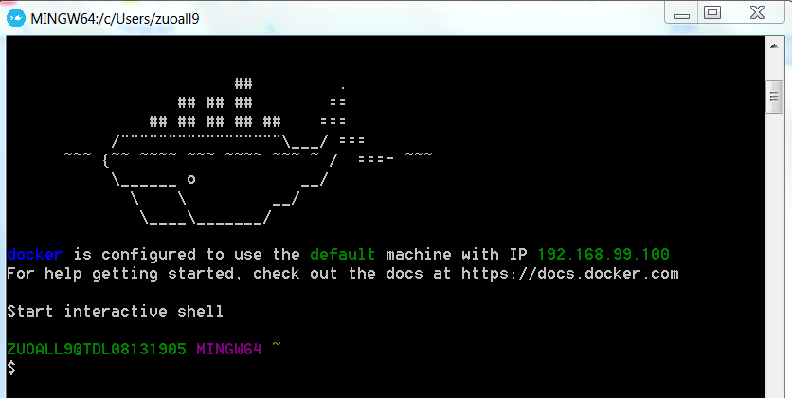

* 1. Docker version

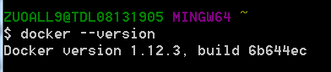

* 1. Docker-compose verison

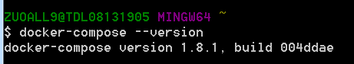

1. Run this api
   1. cd root path in docker toolbox
   2. run docker-compose up –d (if download mongo image failed, please manually docker pull mongo, sometimes it failed..)



* 1. run docker ps, check process

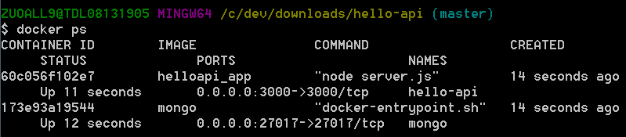

* 1. use postman to test this api, this api running in port 3000, for my machine, docker toolbox run in 192.168.99.100

name is allen

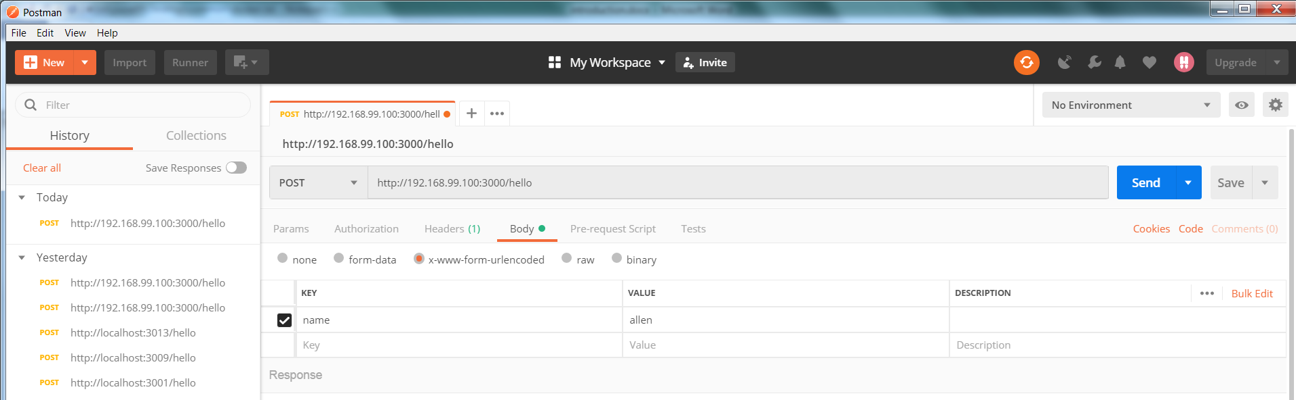

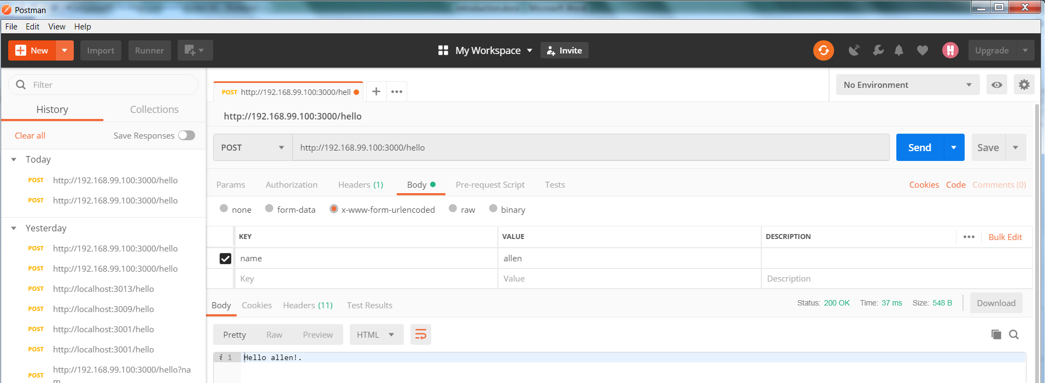

name is empty

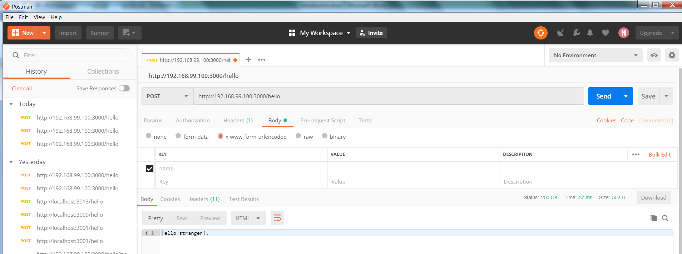

* 1. check the data in mongodb, for the dabase, my design is when "name" is empty, in database, it will be empty, for name have values, it will store the values, and allow duplicate name values
     1. docker ps get the mongo container id

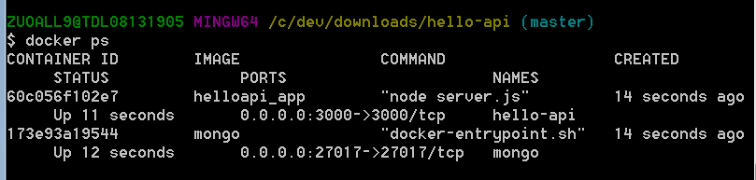

* + 1. run docker exec –it {containerid} bash

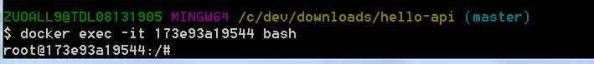

* + 1. run mongo

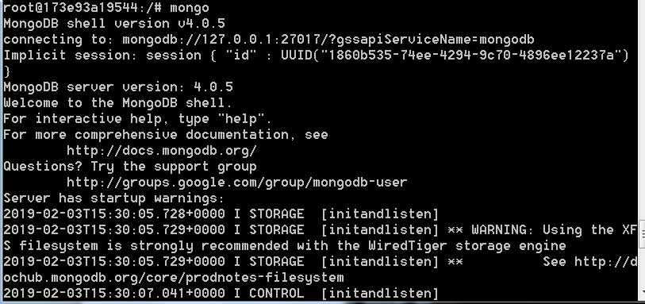

* + 1. run show dbs

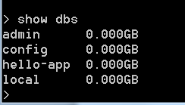

* + 1. run use hello-api

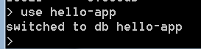

* + 1. run show collections

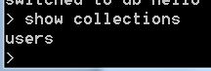

* + 1. run db.users.find()

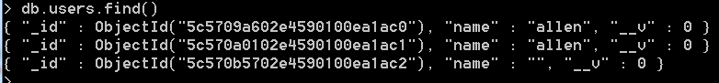

1. Test
   1. Use mocha to test
   2. Install mongodb in machine, make sure mongdb process start

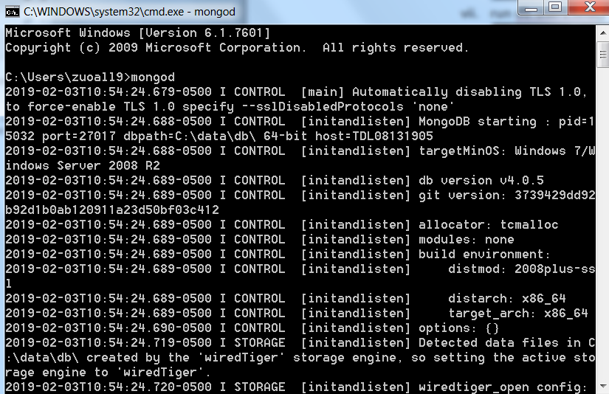

* 1. cd root path
  2. run npm install, install dependency

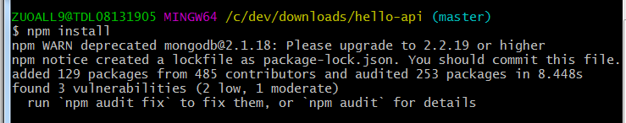

* 1. run npm test

