**Information Resources and Libraries**

Citation Indexes

**Citation Index DB Sources**

(1) Taiwan Citation Index - Humanities and Social Sciences (TCI-HSS-THCI, TSSCI)

(2) Scopus

(3) WOS (Science Citation Index Extended-SCIE, Social Science Citation Index-SSCI)

Related sources, also provide citation information

(1) EBSCO Academic Search Complete

(2) Electronic Theses and Dissertation System

(3) Scholar Google

**Highlights**

*Discussion on Citation Index will be heighted in the class, please try other resources after lectures.

1. Terms related to Citation Index

Citing: Citing article, Source Article, Number of citations (cited references)

Cited: References (Shared references), Cited references, Cited articles, Times of cited

2. Data source for JCR, e.g. number of published articles, times cited … etc.

3. Field and operator

a. address vs. SAME

b. keywords vs. NEAR (=NEAR/15, NEAR/X)

4. True or False?

a. Cited article B was published after citing article A was published.

□ True ☑ False

b. In citation index, such as SCIE, source article A could be a chapter of a book, a journal article or a proceeding paper.

□ True ☑ False

c. In citation index, such as SCIE, cited materials B has to be journal articles.

□ True ☑ False

d. From citation index’s point of view, articles Z and Y are subject-related because the authors of both articles referenced article A.

☑ True □ False

5.

a. To paper B, paper A is ☑ Citing article □ Cited materials □ Shared reference?

b. To paper Z, paper A is □ Citing article ☑ Cited materials □ Shared reference?

c. To papers A and X, paper B is □ Citing article ☑ Cited materials □ Shared reference?

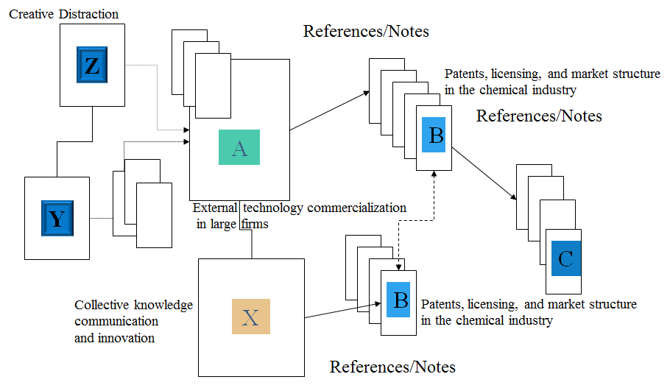

Article: External technology commercialization in large firms

6. Search the paper, “The many applications of patent analysis” in EBSCO ASC, SCIE, Scopus and Scholar Google for information about this article and citations, including author, sources, materials used by author during the writing process and the works cited this paper after it was published. Among works done by the author, which one is cited most?

Author: [Breitzman, AF](https://www.webofscience.com/wos/author/record/2920849)  ; [Mogee, ME](https://www.webofscience.com/wos/author/record/2476910)

Sources: Journal of Information Science

Materials: 27 references

Works: Science and technology as predictors of stock performance

Cited most: [Breitzman, AF](https://www.webofscience.com/wos/author/record/2920849): [The many applications of patent analysis](https://www.webofscience.com/wos/woscc/full-record/WOS:000177412300002)

[Mogee, ME](https://www.webofscience.com/wos/author/record/2476910): [Indicators for national science and technology policy: how robust are composite indicators?](https://www.webofscience.com/wos/woscc/full-record/WOS:000226145600007)

7. Look for a paper written by Prof. Chiang Kao, which is named “東亞十國企業人力資源狀況評估” via TCI. Who were the co-authors? How many times this paper was cited?

8. Try the following search, (timespan, year to date)

a. ADDRESS, natl taiwan univ AND dept phys

b. ADDRESS, natl taiwan univ SAME dept phys