04.02 Formatting, Formulas, and Functions Assignment

Directions
Have you ever stopped to really think about how you spend your day? A day is made up of 86,400 seconds, which is 1,440 minutes—or 24 hours, if you want the simple math. This assignment will help you evaluate a day in your life.

Step One: Create Your Spreadsheet
- Open a new Excel Online worksheet. Type the following column headings in the designated column:
  - Column A – Activity
  - Column B – Minutes
  - Column C – Percentage of Day
- Type the following row headings in the designated row:
  - Row 2 – Sleeping
  - Row 3 – School
  - Row 4 – Homework
  - Row 5 – Extra-Curricular
  - Row 6 – Computer
  - Row 7 – Phone
  - Row 8 – Television
  - Row 9 – Exercise
  - Row 10 – Family Time
  - Row 11 – Other
  - Row 12 – Total
Note: After typing this content, remember to adjust the column widths so the content fits within the cell. Your spreadsheet should look like the sample provided here.

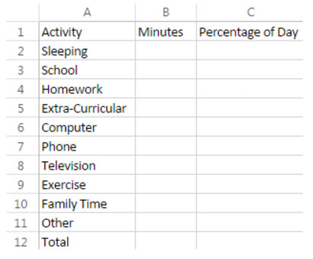

Step Two: Log Your Activities
Keep track on the chart of how many minutes you spend in one day per activity. Here are some tips about the activities:
  - Extra-curricular refers to clubs, sports, music lessons, etc. that happen outside school hours.
  - Computer relates to fun things like time spent gaming or on social media websites.
  - Phone refers to things like text messaging, playing games, looking at social media apps, etc.
  - Exercise relates to the amount of physical activity, like walking, bike riding, swimming, etc.
  - Other can be anything else you do in the day that is done on a regular basis, like work, attend church services, hang out with friends, etc.

Step Three: Calculations
Now it’s time to put Excel to work. Use the following formulas and functions to calculate your data.
- Place your cursor in B12. Calculate the sum of the minutes. Hint: =SUM(B2:B11).
- Place your cursor in B13. Perform an IF function to determine if your total activity minutes are within a 24 hour period. Hint: =IF(B12=1440, "Great Job!", "Your total minutes do not equal one day."). If your conditional function states, "Your total minutes do not equal one day." then you need to recalculate your activity minutes.
- Place your cursor in C2. Calculate the percentage of your day spent on each activity. Hint: =SUM(B2/2$B$12). Use the fill handle to drag the formula down to the other cells (much quicker than typing it 10 more times).
- Change Column C to a percentage.

Step Four: Analysis
How is the majority of your day spent?
- Highlight the largest percentage in Column C in green.
- Highlight the second largest percentage in Column C in blue.
- Highlight the third largest percentage in Column C in yellow.

Step Five: Save Your Spreadsheet
Save your Excel spreadsheet to your OneDrive using the file name format, "LastName_FirstName_M4L2." For example, if your name is Jane Smith, you would save the file as "Smith_Jane_M4L2."

