04.02 Formatting, Formulas, and Functions Assignment

Directions
Have you ever stopped to really think about how you spend your day? A day is made up of 86,400 seconds, which is 1,440 minutes—or 24 hours, if you want the simple math. This assignment will help you evaluate a day in your life.

Step One: Create Your Spreadsheet
- Open a new Excel Online worksheet. Type the following column headings in the designated column:
  - Column A – Activity
  - Column B – Hours
  - Column C – Percentage of Day
- Type the following row headings in the designated row:
  - Row 2 – Sleeping
  - Row 3 – School
  - Row 4 – Homework
  - Row 5 – Extra-Curricular
  - Row 6 – Computer
  - Row 7 – Phone
  - Row 8 – Television
  - Row 9 – Exercise
  - Row 10 – Family Time
  - Row 11 – Other
  - Row 12 – Total
Note: After typing this content, remember to adjust the column widths so the content fits within the cell. Your spreadsheet should look like the sample provided here.

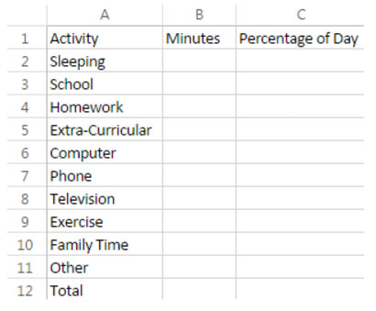

Step Two: Log Your Activities
Keep track on the chart of how many minutes you spend in one day per activity. Here are some tips about the activities:
  - Extra-curricular refers to clubs, sports, music lessons, etc. that happen outside school hours.
  - Computer relates to fun things like time spent gaming or on social media websites.
  - Phone refers to things like text messaging, playing games, looking at social media apps, etc.
  - Exercise relates to the amount of physical activity, like walking, bike riding, swimming, etc.
  - Other can be anything else you do in the day that is done on a regular basis, like work, attend church services, hang out with friends, etc.

Step Three: Calculations
Now it’s time to put Excel to work. Use the following formulas and functions to calculate your data.
- Place your cursor in B12. Calculate the sum of the minutes. Hint: =SUM(B2:B11).
- Place your cursor in B13. Perform an IF function to determine if your total activity hours are within a 24 hour period. Hint: =IF(B12=1440, “Great Job!”,“Your total minutes do not equal one day.”). If your conditional function states, “Your total minutes do not equal one day.” then you need to recalculate your activity hours.
- Place your cursor in C2. Calculate the percentage of your day spent on each activity. Hint: =SUM(B2/24). Use the fill handle to drag the formula down to the other cells (much quicker than typing it 10 more times).
- Change Column C to a percentage.

Step Four: Analysis
How is the majority of your day spent?
- Highlight the largest percentage in Column B in green.
- Highlight the second largest percentage in Column B in blue.
- Highlight the third largest percentage in Column B in yellow.

Step Five: Save Your Spreadsheet
Save your Excel spreadsheet to your OneDrive using the file name format, “LastNameFirstName_M4L2.” For example, if your name is Jane Smith, you would save the file as “SmithJane_M4L2.”

