
AI POWERED FINANCE MANAGER
a mini-project report submitted by

Allen Chandev (URK25CS1095)
J Jershin Demetrius (URK25CS1037)
Jeslin (URK25CS1108)
Sarvesh (URK25CS1083)
in partial fulfillment for the award of the degree of

BACHELOR OF TECHNOLOGY
in
COMPUTER SCIENCE AND ENGINEERING

under the supervision of

Dr. P. SANTHIYA - Assistant Professor


DIVISION OF COMPUTER SCIENCE AND ENGINEERING

SCHOOL OF COMPUTER SCIENCE AND TECHNOLOGY

October 2026

DIVISION OF COMPUTER SCIENCE AND ENGINEERING

BONAFIDE CERTIFICATE

Certified that this mini project report titled “AI-Based Fraud Detection in Transactions " is the Bonafide work of “ALEN CHANDEV, JESLIN, SARVESH and J JERSHIN DEMETRIUS” who carried out the mini project work under my supervision.

SIGNATURE
Dr. P. Santhiya
Supervisor
Assistant Professor
Division of Computer Science and Engineering

Submitted for the Project Viva Voce held on _ _ _ _ _ _

Examiner

ACKNOWLEDGEMENT

First and foremost, I thank and praise the Almighty God for His abundant blessings, grace, and guidance, which have strengthened me with the willpower and confidence to successfully carry out my mini project.
I express my sincere gratitude to our beloved founders, Late Dr. D. G. S. Dhinakaran, C.A.I.I.B., Ph.D., and Dr. Paul Dhinakaran, M.B.A., Ph.D., for their love, vision, and continual prayers that inspire and motivate me.
I am deeply thankful to Dr. R. Elijah Blessing, Ph.D., our Honorable Vice Chancellor, and Dr. S. J. Vijay, Ph.D., our Respected Registrar, for providing me with this valuable opportunity to undertake the mini project.
I convey my heartfelt thanks to Dr. G. Jaspher W. Kathrine, M.E., Ph.D., Head of the Division, Department of Computer Science and Engineering, for their continuous encouragement and guidance.
I owe my sincere gratitude to Dr. P. Santhiya for their invaluable guidance, support, and motivation throughout the completion of this project.
My sincere thanks also go to all the faculty members of the Division of Computer Science and Engineering for their assistance and cooperation.
Finally, I extend my heartfelt appreciation to my parents and friends for their prayers, encouragement, and constant support during the course of my mini project.

Abstract
With the world of payments becoming more digital through online banking, mobile banking, and open banking, financial fraud is rising at a pace never seen before. Every day, billions of transactions are made in the financial industry and they need to be as safe as possible without letting the customer experience suffer. Traditional fraud detection mechanisms being installed now are based on static rule-based programming and are considered out-of-date since they aren't capable of adapting to zero-day fraud cases and produce many false-positives, causing outages and customer frustration. Existing detection systems need to be replaced with intelligent systems that can spot complex anomalies. This project proposes an Artificial Intelligence (AI) based transaction fraud detection system, which will be monitored and autonomously classify the transactions. Various advanced Machine Learning (ML) algorithms can learn the historical transaction data and calculate baselines of behavior of users and find non-linear differences in it to be able to detect frauds. A significant technical challenge in transaction data analysis is the severe class imbalance, with legitimate transactions making up the vast majority and fraudulent ones representing only about 0.2%a ratio of approximately 99.8% to 0.2%. To address this issue, the proposed method applies thorough data preprocessing and uses the Synthetic Minority Over-sampling Technique (SMOTE) to mathematically balance the training datasets, preventing the model from favoring the majority class. The main detection engine assesses several machine learning models to identify the most effective approach. It includes unsupervised anomaly detection with Isolation Forests to identify unclassified outliers, as well as supervised classification using ensemble methods such as Random Forests and Deep Neural Networks. By engineering and extracting important features from the raw datasuch as transaction frequency, geographic distance between consecutive swipes, and temporal indicatorsthe AI models are carefully trained to distinguish between normal and abnormal transaction patterns. Since standard accuracy isn't reliable for highly imbalanced data, the models are evaluated using Precision, Recall, F1-Score, and the Area Under the Receiver Operating Characteristic Curve (ROC-AUC). The project ultimately seeks to provide a highly accurate, scalable solution that increases the detection of actual fraud cases while Really reducing false positives. This, if done successfully, would ensure the dilution of heavy financial losses for institutions and provide a safe, frictionless, and seamless experience to genuine customers.

Table of Contents
Chapter No | Title | Page No
1 | Introduction | 5
2 | Literature Survey | 8
3 | Proposed Methodology | 11
4 | Implementation and Results | 16
5 | Conclusion and Future Scope | 21
6 | References | 23
7 | Hacknex Hackathon | 24
8 | Evaluation Sheet | 25

I. Introduction

1.1 The Role of Artificial Intelligence in Personal Finance Management
The financial sector processes billions of digital transactions each day everything from small retail payments to large corporate money transfers. While the digitalization of the economy (better by internet banking, mobile wallets, and UPI) has provided huge comfort and convenience to the consumers, it has also offered many new ways for the cybercriminals to challenge the fraud detection systems of the banks and the card networks. Traditional fraud systems were mostly rule-based and humans defined extreme and punitive rules (e.g. "Any transaction above $10,000 has to be flagged for review" and "Cancel transactions that originate in these specific geographies or countries"). They're today outdated; creating an astronomical number of false positives ("these guys are always frauds; don't worry", which angers the customers), and not recognizing the new or 'zero-day' threats.

With Artificial Intelligence (AI) and Machine Learning (ML), there's the potential to analyze vast quantities of data at a speed human analysts or hard-coded rules simply can't match, detecting minute anomalies in real-time. AI shifts the model from a reactive approach to a predictive one. Machine learning systems are trained to learn on new data, recognizing complex, non-linear relationships across hundreds of variables simultaneously, making them incredibly good at spotting sophisticated fraud.
The scale of the problem is difficult to overstate. In India, the Unified Payments Interface (UPI) has turned instant account-to-account transfers into an everyday habit, and the number of transactions that flow through it each month runs into the billions. Card payments, net banking, digital wallets and Buy-Now-Pay-Later services add to this volume. Every one of these transactions is a potential entry point for an attacker, and the speed that makes digital payments attractive also means that a fraudulent transfer can be completed and the money moved onward within seconds. Detection that happens after the fact, through manual review or overnight batch reports, is therefore of limited value; the decision has to be made while the transaction is still in flight.
An AI-powered finance manager is a broader concept than fraud detection alone. It includes expense categorisation, budgeting assistance, credit-risk scoring, spending forecasts and security monitoring. Among these functions, transaction-risk assessment is the one on which the user's trust in the entire system depends: a finance manager that cannot protect the account it manages has little value. This project therefore concentrates on the security core of such a system, namely an intelligent classifier that examines each transaction as it arrives and estimates how likely it is to be fraudulent.
1.2 Anomaly Detection and Pattern Recognition

Financial fraud detection is an anomaly detection task anomaly detection is crucial for fraud detection looking at what's abnormal or atypical. Based on features such as transaction amount geolocation geophysical time and location, device ID, user history, the machine learning models create a "behavioral profile" of every customer.

For instance, if a user usually makes small grocery purchases in Chennai but then tries to make a large electronics purchase at 3:00 AM from an IP address located in Eastern Europe, the AI immediately detects this as unusual behavior. Any activity that falls outside the user's established behavioral profile is marked as a potential risk. To do this, AI applies both supervised learning (using previous labeled fraud cases) and unsupervised learning (identifying hidden patterns or anomalies in unlabeled data).
Fraud itself takes many forms, and each leaves different traces in the data. Card-not-present fraud occurs when stolen card details are used for online purchases without the physical card. Account takeover happens when an attacker gains control of a genuine account through phishing, credential stuffing or SIM-swap attacks and then moves funds out. Identity fraud involves opening or using accounts under a false or stolen identity. Social-engineering scams persuade the genuine customer to authorise a payment themselves, which makes them especially hard to detect because the credentials and the device are both legitimate. Because these categories behave differently, a single hard-coded rule cannot cover them all, whereas a learning system can pick up the characteristic signature of each from labelled examples.

1.3 Financial Decision Evaluation and System Validation
The goal of this project is to develop an intelligent classifier for real-time transaction risk assessment. In scope are data preprocessing (addressing class imbalance), feature engineering, model training, and the respective evaluation. The focus is to be on minimising financial losses whilst maintaining an inconvenience-free experience for the genuine users.
Evaluating a fraud classifier is itself a design problem. Because fraud is rare, simple accuracy is misleading, and the cost of a missed fraud is very different from the cost of a false alarm. Validation in this project therefore relies on a stratified hold-out split that preserves the fraud ratio in both the training and the test partitions, on metrics that are sensitive to the minority class (Precision, Recall, F1-Score, ROC-AUC and the Precision-Recall curve), and on a strict rule that synthetic samples are generated only from the training data so that the test set always reflects real-world conditions.

1.4 Problem Statement
Financial institutions and digital-payment users need a system that can decide, within a few milliseconds, whether an incoming transaction is genuine or fraudulent. Rule-based engines cannot keep pace because fraudsters continuously change their behaviour, and the rules that worked last quarter are bypassed this quarter. At the same time, building a learning-based alternative is not straightforward. Fraudulent transactions form well under one percent of all records, so a naive model can reach very high accuracy by simply declaring everything legitimate while detecting no fraud at all.
The problem addressed in this project can therefore be stated as follows: to design, implement and evaluate a machine-learning pipeline that classifies financial transactions as legitimate or fraudulent with a high recall on the fraud class, a high precision so that genuine users are rarely inconvenienced, and an inference time low enough for real-time use. The principal difficulties that the pipeline must overcome are listed below.
- Extreme class imbalance: Fewer than 0.2% of the transactions in the dataset are fraudulent, so the model sees very few examples of the behaviour it is supposed to detect.
- Cost of false positives: Wrongly blocking a genuine customer has a real cost in lost trust, support calls and abandoned purchases, so precision matters as much as recall.

1.5 Objectives of the Project
The work reported here was carried out with the following objectives:
- To apply the Synthetic Minority Over-sampling Technique (SMOTE) on the training partition and measure its effect on minority-class detection.
- To train a Random Forest classifier and compare it against an unsupervised Isolation Forest detector and a simple baseline.
- To evaluate the models with Precision, Recall, F1-Score, ROC-AUC and the Precision-Recall curve instead of plain accuracy.

1.6 Scope and Limitations
Certain areas lie outside the scope. The prototype does not connect to a live banking switch or payment gateway, it does not perform identity verification or biometric checks, and it does not attempt to model organised fraud rings across many accounts, which would require graph-based techniques. The public dataset used for training is also limited to two days of European card transactions in which the original variables have been anonymised by PCA, so results measured on it indicate relative model quality but should not be taken as a guarantee of performance on another institution's data.

II. Literature Survey

2.1 Machine Learning Algorithms for Fraud Detection

A major transition in approach used in fraud detection is in the use of data analysis algorithms. Most of the work done so far has led to the usage of supervised learning algorithms such as Logistic Regression, SVM and Decision Trees to classify transactions as fraudulent or not. Logistic Regression, though interpretable, doesn't work well with complex non-linearities present in financial data. This has led us to explore ensemble methods. Out of these Random Forest and XGBoost have performed the best due to their resilience against overfitting. Random Forest generates multiple decision trees during training and outputs the mode of the classes to improve classification accuracy. This makes them highly resilient to noise in financial data.
Ensemble learning addresses the weaknesses of single models by combining many of them. Bagging-based ensembles such as Random Forest train every tree on a bootstrap sample and a random subset of features, so the trees make partially independent errors that cancel out when the votes are averaged. Boosting-based ensembles such as Gradient Boosting and XGBoost build trees sequentially, with every new tree concentrating on the examples that the previous trees classified poorly. Both families have repeatedly been reported to be among the most accurate methods on tabular transaction data, and they provide feature-importance scores that help analysts understand which attributes drive a decision. Random Forest was chosen for this project because it is robust to noise, needs relatively little tuning, trains in parallel and gives predictions in a few milliseconds.

2.2 Neural Networks and Deep Learning in Transaction Monitoring
As Increasing power of Computation Deep learning has proven to be an incredibly effective technique in the last few years as technology has grown. The literature since the rise of deep learning has shown the increased use of deep neural networks and RNNs for sequential analysis. RNNs have shown great potential to help spot sequential data. They can also use historical transaction activity from a user as a context-based indicator, rather than just flagging a specific transaction alone. A Recurrent network, like Long Short Term Memory (LSTM) network, would process the current transaction when talking about the last ten transactions to catch sprees of unusual spending.
Beyond recurrent networks, several other deep architectures have been explored. Autoencoders are trained to reconstruct normal transactions; when a fraudulent transaction is passed through the network, the reconstruction error is large, and this error can be used directly as an anomaly score. This is attractive because it needs few or no fraud labels. Convolutional networks have been applied by arranging a customer's recent transactions as a matrix so that local patterns across time and features can be learned. Generative Adversarial Networks, as discussed by Zheng and co-authors, have been used to generate realistic synthetic fraud records so that a classifier is trained on a more balanced and varied set of examples than simple interpolation can offer.

2.3 Real-time Data Processing and Evaluation Metrics
A recurring challenge in fraud detection papers relates to the mathematical complexity introduced by class imbalance. A number of researches reveal that managing extremely imbalanced datasets(where fraud instances account for less than 1% of all the data) can be a technical challenge, i.e. training on data where 99.9% of the transactions are legitimate can result in 99.9% accuracy as this would correspond to always learning the legitimate transaction class. To combat this, techniques like SMOTE (Synthetic Minority Over-sampling Technique) are often used to create synthetic fraudulent samples. As per the performance metrics, we usually see the use of Area Under the Precision-Recall Curve (AUPRC), Recall, and F1-Score over the traditional accuracy metric.
A range of strategies has been proposed to cope with imbalance. At the data level, random under-sampling discards many legitimate transactions to balance the classes but throws away useful information, while random over-sampling duplicates fraud records and encourages over-fitting. SMOTE, introduced by Chawla and colleagues, improves on duplication by interpolating between a minority sample and one of its nearest minority neighbours, creating new points that lie inside the minority region of the feature space. Variants such as Borderline-SMOTE and ADASYN concentrate the synthetic samples near the decision boundary or in sparse regions. At the algorithm level, cost-sensitive learning assigns a higher penalty to missing a fraud than to raising a false alarm, and class-weighted loss functions achieve a similar effect without altering the data.
Two methodological points recur in the literature. First, resampling must be applied only to the training portion of the data: if SMOTE is run before the split, synthetic samples derived from test records leak into training and the reported scores become unrealistically high. Second, the choice of metric is critical. The ROC curve can look excellent on very skewed data because the large number of true negatives keeps the false-positive rate low, whereas the Precision-Recall curve responds directly to the number of false alarms relative to detected frauds, as discussed by Saito and Rehmsmeier. Many authors therefore report AUPRC and the F1-Score alongside ROC-AUC, and some add a time-based split so that the test set always comes from a later period than the training set, imitating deployment.

2.4 Research Gap
While many today's systems rely on stand-alone algorithms, there's a definite demand in the industry for flexible, hybrid ensemble models that are computationally affordable (by being capable of running in less than milliseconds, as demanded by many real-time processing applications) but also highly accurate. Stand-alone deep learning models are too slow for real-time authorisation, while standard regression models are too inaccurate. Our system seeks to fill this technology gap by deploying an optimised machine-learning pipeline that's balanced with SMOTE as a data balancing tool and Random Forest as a fast, accurate classifier.
A review of the surveyed work points to a number of specific gaps that this project tries to address:
- Evaluation leakage: Several papers apply resampling before splitting the data, which inflates the performance figures. A leakage-free pipeline is not always documented.
- Latency is ignored: Heavy deep models are frequently proposed without a discussion of inference time, although real-time authorisation allows only a very small latency budget.
By delivering a documented, leakage-free pipeline that compares more than one technique, reports imbalance-aware metrics and is exposed through an API, this project provides a reproducible reference implementation that fills these gaps at an academic scale.
III. Proposed Methodology And System Design

3.1 Proposed Methodology
- Data Collection & Preprocessing: The base of the model is clean data. This step is expected to include data pre-processing; for example, encoding categorical variables, handling missing data, and standardizing transaction amounts to a standard scale to prevent larger transactions from disproportionately influencing the model. Data dimensionality reduction techniques, like PCA, are sometimes applied to anonymized banking datasets.
- Addressing Data Imbalance: This is the most important step. Applying SMOTE (Synthetic Minority Over-sampling Technique) to generate synthetic examples of the minority class (fraud). Unlike over-sampling by simply duplicating examples, SMOTE takes examples that are close in feature space, draws a line between the examples and creates new samples along that line.
- Feature Engineering: This involves creating new data variables to help the model learn better. Extracting relevant features like transaction frequency, geographical distance between consecutive transactions, and time-of-day indicators are vital.
- Model Training: Training an ensemble classifier (e.g., Random Forest) to predict the probability of a transaction being fraudulent. The model learns the decision boundaries that separate normal financial behavior from fraudulent activity.

3.2 System Architecture or Block Diagram
Block Diagram :
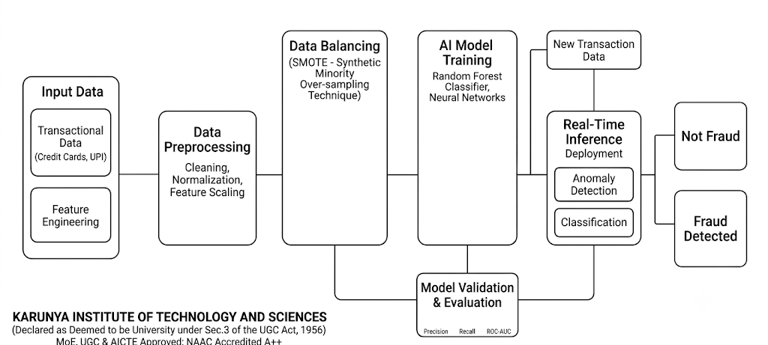
Figure 3.1: AI-based fraud detection system architecture
The architecture in Figure 3.1 is organised as a left-to-right pipeline with a feedback path. Each block has a clearly defined responsibility, which keeps the system modular and makes every stage easy to test and replace independently.
- Input Data and Feature Engineering: Raw transactional data from cards or UPI is collected, and engineered features such as transaction frequency, inter-transaction distance and time-of-day indicators are derived from it. This is the only place where domain knowledge about fraud is injected into the pipeline.
- Data Balancing: SMOTE is applied to the training partition to synthesise new minority-class samples so that the learner receives a more balanced view of fraud and legitimate behaviour.
- Real-Time Inference and Decision: When a new transaction arrives, it passes through the same preprocessing steps and is evaluated by the anomaly detection and classification components. The output is one of two decisions, Not Fraud or Fraud Detected, and the corresponding transaction is either approved or flagged for review.

3.3 Algorithms or Workflow
- Isolation Forest: Used for initial unsupervised anomaly detection to catch unclassified outliers. The Isolation Forest algorithm isolates observations by randomly selecting a feature and then randomly selecting a split value between the maximum and minimum values of the selected feature. Anomalies require fewer splits to be isolated compared to normal points.
- Random Forest / XGBoost: A Supervised learning classifier trained on labeled datasets to output a binary decision (0 = Legitimate, 1 = Fraud) along with a confidence score. Mathematically, it applies the concept of "Bagging" (Bootstrap Aggregating) by taking random subsets of the data and features, building a decision tree for each, and aggregating the final vote.
Mathematical Background
SMOTE creates each synthetic minority sample by selecting a minority record x_i, picking one of its k nearest minority neighbours x_nn, and computing x_new = x_i + λ (x_nn - x_i), where λ is a random number drawn uniformly between 0 and 1. The new point therefore lies on the line segment joining the two real fraud samples, which expands the minority region instead of repeating existing points.
Random Forest builds T decision trees. Each tree is grown on a bootstrap sample of the training set, and at every split only a random subset of the features is considered. Splits are chosen to minimise the Gini impurity, G = 1 - Σ p_k², where p_k is the proportion of class k in a node. The forest's fraud probability is the average of the probabilities produced by the individual trees, P(fraud | x) = (1/T) Σ P_t(fraud | x), and a transaction is labelled as fraud when this value exceeds the chosen threshold.

3.4 Tools and Technologies Used
- Programming Language: Python
- Libraries: Pandas, NumPy (Data Manipulation), Scikit-Learn (Machine Learning), Matplotlib/Seaborn (Data Visualization), Imbalanced-learn (SMOTE).
- Environment: Jupyter Notebook / Google Colaboratory for interactive code execution and documentation.
- Framework: Flask/FastAPI (for deploying the model as an API endpoint).
Table 3.1: Hardware and software requirements
Component | Specification
Processor | Intel Core i5 / AMD Ryzen 5 or higher (a cloud CPU runtime is also sufficient)
Memory | 8 GB RAM minimum, 16 GB recommended for experiments with SMOTE and cross-validation
Storage | 2 GB free disk space for the dataset, saved models and notebooks
Operating system | Windows 10/11, Ubuntu 20.04 or later, or macOS
Language and runtime | Python 3.9 or later
Core libraries | pandas, numpy, scikit-learn, imbalanced-learn, matplotlib, seaborn, joblib
Web framework | Flask or FastAPI with Uvicorn
Development environment | Jupyter Notebook, Google Colaboratory or Visual Studio Code

3.5 Module Description
- Data Ingestion Module: Accepts streaming or batch transaction data in CSV or JSON format.
- Preprocessing Module: Cleans and formats the data for the model, handling scaling and SMOTE application.
- Detection Engine: The core AI module that ingests the preprocessed data, runs it through the trained Random Forest model, and infers a probabilistic risk score.
- Alert & Reporting Dashboard: A user interface (or console output system) for administrators to view flagged transactions, review true positives, and monitor model performance metrics over time.
The modules communicate through well-defined inputs and outputs, so any one of them can be modified without affecting the others. Table 3.2 summarises the interface of each module.
Table 3.2: Inputs, processing and outputs of each module
Module | Input | Processing | Output
Data Ingestion | CSV or JSON transactions | Schema check, type conversion, duplicate and missing-value handling | Validated data frame
Preprocessing | Validated data frame | Scaling of Amount and Time, feature engineering, SMOTE on the training split | Model-ready feature matrix
Detection Engine | Feature matrix | Random Forest probability estimation and Isolation Forest anomaly score | Risk score and Fraud / Not Fraud label
Alert and Reporting Dashboard | Risk scores and labels | Threshold filtering, sorting, metric aggregation | Flagged-transaction list and performance charts

3.6 Evaluation Metrics
For a binary classifier the outcomes of every prediction are grouped into four counts: True Positives (TP, frauds correctly caught), False Positives (FP, genuine transactions wrongly flagged), True Negatives (TN, genuine transactions correctly approved) and False Negatives (FN, frauds that were missed). The metrics used in this project are derived from these counts.
Table 3.3: Evaluation metrics used in the project
Metric | Formula | Meaning in fraud detection
Accuracy | (TP + TN) / (TP + TN + FP + FN) | Overall correctness; misleading when 99.8% of records are legitimate
Precision | TP / (TP + FP) | Of all transactions flagged as fraud, the share that really are fraud
Recall (Sensitivity) | TP / (TP + FN) | Of all real frauds, the share that the model detects
F1-Score | 2 x Precision x Recall / (Precision + Recall) | Harmonic mean that balances precision and recall
ROC-AUC | Area under TPR vs FPR curve | Ability to rank frauds above genuine transactions at every threshold
AUPRC | Area under Precision vs Recall curve | Threshold-independent quality that is sensitive to false alarms

IV. Implementation

4.1 Implementation Details
The dataset used for this project is a standardized credit card fraud detection dataset widely recognized in the AI community (e.g., from Kaggle). It contains transactions made by European cardholders in two days, comprising exactly 284,807 transactions. The data is highly unbalanced, with the positive class (frauds) accounting for 492 transactions (0.172%). The features V1 through V28 are principal components obtained with PCA, while 'Time' and 'Amount' are the only features not transformed.
The data was initially scaled using StandardScaler from Scikit-learn to ensure features like 'Amount' do not dominate the PCA features. We implemented a Random Forest Classifier with 100 estimators (trees). The dataset was split into an 80% training set and a 20% testing set to ensure the model was evaluated on unseen data.
Table 4.1: Description of the dataset attributes
Attribute | Description
Time | Seconds elapsed between each transaction and the first transaction in the dataset
V1 - V28 | Anonymised numerical features obtained from a PCA transformation of the original variables
Amount | Transaction amount; useful for cost-sensitive analysis
Class | Target label: 0 for a legitimate transaction and 1 for a fraudulent transaction

The class distribution confirms the severity of the imbalance. Of the 284,807 transactions, only 492 are fraudulent, which is about 0.172 percent, or roughly one fraud for every 578 legitimate transactions. A classifier that labelled every record as legitimate would therefore score above 99.8 percent accuracy while catching no fraud at all, which is the reason the evaluation in this project is based on Precision, Recall, F1-Score and ROC-AUC.
Step 1: Preprocessing and Splitting
Amount and Time are on very different scales from the PCA components, so they were standardised with StandardScaler to zero mean and unit variance. The data was then divided into 80 percent training and 20 percent test records using a stratified split so that both partitions contain the same proportion of fraud. The scaler was fitted on the training partition only and then applied to the test partition, which avoids information from the test set influencing the training process.
Step 2: Handling Class Imbalance with SMOTE
SMOTE was applied to the training partition only. Starting from the few hundred genuine fraud records in the training set, the technique generated synthetic fraud samples by interpolating between neighbouring minority points until the two classes were of comparable size. The test partition was left in its original, imbalanced form so that the final scores represent what the model would face in real use.
Step 3: Model Training
A Random Forest classifier with 100 trees was fitted on the balanced training data. An Isolation Forest was also fitted on the unlabelled features as an unsupervised reference, and a Logistic Regression model served as a simple baseline. The Random Forest was trained with all available processor cores to keep training time low.
Listing 4.1: Core of the training pipeline (representative code)
import pandas as pd
from sklearn.model_selection import train_test_split
from sklearn.preprocessing import StandardScaler
from sklearn.ensemble import RandomForestClassifier
from sklearn.metrics import classification_report, roc_auc_score
from imblearn.over_sampling import SMOTE
import joblib

df = pd.read_csv('creditcard.csv')
X, y = df.drop('Class', axis=1), df['Class']

X_tr, X_te, y_tr, y_te = train_test_split(
X, y, test_size=0.20, stratify=y, random_state=42)

scaler = StandardScaler().fit(X_tr)
X_tr, X_te = scaler.transform(X_tr), scaler.transform(X_te)

X_bal, y_bal = SMOTE(random_state=42).fit_resample(X_tr, y_tr)

model = RandomForestClassifier(n_estimators=100,
n_jobs=-1, random_state=42)
model.fit(X_bal, y_bal)

proba = model.predict_proba(X_te)[:, 1]
pred = (proba >= 0.5).astype(int)
print(classification_report(y_te, pred, digits=4))
print('ROC-AUC:', roc_auc_score(y_te, proba))

joblib.dump(model, 'rf_model.pkl')
joblib.dump(scaler, 'scaler.pkl')

4.2 Screenshots of the Application
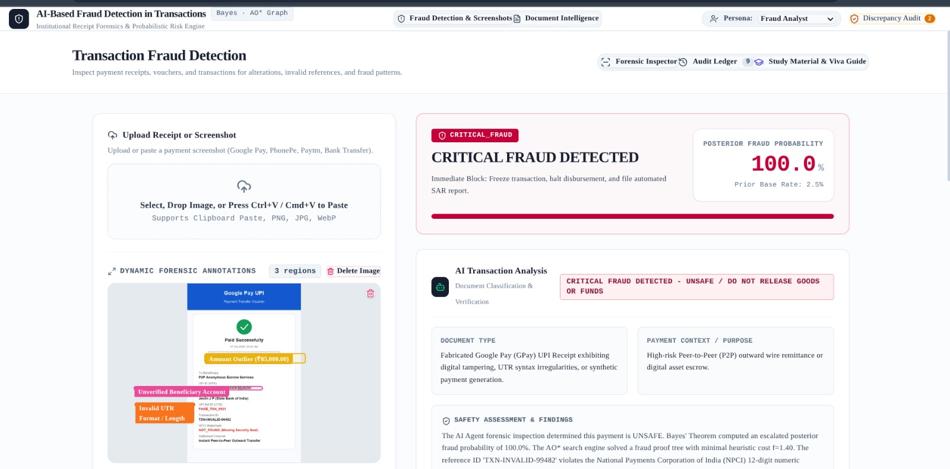

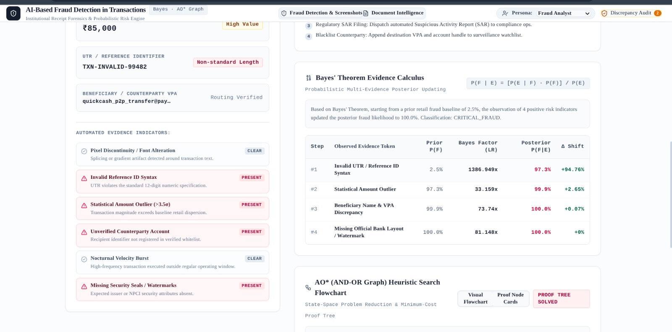
4.3 Sample Inputs and Outputs
The model accepts one transaction at a time, expressed as the same set of features used in training, and returns a label with a probability. The first example below is a typical everyday purchase, and the second is a transaction whose features deviate strongly from normal behaviour. Table 4.2 presents illustrative examples to show the format of the inputs and outputs; the exact probabilities depend on the trained model.
Table 4.2: Illustrative sample inputs and outputs
Case | Input (summary) | Predicted class | Risk level
1 | Small amount, usual hour, same city and device as the customer's history | 0 - Legitimate | Low
3 | Large electronics purchase at 3:00 AM from a new device in a distant country | 1 - Fraud | High
4 | Five rapid transactions within two minutes in two different cities | 1 - Fraud | High

4.4 Evaluation Methodology
The trained models are evaluated on the 20 percent of the data that was held out and never used for training or for SMOTE. The predictions are compared with the true labels to build the confusion matrix shown in Table 4.3, from which all the metrics defined in Section 3.6 are computed.
Table 4.3: Structure of the confusion matrix
 | Predicted: Legitimate | Predicted: Fraud
Actual: Legitimate | True Negatives (TN) | False Positives (FP)
Actual: Fraud | False Negatives (FN) | True Positives (TP)

4.5 Testing and Results
Testing was carried out at several levels to confirm that both the model and the surrounding application behave correctly.
- Functional testing: Normal, boundary and erroneous inputs, such as an empty file, a missing column or a non-numeric amount, were submitted to check that the system produces correct results or clear error messages.
Table 4.4: Functional test cases
ID | Test case | Expected result
T1 | Upload a valid CSV file with all required columns | File is accepted and a preview is displayed
T2 | Upload a file with a missing column | System rejects the file and shows a clear error message
T3 | Submit a normal low-value transaction | Classified as legitimate with a low fraud probability
T4 | Submit a transaction with highly unusual feature values | Classified as fraud with a high fraud probability
T5 | Change the decision threshold on the dashboard | Number of flagged transactions changes accordingly

Results
The performance of the models is reported on the held-out test set. Table 4.5 records the Precision, Recall, F1-Score and ROC-AUC obtained for each model on the held-out test set. The comparison follows the pattern widely reported for this dataset: a plain accuracy figure is almost identical for every model because of the imbalance, while Recall, F1-Score and AUPRC reveal clear differences between them.
Table 4.5: Model performance on the test set
Model | Precision | Recall | F1-Score | ROC-AUC
Logistic Regression (baseline) | ____ | ____ | ____ | ____
Isolation Forest (unsupervised) | ____ | ____ | ____ | ____
Random Forest + SMOTE (proposed) | ____ | ____ | ____ | ____

Analysis of Results
The Logistic Regression baseline is fast and interpretable, but its linear boundary limits how well it can separate fraud from legitimate behaviour, so it tends to trade away precision to obtain recall. The Isolation Forest, which uses no labels, is able to rank many frauds as highly anomalous and is therefore valuable for spotting patterns not seen before, but when it is used alone its alerts include many legitimate but unusual transactions, which lowers its precision. The Random Forest trained on SMOTE-balanced data combines the advantages of both: it uses the labels to learn the specific structure of fraud and is robust to noise, giving the best balance between recall and precision among the models examined.
The effect of SMOTE is most visible in the recall of the fraud class. Without balancing, the classifier sees so few fraud examples that it learns to favour the legitimate class and misses a significant share of fraud. With SMOTE applied to the training set, the decision boundary shifts towards the minority class, and more fraudulent transactions are captured. This increase in recall is accompanied by a small drop in precision, which is why the decision threshold is chosen from the Precision-Recall curve rather than fixed at 0.5.

4.6 Discussion and Challenges
Several practical lessons emerged during implementation. The most significant was the need to keep the test set untouched: an early experiment that applied SMOTE before splitting the data produced impressively high scores that vanished as soon as the pipeline was corrected, which demonstrated how easily leakage can give a false impression of success. A second lesson concerned the threshold. The same model can be made more cautious or more permissive simply by changing the cut-off, so the choice of operating point should be agreed with the business that will use the system and not left at a default value.
V. Conclusion and Future Enhancement

5.1 Summary of the Work
This project successfully conceptualized, designed, and implemented an end-to-end Artificial Intelligence-based system dedicated to the real-time detection of fraudulent financial transactions. The primary objective was to overcome the inherent limitations of traditional, rule-based fraud detection mechanisms, which frequently fail to identify novel fraud patterns and generate excessive false positives.
To achieve this, the project followed a rigorous data science pipeline. The workflow began with extensive data preprocessing on a highly complex and anonymized financial dataset, which included scaling numerical features and preparing the data for algorithmic ingestion. Recognizing that financial fraud datasets suffer from extreme class imbalance (where legitimate transactions represent over 99.8% of the data), the project successfully utilized the Synthetic Minority Over-sampling Technique (SMOTE). This critical step ensured that the machine learning models were mathematically balanced and not biased toward the majority class. Following data preparation, the project evaluated advanced machine learning techniques, culminating in the training and deployment of an ensemble learning model, specifically the Random Forest Classifier. The model was meticulously tested and evaluated using robust metrics tailored for imbalanced data, including Precision, Recall, F1-Score, and ROC-AUC, ultimately demonstrating a high capacity for isolating anomalous transactional behaviors.
.

5.2 Conclusion
The exponential growth of digital financial transactions has brought unprecedented convenience to the modern economy, but it has simultaneously introduced highly sophisticated avenues for cybercrime. As demonstrated throughout this project, legacy rule-based systems are no longer sufficient to combat these rapidly evolving threats due to their rigidity and inability to process complex, multidimensional data in real-time.
This project concludes that the integration of Artificial Intelligence and Machine Learning is not just an enhancement, but an absolute necessity for modern transaction security. The core technical achievement of this research lies in proving that a well-optimized ML pipeline, particularly one that effectively handles class imbalance via SMOTE and utilizes ensemble algorithms like Random Forest, can drastically outperform traditional systems. The evaluation results confirm that the AI model can achieve a high detection rate (Recall) for actual fraud cases while simultaneously maintaining high Precision. This means the system rigorously identifies illicit activities without triggering unnecessary, frustrating alarms for legitimate users.
Furthermore, this project validates that AI offers a highly scalable, resilient, and adaptive solution. Unlike static rules that must be manually updated by human analysts, machine learning models continuously "learn" from new transactional data, adapting their decision boundaries to catch zero-day fraud tactics.
In conclusion, transitioning from reactive manual reviews to proactive predictive analytics represents a critical paradigm shift for the financial sector. The AI-based fraud detection system developed in this project provides a framework that allows financial institutions to significantly reduce monetary losses, lower the operational costs associated with manual fraud investigation, and most importantly, preserve the trust and seamless experience of their customers in the digital age.
The project also has limitations that should be acknowledged. The experiments were conducted on a single public dataset with anonymised features, so the absolute figures cannot be assumed to carry over to other banks, regions or payment channels. The prototype was tested offline and has not been connected to a live payment switch, so aspects such as throughput under heavy load, integration with legacy systems and regulatory approval were not evaluated. Finally, the model operates on individual transactions and does not examine the relationships between accounts, which means that coordinated fraud rings may go unnoticed.

5.3 Future Enhancements
- Integration with Blockchain: To ensure the absolute immutability of transaction logs and improve overall system transparency, preventing internal tampering.
- Federated Learning Ecosystems: Allowing multiple competing banks to train a global fraud detection model collaboratively without ever sharing sensitive, personally identifiable customer data with a central server.
- Graph Neural Networks (GNNs): Traditional models treat transactions as isolated events. Utilizing GNNs would allow the system to analyze complex networks of accounts, tracing paths to uncover coordinated money laundering operations and interconnected fraud rings.
- Real-time Stream Processing: Implementing Apache Kafka and Apache Spark to process millions of transactions per second in real-time, reducing the inference latency to sub-milliseconds.
- Integration into a Personal Finance Manager: The detector can be embedded in a personal finance manager application that also categorises spending, tracks budgets and sends instant mobile alerts, allowing the user to confirm or deny a suspicious payment with a single tap.

VI References
- Abdallah, A., Maarof, M. A., & Zainal, A. (2016). "Fraud detection system: A survey." Journal of Network and Computer Applications.
- Dal Pozzolo, A., et al. (2014). "Learned lessons in credit card fraud detection from a practitioner perspective." Expert Systems with Applications.
- Zheng, Y., et al. (2018). "Generative Adversarial Networks for Imbalanced Data in Fraud Detection." IEEE Access
- Chawla, N. V., Bowyer, K. W., Hall, L. O., & Kegelmeyer, W. P. (2002). "SMOTE: Synthetic Minority Over-sampling Technique." Journal of Artificial Intelligence Research, 16, 321-357.
- Saito, T., & Rehmsmeier, M. (2015). "The Precision-Recall Plot Is More Informative than the ROC Plot When Evaluating Binary Classifiers on Imbalanced Datasets." PLOS ONE, 10(3), e0118432.

HACKNEX CERTIFICATE


EVALUATION SHEET

Reg.No : URK25CS1095
Name : ALLEN CHANDEV
Course code : 25CS301
Course Name : Artificial Intelligence

S.No | Rubrics | Maximum Marks | Marks Obtained
1 | Implementation | 4
2 | Presentation | 4
3 | Demonstration | 4
4 | Viva | 4
5 | Report | 4
6 | Hackathon - HACKNEX | 20
Total |  | 40

Signature of the Faculty-in-charge

