**1**

**介绍**

**Chapter Contents章节内容**

一致性的必要 1

TWAIN的组成 2

使用TWAIN的好处 3

使用TWAIN进行开发 4

**The Need for Consistency一致性的必要**

随着扫描仪，数码相机和其它图像获取设备的发展，用户对于将图像信息纳入他们的文档和其它工作中的渴望非常强烈。然而，要开发支持和操纵这种光栅数据的应用程序来说对于开发成本要求非常高。首先你得创建用户图形界面，而且要使程序能兼容大多数的图像设备。一旦开发出来的应用程序只能支持给定的设备，就将面临令人沮丧的新功能和特性的升级。开发者将持续不断的升级他们的应用程序。（想想这将令多少程序猿抓狂！）

图像设备开发者和应用程序开发者都意识到了制定两者（图像设备和上层应用程序）的通信标准的必要性，程序员和用户都将由此受益。而且对于设备生产商来讲，他们的设备将支持更多的应用程序提供者从他们的设备中获取数据，而不必考虑设备类型。TWAIN便是因一致性、简单化的原因而开发的。

*TWAIN 1.9 说明书 1-1*

***Chapter 1***

**TWAIN的组成**

TWAIN的定义了一个标准的软件协议和众多API用于应用软件和图像获取设备的通信。

TWAIN的三大关键组成如下：

* **应用软件** – 一款应用必须使用WTAIN。
* **源管理软件** – 用于管理应用和数据源的交互。这部分代码由TWAIN开发者工具包提供，并且应该对每个基于TWAIN协议开发的应用程序开源。
* **源软件** – 控制图像获取设备，并且这部分由硬件设备开发者通过TWAIN说明书提供。传统设备驱动现在也包含了源软件，and do not need to be shipped byapplications.

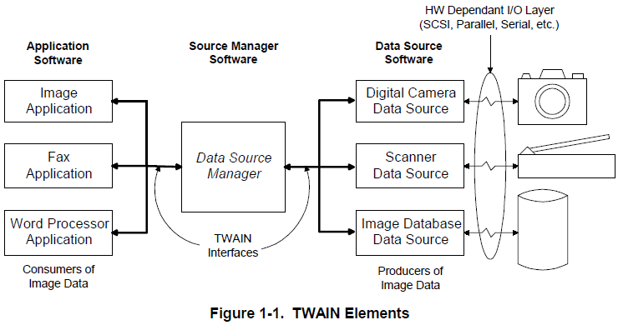

**Benefits of Using TWAIN使用TWAIN的好处**

**For the Application Developer对应用开发者来说**

* 可以使用户直接在应用程序里从任何兼容性的图像设备中获取图像。
* 节省时间和金钱。如果你要为设备编写底层驱动，那么就无需再重写或支持这些设备驱动。基于TWAIN的图像获取设备可以提供源软件模块来避免以上。
* 使用上层TWAIN应用程序编程接口，只需要修改一次程序代码，便能轻松处理任何基于TWAIN的图像获取设备，从而访问或处理图像数据。不需要定制产品。TWAIN图像设备能兼容桌面扫描仪，人工扫描仪，数码相机，图像采集卡，图像数据库，或任何符合TWAIN API协议的光栅设备。

• Allows you to determine the features and capabilities that an image acquisition device can

provide. Your application can then restrict the Source to offer only those capabilities that are

compatible with your application’s needs and abilities.

• Eliminates the need for your application to provide a user interface to control the image

acquisition process. There is a software user interface module shipped with every TWAINcompliant

Source device to handle that process. Of course, you may provide your own user

interface for acquisition, if desired.

**For the Source Developer**

• Increases the use and support of your product. More applications will become image

consumers as a result of the ease of implementation and breadth of device integration that

TWAIN provides.

• Allows you to provide a proprietary user interface for your device. This lets you present the

newest features to the user without waiting for the applications to incorporate them into their

interfaces.

• Saves money by reducing your implementation costs. Rather than create and support various

versions of your device control software to integrate with various applications, you create just

a single TWAIN-compliant Source.

**For the End User**

• Gives users a simple way to incorporate images into their documents. They can access the

image in fewer steps because they never need to leave your application.

**Note:** TWAIN is supported on all versions of Microsoft Windows and Apple Mac OS X.

TWAIN 2.x and higher includes support for Linux and 64-bit operating systems.

Information about supporting TWAIN on 16-bit operating systems and older versions of

the Apple Macintosh OS are no longer described in the current TWAIN specification.

Please refer to version 1.9 of the Specification for support of older operating systems.