How to install map tiles

Introduction
This document will guide you through the steps necessary to install an overlay server on your windows PC. The procedure requires that you have administrative access to your PC. The procedure is comprised of several steps:
- Installing a web server on your PC if you don’t currently have one running.
- Configuring the web server to serve map tiles using the tileserver.php software.
- Downloading the desired files (mbtiles files) that contain the desired files.

Web Server
First, it must be determined whether a webserver is running on your PC. One way to do this is to open a browser and visit “localhost. If you get a screen like this, then you don’t have a web server running.
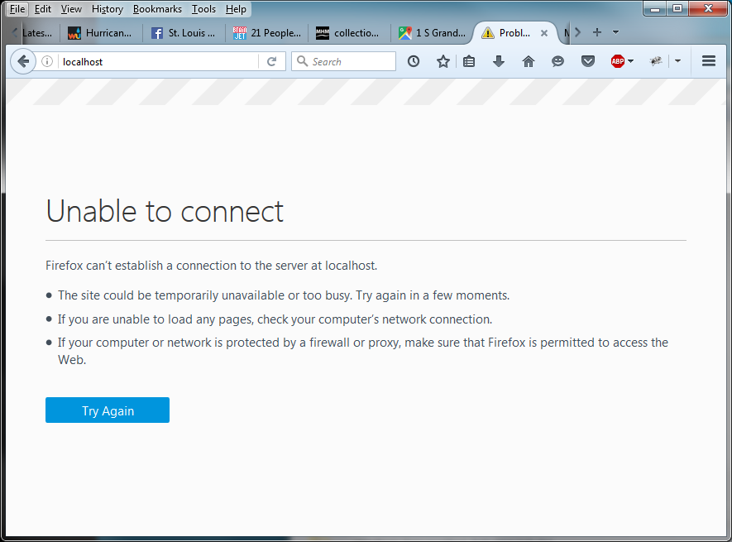
If a web page is displayed, then there is a web server running. In this case, we can skip the following steps to install the web server.

Installing Internet Information Services
More detailed instructions for installing a Microsoft IIS web server can be found here: http://www.iis.net/learn/application-frameworks/scenario-build-a-php-website-on-iis/configure-a-php-website-on-iis These instructions say that you must have Windows 8 but the procedure seems to work Ok on Windows 7 and presumably will work for Windows 10 as well.

To install IIS on Windows 8
- On the Start page, type Control Panel, and then click the Control Panel icon in the search results.
- In Control Panel, click Programs, and then click Turn Windows features on or off.
- In the Windows Features dialog box, click Internet Information Services, note the preselected features that are installed by default, and then select CGI. This selection also installs FastCGI, which is recommended for PHP applications.
- Click OK.
- To verify that IIS installed successfully, type the following into a web browser:
http://localhost
You see the default IIS Welcome page.

To install PHP by using Web PI
- Open a browser to the following website: Microsoft Web Platform Installer 3.0.
- Click Download It Now, and then click Run.
- At the top of the Web Platform Installer window, click Products.
- Click Frameworks, and then select the current version of PHP.
- Click Install. The Web Platform Installation page displays the version of PHP and its dependencies that will be installed.
- Click I Accept. Web PI installs the PHP packages.
- Click Finish.
When installing PHP, version 5.6 should give adequate results.

To test your PHP installation
- Open a text editor, for example Notepad, as Administrator.
- In a new file, type the following text: <?php phpinfo(); ?>
- Save the file as C:\inetpub\wwwroot\Phpinfo.php.
- Open a browser and enter the following URL:
http://localhost/phpinfo.php
A nicely formatted webpage is displayed showing the current PHP settings.

Install the server software
A simple php script to serve images from mbtiles files can be found here: https://github.com/bmcbride/PHP-MBTiles-Server.
- Download the zip file containing the php script and extract it.
- Open a Windows Explorer window and in the directory “C:\inetpub\wwwroot” create a new folder “map_tiles”.
- Copy the “mbtiles.php” script file in th extracted zip file to the C:\inetpub\wwwroot\map_tiles” directory.

Download the mbtiles files containing the Overlay
- Download the zip file containing the mbtiles files from: https://drive.google.com/open?id=0B15wS9-3PzfYRHVDMEhYT1RLSDQ
- Unzip the file to C:\inetpub\wwwroot\map_tiles.

Now, click on the OK button.

