CB demo:

As the number of points increases, the mean error of the IPS estimates and their variance converge to 0

RL demo:

(uni_ran, least_load_03):

(uni_ran, least_load_0):

(uni_ran, eps_greedy_03):

(uni_ran, ucb1):

(eps_greedy_03, least_load_03):

(eps_greedy_03, least_load_0):

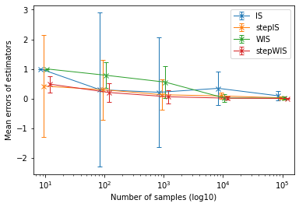

(eps_greedy_03, uni_ran):

(eps_greedy_03, ucb1):

