Mean DR convergence: -0.001202047854787664

Mean DR convergence: 0.0033940118873031

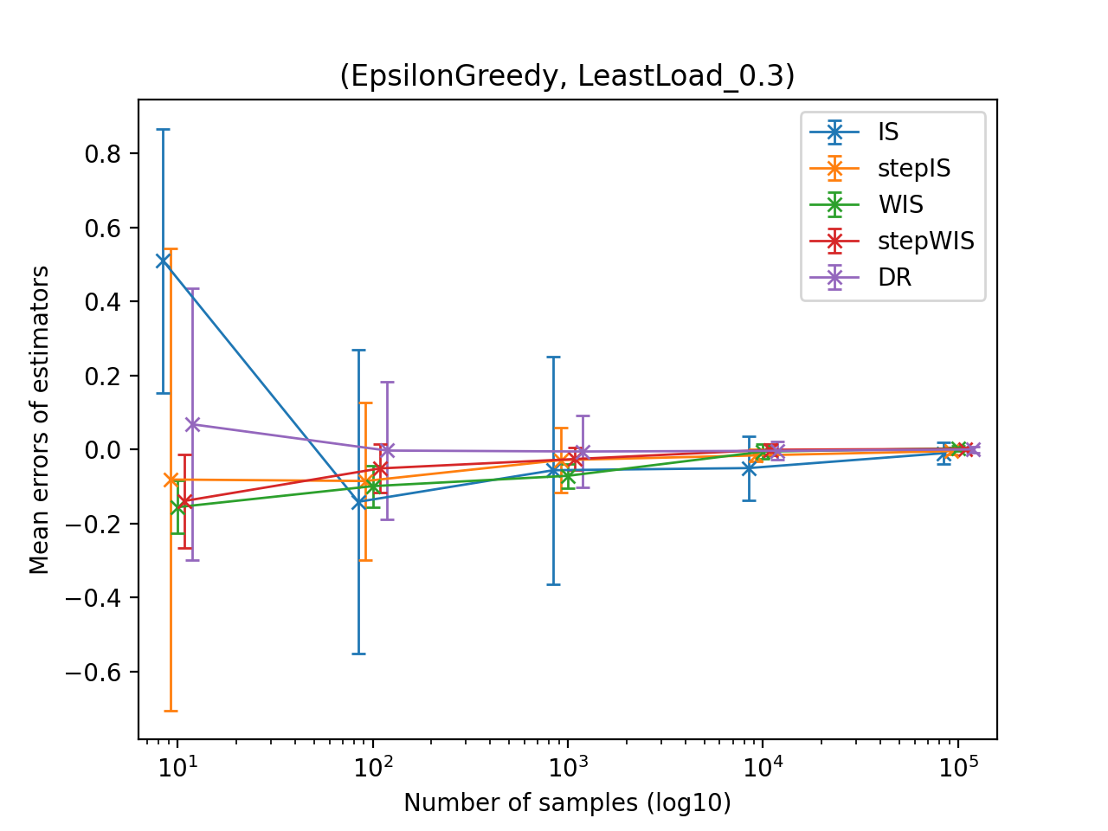

Mean DR convergence: -0.01726374667955707

Mean DR convergence: 0.00012780230751880588

Mean DR convergence: 0.0018026028377716153