Q3:

The words I chosen are: jack, students, lovely, fly, California, vehicles

|  |  |  |
| --- | --- | --- |
| Word | Top-10 similar words | Explanation |
| jack | 1: adam (0.879731849466)  2: james (0.859791406534)  3: susan (0.856596258738)  4: daniel (0.847600400729)  5: jonathan(0.847532173876)  6: peter (0.844088466095)  7: eric (0.843254808498)  8: elizabeth(0.843212500388)  9: andrew(0.837502134837)  10: max (0.837313367421) | The list for similarity words of “jack”. They all names that may appear similar positions in contexts. Make sense. |
| students | 1: teenagers (0.90506951027)  2: teachers (0.894963701817)  3: artists (0.881470107477)  4: workers (0.875842429749)  5: musicians (0.872420597661)  6: passengers (0.870055778661)  7: writers (0.866744226293)  8: players (0.86398743223)  9: patients (0.863965477776)  10: doctors (0.860676886079) | The list for similarity words of “students”. They all words that relate to education themes and usually appear together with ‘students’. Make sense. |
| lovely | 1: wonderful (0.956797234956)  2: strange (0.952925286023)  3: brilliant (0.951478419124)  4: terrible (0.949593013664)  5: small (0.949123911397)  6: handsome (0.944957778292)  7: rare (0.943611600303)  8: strong (0.941459897846)  9: sharp (0.935127990384)  10: massive (0.929865135644) | The list for similarity words of “lovely”. They all adj words that are synonym or antonym. |
| fly | 1: move (0.890553751213)  2: ride (0.861486607037)  3: go (0.856600917141)  4: walk (0.854025102725)  5: drive (0.851442448146)  6: play (0.847781266963)  7: pass (0.825400217155)  8: stick (0.822155644052)  9: cheat (0.820508678492)  10: visit (0.820125783797) | The list for similarity words of “fly”. Some of the words are different transport ways but the words such as ‘cheat’and ‘visit’do not make sense. |
| California | 1: massachusetts (0.929528816433)  2: parliament (0.926764079682)  3: pennsylvania (0.923939932312)  4: connecticut (0.909955405571)  5: texas (0.903871934072)  6: chicago (0.899457046856)  7: france (0.883675708923)  8: florida (0.880151711863)  9: virginia (0.876764122872)  10: baghdad (0.872795401219) | The list for similarity words of “california”. Most of them are USA states names, however ‘france’ ‘parliament’ and ‘baghdad’are contry’s name or city name, even organization, that may due to the corpus limitations, do not make sense. |
| vehicles | 1: cars (0.899643253849)  2: products (0.896096295512)  3: jobs (0.880102372999)  4: clothes (0.872600093959)  5: systems (0.87154951572)  6: programs (0.871017726647)  7: films (0.868010271145)  8: activities (0.865815758725)  9: shoes (0.865438623427)  10: communities (0.857974706724) | The list for similarity words of “vehicles”. The top-10 words all are nouns and the meanings variety widely. Make sense |

According to the sheet I can see that the similarity between pairs are same irrespective of orders.

Screenshot as follow:

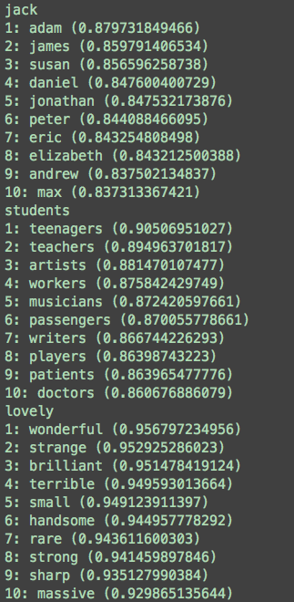

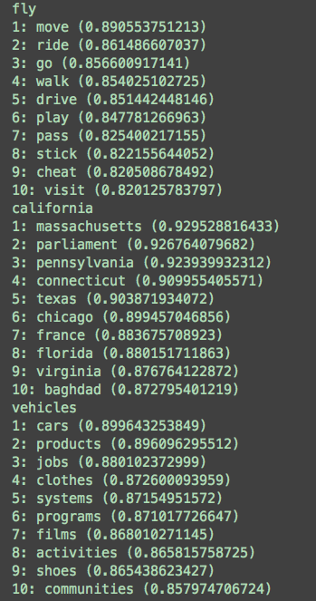

For further analysis, I choose the first word ‘jack’to analyze its most-similar list. Do analyze to ‘adams’and ‘james’, the results as follow:

|  |  |  |
| --- | --- | --- |
| Word | Top-10 similar words | Explanation |
| adam | 1: susan (0.906303287797)  2: jonathan (0.903141469464)  3: eric (0.898352454499)  4: daniel (0.890523863894)  5: peter (0.888142865848)  6: andrew (0.887256313909)  7: james (0.883557711366)  8: elizabeth (0.882771436888)  9: david (0.880152191565)  10: jack (0.879731849466) | The list for similarity words of “adam”. They all names that may appear similar positions in contexts. Make sense. |
| james | 1: peter (0.920780552412)  2: david (0.91994398634)  3: robert (0.917601586427)  4: thomas (0.914829148349)  5: andrew (0.912412100825)  )6: daniel (0.912336599771)  7: eric (0.90213572096)  8: jonathan (0.894416009034  9: joseph (0.889429606845)  10: steven (0.889429153845) | The list for similarity words of “james”. They all names that may appear similar positions in contexts. Make sense. |

According to this sheet it can be observed that pairs similarity (‘jack’, ‘adam’) = (‘adam’, jack’) . The list of ‘jack’, ‘james’ and ‘adam’has some different words and probabilities.

