Name - Allen Fanial
Module Name – Module 4_ Data and predictive analysis
Set And Question no. –: D - 1

GLOBAL DISASTER DATA ANALYSIS USING POWER BI

PROBLEM STATEMENT
Global disasters such as earthquakes, floods, hurricanes, and wildfires affect countries every year. Analyzing disaster data using Power BI helps understand disaster patterns, impact severity, economic loss, and response efficiency.

OBJECTIVE

- To analyze global disaster data from 2018 to 2024.
- To visualize disaster frequency and country-wise impact.
- To compare economic loss by disaster type.
- To analyze response efficiency and recovery duration.
- To design an interactive Power BI dashboard.

REQUIREMENTS
Software Used:
- Microsoft Power BI Desktop
- Microsoft Word
Dataset:
- Global Disaster Dataset (2018–2024)

STEPS

Home Page: Global Disaster Impact and Response Analysis (2018–2024)
The Home page gives a short introduction about the project. It explains that from 2018 to 2024, global disasters had high frequency and caused serious economic damage. It also mentions that response efficiency improved over time, but higher disaster severity led to longer recovery periods. This page mainly acts as a navigation page for the dashboard.
There are navigation buttons like “Global Disaster Overview (2018–2024)”, “Disaster Severity & Response Analysis”, and “Country-wise Disaster Impact.” When we press Ctrl + Mouse Click on the “Global Disaster Overview (2018–2024)” button, it directly takes us to that specific report page. In the same way, other buttons also help in moving between different dashboard pages easily.
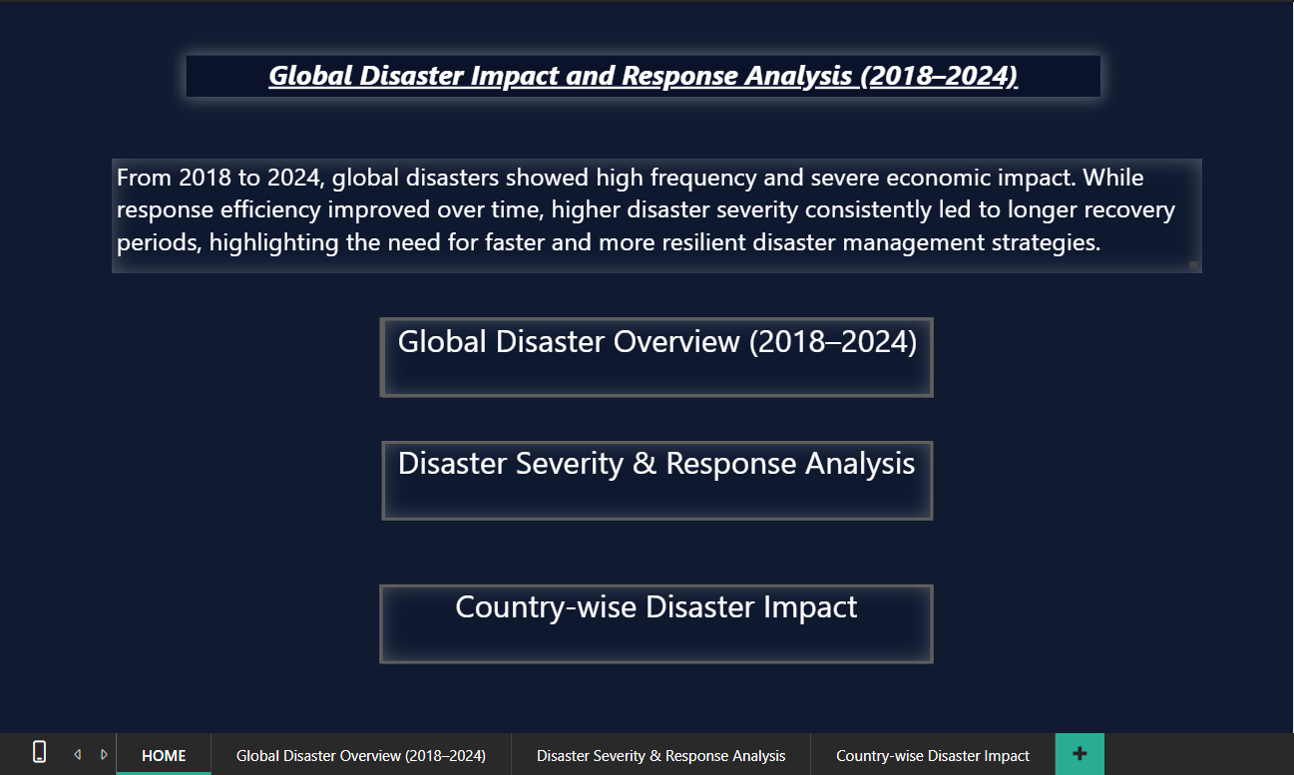

STEP 1: Load the Dataset
The dataset was loaded into Power BI using the Get Data option.


STEP 2: Understand Dataset Structure
Columns and data types were reviewed to understand the dataset.
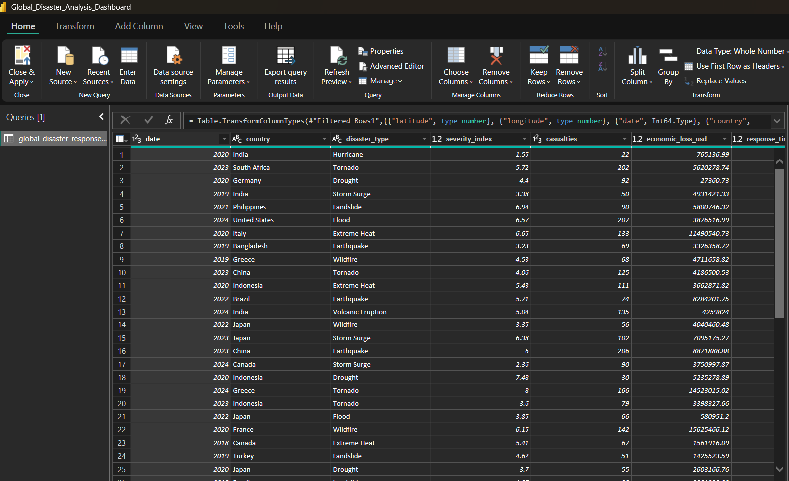

STEP 3: Global Disaster Overview (2018–2024)
The dashboard gives an overall idea of global disasters between 2018 and 2024. It shows total disasters, total casualties, and total economic loss using simple number cards. A bar chart is used to show different disaster types and how often they occurred. A map is also used to show which countries were more affected. Year and disaster type filters are added so the data can be easily understood.

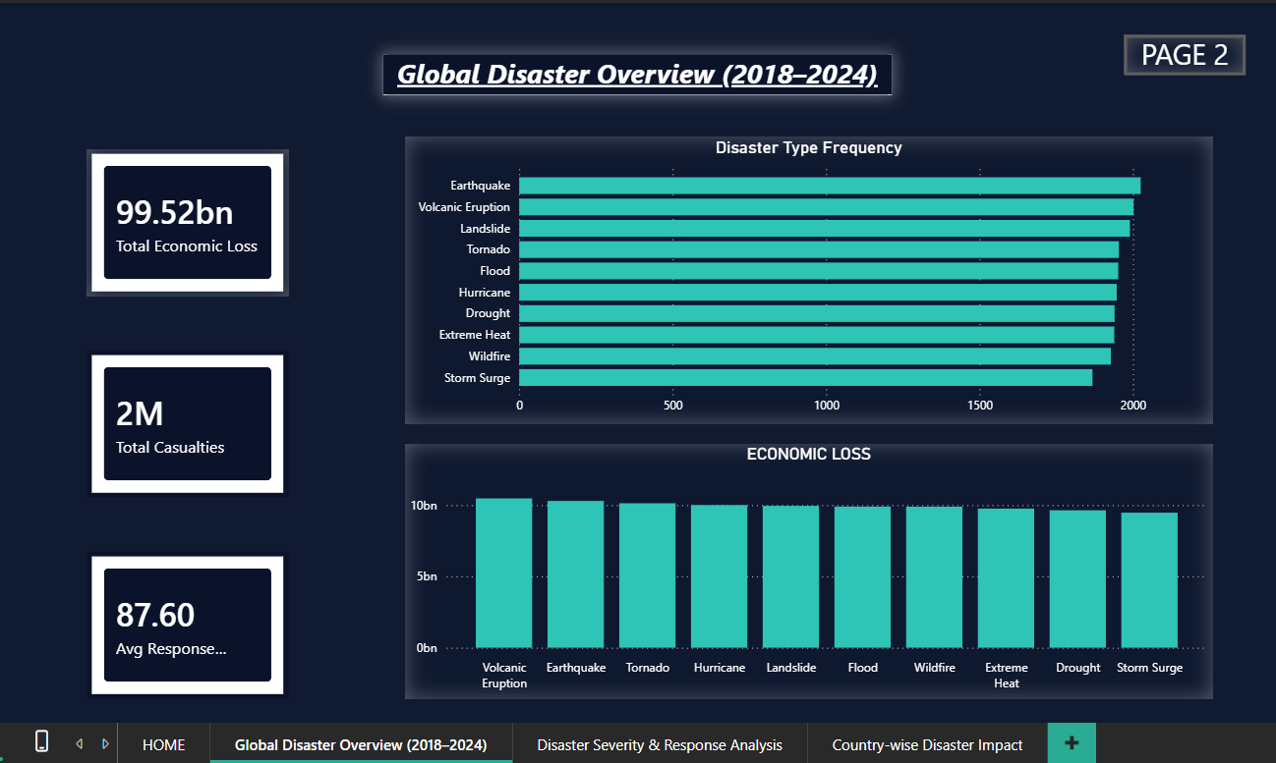

STEP 4: Disaster Severity & Response Analysis
This page focuses on disaster severity and how quickly responses were given. A scatter chart is used to show the relationship between severity index and recovery duration, which helps to understand that higher severity disasters usually take more time to recover. A line chart shows average response efficiency by year from 2018 to 2024, which helps in analyzing improvement or decline in disaster response. A severity index slider is also used to filter the data easily.

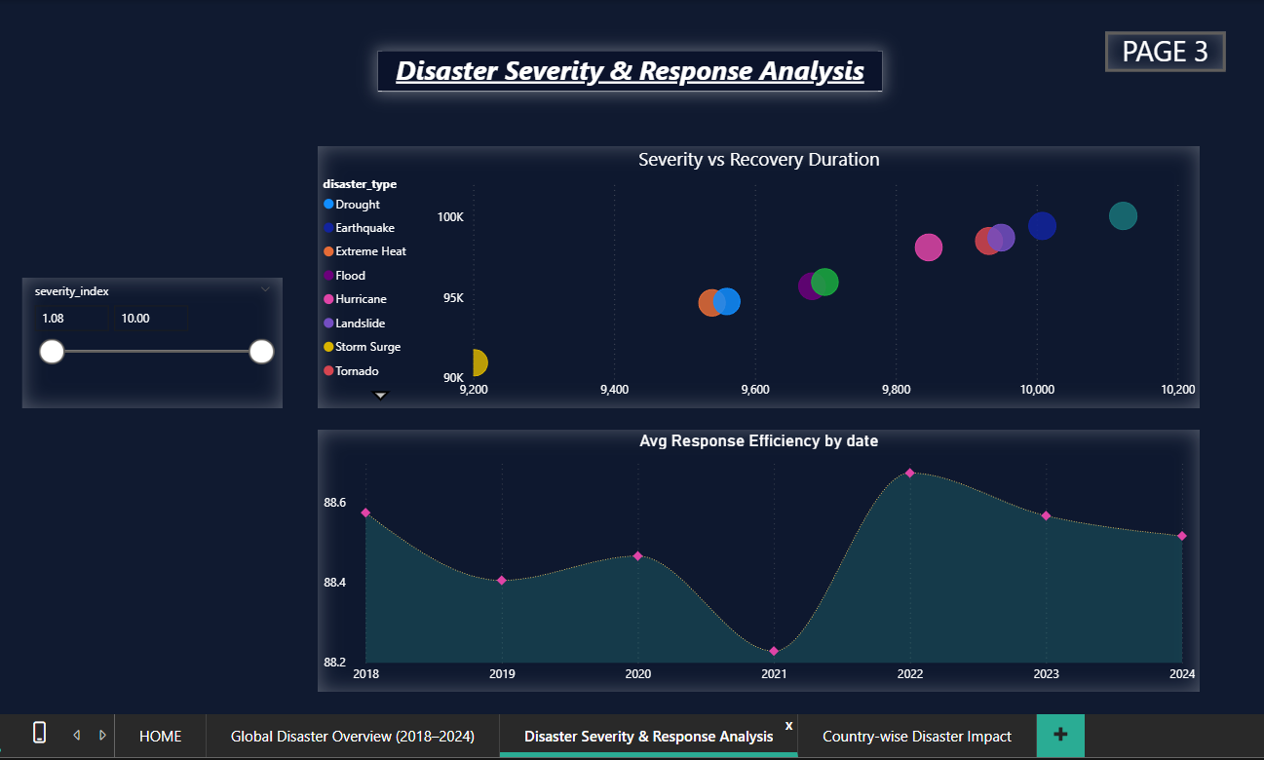

STEP 5: Country-wise Disaster Impact
This page shows the impact of disasters on different countries. A map visualization is used to display country-wise casualties using geographic locations. Filters are provided to select different options like country and disaster type. This page helps in understanding which countries are more affected by disasters and comparing disaster impact across the world.
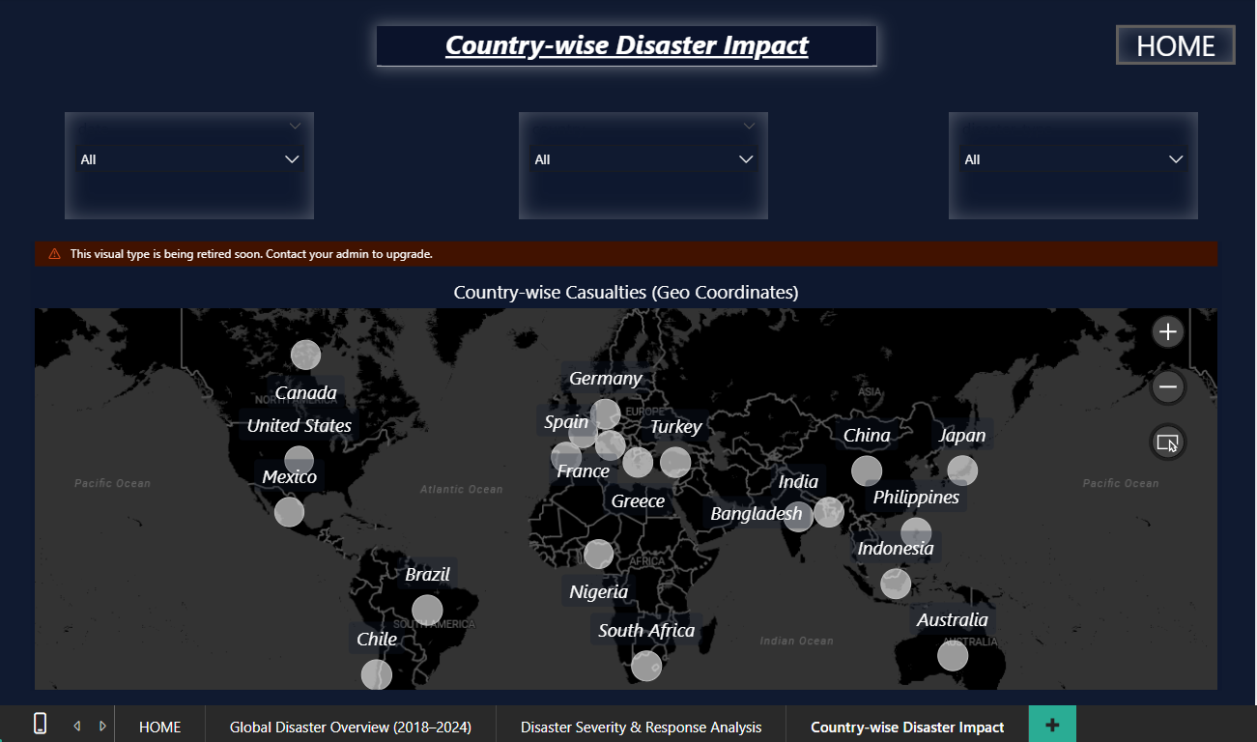

CONCLUSION
This project helps in understanding global disasters and their impact from 2018 to 2024 using Power BI. The dashboard clearly shows disaster frequency, economic loss, casualties, severity, response efficiency, and recovery time. It is observed that while response efficiency has improved over the years, disasters with higher severity still take longer to recover and cause more damage. The country-wise analysis helps in identifying the most affected regions. Overall, this dashboard makes disaster data easy to understand and supports better planning and decision-making for disaster management.

