AH Campus 2 Branch Network Configuration Report

1. Project Overview
The AH Campus 2 Branch Network supports staff and student lab users through VLAN-based segmentation. Router-on-a-Stick inter-VLAN routing is implemented, with DHCP services provided by the branch router and RIPv2 enabling WAN connectivity.

2. Network Topology Diagram
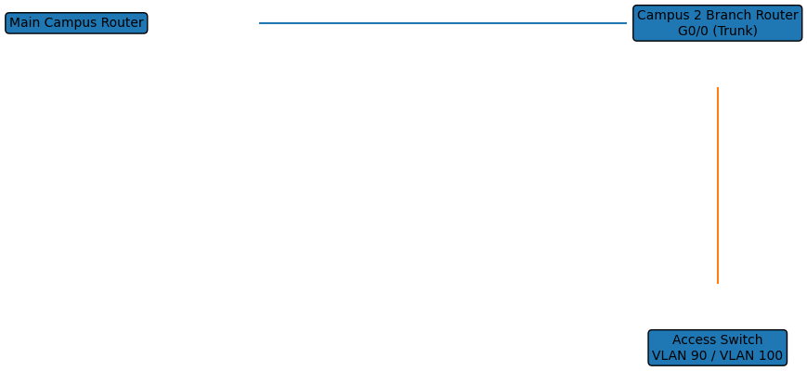

3. Address Table
VLAN ID | Network | Network Address | Subnet Mask | Default Gateway
90 | Staff | 192.168.9.0 | 255.255.255.0 | 192.168.9.1
100 | Student Lab | 192.168.10.0 | 255.255.255.0 | 192.168.10.1

4. VLAN and Port Assignment Table
VLAN | VLAN Name | Router Interface | Purpose
90 | STAFF | G0/0.90 | Staff Users
100 | STUDENT-LAB | G0/0.100 | Student Lab PCs

5. Switch Configuration
hostname Campus2-SW1
!
vlan 90
name STAFF
!
vlan 100
name STUDENT-LAB
!
interface range fa0/1-12
switchport mode access
switchport access vlan 90
!
interface range fa0/13-24
switchport mode access
switchport access vlan 100
!
interface g0/1
switchport mode trunk
!
spanning-tree mode pvst
!
end

6. Router Configuration
hostname Router – Allen H Campus 2 Branch Network
!
ip dhcp pool Staf-pool
network 192.168.9.0 255.255.255.0
default-router 192.168.9.1
dns-server 192.168.9.1
domain-name wr
!
ip dhcp pool Studlb-pool
network 192.168.10.0 255.255.255.0
default-router 192.168.10.1
dns-server 192.168.10.1
!
interface GigabitEthernet0/0
no ip address
!
interface GigabitEthernet0/0.90
encapsulation dot1Q 90
ip address 192.168.9.1 255.255.255.0
!
interface GigabitEthernet0/0.100
encapsulation dot1Q 100
ip address 192.168.10.1 255.255.255.0
!
interface Serial0/2/0
ip address 10.10.10.2 255.255.255.252
!
router rip
version 2
network 10.0.0.0
network 192.168.9.0
network 192.168.10.0
!
end

