AH Campus Cloud Network Configuration Report

1. Project Overview
The AH Campus Cloud Network provides backbone connectivity between the Allen H campus infrastructure and external cloud or ISP services. This router operates as a WAN transit device using dynamic routing to ensure reliable communication between campuses.

2. Network Topology Diagram
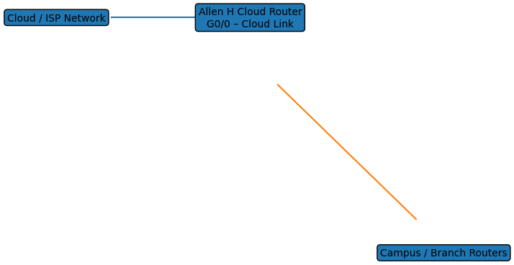

3. Address Table
Interface | IP Address | Subnet Mask | Purpose
GigabitEthernet0/0 | 20.0.0.1 | 255.255.255.252 | Cloud / ISP Link
Serial0/1/0 | 10.10.10.6 | 255.255.255.252 | Campus WAN Link

4. VLAN and Port Assignment Table
This router does not implement VLAN segmentation. All interfaces operate at Layer 3 for WAN and cloud routing.

5. Router Configuration (CLI)
hostname Router – Allen H Cloud Network
!
spanning-tree mode pvst
!
interface GigabitEthernet0/0
ip address 20.0.0.1 255.255.255.252
duplex auto
speed auto
!
interface GigabitEthernet0/1
no ip address
shutdown
!
interface GigabitEthernet0/2
no ip address
shutdown
!
interface Serial0/1/0
ip address 10.10.10.6 255.255.255.252
!
interface Serial0/1/1
no ip address
clock rate 2000000
shutdown
!
interface Vlan1
no ip address
shutdown
!
router rip
version 2
network 10.0.0.0
network 20.0.0.0
!
end

