Allen H Enterprise Network Configuration Report

1. Project Overview
This enterprise network integrates the Allen H Main Campus, Campus 2 Branch, and Cloud Network into a unified routed infrastructure. The design uses VLAN segmentation at campus sites, Router-on-a-Stick inter-VLAN routing, and RIPv2 for dynamic WAN routing.

2. Enterprise Network Topology
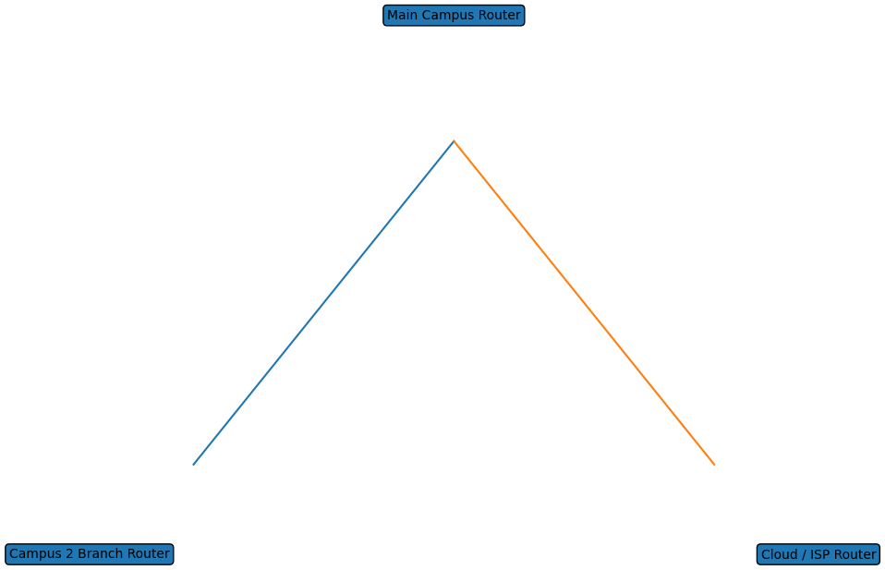

3. Addressing Summary
Site | Network Range | Purpose | Routing
Main Campus | 192.168.1.0 – 192.168.8.0 | Department VLANs | RIPv2
Campus 2 | 192.168.9.0 – 192.168.10.0 | Staff / Student | RIPv2
Cloud | 20.0.0.0 /30 | ISP Connectivity | RIPv2

4. Site Configurations
Detailed router and switch configurations for each site are maintained in their respective campus configuration reports. This enterprise report documents the overall architecture and inter-site connectivity.

