AH Main Campus Network Configuration Report

1. Project Overview
The AH Main Campus network uses VLAN-based segmentation with Router-on-a-Stick inter-VLAN routing. Each department is assigned a unique VLAN and subnet. DHCP services are provided by the main router, and RIPv2 enables WAN routing.

2. Network Topology Diagram
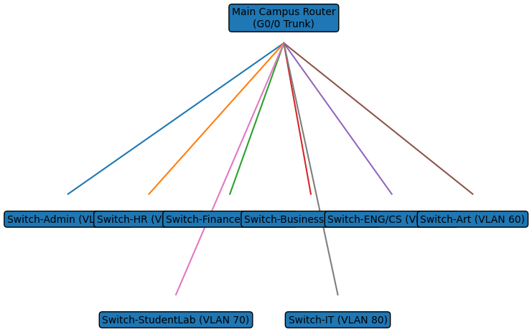

3. Address Table
VLAN | Department | Network | Subnet Mask | Gateway
10 | Admin | 192.168.1.0 | 255.255.255.0 | 192.168.1.1
20 | HR | 192.168.2.0 | 255.255.255.0 | 192.168.2.1
30 | Finance | 192.168.3.0 | 255.255.255.0 | 192.168.3.1
40 | Business | 192.168.4.0 | 255.255.255.0 | 192.168.4.1
50 | ENG/CS | 192.168.5.0 | 255.255.255.0 | 192.168.5.1
60 | Art & Design | 192.168.6.0 | 255.255.255.0 | 192.168.6.1
70 | Student Lab | 192.168.7.0 | 255.255.255.0 | 192.168.7.1
80 | IT | 192.168.8.0 | 255.255.255.0 | 192.168.8.1

4. Switch Configuration (Sample Access Switch)
hostname Switch-Admin
!
vlan 10
name ADMIN
!
interface range fa0/1-24
switchport mode access
switchport access vlan 10
!
interface g0/1
switchport mode trunk
!
end
Note: Additional switches follow the same configuration pattern,
changing only the VLAN ID and VLAN name to match their department.

