## MGMT 241: Technology Management

Team: Amit Bhowmik, Allen Huang, Aniket Patil, David Winograd, Drew Chang, Vanessa Tse, Vanessa Freire

## Glucose Mommy: Revolutionizing Gestational Diabetes Prevention & Care

## Problem/Context: *Nutrition management during pregnancy is critical for preventing gestational diabetes (GD) and ensuring healthy child growth — yet pregnant women face barriers to accessing personalized and affordable nutrition guidance.*

## Navigating nutrition during pregnancy is complicated and anxiety-inducing. There are limited options available for pregnant women to manage and prevent gestational diabetes (GD), forcing many to rely on applications that do not offer personalized information or assistance. Lack of specialized solutions is particularly evident among pregnant women from ethnic minority groups. Hiring a nutritionist or dietician is expensive, making it difficult for some pregnant women to access the necessary support. Additionally, existing solutions may not provide tailored recommendations that suit the unique nutritional needs and preferences of each pregnant woman. This results in a significant gap in the market for an affordable and personalized solution that caters to their individual nutritional needs. Furthermore, certain ethnic minority groups are at a higher risk of developing GD, and women who end up being diagnosed with GD have an increased risk of developing type 2 diabetes after childbirth. To tackle this, our solution addresses these challenges by offering pregnant women a reliable and easy-to-use nutrition recommendation app that caters to their unique needs and preferences, ensuring a healthy pregnancy.

## Target Audience/Market: *Glucose Mommy targets insured, U.S. based pregnant women at risk for GD.*

In 2021, there were 3.7 million births in the U.S (TAM). In the past year, the median age of motherhood has increased to 30 years old. Per Johns Hopkins Medicine, women who are older than 25 are at a greater risk for developing GD, with the risk becoming exponentially larger as age increases. Other risk factors include: being overweight or obese; a prior diagnosis of certain health conditions (including GD in a prior pregnancy), prediabetes, polycystic ovary syndrome; a family history of diabetes and having previously delivered a baby weighing more than 9 pounds. Additionally, the prevalence of GD varies widely by ethnicity, with ethnic minorities at a higher risk for diagnosis.

About 89% of women ages 19-64 are insured, with pregnant women accounting for 3.3 million of the total population of insured women (SAM, Exhibit 1). 70% of pregnant women are at risk of GD throughout their pregnancy and have to carefully monitor their food intake and vitals, ultimately comprising a pool of 2.3 million insured, at-risk pregnant women in the U.S. (SOM). The fourth trimester of pregnancy is overlooked but constitutes a pivotal change in each woman’s body as she sheds pregnancy hormones, begins producing breastfeeding hormones, and adapts to motherhood. This is a critical period where both mother and child need nutrient dense foods to help the mother continue to pass the right nutrients to the baby.

## Stakeholder Analysis: *Glucose Mommy solves problems for a diverse group of stakeholders with direct or indirect interests in preventing and managing GD.*

**Pregnant women** diagnosed with or at a higher risk for GD are the primary users and stakeholders of our product. Our solution will help users effectively manage the unique challenges; specifically by: (1) educating about GD risks and prevention measures; (2) developing personalized nutrition programs to prevent and minimize health risks; (3) adhering to nutrition programs; and (4) monitoring the biometric response to nutrition programs.

**Healthcare providers** such as OB/GYNs are the primary referrers of our product. They are inclined to recommend products geared at improving patient outcomes. Doctors often do not have the visibility to the patient’s health outside the doctor’s office (such as diet) and have difficulty holding patients accountable for decision that can negatively impact their health. Information sharing features between doctors and patients will give healthcare professionals visibility into valuable data (for example, glucose levels trends and nutritional intake data). Studies suggesting positive patient outcomes make a product more attractive to healthcare providers.

**Health influencers** want to grow and engage their audience by sharing relevant, value-add content on social media. While it is increasingly common for influencers to be paid for product endorsements, they are also known to recommend products they have had positive experiences with. “Mommy” influencers share tips and advice about having and raising kids and are inclined to advocate solutions that help women mitigate pregnancy risks.

**Glucose monitoring manufacturers** seek to maximize sales and profit. They are incentivized to partner with solution providers to generate demand for their product and differentiate themselves against competitors. An exclusive partnership would likely be viewed even more positively by device makers. ***Risk:*** However, many glucose monitor brands also have their own apps and might be wary of partnering with a company that offers an app they consider to be too similar to their own.

**Grocery retailers and delivery platforms** also seek to maximize sales and profit. Online grocery services, such as Amazon Fresh and InstaCart, offer commissions to affiliates who drive conversions by linking to products on their platforms. Grocery retailers also seek to expand their markets beyond in-store shoppers.

**Policymakers and regulators** want to improve public health and safety. There are multiple regulatory organizations in the U.S. aiming to help pregnant women manage or reduce the risk of GD. The FDA regulates “mobile medical apps,” defined as apps used in medical diagnoses, disease treatment, and prevention. A product that requires glucose-monitoring technology has a relatively low risk of failing to receive FDA approval given legal precedent. Mobile medical apps are not regulated under HIPAA, since health apps do not qualify as “covered entities.” (***Risk:*** There is a low-to-moderate risk that the FDA review process could delay the go-to-market timeline if product development is not managed carefully to ensure FDA compliance.) Data privacy in the U.S. relies on a patchwork of federal and state laws. The FTC has the authority to sue app-makers who violate their own data privacy policies, and California’s privacy law allows residents to sue companies for certain types of data breaches. California also forces devices and browsers to allow users to opt out of all third-party data sharing. Though there are regulatory considerations, a product that provides science-backed nutritional recommendations to pregnant women, takes adequate steps to safeguard user data, and respects users’ data sharing preferences would likely be viewed positively by policymakers and regulators.

## Tech Trends: *Abbott’s Freestyle Libre Gen 3 is the optimal product fit for collecting user glucose level data. With Apple pioneering non-invasive glucose monitoring technology, a technology convergence is expected to consolidate glucose monitoring into existing connected fitness devices within 3-7 years.*

Modern applications of technology in diabetes management and prevention include hardware and software. Hardware devices include blood glucose monitors, insulin pumps, connected fitness devices, and connected weighing scales. Such devices help prediabetic and diabetic patients monitor blood glucose levels, deliver medicine, and track and improve their overall health. Software applications are used in conjunction with hardware devices to help diabetic patients analyze blood glucose level trends and track caloric intake. Most applications in the market focus on diabetes management, less on prevention.

Glucose monitors are commonly used and arguably the most powerful devices in diabetes prevention and management, helping monitor and track the leading health indicator: blood sugar levels. The two most common types of blood glucose monitors are blood glucose monitors (BCMs) and continuous glucose monitors (CGMs). BCMs use a small amount of blood usually collected by puncturing the user’s finger to measure blood glucose level at any given time. CGMs are a wearable technology that helps measure glucose level continuously by inserting a small sensor under the skin (usually in the abdomen or upper arm) and lasts up to two weeks. The sensor transmits data via NFC or Bluetooth to a smart device like a smartphone or proprietary handheld device which stores, analyzes and enables data sharing. Longer lasting CGMs require surgically inserting a sensor and are priced significantly higher albeit a better fit for high risk diabetic patients.

Two companies currently lead the $11.3B glucose monitoring market: Abbott with the FreeStyle Libre and Dexcom with their Dexcom CGMs. Dexcom’s offering comes at a price premium due to its differentiators – integration with Dexcom’s insulin delivery systems and longer patch life (14 days/patch for Dexcom vs. 10 days/patch for Freestyle Libre). Preliminary analysis of unit economics proves the Freestyle Libre 3 to be financially favorable even with a lower patch life over the expected customer lifecycle.

In late February 2023, news outlets reported on Apple reaching a proof of concept stage for a non-invasive glucose monitoring system integrated into the Apple Watch. If successful, Apple has the potential to upend the $11.3B glucose monitor industry by adding glucose monitoring as a health and fitness feature. While Apple will pioneer this effort, other connected device companies like Fitbit and Pixel Watch are expected to enter the market in the next 3-7 years. This impending technology convergence has the potential to compound our growth, increase profitability by increasing adoption, and reduce costs by negating the need to subsidize CGM devices.

Across industries, improvements in AI enable increasing returns to scale and new ML capabilities. A requirement for building a ML model includes collection of big data. While non-invasive glucose monitoring technology does not exist today, as mentioned, technology convergence is not far off. In the interim, CGM devices can be self-applied by the user and produces a continuous flow of blood sugar data.

Along with shifting technology trends, consumer trends are also important considerations when choosing the right business model. The Covid-19 pandemic changed the way consumers shop for food and groceries, with consumers moving away from traditional in-store grocery shopping to online ordering. Consumers spent $1.7 trillion online between March 2020 to February 2022, an increase of 55% compared to the previous period. Online spending is up 15.5% YoY in February 2022 showcasing continued growth even after the pandemic, with grocery shopping seeing the most drastic change.

## Product: *Our product, Glucose Mommy, is a revolutionary digital GD prevention and management solution. Backed by AI / ML, it is well positioned to disrupt both traditional (pregnancy nutrition) and digital (generic diabetes app, generic pregnancy app) industries.*

## Glucose Mommy delivers a GD prevention and management solution by providing pregnant women with nutrition recommendations in a simple and intuitive mobile app. For pregnant women who do not carefully monitor nutrition prior to pregnancy, Glucose Mommy serves as a companion during this life stage transition and reduces the cumbersome and manual meal planning process to minimize the risk of GD. Integration with the FreeStyle Libre 3 glucose monitoring device enables Glucose Mommy to capture glucose levels, nutrition, and pregnancy data to train a predictive AI / ML model. Users receive automated in-app notifications and alerts based on forecasted blood sugar trends and recommended meals that optimize for nutritional value while minimizing added risk to GD. These meal recommendations are tailored and holistically consider food preferences, dietary restrictions, prior nutrition intake, and feedback from previous recommendations.

**Value Proposition:** Preventing and managing GD ensures pregnant women experience a healthy pregnancy and baby. If left untreated or managed poorly, GD can lead to macrosomia (a "fat" baby) and increase the risk of the baby developing obesity and type 2 diabetes into adulthood. Glucose Mommy’s key value proposition in solving this critical and underserved problem is to be a reliable, trustworthy companion during this critical life stage for pregnant women. Since the first glucose meter was invented in the 1970s with the Dextrostix, the category has experienced a severe lack of innovation in catering to the underserved GD sector, and it is time for that to change. Glucose Mommy’s proprietary AI / ML models are designed to accurately track and comprehend CGM signals as inputs, and consequently deliver recommendation outputs to educate pregnant women on best practices optimizing health and nutrition for them and their baby.

**Disruptive Potential:** As the first-of-its-kind GD app that reduces risk by generating data-backed food recommendations and notifications, Glucose Mommy will primarily disrupt traditional nutritionists who help pregnant women manually craft meal plans. Digital industries, such as generic diabetes monitoring and pregnancy apps, will also be disrupted, especially as Glucose Mommy’s data on GD and optimal nutrition for prevention becomes more valuable - eventually becoming the product itself.

**How it works:**

**Customer Onboarding Process:**

* ***User account creation:***Users download the iOS mobile app and create an account.
* ***Libre device integration:***Users enter insurance information and select to either purchase a subsidized Libre device or to connect with an existing Libre device for CGM data collection.
* ***Food preferences and restrictions:***Users select food preferences and dietary restrictions to be utilized for curating meal recommendation results. (Exhibit 3)
* ***Communication Preferences:***Users can opt-in to data sharing data with primary care physicians and receive push notifications.
* ***Hardware Shipping:*** After purchasing, the Abbott Freestyle Libre device (application, and the selected sensor supply) ships to the user.

**Data Collection & Machine Learning System Architecture:**

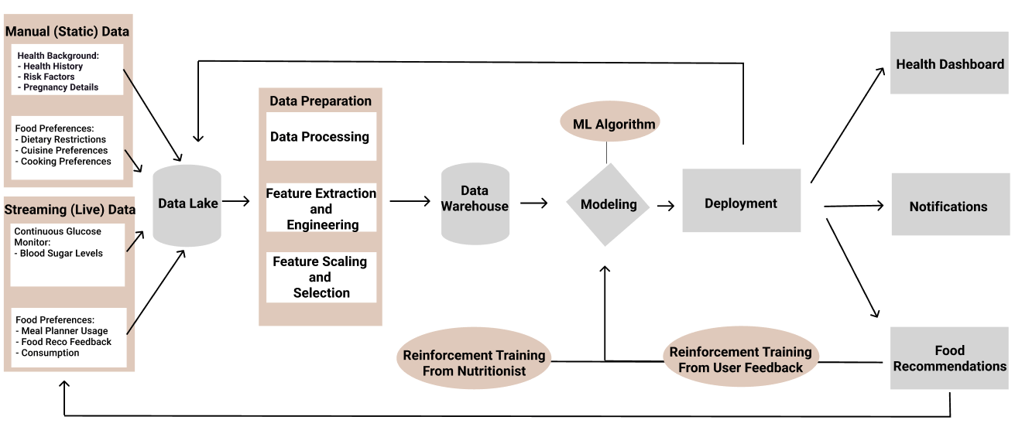

**Machine Learning:** Glucose Mommy uses machine learning to recognize patterns in its data set and create algorithms that predict optimal food consumption to regulate blood sugar levels.

***Step 1 Data Collection / Pre-Processing:*** Once users receive a device and begin tracking glucose data, pre-processed data is then captured and stored in an AWS S3 bucket.

* **Manual data inputs collected via app (Exhibit 3):** *General Health*: Name, age, weight, height, history of diabetes in family, existing health conditions, ethnicity, GD diagnosis. *Pregnancy Data*: Pregnancy week, weight tracking throughout pregnancy, type of pregnancy (single, twins, triplets). *Preferences:* Cuisine preferences, Cooking method preference.
* **Continuous data inputs (Exhibit 3):** CGM data (current blood sugar levels), food logging via barcode/manual entering/pick a recommendation (calories, carbohydrates, sugar, protein, fat; weight Log (manual with the option to connect weighing scale).

***Step 2 Training the Model:*** Glucose Mommy’s machine learning model utilizes both the manual data inputs and continuous data inputs listed above to identify patterns and classify data.

* **Focus features (attributes) for ML model:** *Risk Level:*User’s general health history information is captured upfront to calculate a risk score of GD. *Current (Live) Data:* Continuous data inputs captured are used to assign an attribute that classifies that specific user’s health status (% of time user falls outside of optimal blood sugar level range). *Diagnosis of GD:* If a user is diagnosed with GD, identify a pattern between the user’s risk level and their continuous data inputs. Conversely, if a high-risk user completes their pregnancy without being diagnosed, identify those patterns of positive behavior as well.

***Step 3 Reinforcement Learning:*** Once users begin to receive their food recommendation output, the machine learning algorithm will continue to improve through trial-and-error in the form of user feedback.

* **In-house nutritionists** will serve as the reinforcement training layer to verify the nutritional legitimacy of the food recommendation output. This is critical in the early phases of development, when data is limited.
* **Users** also serve as an additional layer for reinforcement training. After each food recommendation screen that the user visits, the user is given the ability to provide feedback about their satisfaction with the recommendation.

***Step 4 Predictive Output:*** Based on risk level and continuous data inputs and learnings from patterns identified in previous data sets, the ML model outputs a rank ordered list of meal recommendations. From the optimal list output, refine recommendations by applying user food preference data as a filter.

***Risk - Machine Learning Bias:*** As with all machine learning algorithms, there is a risk of biases. As a result, efforts must be taken during data collection, pre-processing, and processing phases to reduce the risk of bias within the data set. If the training data for the ML algorithm has biases, biases will show up in the algorithm's results.

* **Pre-Processing**: Any biases in the data set should be removed during pre-processing. Any outliers that could skew the data and the algorithm's results should be identified and removed.
* **Processing**: During the training phase, methods like stratified sampling could help ensure that the training data contains a representative sample of all groups.

**Output - Health Dashboard:**

* ***Dashboard:***Highlights key metrics that pregnant women should closely monitor (current blood sugar levels, exercise minutes, pregnancy week).
* ***Notifications****:* Automated alerts to inform users of actions they must take (ex. blood sugar is low - time for a snack), predicting when a user will go outside of blood sugar level range at a certain point in time + factoring in cooking time.
* ***Education Center:*** Resources are available in the app for users to learn more about GD and recommended action items, vetted by medical professionals. Display and video ads via an integration with the Google Ad Network will be included within the articles and videos to serve as a revenue source.
* ***Risk – Policy and Regulation:*** As with all products handling personal data, security is of the utmost importance. While developing the app, prioritizing security measures is crucial for obtaining user trust, as well as complying with FDA policies and obtaining FDA approval.

**Output - Meal Recommendation:**

* ***Food Recommendations****:* After the user starts tracking their glucose data, the Glucose Mommy recommendation system begins suggesting meals for the user to cook at home. Users can order ingredients directly in the app via an integration with MealMe (food delivery API with grocery store location and inventory data) for delivery or pick up in store. If they have the ingredients at home, they can select “I Have These Ingredients” and get the meal captured in their food log.
* ***Error Analysis & User Feedback:*** Users have the option to provide the app with feedback on the food recommendations - used to further train the model and personalize future recommendations

**Product Roadmap: As we look into the future, we aspire to add features and expand our product to serve our customers better and grow our serviceable obtainable market**

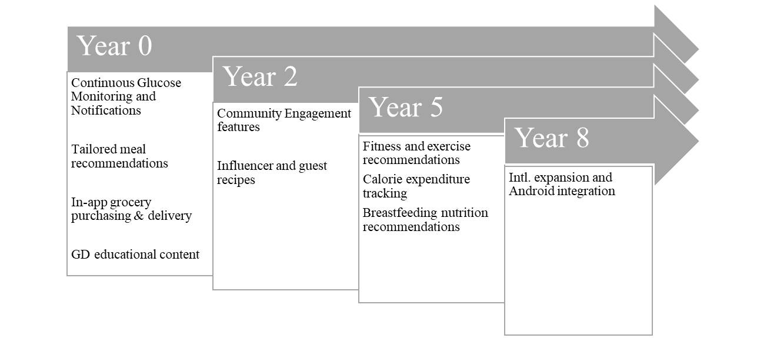

*\*Note: Financial projections are based on Year 0 features.*

## Roger’s 5 Factors: *When assessed against Roger’s Five Factors, Glucose Mommy demonstrates strong potential to disrupt the GD market.*

Considering there are multiple diabetes monitoring solutions in the industry, Glucose Mommy strategically differentiates itself by catering to a niche, underserved sector of pregnant women that are at increased risk of developing GD. An analysis of Roger’s Five Factors demonstrates its innovative nature.

**Relative Advantage:** (High) Glucose Mommy possesses a strong relative advantage considering there are no current solutions that actively monitor and prevent GD. Specifically, Glucose Mommy provides two notable solutions that work in harmony. First, it accurately and continuously monitors the vitals of both the mother and child throughout the pregnancy. With reliable and secure monitoring, pregnant mothers using our service can be rest assured of the data integrity. Second, our individually tailored recommendations provide the proper guardrails to educate pregnant mothers on best practices to prevent and manage GD.

**Compatibility:** (High) Glucose Mommy has favorable compatibility given its seamless integration with 1) Libre’s CGM devices to track vitals and 2) local grocery stores to offer tailored recommendations. The end-to-end value chain from monitoring vitals to providing tailored recommendations work in harmony to optimize the value proposition through considering existing values, previous experiences, and needs of the pregnant mothers. As more pregnant mothers become comfortable with Glucose Mommy, our recommendation engine will become stronger and offer better recommendations, thereby creating a virtuous cycle.

**Complexity:** (Low-Medium) Being the first of its kind, Glucose Mommy is a modern, tech forward solution that will require an adjustment period for pregnant mothers. From educating healthcare providers (ie. OBGYNs) on the benefits of Glucose Mommy so that they are comfortable advocating for it to newly pregnant mothers, to ensuring pregnant mothers that Glucose Mommy is a safe, secure, and reliable solution that monitors the health of them and their babies, our solution will initially be challenging for pregnant women that are not tech savvy. However, all aspects of Glucose Mommy, from preliminary onboarding to the user CX, have been thoughtfully crafted to optimize usability and minimize friction for the user.

**Trialability:** (Medium) Materially high setup costs for Libre’s CGM and Glucose Mommy will initially impede trialability for price sensitive pregnant mothers. Since the recommendation engine behind Glucose Mommy largely relies on the data from early adopters to iterate and optimize its recommendations, increasing trialability in the early stages following launch will be a high priority. We expect to manage this risk by subsidizing Libre’s CGM costs for the uninsured and incentivizing insurance providers to lower costs for the insured.

**Observability:** (Medium) Glucose Mommy has medium observability given initial adoption will take time with pregnant mothers that are not tech-forward, however the pregnant mother community is highly interconnected which is conducive to long term growth. By focusing on delivering outsized value and building credibility and trust with early adopters, we expect high customer satisfaction rates will result in word of mouth referrals amongst friends, families, and peers — which is conducive to generating strong observability.

## Competition: *The market for preventing and managing GD has few direct competitors offering an integrated solution, leaving room for opportunities to innovate and improve technology in this space.*

Few main rivals currently offer a full solution for preventing and managing GD. Nonetheless, there are a number of indirect competitors that offer comparable functions, such as diabetes management applications and CGM systems. Please see Exhibit 2 for a comprehensive competitive analysis.

* The MySugr app, which includes tailored diabetes management capabilities like glucose tracking, food recommendations, and medication tracking, is one of the indirect competitors. MySugr is not created exclusively for pregnant women but can be utilized to manage GD throughout pregnancy. However, the program lacks pregnancy-specific features and tips, which could be considered a shortcoming.
* The Dexcom CGM System is a wearable device that continually detects blood glucose levels and delivers real-time warnings and insights. The Dexcom system can be utilized to manage GD throughout pregnancy but does not have nutrition advice and personalized meal planning features.
* Several general pregnancy applications, such as the “What to Expect Pregnancy & Baby” app and the “Ovia Pregnancy” app also offer basic GD tracking tools. Unfortunately, these applications lack the tailored nutrition advice and continuous glucose monitoring our product offers.

**GTM Strategy: *Glucose Mommy will invest heavily in marketing to acquire users quickly, initially targeting women who are likely to be early adopters of the product. This includes pregnant women with health insurance who are (1) higher risk for GD; or (2) upper-middle income with an interest in HealthTech.***

All women face a risk of GD during pregnancy, and therefore are potential customers for this product. However, Glucose Mommy’s go-to-market strategy will initially focus on women with health insurance, as they face lower barriers to adoption. Within this group, we will target two customer profiles. The first group (high risk customers) has at least one of the following attributes: (1) age: 27 years or older; (2) ethnicity: (non-white) minority; (3) health conditions: overweight, history of diabetes/prediabetes, or existing GD diagnosis. The second group (early HealthTech adopters) consists of upper-middle income women who have a demonstrated interest in HealthTech. These customers have the following attributes: (1) income: $75,000+; (2) education: College degree or higher; (3) psychographics: history of engagement with health monitoring apps. These profiles are not mutually exclusive. To reach these segments, the Glucose Mommy will allocate about $1 million marketing in year 1. Marketing efforts will rely heavily on digital channels but will also leverage traditional channels.

**Social Media:** Approximately a third of Glucose Mommy’s marketing budget will be dedicated to social media, and Glucose Mommy will tap into a vibrant community of social media users who are already talking about GD. On TikTok, 5,000 posts with the #gestationaldiabetes hashtag generated 48 million views in the last 12 months. Additionally, posts with #gestationaldiabetestips garnered 2 million views. On Instagram, there are nearly 160,000 posts globally with the #gestationaldiabetes hashtag and ~20,000 posts using the hashtag #gestationaldiabetesdiet. On Facebook, there are dozens of Groups dedicated to GD, which have more than 100,000 members combined. The social media strategy consists of organic posts, influencer engagement, and targeted ads. Organic social media and influencer engagement is critical because they are low cost and high reach. Glucose Mommy’s social media manager will create and share engaging content to the company’s social accounts and be active in forums like Facebook Groups and Reddit threads. Organic content will primarily focus on “value-add” GD education, advice, and tips and tricks to drive social sharing, engagement, and brand awareness. Glucose Mommy will also engage with “mommy” influencers who may be inclined to talk about the product. Health and wellness influencer Sami Hoffhines, for example, shared her experience with GD in a video that got more than 350,000 views. Offering free subscriptions to influencers could incentivize them to share their experience on social media and help drive “observability.” Influencers will be further incentivized to promote the app when a feature that allows experts to contribute recipes for the app’s recommendation engine goes live. Sponsored posts on Facebook, Instagram, and TikTok will be used to drive interest and conversions amongst social media users who signal they are pregnant and fall into one of our two target profiles (high risk customers or early HealthTech adopters). Social media ads are one of the more expensive digital channels, with the cost per install (CPI) for app download campaigns on Facebook averages $2.25. Still, social media ads are extremely effective at targeting users by demographic attributes and interest and have the ability to drive additional organic engagement.

**Search & Digital:** Glucose Mommy will allocate $400,000 to search and digital advertising in year 1. Search ads will be used to reach potential customers with demonstrated intent. According to Google Keyword Planner, the keyword “gestational diabetes” was searched on average between 100,000 and 1,000,000 a month in the United States over the last year. It estimates cost per click for a “top of the page” ad to average $1.30, suggesting that $300,000 in search advertising spend would allow us to reach 76,000 prospective customers. If 2% of those convert to subscribers, that translates into about 4600 users, which is 30% of the company’s year 1 target. The remaining $100,000 will be used for targeted video and audio pre-roll ads on pregnancy-related content on YouTube, Spotify, and other platforms to help engage a highly interested audience, as well as a remarketing campaign on pregnancy magazine websites and blogs.

**Traditional Channels:** The remaining marketing budget will be dedicated to traditional channels. While more costly and time-intensive, trade events and media appearance could drive referrals and word-of-mouth buzz. Success in these channels will require building up a senior member of the management team (i.e. a founder or the medical or product lead) as a thought leader in the space. Having the company’s thought leader attend conferences and trade events can cost $500-$2,000 per event, plus business travel expenses. However, thought leader presence at conferences and events for organizations like the Perinatal Research Society or the Society for Maternal-Fetal Medicine is an invaluable opportunity for networking and driving awareness with members of the medical community who could advocate for our product, like physicians, OBGYNs, and diabetes specialists. Glucose Mommy will also sponsor events at Lamaze studios and other types of parenting classes. In addition, earned media will be crucial for generating awareness and word-of-mouth referrals, which is why we will dedicate $100,000 of the marketing budget to a 3-month contract with a public relations firm to help generate media coverage in publications like Women’s Health and Pregnancy Magazine and popular podcasts like Birthful.

**Market Size / Pricing:** ***Glucose Mommy will provide superior value at a lower price than existing competitors and has the potential to capture 10% of the SOM, consisting of a diverse, and growing market with a significant need.***

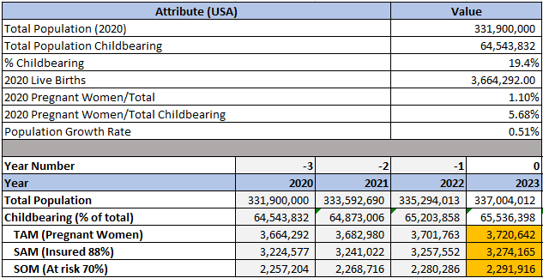

## Market Sizing Breakdown: *Glucose Mommy targets insured, U.S. based pregnant women at risk for GD.*

* Total Addressable Market – TAM (Total number of births in the U.S.): 3.72MM
* Serviceable Addressable Market – SAM (Insured 88% of pregnant women): 3.27MM
* Serviceable Obtainable Market: - SOM (70% at risk): 2.29MM

**Market Share Growth Projection:** Our projected market share is a steady growth from 0.65% of the serviceable obtainable market in the first year to approximately 10% in year 10 post-launch. During the first year of launch, the product is expected to acquire 15,000 users - eventually reaching 240,329 users by year 10.

**Pricing – Competitive Set:** *Glucose Mommy is price competitive. (Exhibit 11)*

* Pricing for comparable hardware is $91.94 to $299.00 a month (CGM) with an average cost of $195.47.
* Pricing for comparable diabetes management apps (glucose monitoring/reporting) are $4.00 avg/month.
* Pricing for comparable Health/Food Apps are $6.81/month.

**Glucose Mommy Pricing Strategy:** Our pricing is $4.99/month for the app (3.49 revenues after 30%) and $9.99/month (100% revenue) for the hardware CGM subscription with insurance model – a competitive price when compared to the competitive set.

**Business Model & Financial Projections:** ***Our financial forecast and sensitivity analysis shows that our company’s path to profitability does not rely on the expected technology convergence. The company's valuation is $128mm, with an IRR of 42.64% (see Exhibit 4). The true value of the company will be driven by data as the eventual product and increasing returns with scale as the relevance of our recommendation engine improves and the platform of food delivery systems grows.***

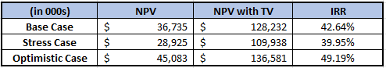

Our financial model reflects our business plan to enter the market with an application integrated with a CGM (FreeStyle Libre 3) to collect data on blood glucose levels and improve our nutrition recommendation engine.

**There are three sources of revenue for Glucose Mommy:** (1) Subscription fees (app $3.49 per month and hardware $9.99); (2) In-app Advertising; and (3) Commission fees from API to grocery ordering platforms.

**There are three primary costs of revenue:** (1) Applicator for the CGM, which would include the applicator and sensor patches; (2) Customer acquisition cost; and (3) R&D expenditure to build the platform application.

Our short-term plan requires subsidizing the Abbott Freestyle Libre device over the first 5 years to facilitate the data collection. We also plan to invest in R&D to build the technology and integration with connected fitness devices we will need in the future. We expect tech convergence of glucose monitoring to existing connected fitness devices within the next 3-7 years which would negate the need for CGM monitors and reduce our costs. Our base case scenario assumes that technology convergence will occur at year 7 (2029) but we performed a sensitivity analysis to understand if and when we could expect to turn a profit in the absence of tech convergence as well as an optimistic position where technology convergence happens within 3 years. (See Exhibit 5 for the stress case and Exhibit 6 for the optimistic case).

**User Growth and Acquisition:** Our GTM strategy necessitates high marketing spend in the beginning to drive customer acquisition and user engagement which will kickstart a data flywheel with our nutrition recommendation engine and develop our recipe database. Our user growth forecast assumes high user growth in the beginning going from 0.65% of the SOM (serviceable obtainable market) tapering down to a 3% user growth rate until we reach 10% of SOM at year 10.

**Cost Management:** We expect a large R&D spend three times over the course of 10 years. In 2023 (Initially), 2027 (Year 4), and 2031 (Year 8). Initial R&D spend would go towards developing the application, creating a system architecture, and integrating with CGMs. As the market gets closer to tech convergence with wearables enabling glucose monitoring, our next allocation of R&D budget will go towards integrating wearables with our existing platform. Our final R&D budget allocation is reserved to increase scalability. Our forecast assumes a reduction in COGs starting in 2030 (Year 7) reflective of when we expect to remove integration with CGMs and move solely to connected fitness devices. In our stress case scenario, we forecast that tech convergence will occur after 10 years, therefore, Glucose Mommy will not be able to reduce COGS until this convergence occurs.

**Unit Economics:** ***Glucose Mommy is expected to operate at a net loss of 22% at inception but will reach profitability with a 78% margin by year 10 due to increasing returns to scale with customer acquisition cost and ad revenue (Exhibit 12).***

**Revenue Trends:** We expect app/subscription pricing to stay constant while revenue will increase with user volume growth. Ad revenue will be low at inception; we anticipate it to grow at a rate of 10% in the beginning and taper off to 2%. This initial high growth is due to the combination of higher click-through rate, high value ads for our non-core functionalities (i.e. full page/video for our FAQ, Education section), and the ability to charge a higher premium to advertisers as our platform increases its user base and captures more data to increase advertisement relevance. We will eventually reach a ceiling for how much advertisers will spend, which will lead to the tapering in growth. Partnership commissions will be $4.47/user (3% of average monthly spend on grocery apps) and maintain a steady 5% growth rate.

**Cost Trends:** The business model is to subsidize the customer’s CGM cost over the first 7 years to facilitate data collection to improve our recommendation engine. The cost of the CGM system includes a reusable applicator at a cost of $200 per applicator, expected to be used for 8 customer cycles (therefore $25/user), and patches at a cost of $15/month/user. Customer acquisition costs are expected to be high at $68/customer in the beginning but will decrease slowly to $56/customer by year 10 as user growth fuels decreasing marketing cost/user and increased brand awareness.

## Appendix:

**Exhibit 1: Insured vs Uninsured breakdown**

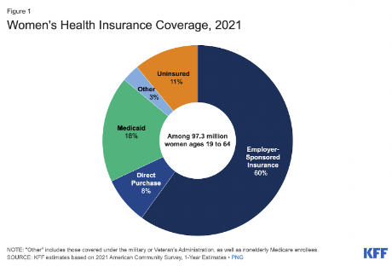

**Exhibit 2: Competition Matrix**

|  |  |  |  |
| --- | --- | --- | --- |
| **Competitor** | **Key Features** | **Strengths** | **Cons** |
| MySugr app | Personalized diabetes management tools, including glucose tracking, meal recommendations, and medication tracking | Offers a comprehensive diabetes management solution, but lacks pregnancy-specific features and recommendations | Lacks pregnancy-specific features and recommendations |
| Dexcom Continuous Glucose Monitoring System | Wearable device that continuously monitors blood glucose levels and provides real-time alerts and insights | Provides accurate and continuous glucose monitoring, but does not offer nutrition recommendations or personalized meal planning | Does not offer nutrition recommendations or personalized meal planning |
| What to Expect Pregnancy & Baby app | Basic GD tracking features | Offers basic tracking features, but lacks continuous glucose monitoring and personalized nutrition recommendations | Lacks continuous glucose monitoring and personalized nutrition recommendations |
| Ovia Pregnancy app | Basic GD tracking features | Offers basic tracking features, but lacks continuous glucose monitoring and personalized nutrition recommendations | Lacks continuous glucose monitoring and personalized nutrition recommendations |

**Exhibit 3: Application Onboarding Workflow**

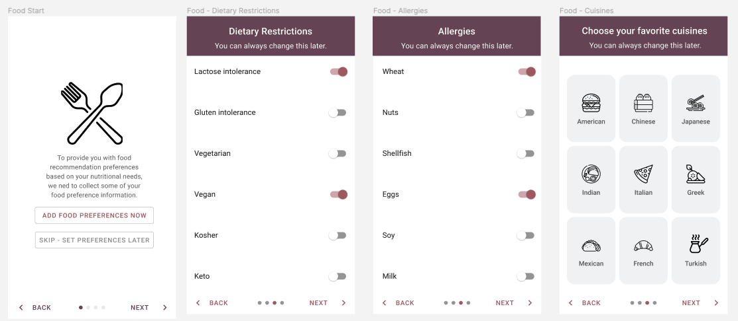

**Exhibit 4: 10 year DCF model (Base Case Scenario)**

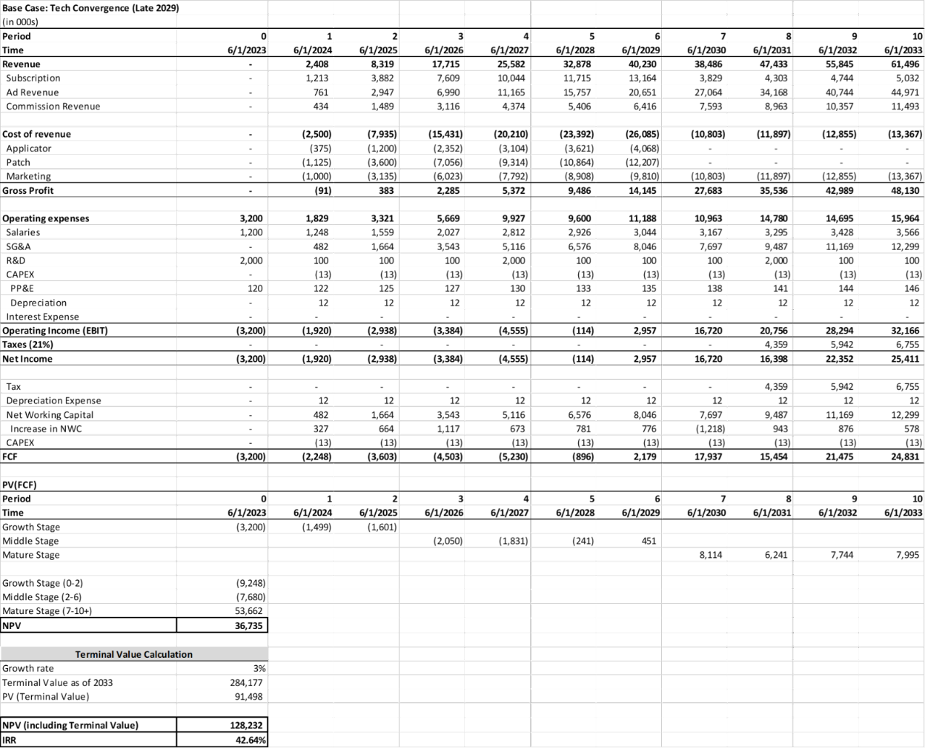

**Exhibit 5: 10 year DCF model (Stress Case Scenario with no technology convergence in 10years)**

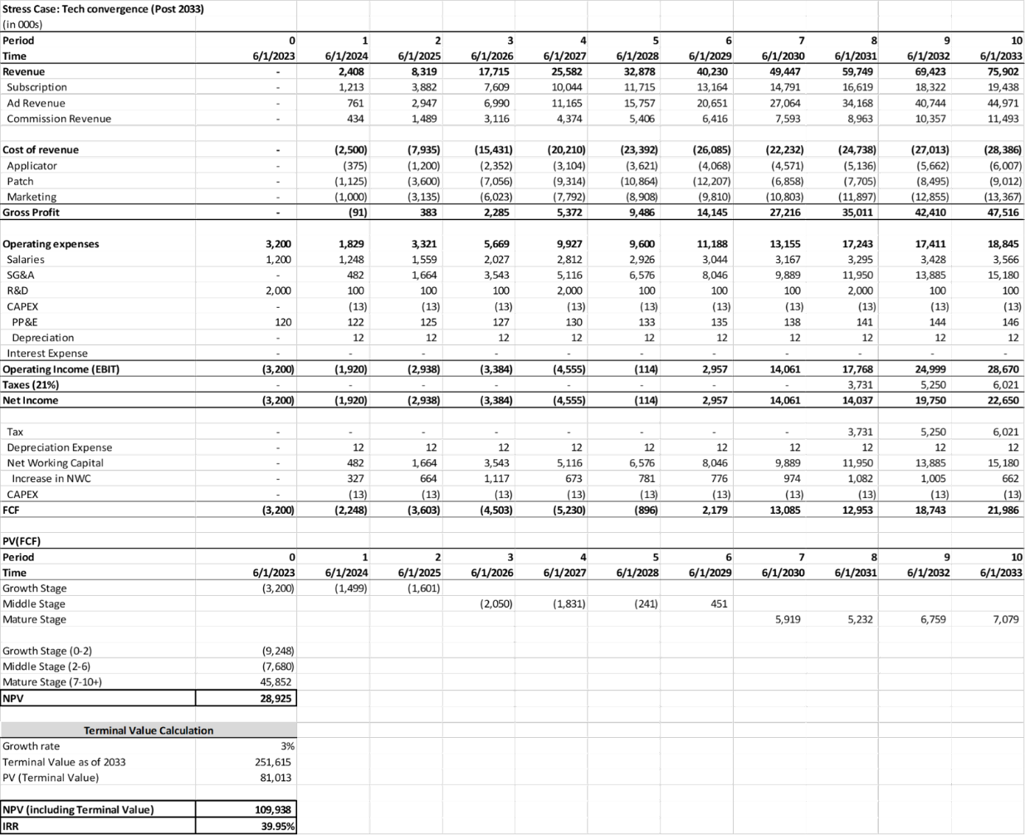

**Exhibit 6: 10 year DCF model (Optimistic Scenario with technology convergence in 3 years)**

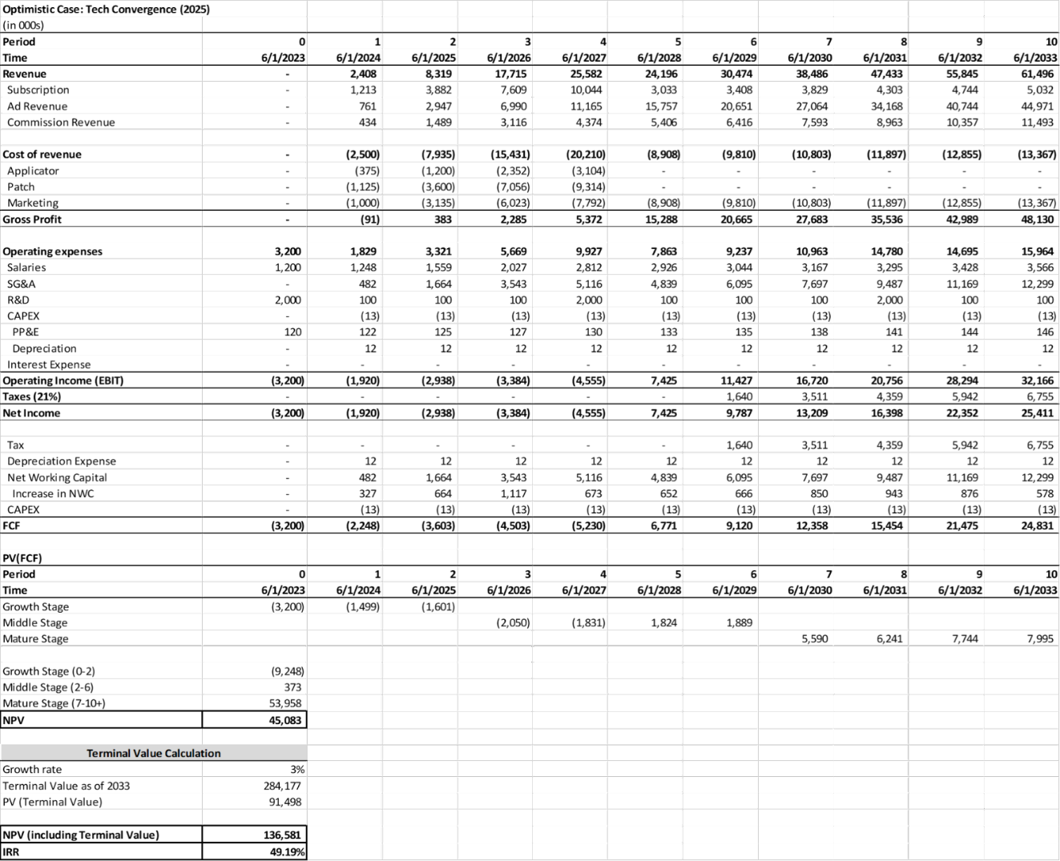

**Exhibit 7: Financial Forecasting Assumptions:**

* Employee Count and Growth:
  + Year 0, Added 15 total employees (10 salary, 5 equity only), this gives room for 3 engineers, 1 or 2 doctors, 1 or 2 health insurance experts, 2 shipping experts.
  + Grows to 20 employees (all salaried) by Year 4, remains 20 employees through Year 10.
* User growth: High growth in the beginning then steady 10%, 8%, 6% then 3% growth
* Cost: The main costs of revenue are the hardware and the customer acquisition cost.
  + Hardware:
    - Applicator: The applicator was set to $25 per user. The assumption was that an applicator costs about ~$200, I assumed the useful life of an applicator was 8 users, therefore, $200/8 = $25.
    - The assumption for the patches is $15 per month, per insured user. We expect to get discounts from large order placements with Abbott for their Freestyle Libre 3. Retail price per path ranges from $10/patch to $75/patch.
  + Customer Acquisiton: Acquisition cost, including marketing cost is initially $68 per customer slowly decreasing to $56 per customer by year 10. We expect customer acquisition costs to decline with increasing awareness from early marketing campaigns and increasing word of mount and influencer marketing with the growth of active users.
  + R&D Expenditure: Base case scenario assumes that tech convergence will occur by 2029 (year 7). Our total R&D spend is 7.5 mm over the 10 years - strategically $2mm on initial start up, and then $100,000 maintenance R&D costs, followed by a $2mm spend in 2027(year 5) to prepare infrastructure for the tech convergence and the final projected spend of $2mm in 2031 to fund additional work needed to integrate with connected fitness devices (i.e., sensors on the camera on your phone, more detailed data, etc.)
* Discount Rate: We used a variable discount rate using available information on comparable firms on Pitchbook, starting with 50% for the first three years, (high growth/high risk stage) followed by 30% during the medium growth years. As we turn profitable and grow to maturity, we settled on a 12% discount rate, based on market risk premium of the United States at 5% (Bloomberg 5.5%), risk free rate of 4.57% based on 6 year treasuries (Bloomberg 5.19%) and 10 year treasuries (Bloomberg 3.95%), and industry adjustment (Beta).
* Terminal Value: Terminal growth rate was 3% based on our steady revenue growth by year 10. This includes the growing market size of CAGR 0.51%, and our increasing market share.

**Exhibit 8: Unit Economics Analysis**

**Unit Economic Financial Assumptions:**

* Revenue:
  + Application and hardware subscription remains constant at $9.99/month/user for the CGM, $3.49/month/user for the application.
  + Ad revenue: 10% growth in the beginning, 8% by 2029 (Year 5), 6% by 2031 (Year 8), 4% by 2032 (Year 9) then 2% by 2023 (Year 10)
* Costs:
  + Customer Acquisition:
  + CGM:
    - Applicator: $200/unit, estimated to be used by 8 users, $25/user
    - Patches: $15/month/user. Research shows sensor patches can cost anywhere from $10 to $75 per month retail depending on insurance. We expect to be able to get bulk order discount.
  + Partnership commissions estimated at 3% of average monthly spend on grocery apps ($4.47). The growth from partnership commission revenue is steady at 5% ending year 10 with $7.97.

**Exhibit 9: Financial Comps**

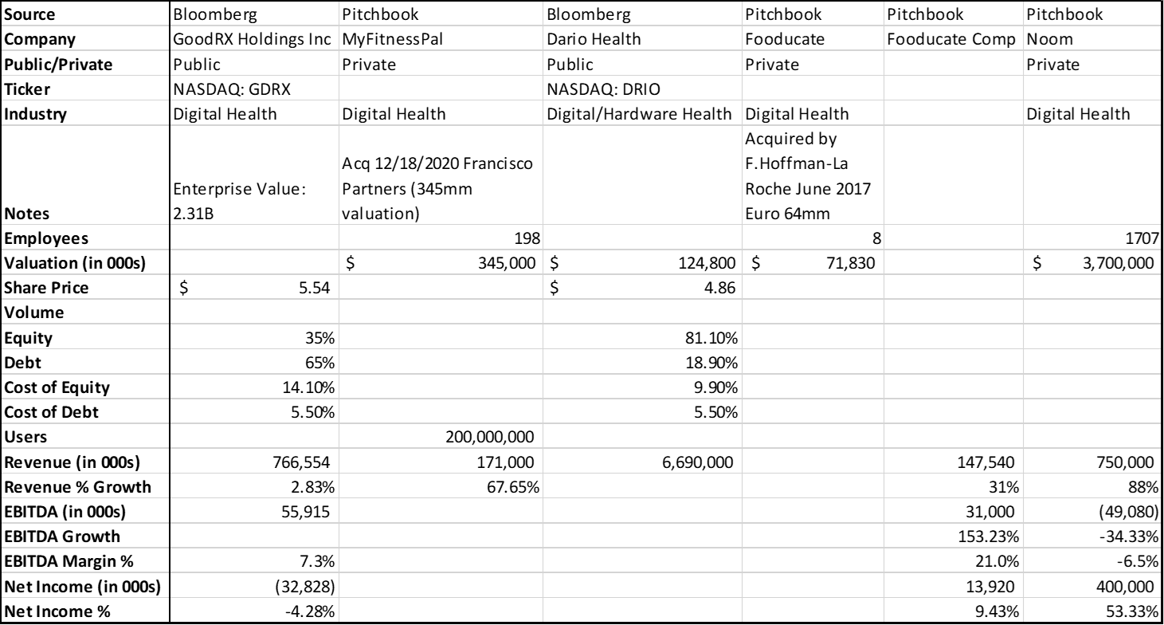

|  |  |
| --- | --- |
| **Exhibit 10: Market Sizing Assumptions**  Market Sizing Assumptions:   * All numbers are based of 2020 Census and current projections * 0.51% population growth rate (linear growth for our subset) | **Exhibit 11: Pricing Comps for Hardware and Software** |

**Exhibit 12: Unit Economics Analysis**

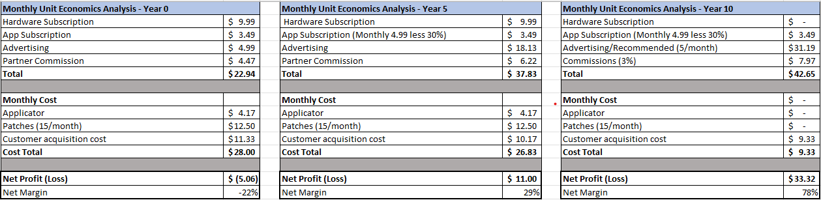

**Citations:**

<https://www.glassdoor.com/Salaries/social-media-manager-salary-SRCH_KO0,20.htm>

<https://www.cdc.gov/diabetes/basics/gestational.html>

<https://diabetes.org/diabetes/gestational-diabetes>

[https://www.hopkinsmedicine.org/health/conditions-and-diseases/diabetes/gestational-diabetes](https://www.hopkinsmedicine.org/health/conditions-and-diseases/diabetes/gestational-diabetes#:~:text=Age%20)

<https://www.statista.com/topics/1850/pregnancy/>

<https://www.bloomberg.com/news/articles/2023-02-22/apple-watch-blood-glucose-monitor-could-revolutionize-diabetes-care-aapl>

<https://revealbot.com/facebook-advertising-costs/cpi-cost-per-install-mobile-app>

<https://www.businessofapps.com/data/app-conversion-rates/>

<https://www.nytimes.com/wirecutter/blog/state-of-privacy-laws-in-us/>

<https://yalehealth.yale.edu/sample-meal-plan-women-gestational-diabetes>

[https://www.hopkinsmedicine.org/health/conditions-and-diseases/diabetes/gestational-diabetes#](https://www.hopkinsmedicine.org/health/conditions-and-diseases/diabetes/gestational-diabetes#:~:text=Age%20)

<https://www.cdc.gov/nchs/fastats/births.htm>

<https://www.statista.com/topics/1850/pregnancy/>

<https://www.diabetesfoodhub.org/articles/what-is-the-diabetes-plate-method.html#:~:text=The%20Diabetes%20Plate%20Method%20is,you%20need%20is%20a%20plate>!

<https://diabetes.org/diabetes/gestational-diabetes>

<https://www.mayoclinic.org/tests-procedures/glucose-challenge-test/about/pac-20394277#:~:text=The%20glucose%20challenge%20test%2C%20also,diabetes%20that%20develops%20during%20pregnancy>.

<https://diabetes.org/diabetes/gestational-diabetes>

<https://www.kff.org/womens-health-policy/fact-sheet/womens-health-insurance-coverage/>

<https://www.mayoclinic.org/diseases-conditions/gestational-diabetes/symptoms-causes/syc-20355339>

<https://www.ftc.gov/reports/protecting-consumer-privacy-era-rapid-change-recommendations-businesses-policymakers>

<https://www.digitalcommerce360.com/article/coronavirus-impact-online-retail/>

<https://www.marchofdimes.org/peristats/data?reg=99&top=2&stop=2&lev=1&slev=1&obj=1>

<https://www.cdc.gov/breastfeeding/data/reportcard.htm>

<https://www.marchofdimes.org/find-support/topics/pregnancy/gestational-diabetes>

<https://www.nichd.nih.gov/sites/default/files/publications/pubs/Documents/gestational_diabetes_2012.pdf>

<https://pubmed.ncbi.nlm.nih.gov/9868978/#:~:text=The%20incidence%20of%20gestational%20diabetes%20in%20teenage%20pregnancy%20was%205.4,the%20cases%20of%20gestational%20diabetes>

<https://www.cdc.gov/breastfeeding/data/facts.html#:~:text=Younger%20mothers%20aged%2020%20to,years%20or%20older%20(84.9%25>).

<https://www.bloomberg.com/news/articles/2023-02-22/apple-watch-blood-glucose-monitor-could-revolutionize-diabetes-care-aapl>

<https://www.globenewswire.com/news-release/2022/08/08/2494014/0/en/Demand-for-Global-Blood-Glucose-Monitors-Market-Size-Share-to-Hit-USD-17-594-47-Million-by-2028-Exhibit-a-CAGR-of-7-70-Comprehensive-Research-Report-by-Facts-Factors.html>