CSCI222 – Systems Development (Assignment 1)

Warehouse Management Tool

:: Version 0.5

***Presented By***

|  |  |  |
| --- | --- | --- |
| Name | Student ID | Email |
| Chan Xiaoru Kalista | 5986345 | xkchan002@mymail.sim.edu.sg |
| Tam He Sheng (Allen) | 5986485 | hstam001@mymail.sim.edu.sg |
| Teo Heong Hwee (Gavin) | 6098058 | hhteo005@mymail.sim.edu.sg |
| Jonas Chok Wen Jie | 6098459 | jwjchok001@mymail.sim.edu.sg |
| Kyaw Myo Aung , Johns | 6097868 | Myoak001@mymail.sim.edu.sg |

Revision History

|  |  |  |  |
| --- | --- | --- | --- |
| Version | Effective Date | Summary of Change | Prepared by |
| 0.1 | 17/01/2018 | Initial Draft | Kalista Chan |
| 0.2 | 21/01/2018 | Updated:   * Functional Specs and Non-Functional Specs * Risk and Counter Measures * Format entire document * Added Roles and Responsibilities | Kalista Chan |
| 0.3 | 22/01/2018 | Updated:   * Business Case * Project Schedule v2 | Johns |
| 0.4 | 24/01/2018 | Updated:   * Business Case * Role Matrix | Johns |
| 0.5 | 28/01/2018 | Updated:   * Use Case Diagram * Detailed Use Case * Sequence Diagram | Teo Heong Hwee (Gavin) |

table of contents

1 Introduction 4

1.1 Purpose 4

1.2 Business Case 4

1.3 Definitions, Acronyms and Abbreviations 4

2 Roles and Responsibilities 5

2.1 Responsibility Matrix 5

3 Implementation Plan 6

3.1 Project Schedule 6

4 Overview of System 7

4.1 Software Requirements Specification 7

4.1.1 Functional Specifications 7

4.1.2 Non-Functional Specifications 8

4.2 Use Cases 9

4.2.1 Use Case Diagram 9

4.2.2 Use Case Detailed Description 10

4.3 Sequence Diagram 16

4.4 Domain Model 25

5 Risk and Counter Measures 26

# Introduction

## Purpose

This document describes the business case, such as the system that we will be building, whom will it serve and the benefits that they system will bring. It will document the detailed for the whole project, from requirements until implementation, risks and counter measures. It will also include the software requirements specification, use cases as well as a domain model to provide a comprehensive description of the requirements for the proposed system.

## Business Case

The WMS enable the clients to prevent shortage, production delay and tracking inventory in real time basic. It’s the automated operation for incoming, outgoing and in-stock items for your business operation.

1. **Prevent Shortages**: It’s critical to understand the customer needs when your don’t have enough for supply. To avoid the costly delay in production and customer order fulfilment, WMS can help to improve those factors.
2. **Tracking inventory in real time**. The advantage of knowing how much inventory you have at all times is helpful as it allow you make smart decisions about when t make order products. Inventory management software will updates your records when you buy and sell products, which will be very useful to monitor leftover stocks.
3. **Optimize warehouse organization**. Speed is essential in having good customer service. Inventory management software makes your business move faster by improving your warehouse’s layout. You can group & categorized the products together and position popular products in ways that make them easier to access when orders come in.
4. **Improve customer service**: More information means better service.WMS help to reduce human error from inaccurate data .Using WMS can save the time & provide better quality service while it may be more satisfy the customers
5. **Quality Control** .Controlling the quality for your product is important. A good quality control may extend your business & it prevent the unnecessary cost that you may not aware due to using poor QC .WMS can help to monitor the incoming & outgoing date of stocks or you can even record down the product expire date in inventory.
6. **Space & storage management** .Knowing the amount of the products in your warehouse is very beneficial. It will help you to organize the space & storage .WMS will help you to plan your limited space by ordering the right amount of product which can fit into the space you have.

## Definitions, Acronyms and Abbreviations

Acronyms and Abbreviations to be referenced in this document:

|  |  |
| --- | --- |
| **Abbreviation/Acronyms** | **Definitions** |
| SRS | Software Requirement Specification |
| WMS | Warehouse Management System |
| QC | Quality Control |

# Roles and Responsibilities

## Responsibility Matrix

|  |  |  |  |  |  |
| --- | --- | --- | --- | --- | --- |
| Responsibilities | Name | | | | |
| Kalista | Allen | Gavin | Jonas | Johns |
| Business Case |  |  |  |  | **X** |
| Project Schedule |  |  |  |  | **X** |
| Class Diagram | **X** | **X** |  |  |  |
| Project Report | **X** | **X** | **X** | **X** | **X** |
| Software Requirement (SRS) | **X** |  |  |  |  |
| Data Dictionary |  | **X** |  |  |  |
| UseCase Diagram/Description |  |  | **X** | **X** |  |
| Sequence Diagram/Description |  |  | **X** | **X** |  |
| Risk Assessment | **X** |  |  |  |  |
| Overall Project Review |  | **X** | **X** | **X** | **X** |

| **Name | Title** | **Role** | **Responsibilities** |
| --- | --- | --- |
| Name | | The Project Manager is responsible for developing, in conjunction with the Project Sponsor, the project charter. The Project Manager ensures that the project is delivered on time, within budget, and to the required quality standards. | * Manage and lead the project team. * Manage the coordination of the partners and the working groups. * Develop and maintain a detailed project plan. |
| Name | Technical writer | Technical writer prepare the supporting documents & instruction manuals | * Provide manuals &   System reference documents |
| Name | System Analysis | System analysis evaluate system workflow & product specifications. | * Provide the overall workflow & concept |
| Name | System Designer | System designer design the system based on the business needs & functional requirement | * Design interfaces & functionality to include in system |
| Name | Developer | The developer is the one who implement the system according to system design & analysis workflow. | * System implementation * Coding& testing of the products |

# Implementation Plan

## Project Schedule

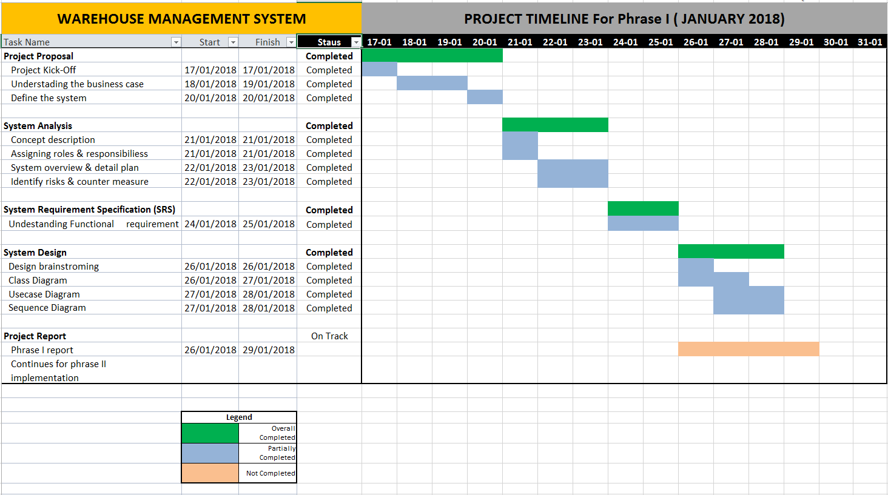

# Overview of System

## Software Requirements Specification

### Functional Specifications

1. **Login**

The system will allow the user to login and the main menu will display the options that they have the permissions to view. System will perform an encryption and decryption of the password. System will have an authentication process and will lock the account if the user has made 3 unsuccessful attempts, this will result in the user not being able to login once the 3 attempts have been used up.

1. **Main Menu**

The system will display a main menu with options, ‘Add new stock’, ‘Remove stock’, ‘Edit stock item’, ‘Search stock item’, ‘Daily stock summary report’, ‘Weekly stock summary report’, ‘Monthly stock summary report’, ‘Yearly stock summary report’, ‘Quit’. The system will allow the user to go back to the main menu once they are in the sub-menu. (i.e. selected the wrong option and wish to go back to the main menu).

1. **Add New Stock**

The system will let the user add new stock by prompting the user to enter a set of details such as item id, item description, item category, item sub-category, amount per-unit, quantity and the transacted date. System will display the information that the user have entered, prompting user’s confirmation before saving into the database.

1. **Remove Stock**

The system will prompt the user to enter the item id, item description, item category or item sub-category that the user wish to remove. Once entered, system will pull the relevant stock items and list it down. System will prompt the user to select the record he wishes to remove and the quantity he wish to remove

1. **Edit Stock Item**

The system will prompt the user to enter the item id, item description, item category or item sub-category that the user wish to edit. Once entered, system will pull the relevant stock items and list it down. System will prompt the user to select the record he wishes to perform an edit. User can choose to edit 1 fields or up till all 7 fields.

1. **Search Stock item**

The system will allow the user to perform a search based on the item id, item description, item category or item sub-category. The system will prompt user to select ascending or descending for the quantity and price. System will then perform a search in the database and display the search results, which will consists of the stock item’s details. The search results will be in an ascending or descending order based on what the user have chosen.

1. **Stock Summary Report**

The system will allow the user to generate 4 different types of summary reports – daily, weekly, monthly and yearly. The report will have 5 different columns, Stock Item, In, Out, Amount (Per Unit) and Total amount. The total amount field will be a calculated field based on the amount (per unit) multiplied by the ‘In’ or ‘Out’ field. These fields are consistent for all 4 reports.

1. **Stock item Alerts**

The system will allow the user to enter threshold for each stock item. For each stock item id, there will only be 1 threshold. The system will alert the user that the particular stock id in the warehouse is below the threshold.

The ‘In’ will represent the incoming stocks that have been added into the warehouse and the ‘Out’ will represent the outgoing stocks.

### Non-Functional Specifications

1. **Implementation Platform**

Implementation of the Warehouse Management (WM) Tool have to be using the C++ programming language.

Implementation of the WM Tool will be on the Ubuntu (Linux) operating systems.

1. **User Interface/GUI**

The menu interface will be option-based with description and user to select by entering the option number.

## Use Cases

### Use Case Diagram (Sub Version)

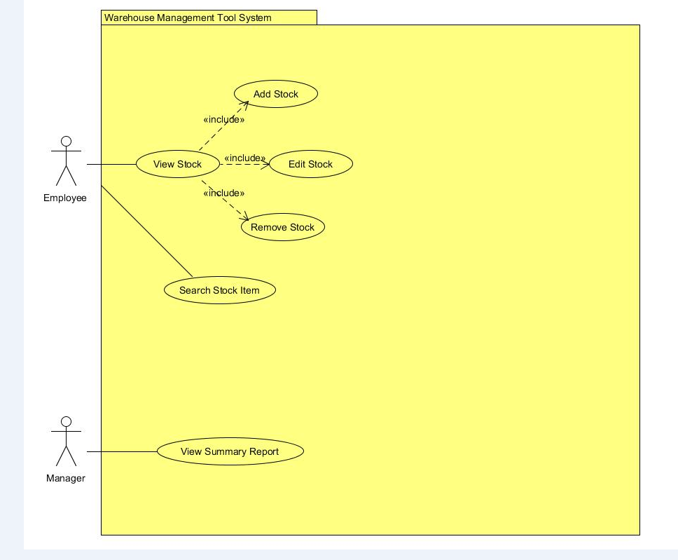

**Use Case Diagram (Final Version)**

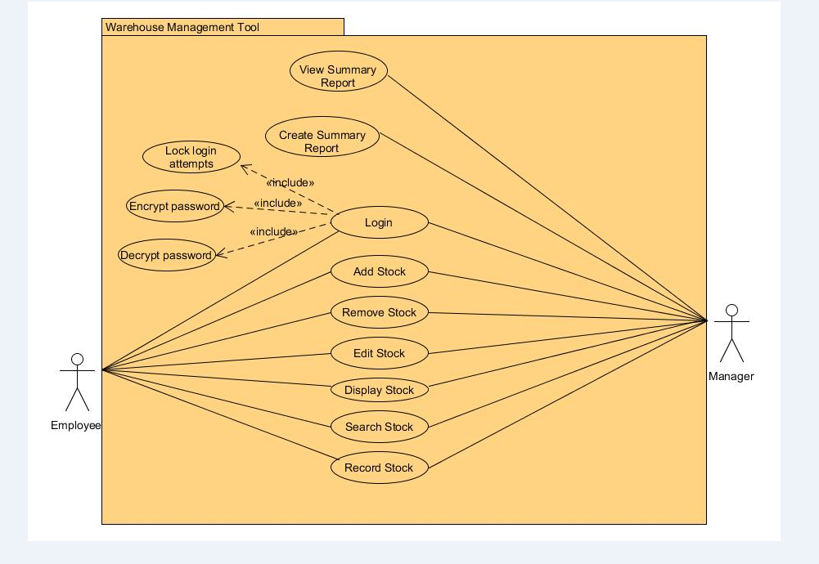

### Use Case Detailed Description

#### Detailed Use Case 1 (Login)

|  |  |
| --- | --- |
| **Use Case Description** | This use case describe how the user login into the system |
| **Primary Actor (s)** | Employee, Manager |
| **Pre-conditions** | User must have a user account in the system  Hash algorithm to encrypt and decrypt password |
| **Flow** | **Main Flow**   1. System provides user with an input dialog box consisting of username and password field 2. User will input the account info into the field provided and press enter 3. System runs hash algorithm on the password to get the hash input 4. System checks if hash input matches user stored hashed password. 5. System will validate the user details 6. System will allow user access   **Alternate Flow (AF1) –Invalid password or username**   1. System inform user that the password or username entered is invalid   **Alternate Flow (AF2) –Three unsuccessful login attempts**   1. System will mark the record of the account as “locked” 2. System will not allow user to login into the system |
| **Post-conditions** | 1. System will open and display user functions |
| **Business Rules** | 1. Mandatory fields must be entered |

#### Detailed Use Case 2 (Create Summary Report)

|  |  |
| --- | --- |
| **Use Case Description** | This use case creates summary report for Manager |
| **Primary Actor (s)** | Manager |
| **Pre-conditions** | Manager authorized access to access database |
| **Flow** | **Main Flow**   1. Manager gets access to database 2. Manager select information to generate report 3. Summary report generated |
| **Post-conditions** | 1. Report from database is generated |
| **Business Rules** | 1. Mandatory fields must be entered |

#### Detailed Use Case 3 (View Summary Report)

|  |  |
| --- | --- |
| **Use Case Description** | This use case describe how manager view the summary report |
| **Primary Actor (s)** | Manager |
| **Pre-conditions** | Summary report exist in the database |
| **Flow** | **Main Flow**   1. User click on view report tab in system 2. System will display all the various past reports created 3. User click on the specific report 4. System will display the details of the specific report |
| **Post-conditions** | 1. System show report to the manager for viewing |
| **Business Rules** | 1. Mandatory fields must be entered |

#### Detailed Use Case 4 (Add Stock)

|  |  |
| --- | --- |
| **Use Case Description** | This use case describes how an Employee and Manager add stock into the system |
| **Primary Actor (s)** | Employee, Manager |
| **Pre-conditions** | User must first login to the system |
| **Flow** | **Main Flow :**   1. Employee or Manager will login to the system with his/her username and password 2. Employee or Manager will click on the “Add Stock” tab 3. Employee or Manager will key in the necessary information for the stock 4. System will store the information 5. System will display the added stock information 6. Use case ends   **Alternate Flow (AF1) – Invalid Entry**   1. Employee or Manager key in information with wrong format 2. System display “Invalid Value” 3. Use case ends |
| **Post-conditions** | 1. All the stocks added will be stored in the system |
| **Business Rules** | 1. Mandatory fields must be entered. |

#### Detailed Use Case 5 (Remove Stock)

|  |  |
| --- | --- |
| **Use Case Description** | This use case describes how an Employee and Manager remove stock from the system |
| **Primary Actor (s)** | Employee, Manager |
| **Pre-conditions** | User must first login to the system |
| **Flow** | **Main Flow :**   1. Employee or Manager will login to the system with his/her username and password 2. Employee or Manager will click on the “Remove Stock” tab 3. Employee or Manager will select the stock that he/she wish to remove 4. System will remove the stock 5. System will display “Selected stock have been removed” 6. Use case ends   **Alternate Flow (AF1) – Selection Exceeded**   1. Employee or Manager select more than 1 record 2. System display “You can only remove 1 stock at a time” 3. Use case ends |
| **Post-conditions** | 1. The selected stock will be removed from the system |
| **Business Rules** | 1. Mandatory fields must be entered. |

#### Detailed Use Case 6 (Edit Stock)

|  |  |
| --- | --- |
| **Use Case Description** | This use case describes how an Employee and Manager edit stock from the system |
| **Primary Actor (s)** | Employee, Manager |
| **Pre-conditions** | User must first login to the system |
| **Flow** | **Main Flow :**   1. Employee or Manager will login to the system with his/her username and password 2. Employee or Manager will click on the “Edit Stock” tab 3. Employee or Manager will select the stock that he/she wish to edit 4. Employee or Manager will edit the stock information 5. System will save the changes made 6. System will display the edited stock information 7. Use case ends   **Alternate Flow (AF1) – Selection Exceeded**   1. Employee or Manager select more than 1 stock 2. System display “You can only edit 1 stock at a time” 3. Use case ends |
| **Post-conditions** | 1. The system will save the edited stock information |
| **Business Rules** | 1. Mandatory fields must be entered. |

#### Detailed Use Case 7 (Display Stock)

|  |  |
| --- | --- |
| **Use Case Description** | This use case describes how an Employee and Manager display the stock/s from the system |
| **Primary Actor (s)** | Employee, Manager |
| **Pre-conditions** | User must first login to the system |
| **Flow** | **Main Flow :**   1. Employee or Manager will login to the system with his/her username and password 2. Employee or Manager will click on the “Display Stock” tab 3. Employee or Manager will select the stock that he/she wish to display 4. System will display the stock information selected 5. Use case ends   **Alternate Flow (AF1) – Selection Exceeded**   1. Employee or Manager select more than 1 stock 2. System display “You can only view 1 stock at a time” 3. Use case ends |
| **Post-conditions** | 1. The system will display the stock selected |
| **Business Rules** | 1. Mandatory fields must be entered. |

#### Detailed Use Case 8 (Search Stock)

|  |  |
| --- | --- |
| **Use Case Description** | This use case describes how an Employee and Manager search the stock from the system |
| **Primary Actor (s)** | Employee, Manager |
| **Pre-conditions** | User must first login to the system |
| **Flow** | **Main Flow :**   1. Employee or Manager will login to the system with his/her username and password 2. Employee or Manager will click on the “Search Stock” tab 3. Employee or Manager will select a particular category or sub-category 4. Employee or Manager will key in the stock name or keyword 5. System will display the stock related to the keyword being searched 6. Employee or Manager will select the stock that he/she wanted 7. Use case ends   **Alternate Flow (AF1) – Stock not found**   1. Employee or Manager key in the stock name on the search bar 2. System unable to locate the stock 3. System display “No available stock found” 4. Use case ends |
| **Post-conditions** | 1. The system will display a list of stock being searched based on the keyword according to the price range and quantity in ascending or descending order |
| **Business Rules** | 1. Mandatory fields must be entered. |

#### Detailed Use Case 9 (Record Stock)

|  |  |
| --- | --- |
| **Use Case Description** | This use case describes how an Employee and Manager record the stock into the system |
| **Primary Actor (s)** | Employee, Manager |
| **Pre-conditions** | User must first login to the system |
| **Flow** | **Main Flow :**   1. Employee or Manager will login to the system with his/her username and password 2. Employee or Manager will click on the “Record Stock” tab 3. Employee or Manager will select “incoming stock” or “outgoing stock” 4. Employee or Manager will key in the stock’s detail 5. System will save the detail 6. Use case ends   **Alternate Flow (AF1) – Invalid Entry**   1. Employee or Manager key in the stock’s detail 2. System detect that the information is in wrong format 3. System display “invalid entry” 4. Use case ends |
| **Post-conditions** | 1. The system will save the detail keyed in by Employee or Manager and store them according to their respective category |
| **Business Rules** | 1. Mandatory fields must be entered. |

## Sequence Diagram

#### Sequence Diagram 1 (Login)

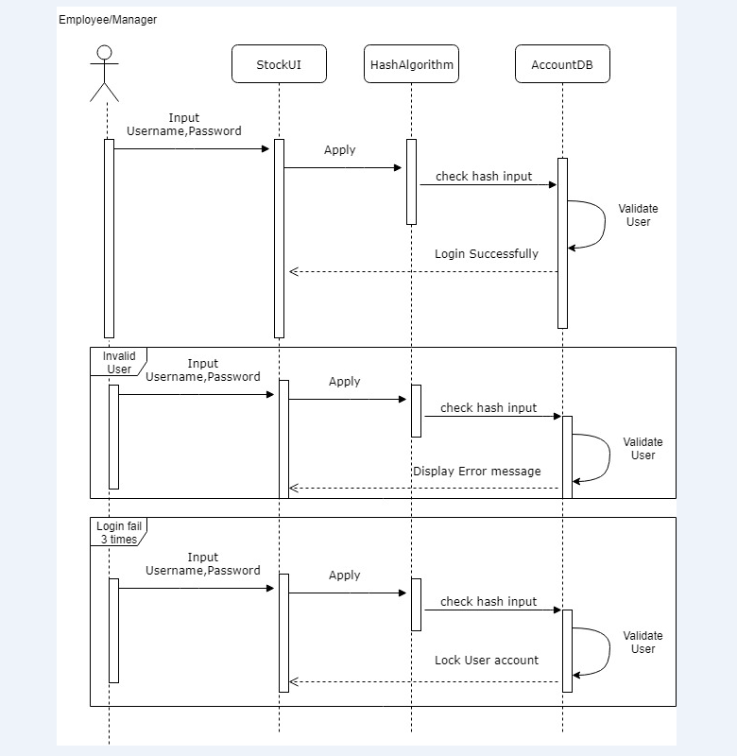

#### Sequence Diagram 2 (Create Summary Report)

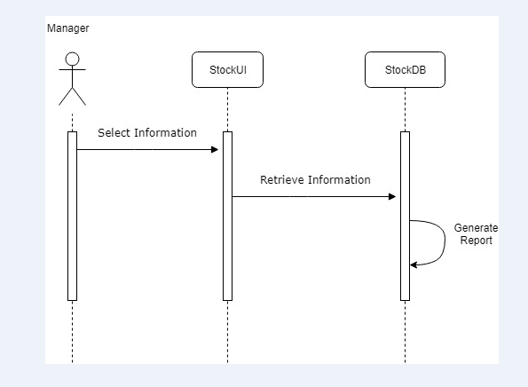

#### Sequence Diagram 3 (View Summary Report)

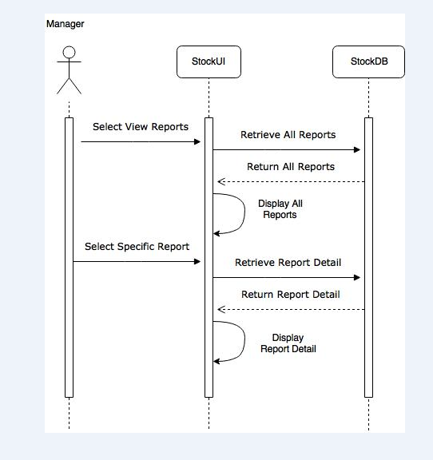

#### Sequence Diagram 4 (Add Stock)

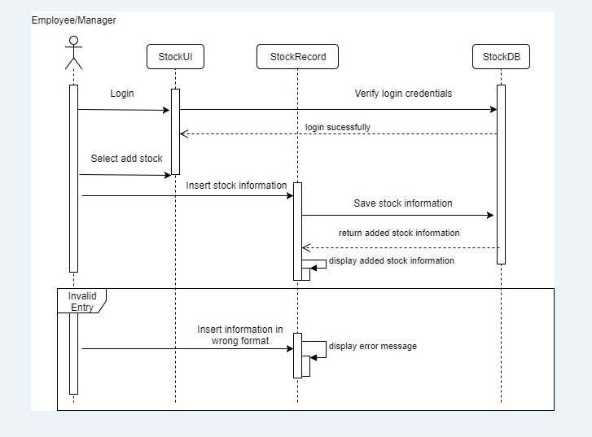

#### Sequence Diagram 5 (Remove Stock)

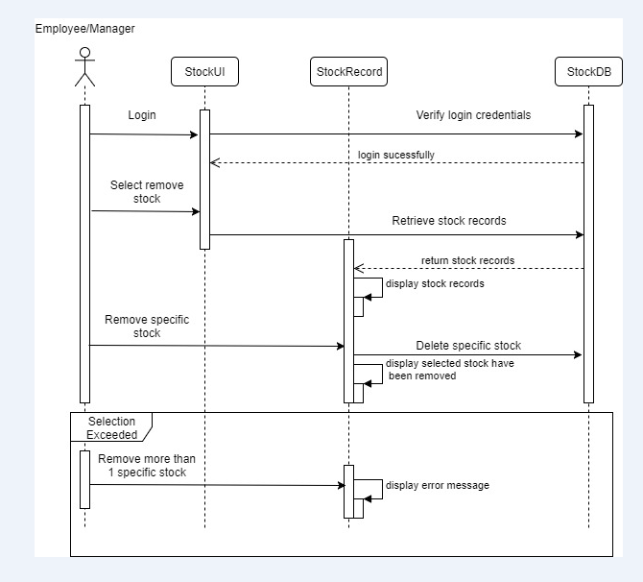

#### Sequence Diagram 6 (Edit Stock)

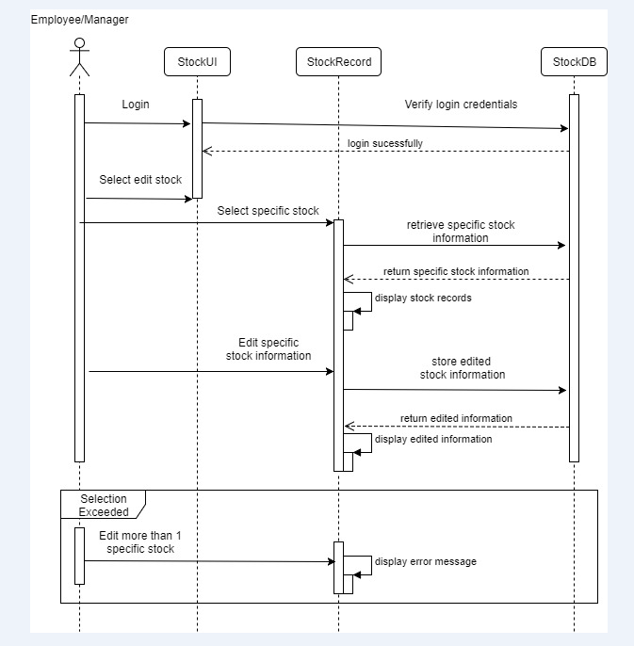

#### Sequence Diagram 7 (Display Stock)

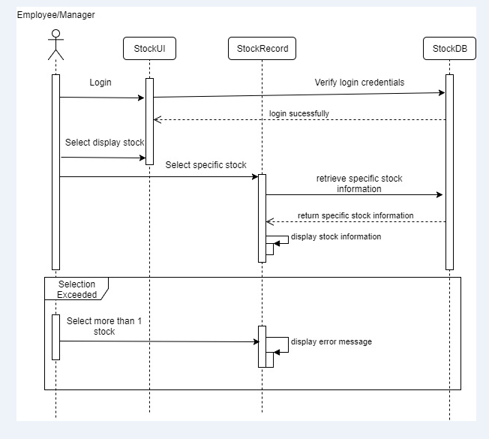

#### Sequence Diagram 8 (Search Stock)

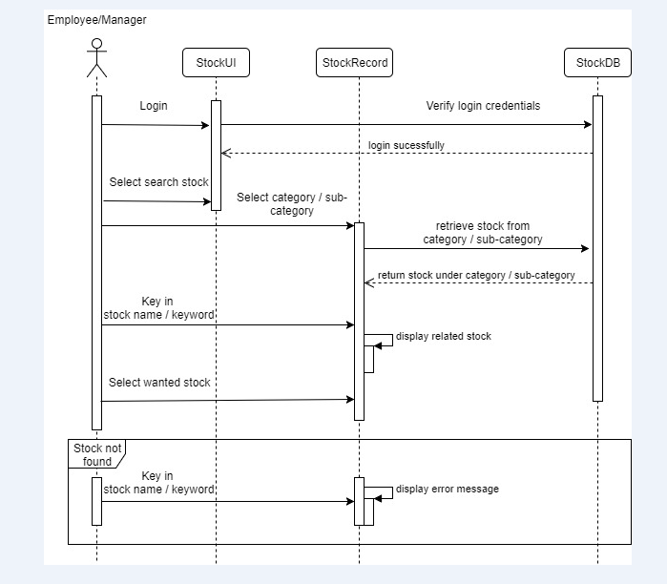

#### Sequence Diagram 9 (Record Stock)

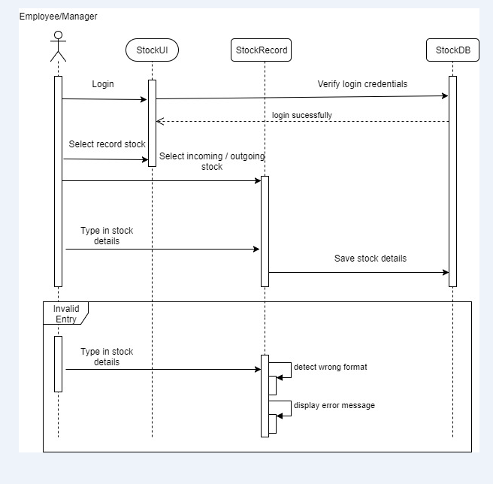

## Domain Model

# Risk and Counter Measures

The following image below will explain how we are going to mitigate the risks in our project:



| **Risk** | **Likelihood** | **Impact** | **Mitigation Strategy** |
| --- | --- | --- | --- |
| Insufficient knowledge on  Sub-versioning | Medium | High | 1. Every individual in the team to research and share their proposed sub-versioning system 2. Use free sub-versioning system online to explore |
| Different understanding of domain model concept | Medium | High | 1. Discuss and talk to lecturer to clear our doubts 2. Finalize our final correct understanding of domain model |
| Tight timeline | Medium | High | 1. Accommodate and find time during the weekends to meet up and discuss |
|  |  |  |  |