Data-Driven College Matching Using Institutional Quality, Cost, and Graduation Outcomes
JD Allen (JD.Allen@ttu.edu), Amanda Jinks (ajinks@ttu.edu), Pedro Hernandez-Lopez (her11223@ttu.edu), Serena Zachariah (serzacha@ttu.edu)
ISQS-5381 Data Science Project, Texas Tech University
Abstract
Lorem Ipsum

Introduction
The idea is to create an application that solves the problem for parents of college-seeking students in finding colleges that meet criteria. Given that IPEDS contains a lot of information, we thought it might be leveraged to provide some data analysis to the data and create an application that does that.
Objective: Build an institution-level decision-support workflow using public higher-ed data
Challenge: Public data has institution-level outcomes, not student-level application histories
Goal: Predict institutional graduation-outcome strength as a proxy for student decision support
Constraint-aware approach: Use transparent, reproducible, auditable transformations
+key finding and discussion
+ contributions?

Approach
The technical approach was to design a pipeline and system that consumes IPEDS data, slap a front-end on it, and call it a day.

Design
There are primarily two significant portions of the design – the data and the technical stack.

Technical Stack
The technical stack is presented here in several parts. Section 2.2.1 covers the human coordination of the project; 2.2.2 discusses the data used; and section 2.2.3 explains the software tools required to develop and deploy the project.

Coordination
Coordination of activities for this project is provided below.
- Standard team communication was provided by GroupMe in the channel called DS Senior Project [1].
- Team meeting hosting was provided by Microsoft Teams in the channel called Data Science Senior Project Team 8.
- Assignment posting and general collaboration hosting by Canvas.

Data
- The Integrated Postsecondary Education Data System (IPEDS) is the U.S. Department of Education’s primary system for collecting comprehensive, annual data from roughly 7,500 U.S. colleges, universities, and vocational schools participating in federal financial aid programs. It tracks key metrics like enrollment, graduation rates, tuition, and staffing, providing the standard public data source for analyzing higher education.
  - 2024 data was our first area of focus, as it represents the most recently compiled dataset. There are many survey data files available, including Institutional Characteristics, 12-Month Enrollment, Admissions, Fall Enrollment, Completions, Graduation Rates, Student Financial Aid, Finance, and Human Resources, each capturing different aspects of institutional structure, student populations, outcomes, and financial operations.
- Public consensus indicates the following key decision factors for parents when choosing a college for their student
$w_{acad}=0.74, w_{cost}=0.67, w_{career}=0.73, w_{location}=0.47, w_{safety}=0.35$ [ref].

Tools
- Visual Studio Code was used to manipulate the data.
- Streamlit application used to provide a web GUI to interact with the data.
- Dify might be used for something
- LLM might be used for something

Methodology
Once the initial data were selected, collection of the data and joining were necessary to determine where complete information exists. The following procedure was used.

Fusing the data
Lorem ipsum

Table 1 Data Set Source Overview
 | Survey | Title | Perceived Value
HD2024 | Institutional Characteristics | Directory information | Core Institutional data
IC2024 | Institutional Characteristics | Educational offerings, organization, services and athletic associations | Core Institutional data
FLAGS2024 | Institutional Characteristics | Response status for all survey components | Core Institutional data
ADM2024 | Admissions and Test Scores | Admission considerations, applications, admissions, enrollees and test scores, fall 2024 | Predictive data
SFA2324 | Student Financial Aid and Net Price | Student financial aid and net price: 2023-24 | Predictive data
COST1_2024 | Cost | Application fees, tuition and required fees, food and housing for undergraduate and graduate students | Predictive data
COST2_2024 | Cost | Full-time, first-time degree/certificate-seeking undergraduate students paying the in-state or in-district tuition rate by living arrangement in public institutions, 2021-22 to 2023-24 | Predictive data
EF2024A | Fall Enrollment | Race/ethnicity, gender, attendance status, and level of student: Fall 2024 | Cohort Sources
GR2024 | Graduation Rates | Graduation rate data, 150% of normal time to complete - cohort year 2018 (4-year) and cohort year 2021 (2-year) institutions | Cohort Sources

Python scripts were created using the Visual Studio Code IDE to orchestrate a repeatable build pipeline for the cohort to participate in development. Table 2 Python Scripting shows each script’s purpose.

Table 2 Python Scripting
 | Function | Input | Output
00_run_pipeline.py | Orchestration script to run following step/scripts in order: 01, 04, 02, 05, 03, 06 | 01_data_audit.py  04_flatten_longformat_ef_gr.py  02_build_analysis_base.py  05_build_project_target.py  03_build_modeling_ready.py  06_train_baseline.py | See details for each script
01_data_audit.py | Audit Inputs and Join Coverage  Profiles all source CSVs (rows, columns, missingness, UNITID completeness), computes cross-file UNITID overlap, and writes audit artifacts | adm2024.csv  cost1_2024.csv  cost2_2024.csv  ef2024a.csv  flags2024.csv  gr2024.csv  hd2024.csv  ic2024.csv  sfa2324.csv | data_audit_summary.csv  unitid_join_coverage.json  and input_inventory.csv
04_flatten_longformat_ef_gr.py | Flatten EF/GR long-format cohort data to one row per UNITID  Converts long-format sources into one-row-per-UNITID aggregate features | ef2024a.csv  gr2024.csv | longformat_unitid_features.csv  longformat_unitid_features_report.json
02_build_analysis_base.py | Build unified analysis base  Left-joins one-row-per-UNITID sources into a source-prefixed master table | adm2024.csv  cost1_2024.csv  cost2_2024.csv  flags2024.csv  hd2024.csv  ic2024.csv  sfa2324.csv  longformat_unitid_features.csv | analysis_base.csv  analysis_base_join_report.json
05_build_project_target.py | Build project target from graduation cohort outcomes  Derives an institution-level graduation outcome target—computing gr_completion_rate_150 from CHRTSTAT=13/12 and binary y_grad_outcome_high via median split | gr2024.csv | project_target_unitid.csv  project_target_report.json
03_build_modeling_ready.py | Build modeling-ready dataset  Merges, selects/cleans baseline features, model-ready output and column-role dictionary. | analysis_base.csv  project_target_unitid.csv | modeling_ready.csv  variable_map.csv
06_train_baseline.py | Train baseline models + export metrics  Trains logistic-regression and random-forest baselines, evaluates holdout performance (accuracy/precision/recall/F1/ROC-AUC). | modeling_ready.csv | baseline_metrics.json  baseline_feature_importance.csv
07_build_recommendation_scores.py | Recommendation Scoring Builder  Takes pipeline outputs and creates the app-ready ranking table | analysis_base.csv  modeling_ready.csv  project_target_unitid.csv | recommendation_base_scores.csv  recommendation_scoring_report.json

Examining the Output
Once the data is adequately fused, the user can interact with the application.
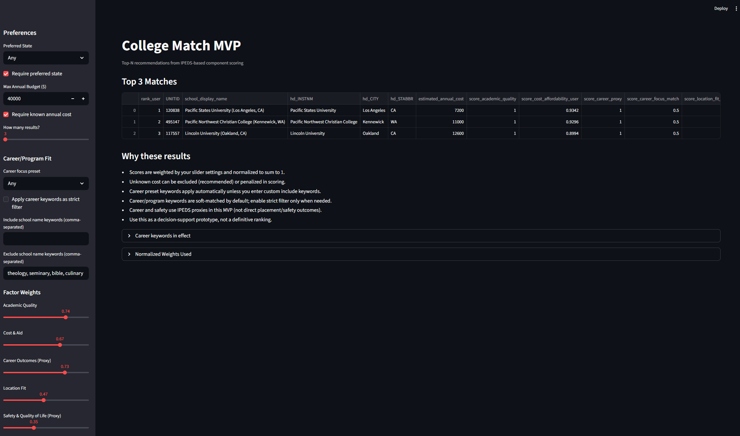

Displays
Talk about all the displays.

Controls
Talk about all the controls.

Reproducing the Results

Environmental Constraints
To reproduce the pipeline and MVP application, the following environmental constraints must be observed.
Software Requirements
- Operating System: Windows 10/11, macOS, or Linux
- Python: 3.10+ (project validated on Python 3.13)
- Package Manager: pip
- Version Control (recommended): Git
- Optional UI runtime: Streamlit (installed via requirements.txt)
Python Dependencies
Install all required libraries with:
- pip install -r requirements.txt
Key packages include:
- pandas
- numpy
- scikit-learn
- streamlit
Minimum Hardware
- CPU: Dual-core processor (4+ cores recommended)
- RAM: 8 GB minimum (16 GB recommended for smoother processing)
- Storage: At least 5 GB free space (raw IPEDS files + generated outputs + environment)
Data/Directory Assumptions
- Required IPEDS source files (.csv and dictionary .xlsx) are placed in the project root.
- Output artifacts are written to outputs.
- Scripts are path-relative (no machine-specific data paths required).
Expected Runtime (Typical)
- python scripts/00_run_pipeline.py: ~2–8 minutes (machine dependent)
- python scripts/07_build_recommendation_scores.py: <1 minute
- python -m streamlit run app/streamlit_app.py: ~5–20 seconds startup
Reproducibility Notes
- The orchestrator writes execution diagnostics to pipeline_run_manifest.json, including step return codes and timestamps.
- If execution fails, the manifest should be used as the first troubleshooting reference.
- For Windows PowerShell script execution of run_app.ps1, temporary policy bypass may be required: Set-ExecutionPolicy -Scope Process -ExecutionPolicy Bypass

Steps to Reproduce
- Download the 2024 IPEDS data sets indicated in Table 1 Data Set Source Overview from either site below:
  - IPEDS site
  - Team SharePoint
- Clone the project from the GitHub repository (or download and unzip locally).
- Open a terminal in the project root folder and create/activate a Python virtual environment:
  - python -m venv .venv
  - .venv/Scripts/activate
- Install required dependencies:
  - pip install -r requirements.txt
- Place all required IPEDS source files in the project root directory (same level as README.md and scripts):
  - hd2024.csv, ic2024.csv, flags2024.csv, adm2024.csv, sfa2324.csv, ef2024a.csv, gr2024.csv, cost1_2024.csv, cost2_2024.csv and corresponding dictionary workbooks (.xlsx) used for metadata mapping.
- Run the core data pipeline:
  - python scripts/00_run_pipeline.py. This orchestrates Steps 01, 04, 02, 05, 03, and 06 and writes outputs to outputs, including: analysis_base.csv, modeling_ready.csv, baseline_metrics.json, pipeline_run_manifest.json
- Build recommendation scores for the application layer:
  - python scripts/07_build_recommendation_scores.py. This generates: recommendation_base_scores.csv, recommendation_scoring_report.json
- Launch the interactive MVP interface: run_app.ps1 or python -m streamlit run app/streamlit_app.py
- Validate successful execution by checking:
  - pipeline status in pipeline_run_manifest.json
  - recommendation output existence in recommendation_base_scores.csv

Troubleshooting (Common Setup Issues)
Table 3 Troubleshooting Initial Setup
Issue | Resolution
FileNotFoundError for IPEDS files | Confirm all required .csv and .xlsx source files are in the project root (same folder as README.md and scripts).
ModuleNotFoundError (for pandas, sklearn, streamlit, etc.) | Activate the virtual environment and reinstall dependencies: pip install -r requirements.txt
Pipeline fails in Step 00 | Open pipeline_run_manifest.json and check return_code, stdout, and stderr for the failed script.
App launches but shows no results | Loosen filters in the sidebar (state requirement, known-cost requirement, budget cap, strict career keyword filtering).  Also verify recommendation_base_scores.csv exists and is non-empty.
Streamlit import unresolved in editor, but terminal runs fine | VS Code likely selected a different Python interpreter. Re-select the project interpreter (.venv) and rerun.
PowerShell blocks script execution (run_app.ps1) | Run once per session:  Set-ExecutionPolicy -Scope Process -ExecutionPolicy Bypass  Then rerun: run_app.ps1

Results
The python scripting—primarily scripts 01-05—primarily dealt with merging of the 2024 data, such that meaningful analysis could occur. Python scripts 06 and 07 seek to answer two questions – is this data strategy scientifically sound and does the human interface (application layer) provide the user tangible results. These questions are explored in the next two sections.

Evaluation of the Model
Script 06 establishes whether the engineered institutional features contain real predictive signal for student-outcome performance. The target variable is defined from the 150% graduation completion rate and converted to a binary label using the sample median cutoff (0.508), which yields a balanced classification problem (1,818 high-outcome institutions and 1,818 lower-outcome institutions). This setup is intentional to balance the classes to prevent inflated performance from majority-class guessing and make model metrics easier to interpret.
Two baseline models were trained and evaluated on a held-out test set (728 institutions): Logistic Regression (interpretable linear baseline) and Random Forest (nonlinear baseline). The purpose was not to claim a valid final production model, but to test whether the feature strategies employed are scientifically valid under these two different modeling assumptions. If both model families perform better than that achieved by chance—and consistently—the data pipeline can be considered analytically credible.
Both baselines show strong performance, with Random Forest outperforming Logistic Regression across all key metrics as shown in Table 4 Held-Out Test Performance of Baseline Models.
Table 4 Held-Out Test Performance of Baseline Models
Model | Accuracy | Precision | Recall | F1 Score | ROC-AUC
Logistic Regression | 0.793 | 0.793 | 0.791 | 0.792 | 0.882
Random Forest | 0.824 | 0.831 | 0.813 | 0.822 | 0.911

In particular, the ROC-AUC reaches 0.911 for Random Forest versus 0.882 for Logistic Regression, indicating that the engineered features separate higher- and lower-outcome institutions well. This is very clearly illustrated in FIGURE X.
<insert chart here that shows the ROC-AUC plot of both models on the same chart with a diagonal chance line. Something like this with a caption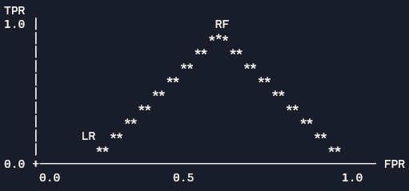>
Accuracy and F1 scores also remain strong (0.824 and 0.822, respectively) on the unseen test data, which further supports the claim that neither model disproportionately favors precision or recall and supports the claim that the signal generalizes well.
These results provide evidence that scripts 01–05 did more than merge data—they produced a feature space with measurable predictive structure. This step sets up how we score and recommend schools later (in script 07). It helps make sure that when the application ranks schools, it uses data and factors proven to relate to good results in testing, not just random guesses or simple rules.
This baseline serves as validation rather than proof. Feature importance highlights informative variables for prediction, such as tuition and room or capacity measures, but does not establish causality. Despite this, the baseline meets methodological standards for the project: it is empirically testable, reproducible, and supported by quantitative data.
Beyond overall performance, model interpretability was examined through Random Forest feature importance rankings. Table 5 Top Predictors from Random Forest Baseline identifies the eight most influential predictors used by the model, showing that tuition- and capacity-related variables contribute substantially to classification decisions. This supports the conclusion that the pipeline is capturing meaningful institutional signals rather than noise.
Table 5 Top Predictors from Random Forest Baseline
Rank | Feature | Importance
1 | cost1_TUITION3 | 0.103
2 | cost1_TUITION1 | 0.081
3 | cost1_TUITION2 | 0.078
4 | cost1_ROOMCAP | 0.053
5 | sfa_UPGRNTP | 0.046
6 | hd_C21BASIC | 0.044
7 | longfmt_ef_eftotlt_mean | 0.033
8 | longfmt_ef_eftotlt_max | 0.032

Evaluation of the User Experience
From a technical perspective, this section is about whether the interface correctly exposes the recommendation logic, not whether it is visually impressive. The application layer is successful only if a user can enter preferences, receive a ranked output, and understand why those institutions appear. In this project, script 07 computes the composite recommendation scores, while the front-end controls allow users to interact with those scores through constraints and weight adjustments.
Figure 1 College Match GUI
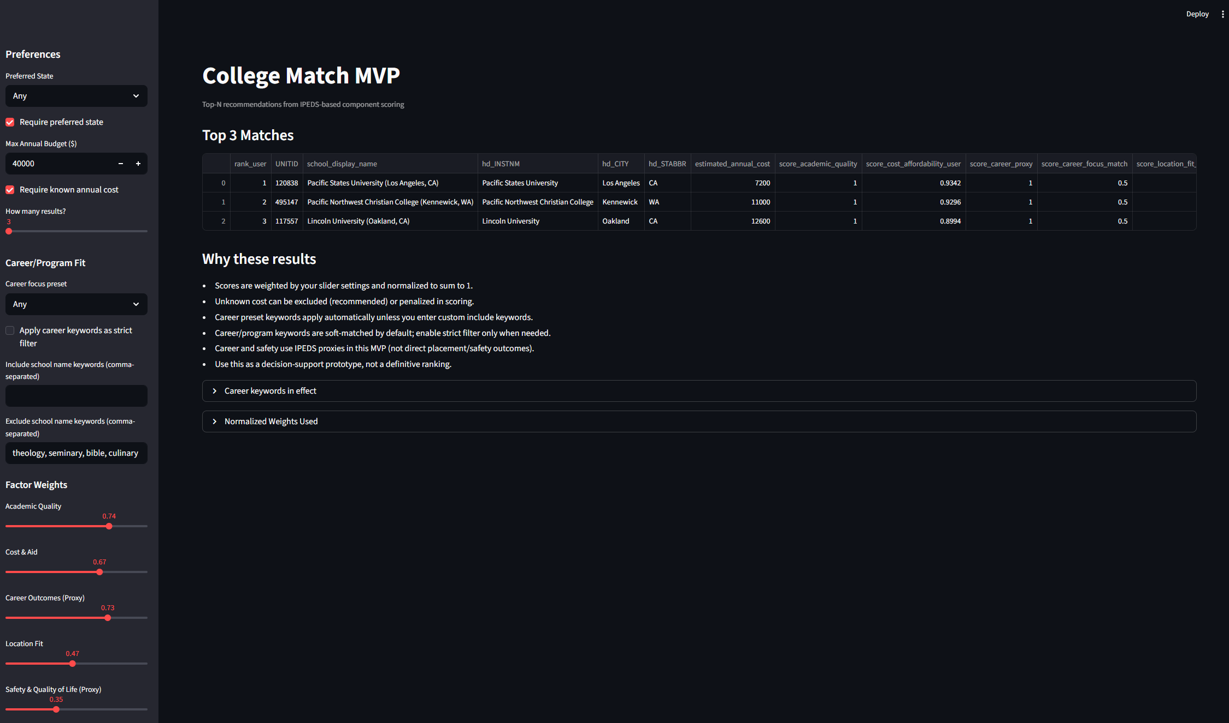
The UX evaluation focused on control-to-logic consistency. Specifically, we verified that state preference can be applied as a hard filter, budget constraints remove schools above the selected threshold, and missing cost values are handled explicitly rather than silently inflating rank positions. We also validated career matching behavior under two modes: soft matching (keyword influence on score) and strict matching (keyword-based exclusion), which prevents confusion when narrow filters produce zero results.
A second technical criterion is interpretability. Users should be able to observe that changing a control (for example, increasing affordability weight) causes expected movement in rankings. This behavior confirms that the application is not returning static results, but dynamically recomputing scores in line with user-defined priorities. In practical testing, this produced consistent and reproducible output changes across common scenarios.
Performance and reliability were also part of UX evaluation. The interface loaded and returned recommendations within acceptable local runtime, and test scenarios consistently produced rankable results when constraints were feasible. Together, these checks indicate that the user experience is functionally aligned with the scoring engine and suitable for decision-support use at the MVP stage.
The current interface still has known limitations. Career matching is keyword-based rather than full program-taxonomy based, some institutions have incomplete cost fields, and recommendation order remains sensitive to user-chosen weights. These are documented design constraints, not hidden failures, and they define clear priorities for future iterations.
Overall, the UX layer meets project goals because it translates validated backend signals into user-controllable, transparent, and reproducible recommendations. In short, Section 3.1 establishes that the model has signal, and Section 3.2 demonstrates that the signal is delivered to users in a technically coherent way.
Table 6. UX Technical Validation Scenarios
Scenario | User Inputs | Expected Technical Behavior | Observed Outcome | Status
State constraint check | Preferred state selected; strict state enabled | Results restricted to selected state only | Returned schools match selected state | Pass
Budget constraint check | Max annual budget set | Schools above threshold excluded | Out-of-budget schools removed | Pass
Missing cost handling | Known-cost requirement enabled | Schools with missing cost excluded | Missing-cost schools not shown | Pass
Career soft match | Career keywords entered; soft mode | Scores boosted for keyword-aligned schools | Relevant schools move upward without full exclusion | Pass
Career strict match | Career keywords entered; strict mode | Non-matching schools filtered out | Only keyword-aligned schools remain | Pass
Weight sensitivity | Affordability or academic weight increased | Rank order shifts toward emphasized factor | Ranking updates as expected | Pass

Expansion
Lorem Ipsum – team members have offered ideas here to expand on this work to include the usage of a large language model (LLM) to further provide information from other sources, such as sentiment of instructors, what locals are saying, and other intangibles that offer more ‘color’ to an otherwise business-like approach to choosing a college. Another potential is the use of Time-Series analysis (as a nod to Dr. Kim) to project the trends of the data; this would require potentially gathering more/deeper data.

Conclusion
Lorem Ipsum

References
[x] Canvas (TTU) | Full Term (ISQS-5381-D01 & D02) | Group 8 Group8
[x] GitHub | ISQS-5381-Group-8
[x] GroupMe | DS Senior Project
[x] IPEDS 2024 Data
[x] Microsoft Teams | Data Science Senior Project Team 8
[x] OneDrive SharePoint | Data Science Senior Project Team 8

Baseline training to be discussed further.
The size of the datasets and dictionaries is too large to be hosted on GitHub.
Datasets downloaded from either site are in a *.zip format and contain a single *.csv file each. Sites also contain the data dictionaries in the *_dict.zip file; dictionary files are *.xlsx format.
gr_completion_rate_150 divides the grand total of the adjusted cohort (revised cohort minus exclusions) (gr.CHRTSTAT=12) by the grand total of completers within 150% of normal time (gr.CHRTSTAT=13).
The terms ‘held-out’ or ‘holdout’ refer to the ‘validation set’ or ‘test set’, i.e. the data not used in training but used to validate the model, e.g. the ‘30’ in a 70/30 training partition. This term was not used in any of the ISQS lectures.
The Receiver Operating Characteristic (ROC) and Area Under the Curve (AUC) is a metric that measures how well the binary classifier separates the positive from the negative class. Values greater than 0.5 demonstrate better to perfect separation than chance (0.5).
The F1 score, $F1=2∙\frac{precision∙recall}{precision+recall}$, represents the harmonic mean between precision and recall.

