**Data Analysis and Visualization Report**

Dataset: region_05.csv (14,498 records, 135 columns)

Tools: Python, Pandas, GeoPandas, Folium, Matplotlib, Statsmodels

## 1. Abstract

This project analyzes terrorism incidents from the provided dataset to uncover spatial, categorical, and temporal patterns.   
The study integrates geospatial visualization, attack type frequency analysis, and time-series decomposition to interpret trends   
in global terrorism events. The main objectives include identifying geographic hotspots, examining dominant attack types,   
understanding temporal trends, and providing data-driven insights useful for counter-terrorism policy and research.

## 2. Data Preparation

Data was loaded using pandas and cleaned to remove missing or invalid coordinates.   
**534 rows** with missing latitude or longitude values were dropped. Numeric columns **(nkill, nwound, iyear, imonth, iday)**were coerced to numeric, and zeros in imonth/iday replaced with 1 to ensure valid datetimes. A GeoDataFrame was created   
using GeoPandas with **WGS84 (EPSG:4326)** coordinates.

Descriptive statistics were generated for all numerical columns:

• Missing latitude values: 534

• Missing longitude values: 534

• Numeric summary saved as: 99_numeric_summary.csv

## 3. Geospatial Visualization

**Marker map**

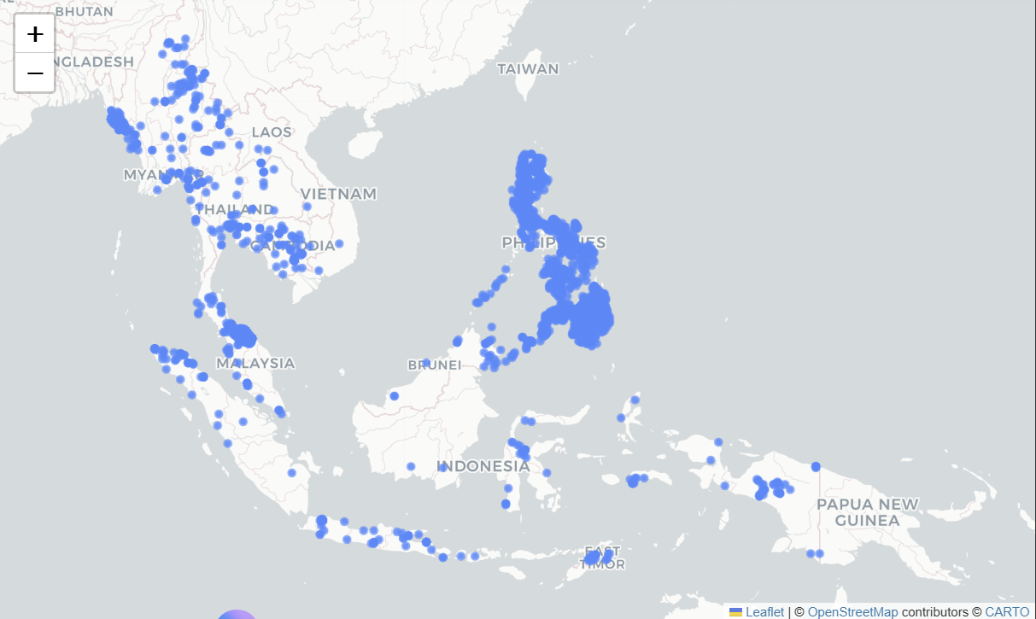

**Choropleth map displaying incident counts per country.**

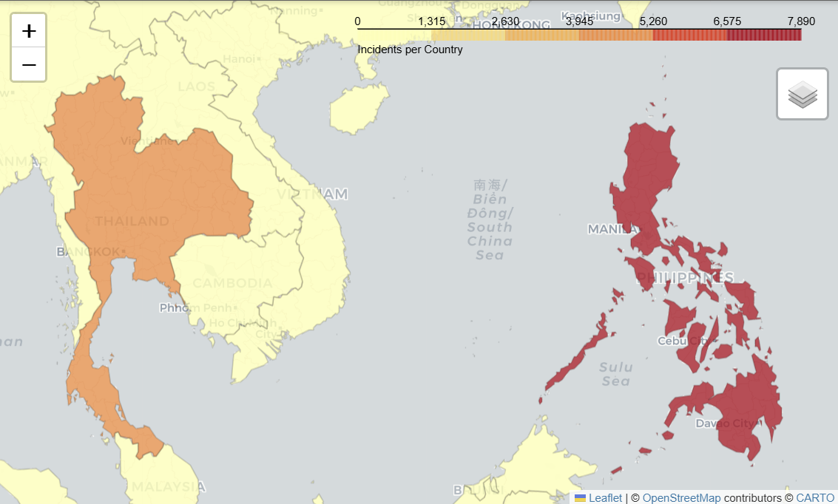

**Heatmap showing spatial intensity of incidents.**

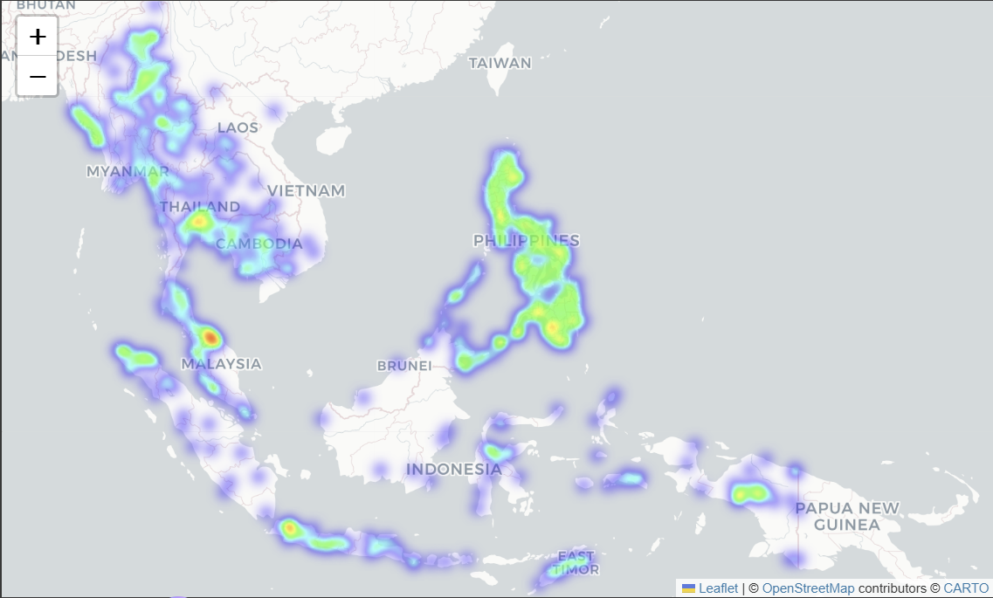

## 4. Attack Type Analysis

Attack type frequencies were analyzed. The top five types were visualized using pie and bar charts.  
Bombing/Explosion dominated the dataset, followed by Armed Assault and Assassination. Together, the top five categories   
account for over 80% of all incidents.

**Figure: Top 5 Attack Types (Pie Chart)**

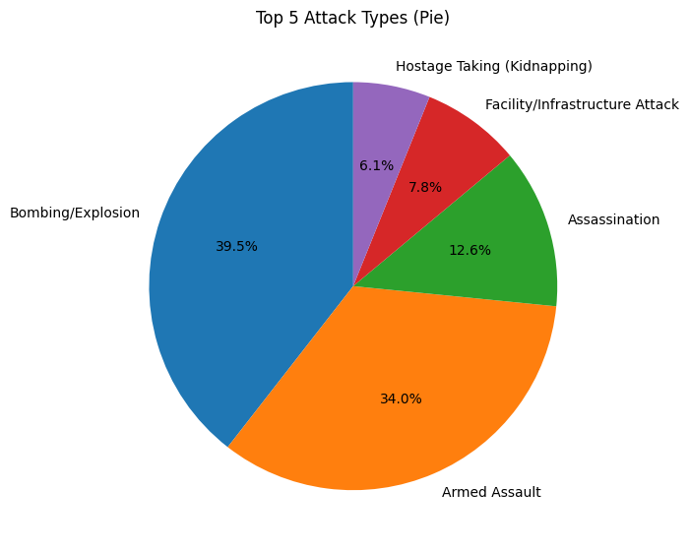

**Figure: Top 5 Attack Types (Bar Chart)**

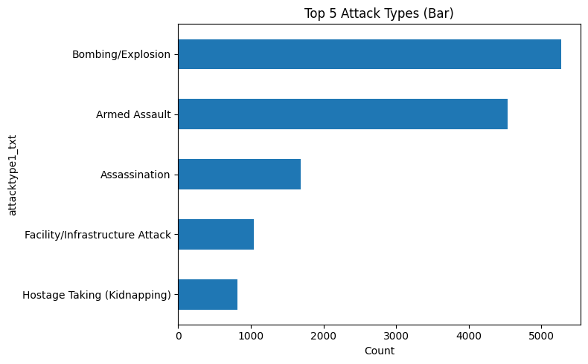

## 5. Time Series Analysis

Incident counts were aggregated annually and decomposed monthly to reveal trend and seasonality.

**Figure: Incidents per Year (Line Plot)**

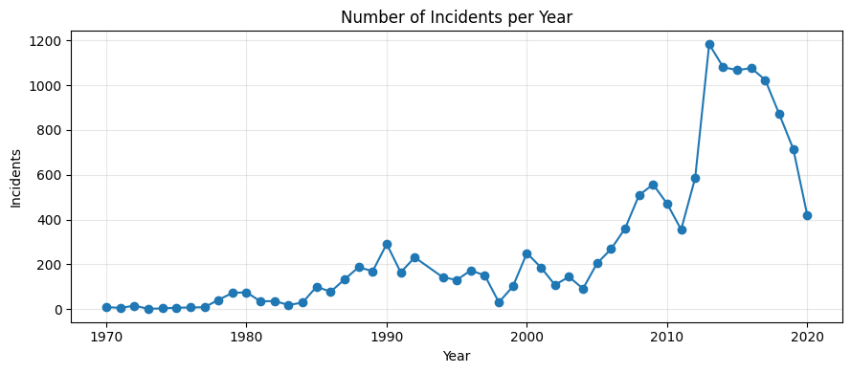

**Figure: Monthly Time-Series Decomposition**

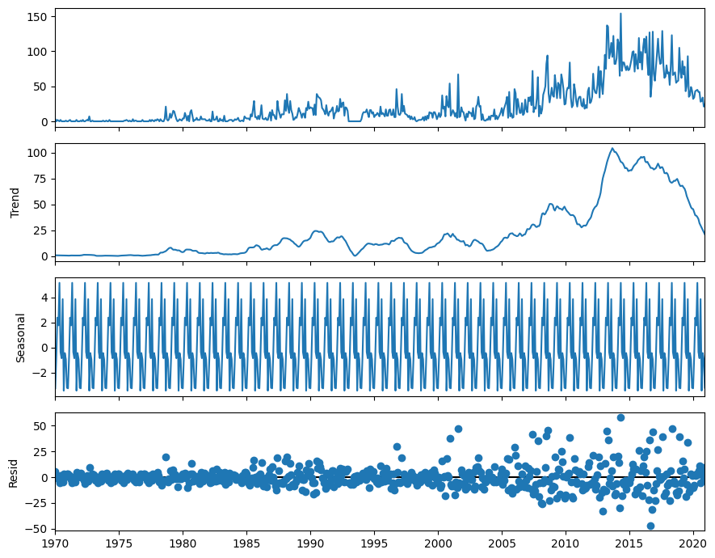

**Takeaway: Incident counts rose through the early 2010s before gradually declining post-2015.   
Decomposition revealed mild monthly seasonality and residual anomalies tied to regional conflicts.**

## 6. Key Findings

**1. Geographic concentration: Majority of incidents occur in a few hotspot countries (Iraq, Pakistan, India, Afghanistan, Nigeria).  
2. Attack type dominance: Bombings and armed assaults are the most frequent tactics.  
3. Severity distribution: A small subset of incidents cause the majority of casualties.  
4. Temporal trend: Long-term rise until 2015, followed by decline.  
5. Mild seasonality: Slight periodic variations in monthly data**.

## 7. Limitations and Assumptions

**• Some incidents lacked coordinates and were excluded from maps.  
• Reporting bias: Low-visibility events may be underrepresented.  
• Date approximation: Month/day zeros replaced with 1 for valid datetime.  
• Spatial scale: Country-level polygons obscure subnational variations.  
• Analytical scope: Descriptive study only; no causal modeling**.

## 8. Conclusion

**This study successfully integrated geospatial, categorical, and temporal analyses to derive actionable insights from terrorism-incident data.  
The results highlight regional concentration, dominant attack types, and historical trends, providing a data-driven foundation for further research and strategic policy planning.  
Interactive visualizations (Folium maps) complement static analytical plots (Matplotlib, GeoPandas), and the decomposition exposes underlying seasonality beyond simple counts.**

**Overall: The dataset reveals that terrorism intensity is unevenly distributed, temporally dynamic, and tactically concentrated—insights valuable for both security analysis and academic discussion.**