**Data Analysis and Visualization Report**

Dataset: region_05.csv (14,498 records, 135 columns)

Tools: Python, JavaScript, HTML

## 1. Abstract

This report analyzes global terrorism incidents using multi-dimensional visualizations. The study highlights target types, attack trends, regional intensities, and dominant terrorist groups. Interactive visualizations created with **Bokeh**, **Plotly**, and **D3.js** allow for deep exploration of the data from ***region_05_clean.csv***, offering insights into temporal, categorical, and geographical patterns of terrorism worldwide.

## 2. Data Preparation

The dataset region_05_clean.csv was cleaned and processed to ensure consistency:

* Removed missing or invalid iyear, targtype1_txt, nkill, nwound values.
* Computed **Total Casualties = nkill + nwound**.
* Handled large dataset sampling for performance optimization.
* Columns used: iyear, targtype1_txt, gname, attacktype1_txt, country_txt, nkill, nwound.

## Visualization1: Geospatial Heatmap (D3.js)

**File:** d3_heatmap.html  
**Goal:** Display global distribution of terrorism incidents per year.  
**Features:**

* Interactive world map with zoom and year slider.
* Red color intensity represents higher number of incidents.
* Tooltip displays country and number of incidents.
* Dynamic statistics below slider show total incidents and affected countries.

**Insight:**  
Regions in the Middle East and South Asia show high-intensity clusters, particularly after 2000, indicating persistent regional instability.

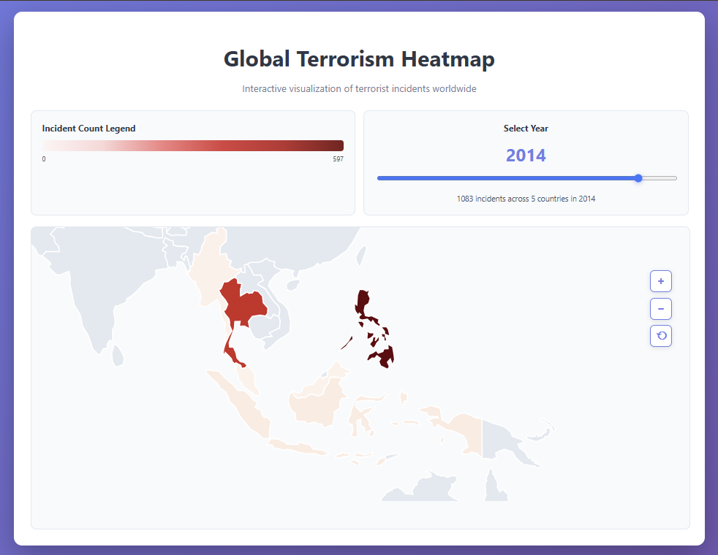

**Visualization 2: Attack Types Over Time (Plotly)**

**File**: attack_types.html  
**Goal**: Analyze changing attack strategies over time.  
**Features**:

* Stacked area chart showing frequency of each attack type per year.
* Toggle between stacked, grouped, and 100% stacked views.
* Hover displays year, attack type, and count.

**Insight**:  
Bombings and armed assaults remain dominant over decades, with a sharp rise between 2010–2015, coinciding with global terrorism escalation.

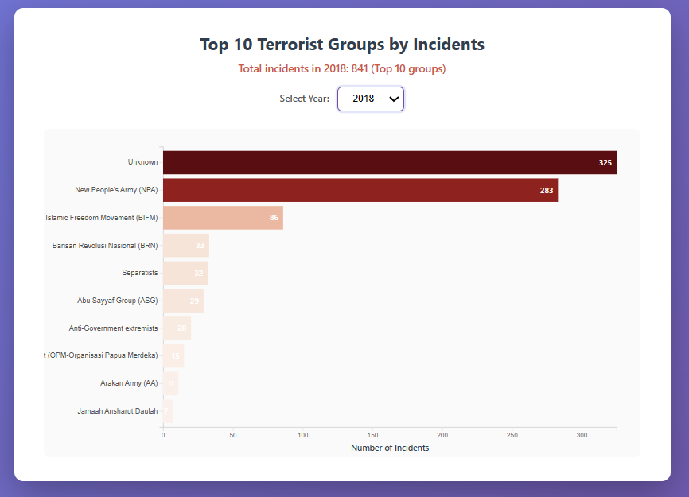

**Visualization 3: Target Types and Casualties (Bokeh)**

**File:** target_types_&_casualities.html  
**Goal:** Compare casualties across target types.  
**Features:**

* Interactive scatter plot with dynamic **year range slider** and **target type filter**.
* Circle size proportional to total casualties.
* Hover tooltip shows detailed incident data.
* Reset button restores full dataset view.

**Insight:**  
Civilian and government targets experience the most casualties, indicating that non-combatant populations bear the brunt of terrorist attacks.

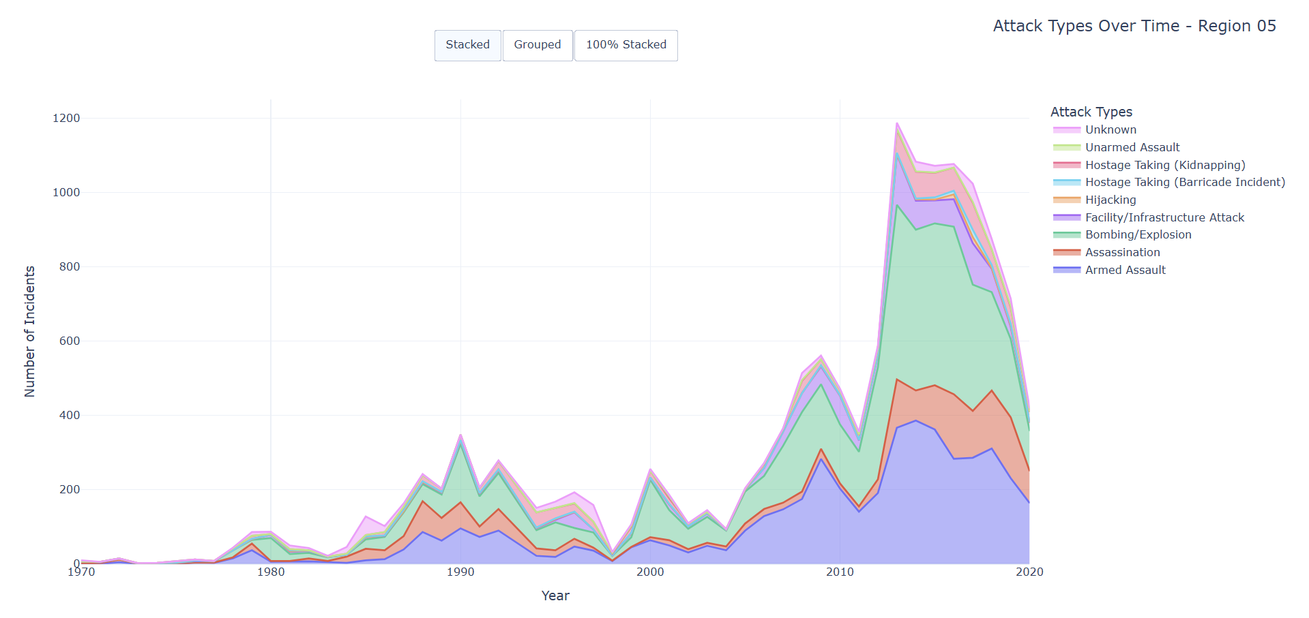

**Visualization 4: Top 10 Terrorist Groups (D3.js)**

**File:** d3_top10_groups.html  
**Goal:** Identify the most active groups per year.  
**Features:**

* Dropdown menu to select year.
* Animated horizontal bar chart for top 10 groups.
* Hover tooltip shows incident count per group.
* Color intensity represents magnitude of incidents.

**Insight:**  
Group dominance changes over time—certain organizations peak sharply in specific years, revealing shifting geopolitical dynamics.

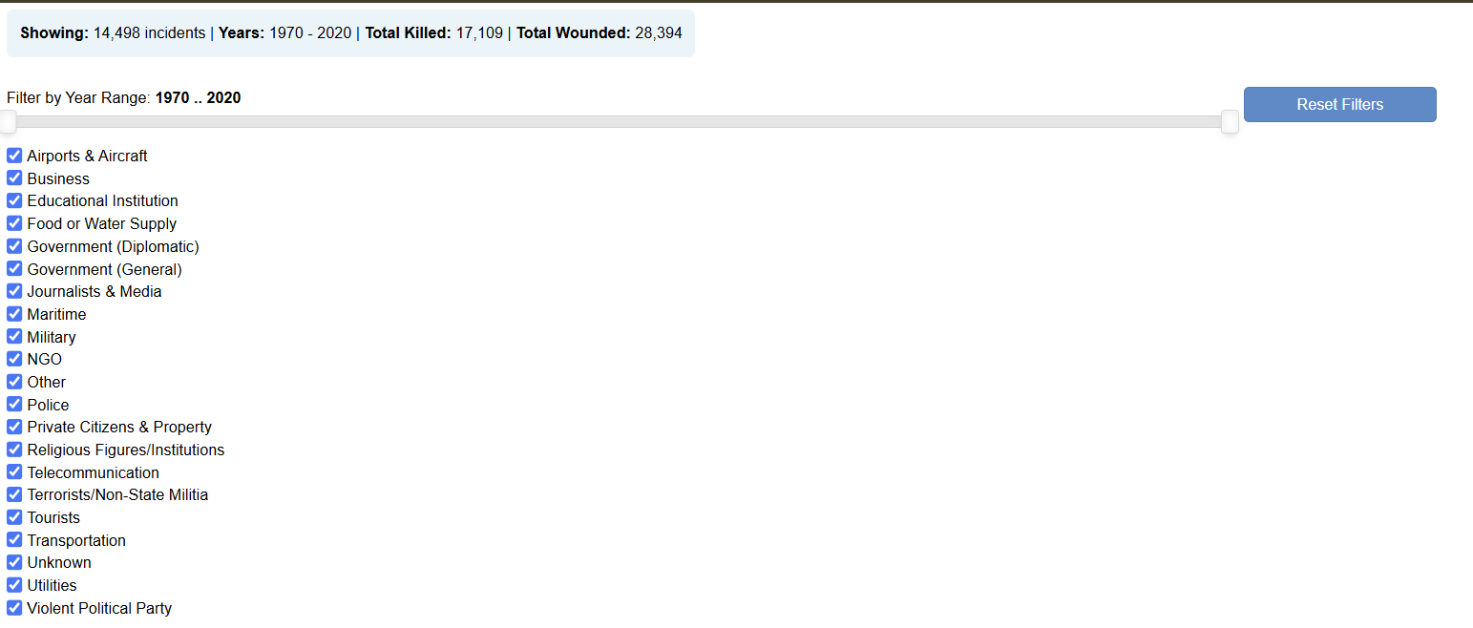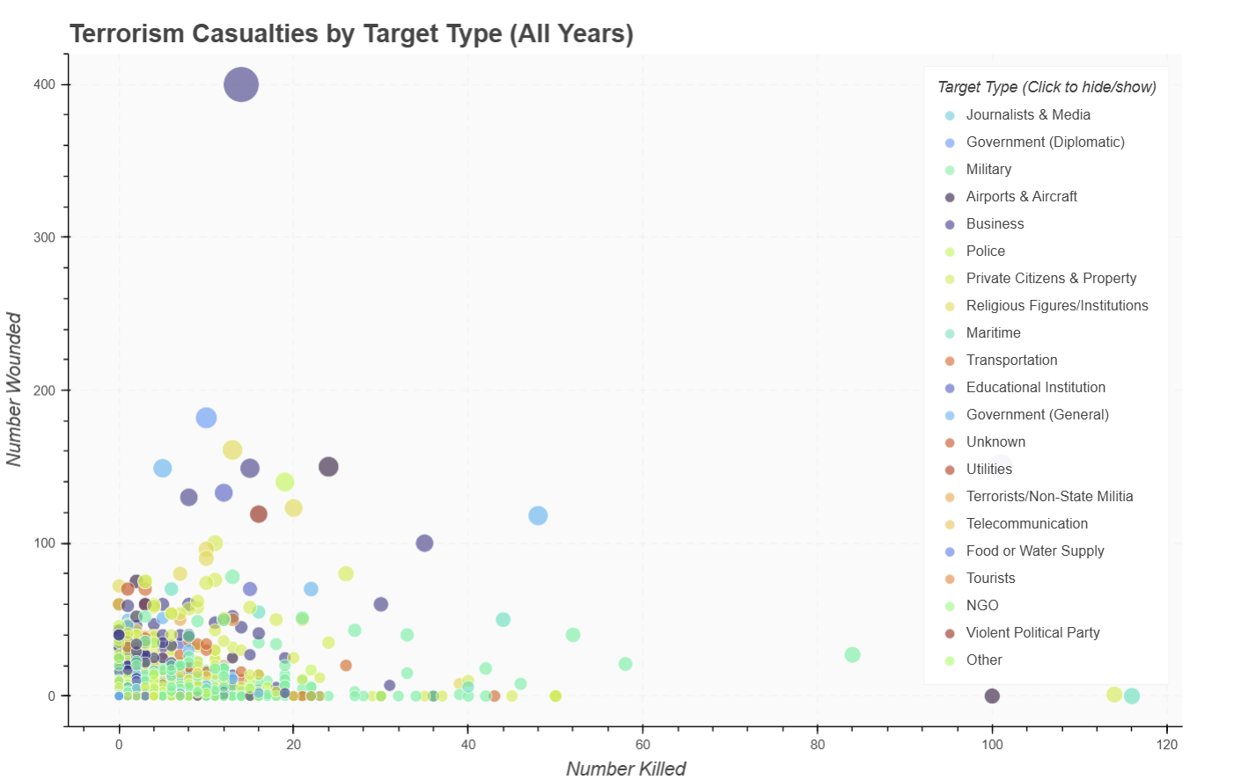

## 6. Key Findings

* **Temporal trend: Steady rise in incidents from 2000–2015.**
* **Geographical pattern: High activity in Middle East, South Asia, and parts of Africa.**
* **Target preference: Civilian and government entities are primary targets.**
* **Attack strategy: Bombings dominate; newer patterns show diversification.**
* **Group dynamics: Few groups account for a large share of incidents in each period.**

## 7. Limitations and Assumptions

* **Missing or inconsistent data in some years may bias results.**
* **Casualty numbers may vary due to reporting accuracy.**
* **Dataset limited to Region_05; may not represent all global patterns.**
* **Visualizations rely on browser rendering; performance depends on local resources.**

## 8. Conclusion

**The visualizations collectively reveal how terrorism patterns evolve spatially, temporally, and strategically. Combining Bokeh, Plotly, and D3.js offers comprehensive exploration — bridging static reporting and dynamic analytics for better understanding and prevention strategies.**

**Overall: The dataset portrays terrorism as a persistent and evolving global threat with dynamic actors, shifting hotspots, and escalating casualty impact through time.**