STUDENT: ALLEN P MANOJ DATE: 24/06/2026 BATCH: 03
INTRODUCTION

With the growth of the internet, cyber attacks have become more common. Traditional intrusion detection systems cannot detect new attacks effectively. Machine Learning helps computers learn patterns from data and identify malicious activities automatically.
This project uses the NSL-KDD dataset and the Random Forest algorithm to detect network intrusions.

Objectives
- To understand Network Intrusion Detection Systems.
- To use Machine Learning for attack detection.
- To train a Random Forest model.
- To classify network traffic as Normal or Attack.
- To evaluate the model performance.

Software Requirements
- Python
- Visual Studio Code
- Pandas
- NumPy
- Scikit-learn
- Matplotlib
- Joblib
IMPLEMENTATION
Step 1 – Explore Data
The dataset is loaded and analyzed. Charts are generated to understand the distribution of normal and attack traffic.

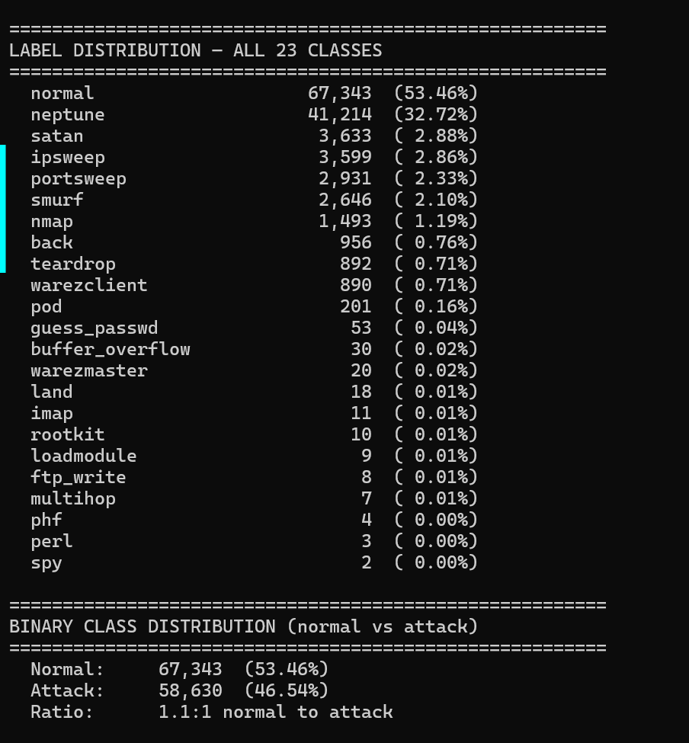

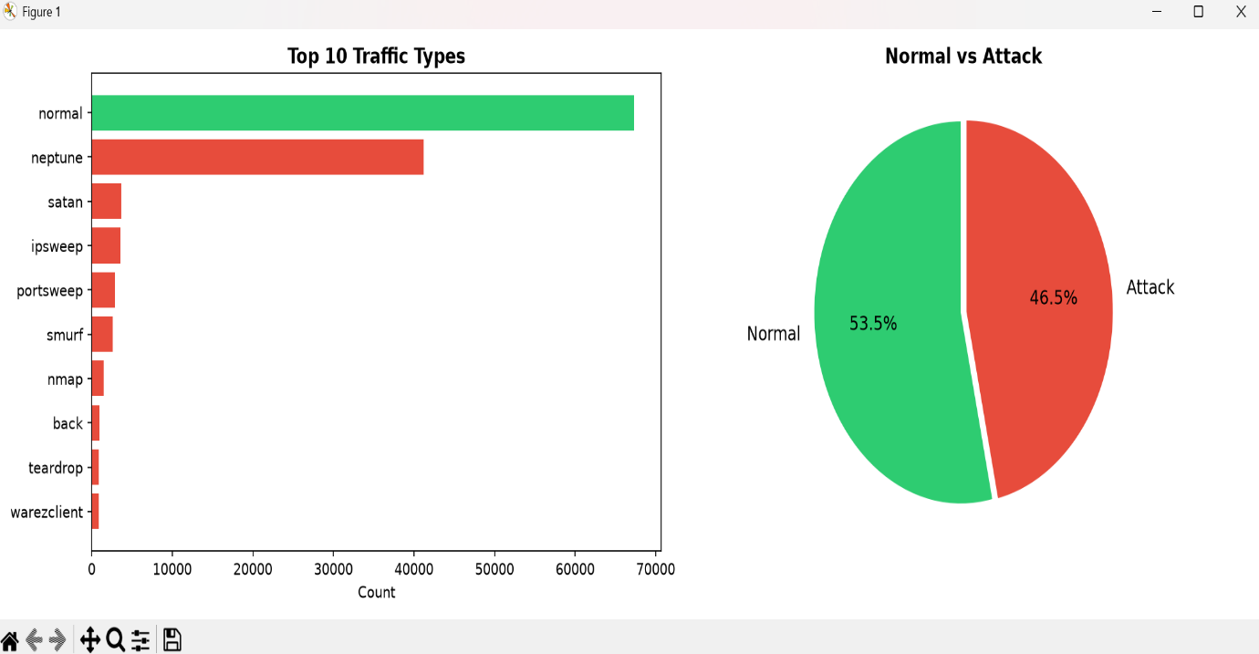

Step 2 – Preprocessing
The dataset is cleaned. Text values are converted into numbers. The data is split into training and testing datasets.
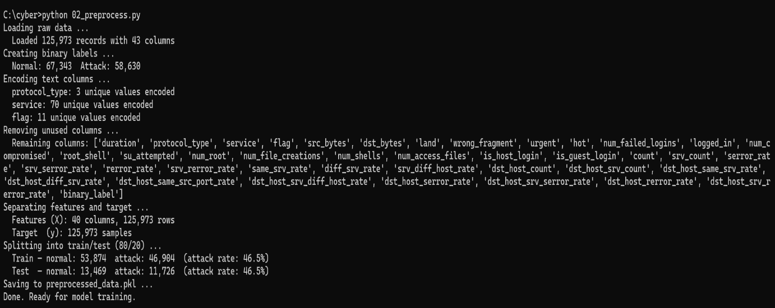

Step 3 – Model Training
The Random Forest algorithm is trained using the training dataset.
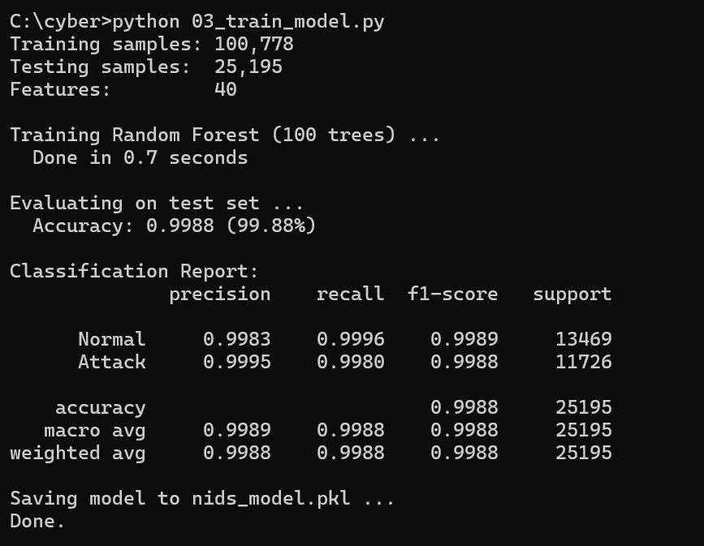

Step 4 – Model Evaluation
The trained model is evaluated using Accuracy, Precision, Recall, F1-Score, and Confusion Matrix.
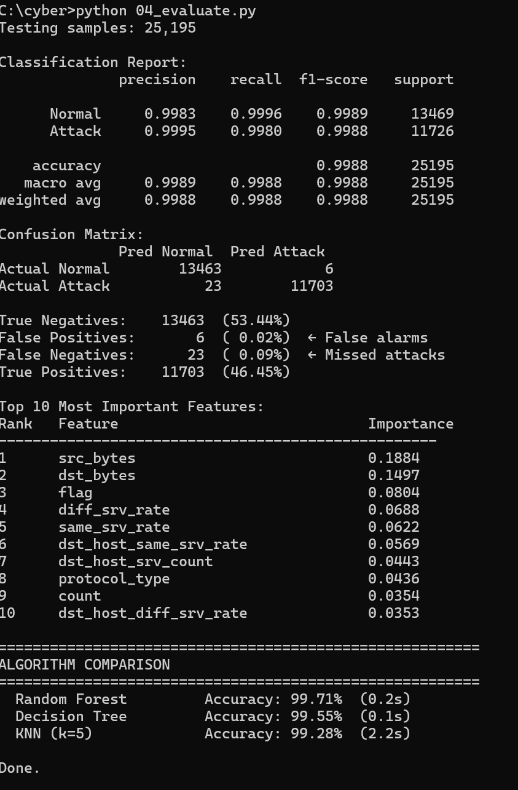

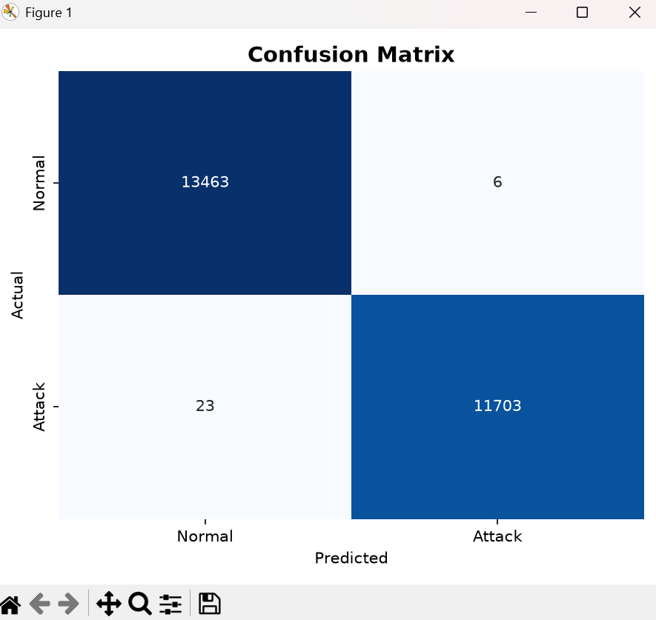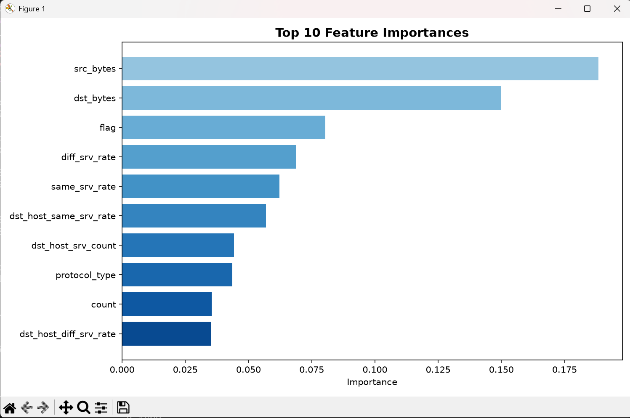

Step 5 – Prediction
The trained model predicts whether a new network record is Normal or an Attack.
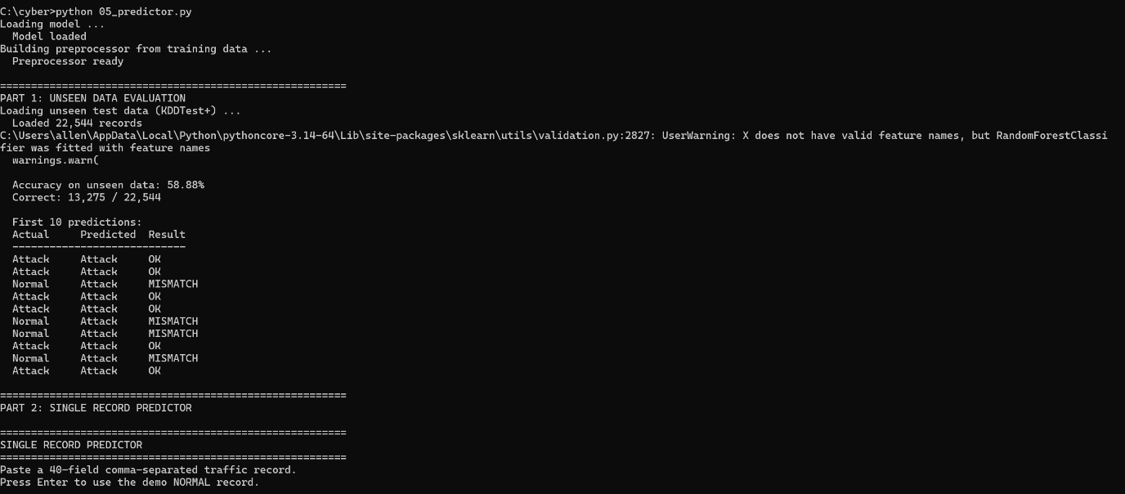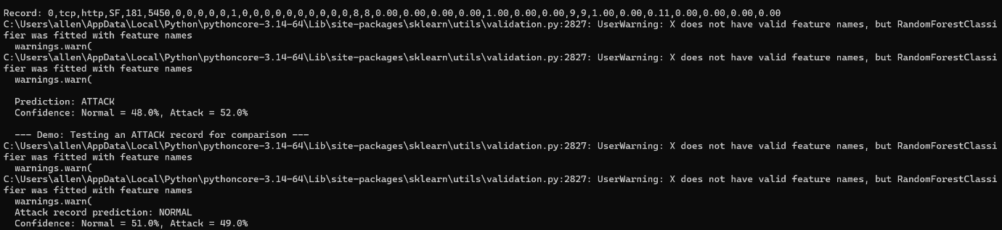
Conclusion
This project successfully demonstrates the use of Machine Learning in cybersecurity. The Random Forest algorithm effectively detects malicious network traffic using the NSL-KDD dataset. The project provides a simple and accurate intrusion detection system and highlights the importance of Machine Learning in network security.

