# Helix Leisure Technical Assessment Test Guideline

1. Project setup
   * Download the project from
   * Open the project by Visual Studio 2017
   * Press F5 to run the project
2. API Testing
   * Use Postman (can be other API testing tools) test getproduct and putproduct API

**Test Case 1:** Set all fields with invalid data

**Test Result:** Model is invalid.

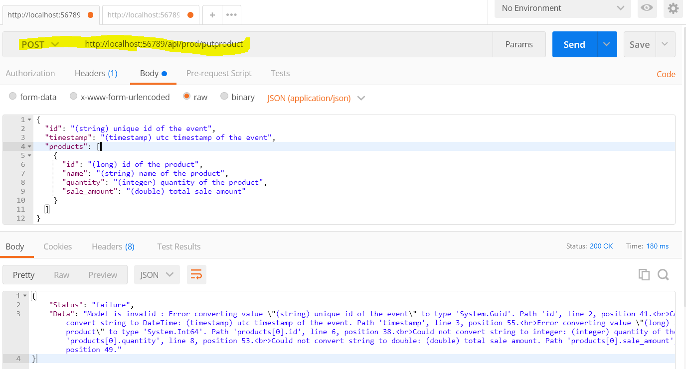

**Test Case 2:** Remove all key fields and set invalid data to quantity and sale_amount

**Test Result:** Model is invalid.

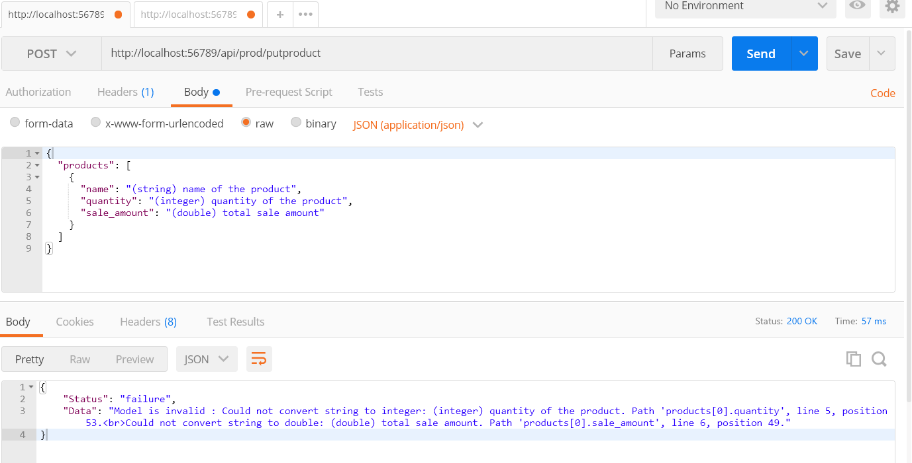

**Test Case 3:** Remove all key fields and set invalid big data to quantity and sale_amount

**Test Result:** Model is invalid.

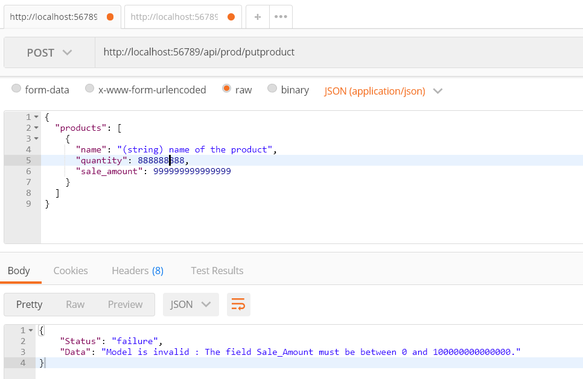

**Test Case 4:** Remove all key fields and set valid data for rest of fields

**Test Result:** Create product successful.

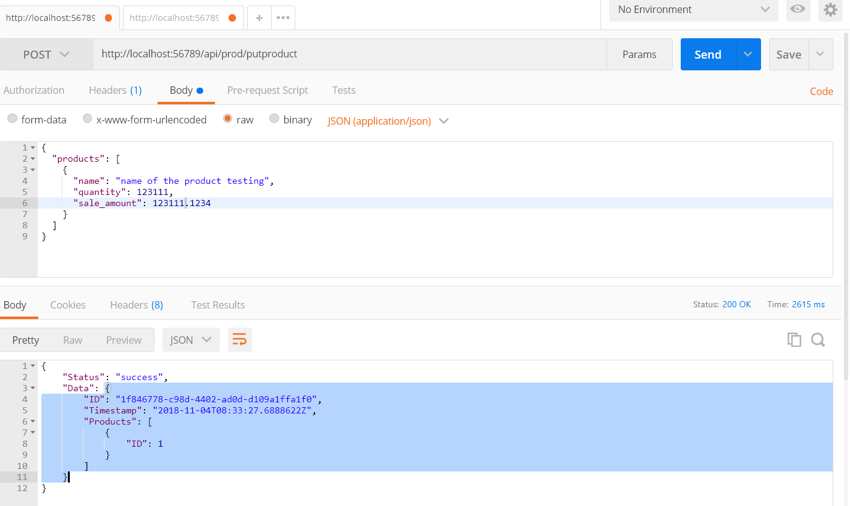

**Test Case 5:** Use **Test Case 4** request data and change quantity and sale_amount

**Test Result:** Create product successful.

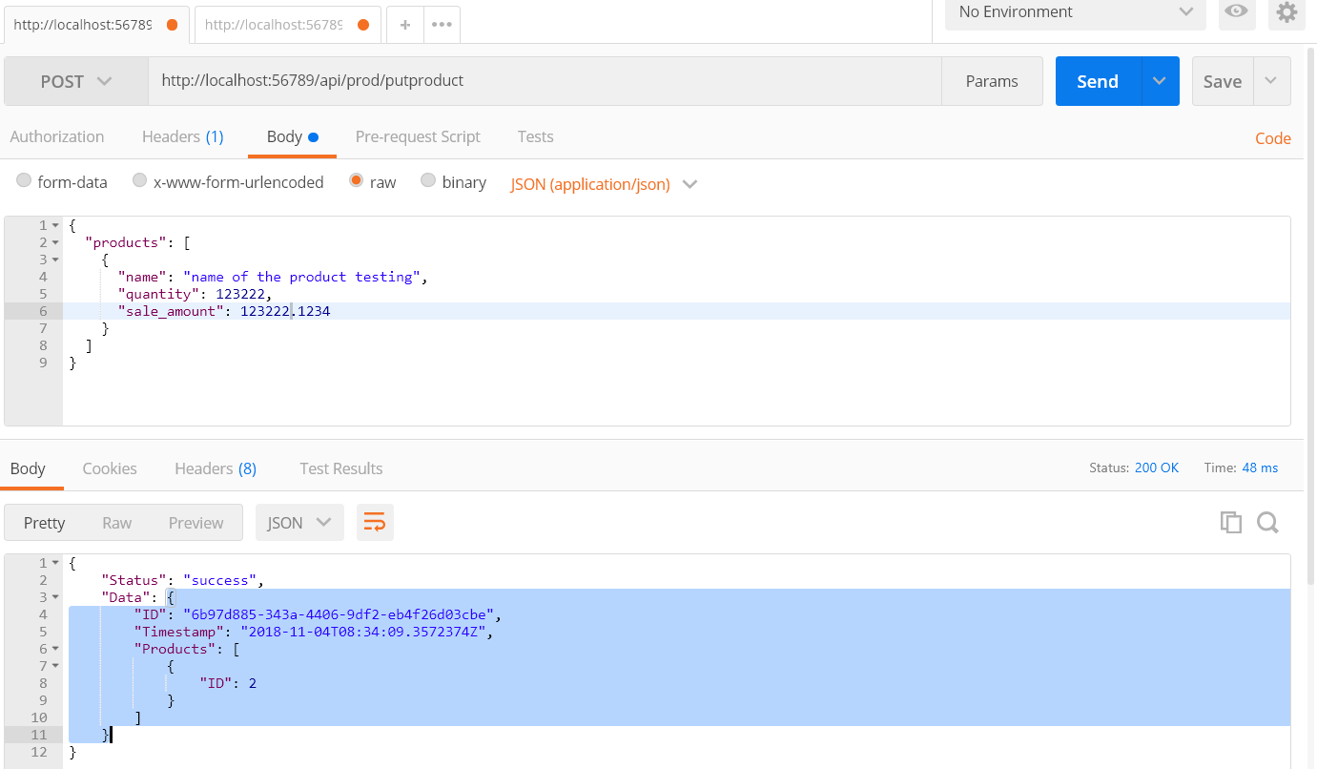

**Test Case 6:** Use **Test Case 5** request data and change quantity and sale_amount

**Test Result:** Create product successful.

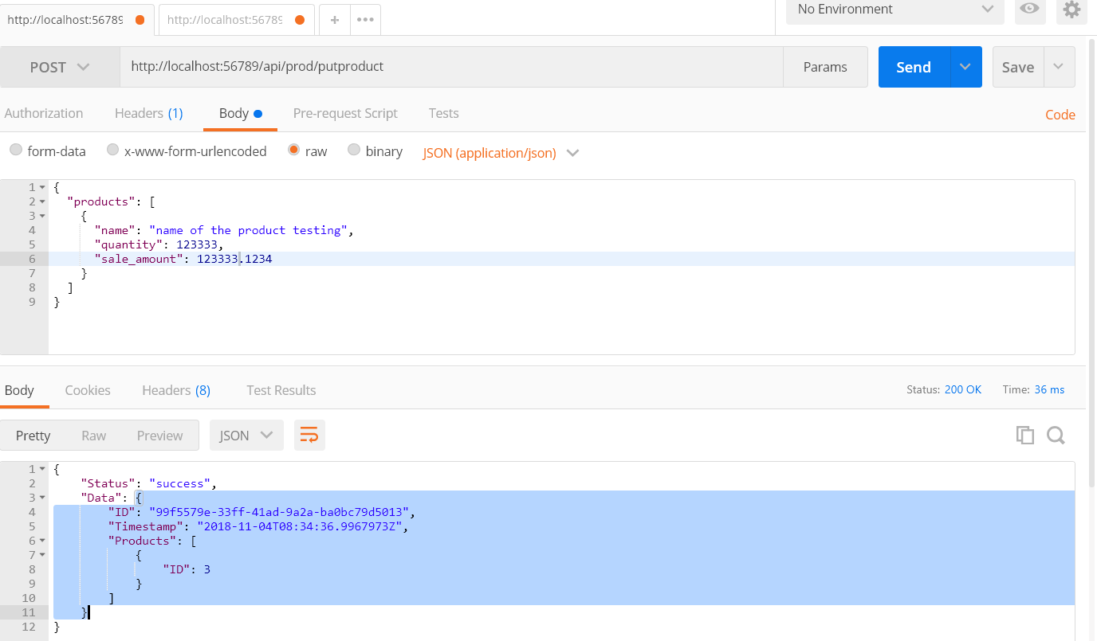

**Test Case 7:** Use **Test Case 6** response data of highlight part to query created product

**Test Result:** Created product was successfully queried.

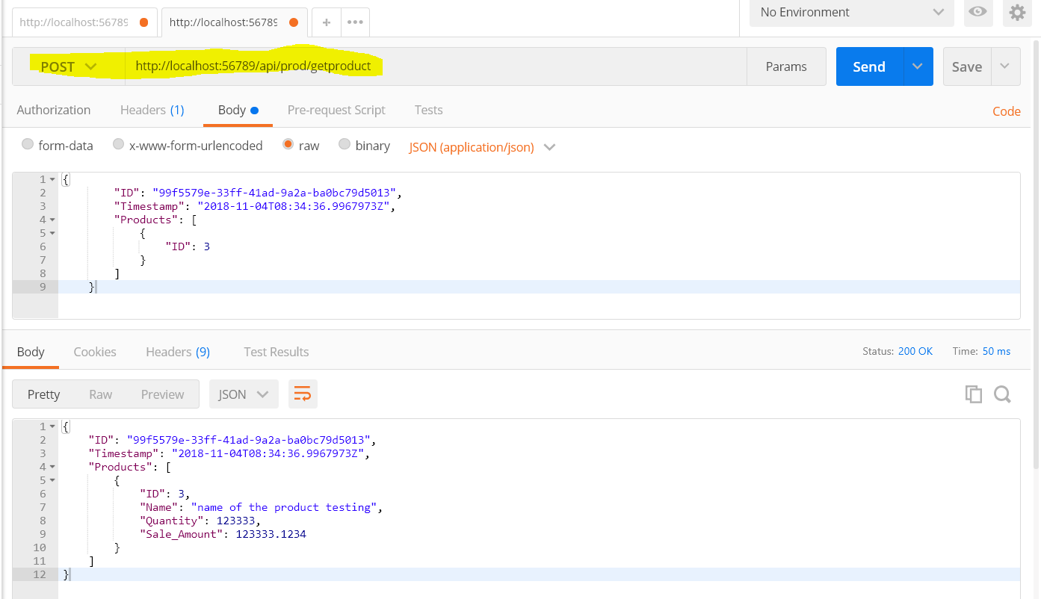

**Test Case 8:** Use **Test Case 7** response data and change product name to long string

**Test Result:** Model is invalid

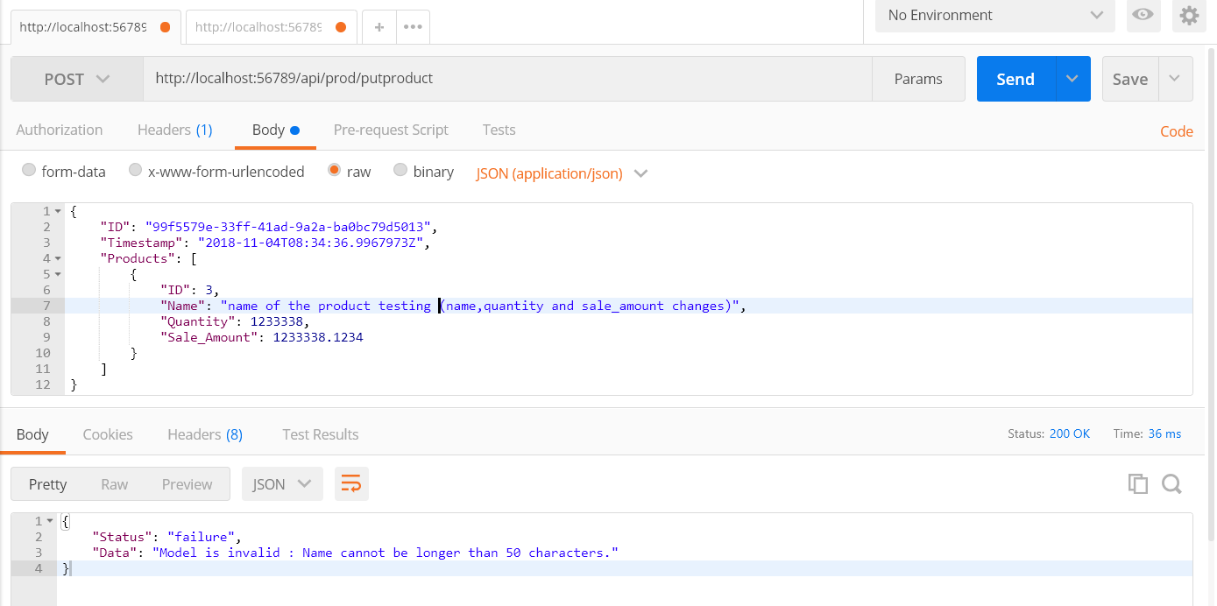

**Test Case 9:** Use **Test Case 7** response data and change product name to proper length

**Test Result:** Update product successfully

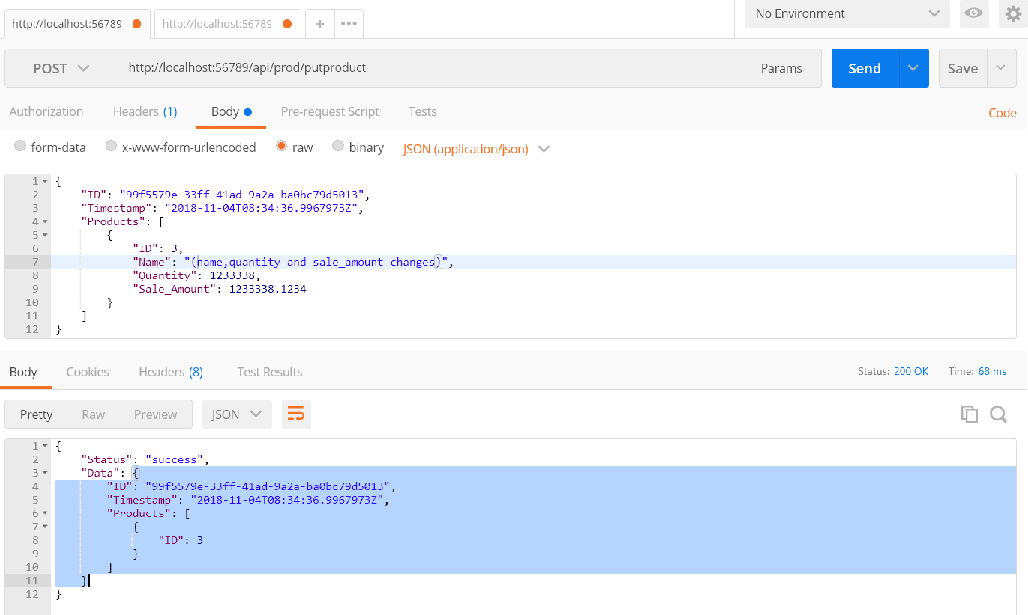

**Test Case 10:** Use **Test Case 9** response data of highlight part and to query modified product

**Test Result:** Created product was successfully queried.

