**HW2**

Q1: Find 3 peaks with Niching Method.

$$\max{ f\left(x,y\right)=}80-x^{2}-y^{2}+10\cos\left(2πx\right)+10\cos\left(2πy\right)$$

$$x∈\left[-0.5,1.5\right]$$

$$y∈\left[-0.5,1.5\right]$$

(solutions: three decimal places)

**Q2: Resolve it with Pareto Frontier.**

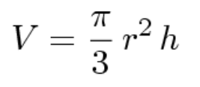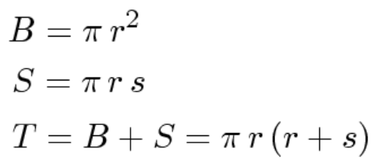

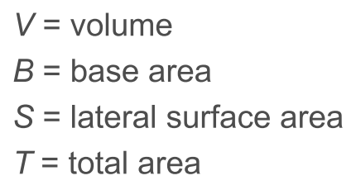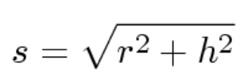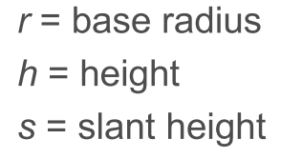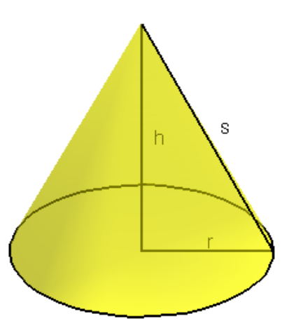

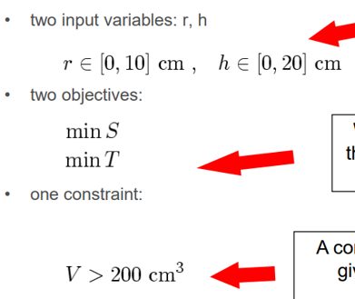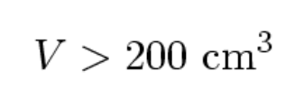

Due Date: 2021/05/18 24:00 Email

Presentation Date: 2021/05/19 class (報告時繳交: EC_P2(OOO).DOC(print out), EC_P2(OOO).PPT(print out))

Email主旨: EC_P2(OOO)

Email內容: EC_P2(OOO).C, EC_P2(OOO).DOC, EC_P2(OOO).PPT

助教：柯玠甫 [jfiii2ofi@gmail.com](mailto:jfiii2ofi@gmail.com)