Optimum Design
Homework #2 (Due Apr 15th, 2021)

- Find local maximum and minimum points of the function f(x) = x²sin(x)cos(x) within the interval [2, 6]. First use the golden section method. (You can directly use the Matlab file goldSearch.m from the Hint folder or write your own code.) Then choose one of the other one-dimensional numerical methods taught in class or from the book by S.S. Rao. If you choose the quadratic interpolation method, stop when |( f(x*) – q(x*) )/f(x*) | < 10⁻⁷. For other methods use the termination interval length = 10⁻⁵. Plot function value versus number of function evaluation in each method. For example, the figure may look like this
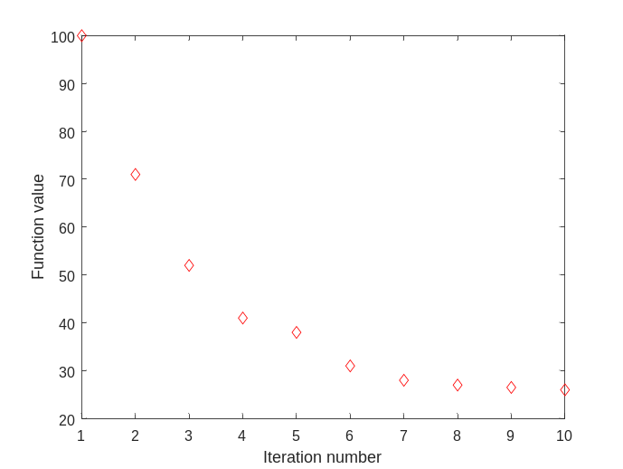
(Hint: You may need to divide the interval several sections to find local minimum/maximum points.)

- The function f(x₁, x₂) =
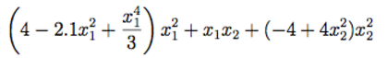
Choose one method (the cyclic coordinate method or Hooke and Jeeves’ method) combining with any 1-dimensional line search method to find 2 local minimum points (position coordinates and function value) within the interval –2 < x₁ < 2 and –2 < x₂ < 2. Use a suitable termination criterion of your choice. You can modify the file tryND1D.m and other related files in the folder hw2hint to perform the optimization. Plot the searching path of finding the global minimum. For example, the searching path of the cyclic coordinate method may look like this:
P_{min}
x₂
x₁
P₁

3. Do the same thing in problem 2 with Powell’s conjugate direction method or Nelder-Mead downhill simplex method (for the searching path, plot the center of the simplex in each iteration).

