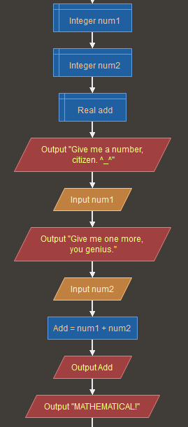

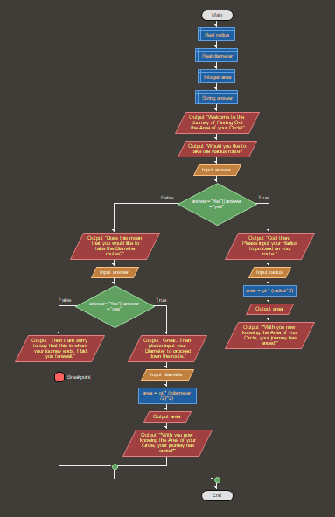

As what you can see with the images above, you can use Flowgorithm to easily add 2 numbers together, and get the Area of the Circle. The first image, showing how to get 2 numbers, is a simple flowchart code that shows a simple process. From there, exploring and finding out how to use Flowgorithm, you do more complex functions. You can go from just plainly adding 2 numbers to finding the Area of the Circle.