**Secure Chat System**

**Group Members: Nathan Sumpter, Stephen Shinn, Jasper Chen, Allen Sarmiento, Hector Medina**

**Abstract**

This project implements a secure chat system where one or more users can join together in a group chat. Each user must be registered with the chat server through a username and password. Security is established through the use of a symmetric key between all users within the chat.

**Introduction**

Our project delivers secure exchange of chat message for all parties involved. Users log into a chat system and can select another user with whom they want to participate in a conversation with. Users can check the authenticity of messages they received through the implementation of digital signatures.

**Design**

This chat system is designed to consist of the following:

* Storing username and hashed passwords in a database
* Directing user to chat interface upon valid username and password
* Input field for user to type in a message
* Send button to be able to send the message to another user
* Clickable icons to select a person to initiate a chat with
* Online and offline indicators to show which users are available and which are not available to hold a chat session
* Logout button to log the user out

Use Cases

|  |  |
| --- | --- |
| Validate User Login |  |
| Use Case # | 1 |
| Objective | Validate username and password to determine whether the user should be logged in or not |
| Priority | Very High |
| Primary Actor | User |
| Flow of Events |  |
| 1 Basic Flow | 1. User opens up the application 2. User enters in username 3. User enters in password 4. User hits the log in button 5. Username and password get compared with the database values 6. Direct user to chat system if login is valid |
| 2 Alternate Flow | NONE |
| 3 Includes | NONE |
| 4 Pre-condition | Username and password must be stored in database |
| 5 Post-condition | User is in the chat system interface |

|  |  |
| --- | --- |
| Send and Receive Message |  |
| Use Case # | 2 |
| Objective | User sends a message to another user |
| Priority | Very High |
| Primary Actor | User |
| Flow of Events |  |
| 1 Basic Flow | 1. User selects an online user to chat 2. User types a message in the input field 3. User hits the send button 4. Other user receives the message |
| 2 Alternate Flow | NONE |
| 3 Includes | NONE |
| 4 Pre-condition | Other users must be online |
| 5 Post-condition | The recipient receives the message |

|  |  |
| --- | --- |
| Logging Users Out |  |
| Use Case # | 3 |
| Objective | Log users out when they hit the log out button |
| Priority | High |
| Primary Actor | User |
| Flow of Events |  |
| 1 Basic Flow | 1. User logs in 2. User is validated and is in the chat system 3. User hits the log out button |
| 2 Alternate Flow | NONE |
| 3 Includes | NONE |
| 4 Pre-condition | User must be logged in  User must be in the chat interface |
| 5 Post-condition | User is logged out and directed to the login page |

**Security Protocols**

The cryptographic protocols used in this project include:

* Hashing and salting of passwords to achieve confidentiality in case of the database being compromised
* Private and public key creation to support authentication through the use of digital signatures to sign a message
* Symmetric keys to offer communication between two parties

**Implementation**

This project runs with Electron on client side and Python on the server side. We chose to use Electron on the client side, because we could create the interface using HTML, CSS, and JavaScript in hopes that designing the interface would be easier and less time consuming. Python is used on the server side because it was the preferred language to use. Some libraries that are included are: jQuery to handle ajax requests, crypto for creating digital signatures, and bcrypt to hash and salt passwords.

Here is a screenshot of the login page:

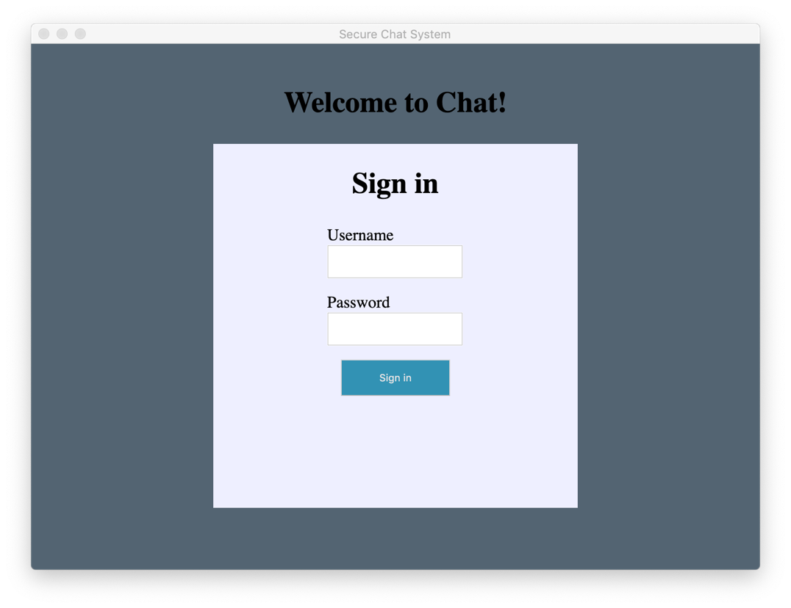

This is a screenshot of the chat system interface:

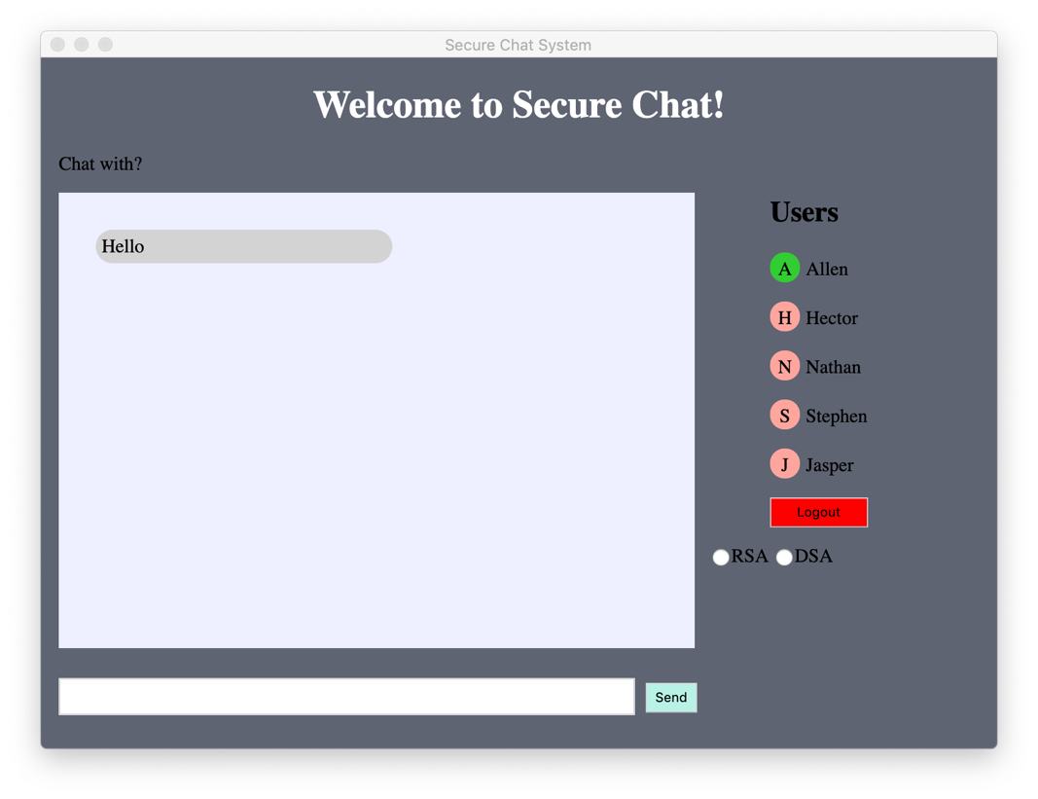

**Conclusion**

This project taught us a lot about how to make chat systems secure. We learned to apply our knowledge of digital signatures to ensure authentication when sending and receiving messages. We learned why it is important to hash and salt passwords due to vulnerabilities without doing so and had the chance to be able to apply that knowledge in an application. When dealing with sensitive information, it is important to implement secure protocols.