Grammy Website Analytics Project Report
Prepared by: Allen George

Project Goal | Analyze Grammy-related website traffic, engagement, demographics, and device usage using the provided data only.

1. Project Overview
This project examines how the Grammy websites perform in terms of traffic, engagement, age demographics, and device usage. The work was completed in a beginner-friendly way so the code is easy to follow and explain in a portfolio setting.

2. Approach
- Loaded and cleaned the website traffic datasets in pandas.
- Converted date fields to datetime format for filtering and time-based analysis.
- Split the original Grammy traffic data into a pre-split combined site and a post-split Grammys site using 2022-02-01.
- Calculated simple KPIs: pages per session, bounce rate, and average session duration.
- Compared audience age distributions and mobile versus desktop traffic share.
- Summarized findings in a recommendation about whether the websites should stay separate.

3. Key Traffic Pattern
Daily visitor traffic shows sharp spikes around Grammy event periods. This means the website is highly event-driven, with awards night acting as the biggest traffic trigger.
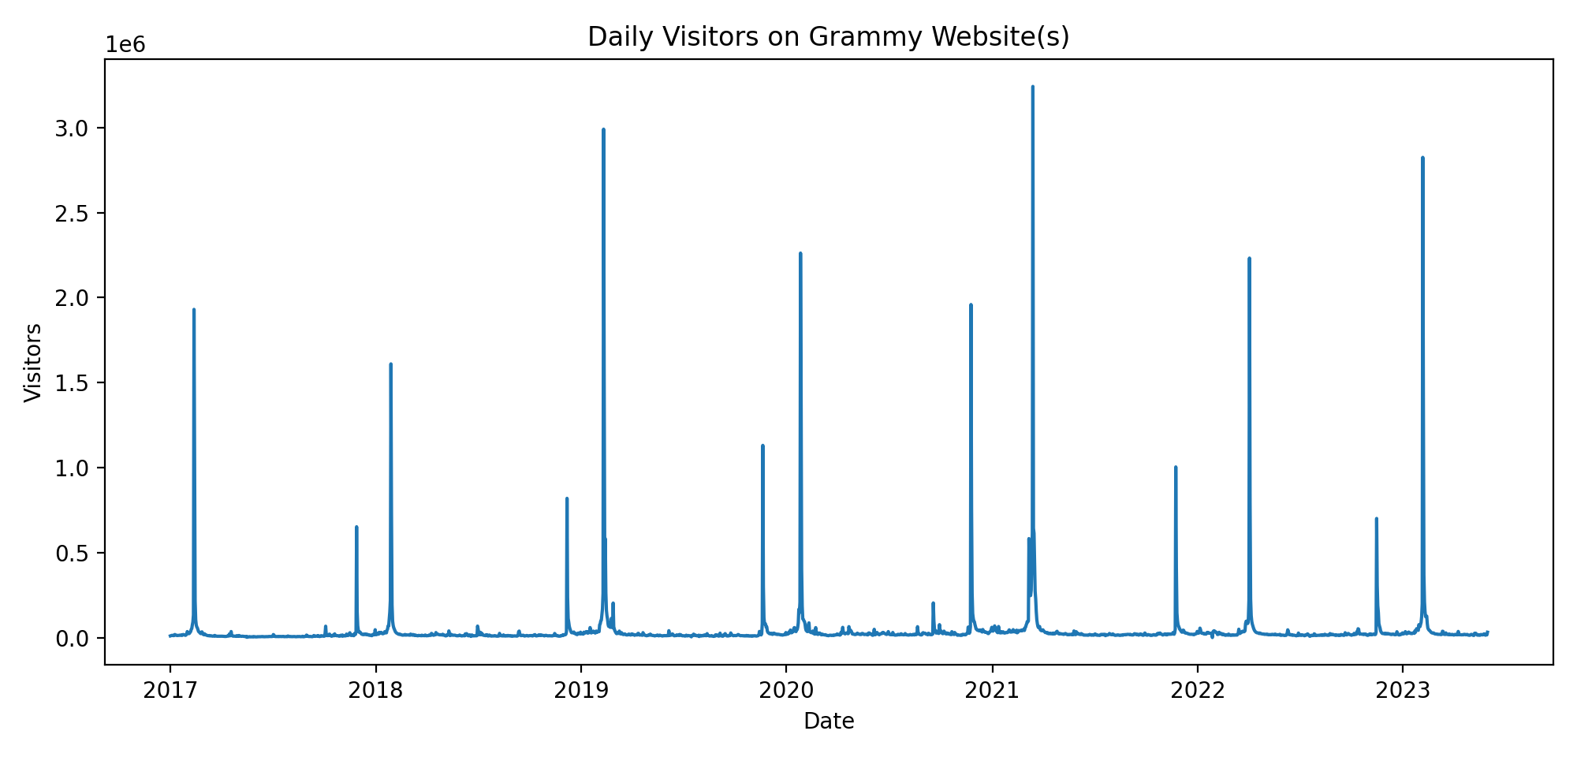
Figure 1. Daily visitor trend across the Grammy website dataset.
Average traffic on a regular day was about 32,388 visitors, compared with about 1,389,590 visitors on awards night. That is an increase of roughly 1,357,202 visitors.
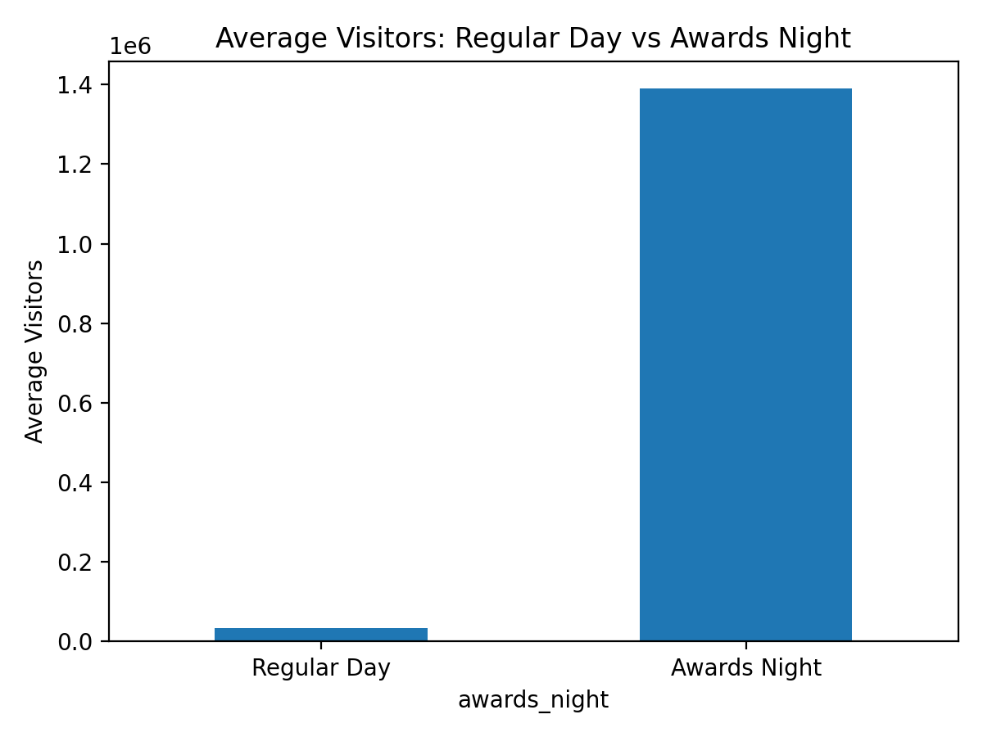
Figure 2. Average visitors on regular days versus awards night.

4. KPI Comparison
After the site split, the separate websites showed stronger engagement than the original combined site in some areas. The Recording Academy site had the best overall KPI mix, while the Grammys site remained more event-centered and mobile-heavy.
Site | Pages / Session | Bounce Rate | Avg Session Duration
Combined Site | 1.59 | 41.58% | 102.85 sec
Recording Academy | 2.78 | 33.67% | 128.50 sec
Grammys | 2.14 | 40.16% | 82.99 sec

Takeaway: the combined site had the lowest pages per session. The Recording Academy website had the highest pages per session, the lowest bounce rate, and the longest average session duration. The Grammys site still delivered strong brand traffic, but users spent less time on it than on the Recording Academy site.

5. Demographics and Device Mix
Both sites attract a younger audience, especially visitors aged 18–24 and 25–34. The Grammys audience skews slightly younger, while the Recording Academy audience is a little more balanced across older age groups.
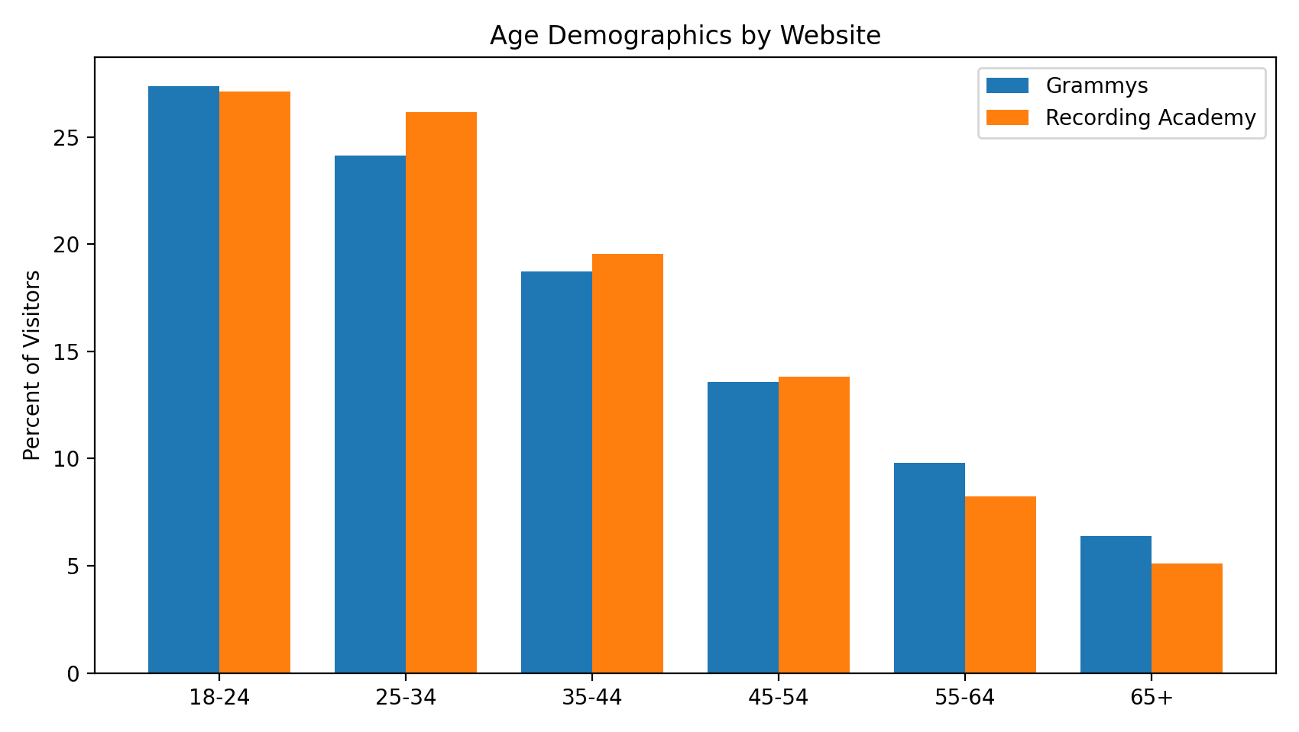
Figure 3. Age demographic mix by website.
For the Grammys site during the comparison window in 2023, device traffic was approximately 31.84% desktop and 68.16% mobile, with a total of 1,428,482 visitors.
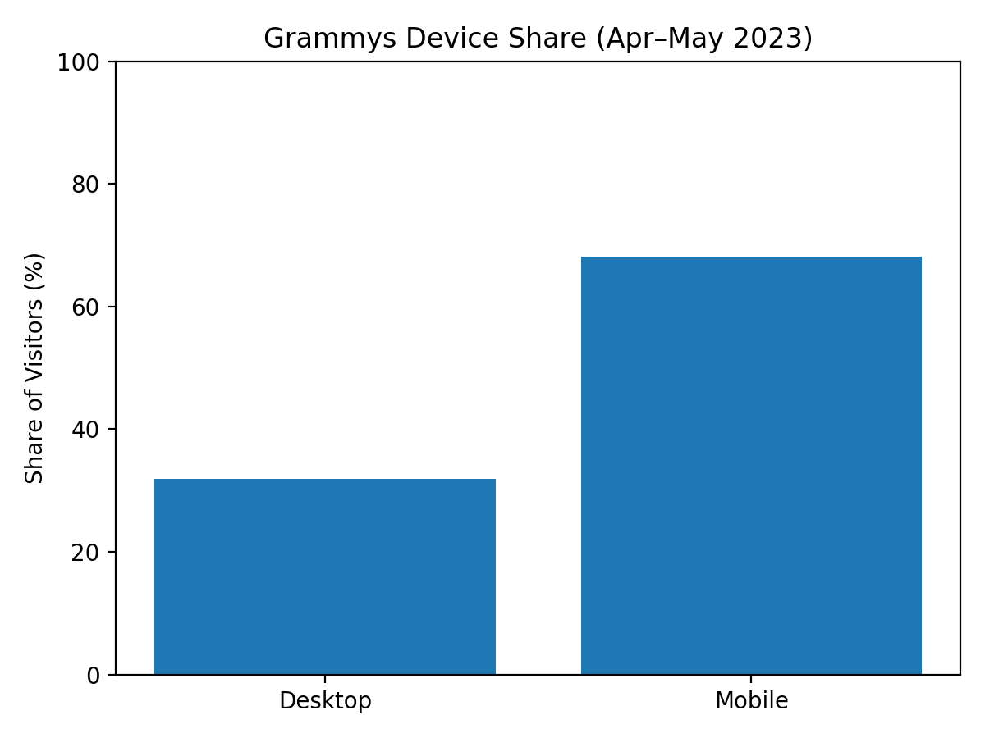
Figure 4. Device share for the Grammys website (Apr–May 2023).

6. Recommendation
I would recommend keeping the websites separate. The split appears to support a more focused user experience, and the KPI results suggest users engage differently depending on the website they visit.
The Recording Academy site performs best as an informational and organization-focused platform, while the Grammys site is better positioned as an event-driven, entertainment-focused destination. Since traffic behavior, engagement, and audience intent differ across the brands, maintaining separate websites is the better business choice.

7. Portfolio Highlights
This project is portfolio-ready because it demonstrates practical analytics skills: data cleaning, exploratory analysis, KPI design, visualization, simple business interpretation, and recommendation writing. The notebook code was kept clean and well-commented so the work is easy to present as a first-time but thoughtful analytics project.

Appendix: KPI Snapshot
Combined Site: Pages / Session = 1.59; Bounce Rate = 41.58%; Avg Session Duration = 102.85 sec.
Recording Academy: Pages / Session = 2.78; Bounce Rate = 33.67%; Avg Session Duration = 128.50 sec.
Grammys: Pages / Session = 2.14; Bounce Rate = 40.16%; Avg Session Duration = 82.99 sec.

