Image Sharpening

609410162 彭郁翔

Data due:11/16

Data handed in:11/16

Give two gray-level images, sharpen the two images using the Laplacian operator, unsharp masking, and high-boost filtering in the spatial and frequency domains. 這裡我分成6個.mat檔分別用3種方法和在spatial domain和frequency domain來執行。

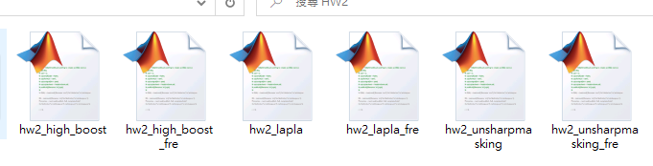

有加上fre的是在frequency domain下的方法。

Technical description

In spatial domain:

Laplacian operator :

根據定義及以下矩陣表示:

$▽^{2}f= \frac{δ^{2}f}{δx^{2}}+\frac{δ^{2}f}{δy^{2}}$，

$$\frac{δ^{2}f}{δx^{2}}=f\left(x+1,y\right)+f\left(x-1,y\right)-2f(x,y)$$

$$\frac{δ^{2}f}{δy^{2}}=f\left(x,y+1\right)+f\left(x,y-1\right)-2f(x,y)$$

* $▽^{2}f= \frac{δ^{2}f}{δx^{2}}+\frac{δ^{2}f}{δy^{2}}$ = $f\left(x+1,y\right)+f\left(x-1,y\right)+ f\left(x,y+1\right)+f\left(x,y-1\right)-4f(x,y)$

Filter mask :

|  |  |  |
| --- | --- | --- |
| 0 | 1 | 0 |
| 1 | -4 | 1 |
| 0 | 1 | 0 |

|  |  |  |
| --- | --- | --- |
| 1 | 1 | 1 |
| 1 | -8 | 1 |
| 1 | 1 | 1 |

這裡我有先把原本image做zero-padding，再設定mask = [1 1 1;1 -8 1;1 1 1]，之後來和原本的image矩陣做convolution，再經過跟原本image做相減，g(x,y) = f(x,y) - $▽^{2}f(x,y)$，g(x,y):sharped image。

可得到一張sharped image。

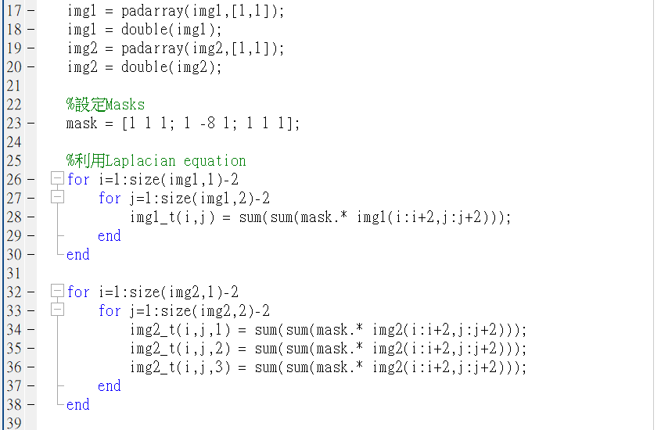

Unsharp masking :

Sharpening images can be implemented by subtracting a blurred version of an image from the image itself.



*fs*(*x*,*y*) : sharpened image

**is a blurred version of *f*(*x*,*y*).

1. Subtract the blurred version from the original (called the mask).

2. Add the mask to the original.

這裡我使用高斯模糊來模糊原圖，再用原圖減去模糊後的圖片，最後再加上原圖得到sharpened image。



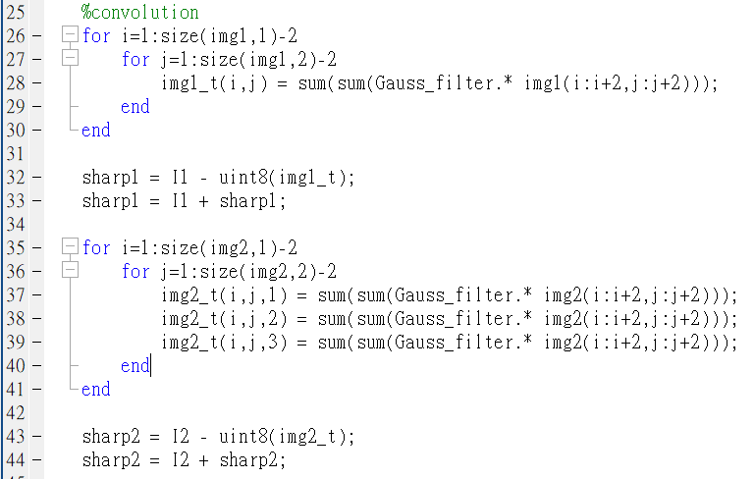

High-boost filtering :

A high-boost filtered image, *f*hb, is defined as:



where A>=1 and  is a blurred version of *f*

$$f_{hb}\left(x,y\right)=\left(A-1\right)f\left(x,y\right)+f\left(x,y\right)-\bar{f}\left(x,y\right).$$

$$f_{hb}\left(x,y\right)=\left(A-1\right)f\left(x,y\right)+f_{s}\left(x,y\right)$$

這裡我把A代4: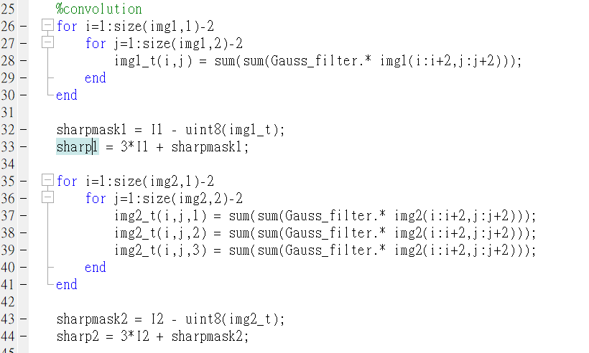

In frequency domain:

Frequency domain filtering operation :

Input image → pre-processing → Fourier transform → Filter function → Inverse Fourier transform → post-processing → enhanced image

Laplacian operator :

這裡我使用一個網路上參考的paddedsize.m檔，呼叫paddedsize function。

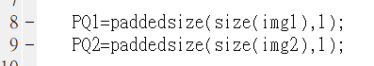

根據講義上去把原圖和filter做fourier transform，再經過convolution，最後再做inverse fourier transform。

$$H(u,v)=\left[1+{4π}^{2}\left[(u-M/2)^{2}+(v-N/2)^{2}\right]\right] .$$

$$g(x,y)=I^{-1}\left\{\left[1+{4π}^{2}\left((u-M/2)^{2}+(v-N/2)^{2}\right)\right]F(u,v)\right\}$$

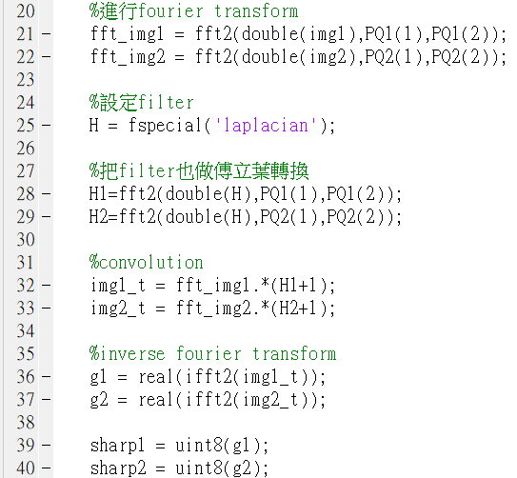

Unsharp masking :

這裡我一樣使用高斯模糊來模糊原圖，再將原圖及gauusian filter做fourier transform，做convolution後再inverse fourier transform得到g，再用原圖減去g，最後再加上原圖得到sharpened image。

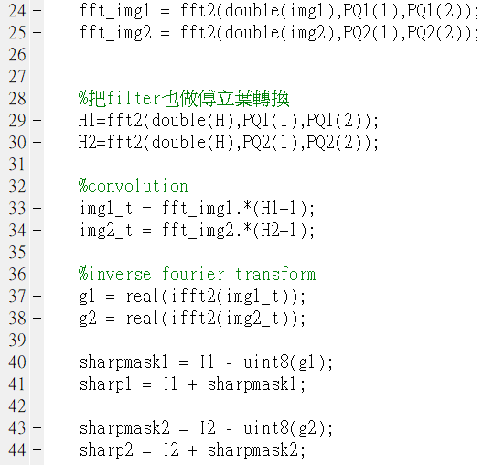

High-boost filtering :

這裡我把A代2.7(投影片上寫的),b代3:

$H_{hb}\left(u,v\right)=\left(A-1\right)+H_{hp}\left(u,v\right)$,

with A>=1.

High-frequency emphasis has a filter transfer function given by:

(4.4-20)

where *a* ≥ 1 and *b* > *a*.

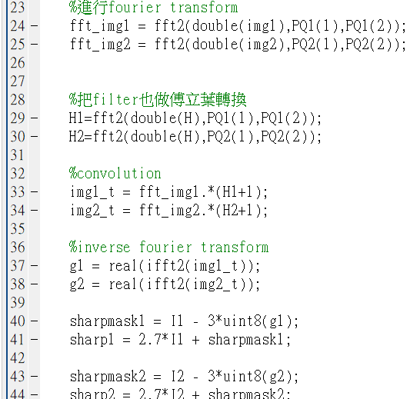

Experimental results

In spatial domain:

Laplacian operator :

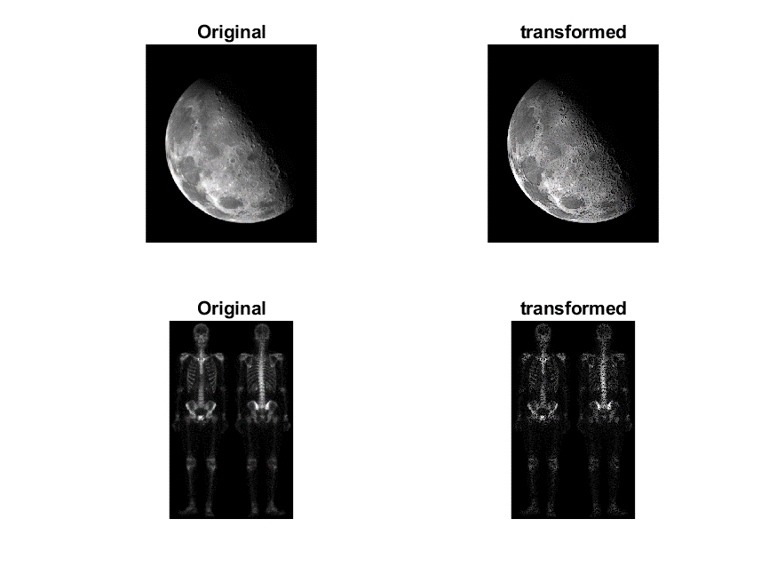

Unsharp masking :

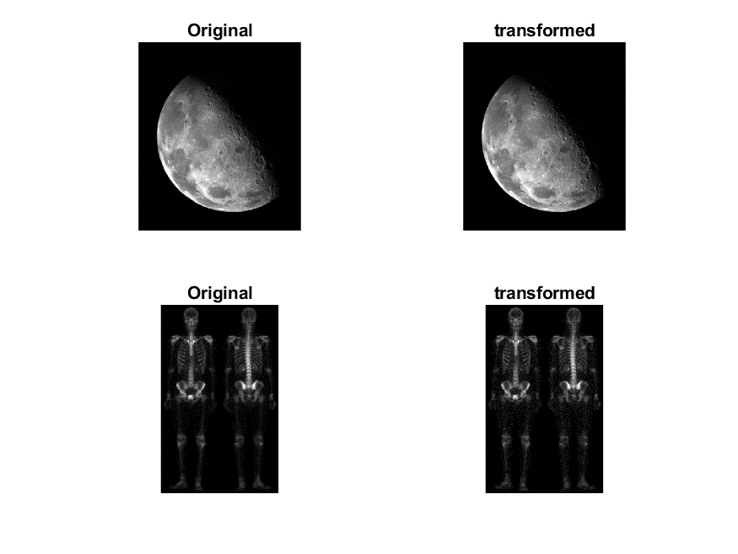

High-boost filtering :

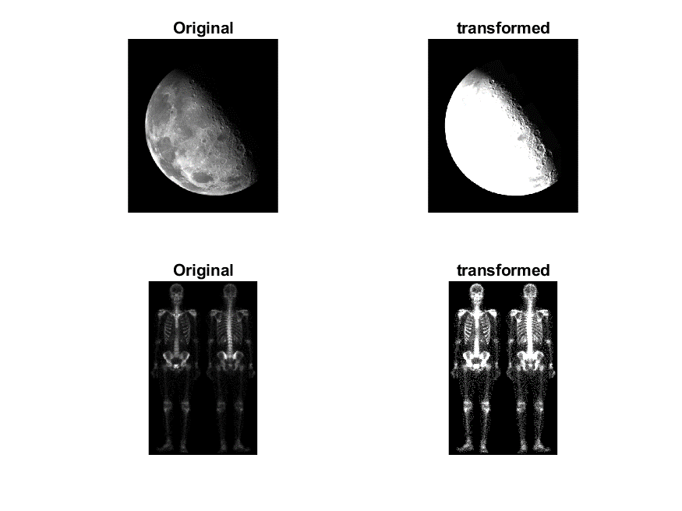

In frequency domain:

Laplacian operator :

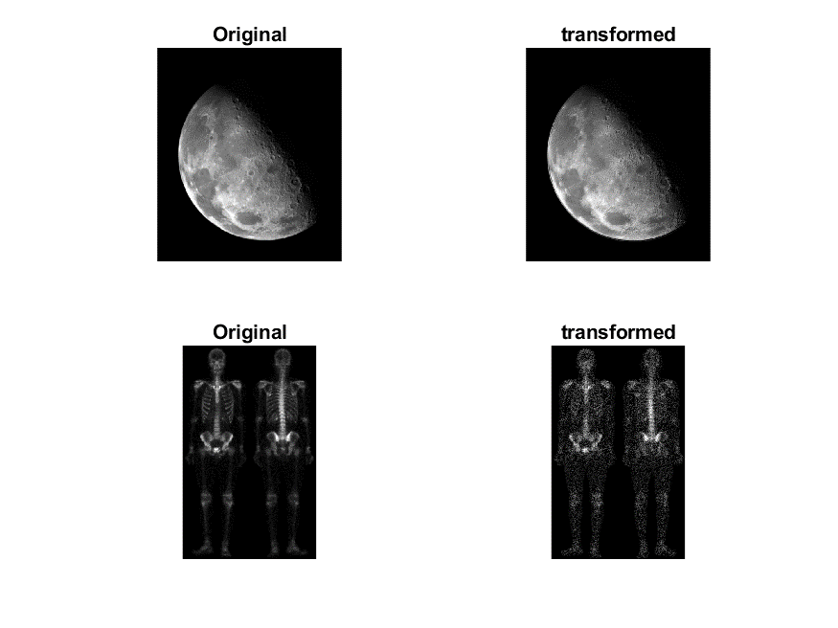

Unsharp masking :

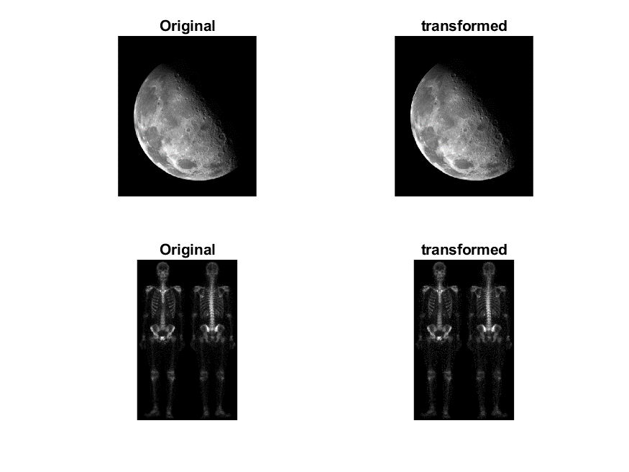

High-boost filtering :

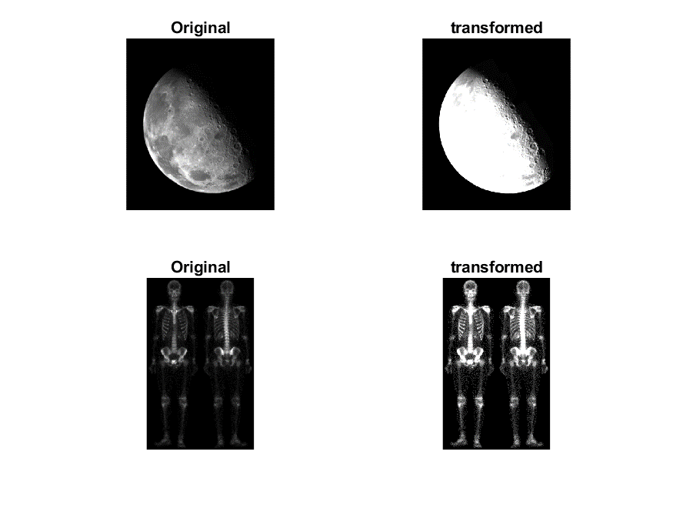

Discussions

Frequency domain的流程及作法不太懂，做出來不知道是對還錯。

希望助教能提供範例程式給大家參考。

References and Appendix

Chapter 3 IMAGE ENHANCEMENT IN THE SPATIAL DOMAIN

Chapter 4 IMAGE ENHANCEMENT IN THE FREQUENCY DOMAIN