影像處理Hw4

Edge Detection

609410162 彭郁翔

Data due:12/28

Data handed in:12/28

Given three images, perform edge detection on the three images using Sobel and Laplacian of a Gaussian (LoG) operators.

Technical description

Sobel operator:

Gx

|  |  |  |
| --- | --- | --- |
| -1 | 0 | 1 |
| -2 | 0 | 2 |
| -1 | 0 | 1 |

Gy

|  |  |  |
| --- | --- | --- |
| 1 | 2 | 1 |
| 0 | 0 | 0 |
| -1 | -2 | -1 |

這裡建立Sobel Operator。



這裡call convolution function。



這裡為convolution function，參考網路上的code做修改。

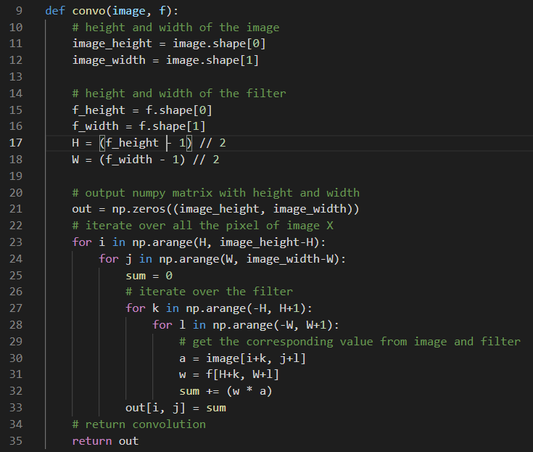

最後計算梯度大小

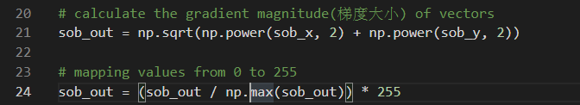

Laplacian operator:

|  |  |  |
| --- | --- | --- |
| -1 | -1 | -1 |
| -1 | 8 | -1 |
| -1 | -1 | -1 |

這裡建立Laplacian Operator。



其餘都一樣。

Experimental results

Sobel operator:

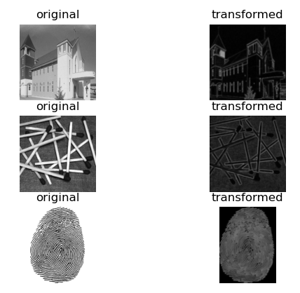

Laplacian of a Gaussian (LoG) operators:

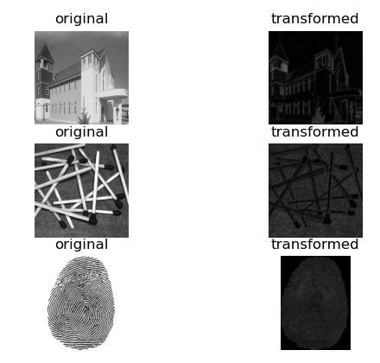

Discussions

無

References and Appendix

Chapter 6 COLOR IMAGE PROCESSING