機器學習Hw4

609410162 彭郁翔

1. **colab URL**

https://colab.research.google.com/drive/1VLYn9Amjxu5vpHy5HxAyRewHS9z9TAym#scrollTo=dCbYDsmYyCb_

1. **Execution results**

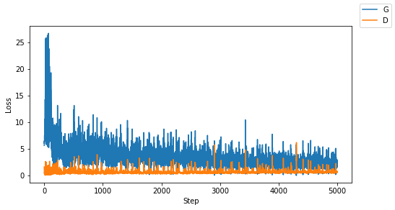

1. **Q1~Q5**

Q1: Compare the visualization images after step 0, 200, 1000, 2500, 5000

Answer : step 0:

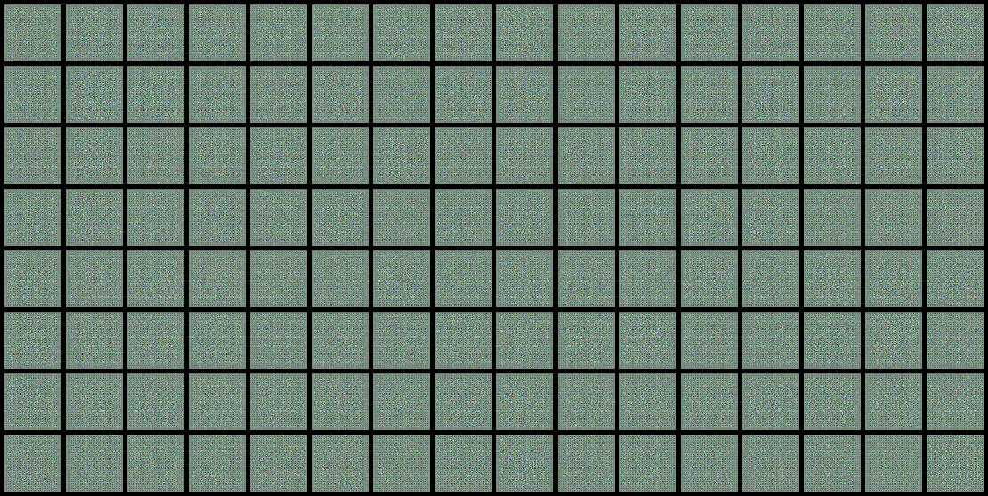

Step 200:

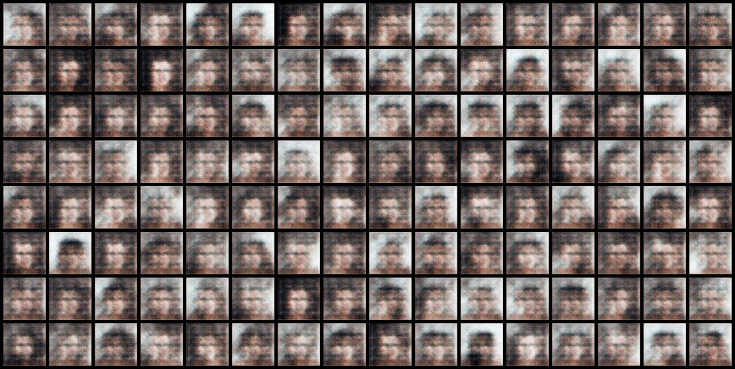

Step 1000:

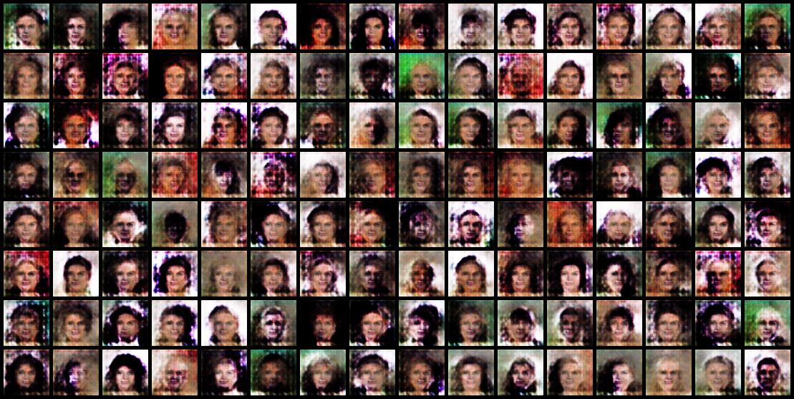

Step 2500:

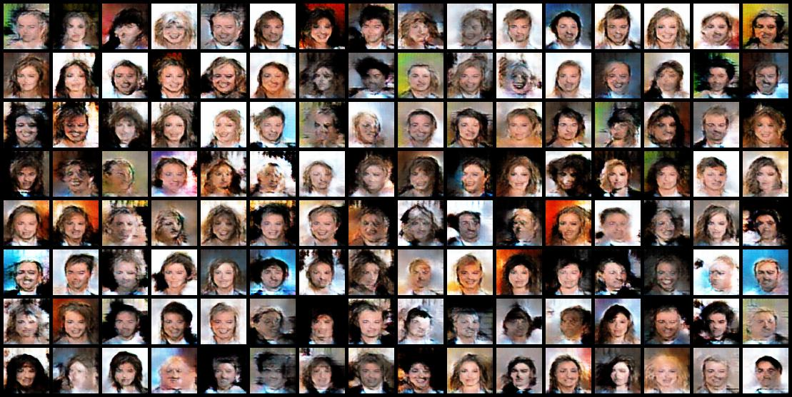

Step 5000:

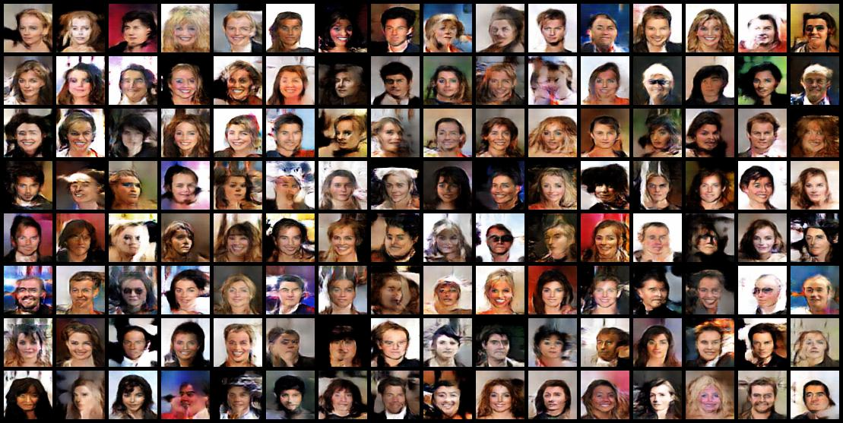

Q2: Why can't we see the typical loss descreasing in generator and discriminator's loss curve?

Answer :

GAN是用generator和discriminator兩個模型之間彼此競爭和相互比較，爭取讓 loss能夠比對方還要低，和一般的Loss機制不太相同。

**Q3:**

1. **Generating Fake Images using N(0, 1):**
2. **Generating Fake Images using N(-10, 1):**
3. **Generating Fake Images using U(0, 1):**

Answer :

using N(0, 1):

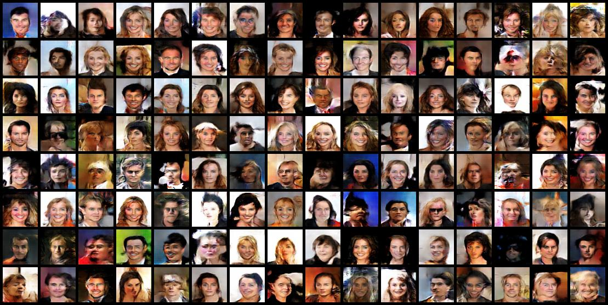

using N(-10, 1):

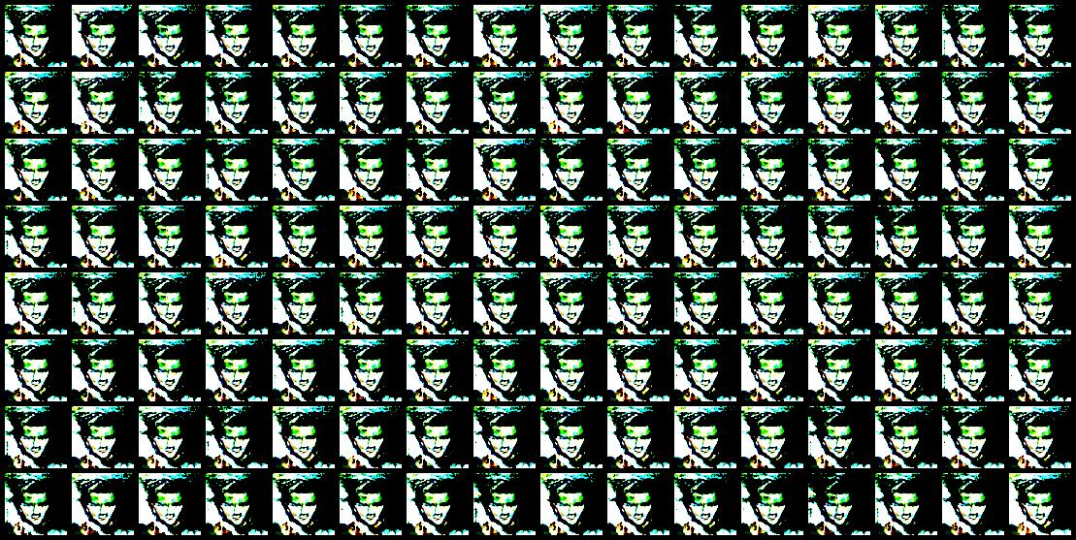

using U(0, 1)

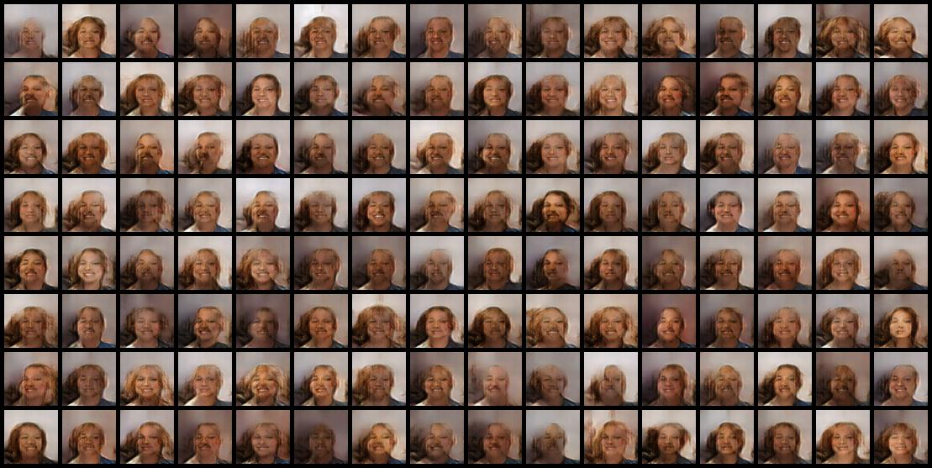

**Q4:**

**Why the result of Q3.2 looks so weird, i.e., Why our generator fails at generating images using latent vector following distribution N(−10,1)?**

Answer :

訓練的時候是利用mean = 0來做訓練，而Q3.2是將mean設為-10，跟訓練時的情況相差太遠，因此效果較差。

**Q5: Why the result images of Q3.3 looks so similar to each other?**

Answer :

因為使用Uniform且範圍只有(0,1)，因此產生的隨機數差異很小，都介於0和1之間，所以產生出來的圖差異很小。