AI FOR HEALTHCARE DIAGNOSTICS
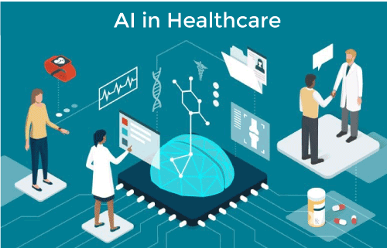
Name : Alan T Sunny

Name : AI

Project Name :AI For Healthcare Diagnostics

Date :15/07/2024

INTRODUCTION:

Artificial Intelligence (AI) is rapidly transforming the landscape of healthcare, and diagnostics is no exception. With its ability to process vast amounts of data and identify complex patterns, AI is poised to revolutionize how diseases are detected and diagnosed. By leveraging advanced algorithms and machine learning techniques, AI systems can analyze medical images, such as X-rays, MRIs, and CT scans, with unprecedented accuracy, often surpassing human capabilities.
This technology holds immense promise for early disease detection, enabling healthcare providers to intervene promptly and improve patient outcomes. AI-powered diagnostic tools can also assist in identifying rare or complex conditions that might otherwise be overlooked. Furthermore, AI can streamline the diagnostic process by automating routine tasks and providing healthcare professionals with valuable insights to support their decision-making.
However, it is essential to approach the integration of AI in diagnostics with caution and ethical considerations. Ensuring data privacy, algorithm transparency, and human oversight is paramount to building trust and confidence in AI-driven healthcare solutions. As AI continues to evolve, its potential to enhance diagnostic accuracy, efficiency, and patient care is undeniable.
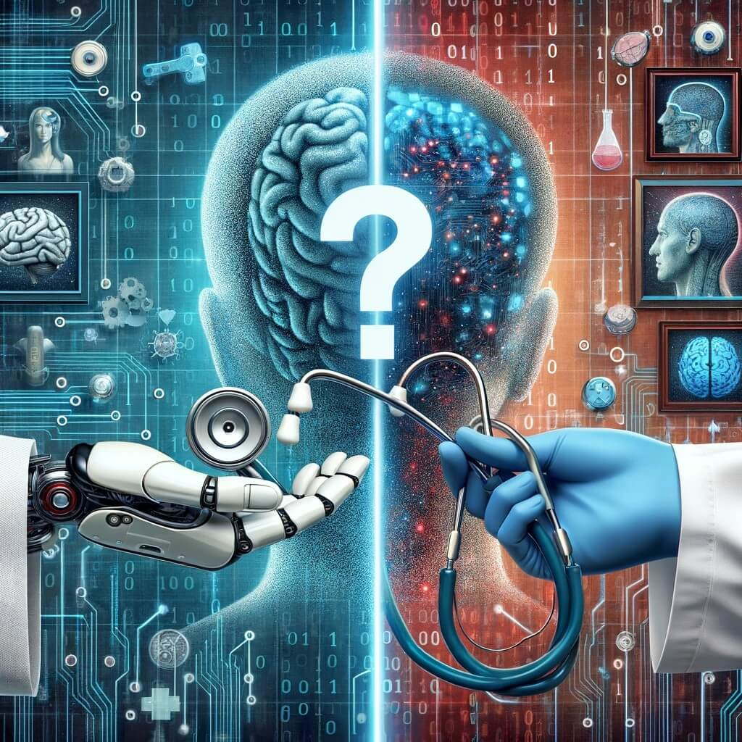

Project Objective:

The primary objectives of employing AI in healthcare diagnostics are to:
- Enhance Diagnostic Accuracy: AI algorithms can analyze medical images and data with exceptional precision, often surpassing human capabilities. This leads to more accurate and reliable diagnoses.
- Accelerate Diagnostic Process: By automating routine tasks and providing rapid analysis, AI can significantly reduce diagnostic turnaround times, enabling timely interventions.
- Early Disease Detection: AI-powered systems can identify disease markers and abnormalities at earlier stages, facilitating proactive treatment and improving patient outcomes.
- Improve Diagnostic Consistency: AI can minimize human error and biases, leading to more consistent diagnoses across different healthcare providers.
- Assist Clinical Decision-Making: AI can provide valuable insights and support to healthcare professionals, aiding in complex diagnostic cases and treatment planning.
- Enable Precision Medicine: By analyzing patient-specific data, AI can contribute to personalized treatment approaches tailored to individual needs.
- Reduce Healthcare Costs: AI-driven diagnostics can optimize resource utilization and streamline workflows, potentially leading to cost reductions in the healthcare system.
- Expand Access to Care: AI-powered diagnostic tools can be deployed in remote areas, improving access to quality healthcare for under served populations.
By achieving these objectives, AI has the potential to transform healthcare diagnostics, leading to better patient care, improved health outcomes, and increased efficiency within the healthcare system.

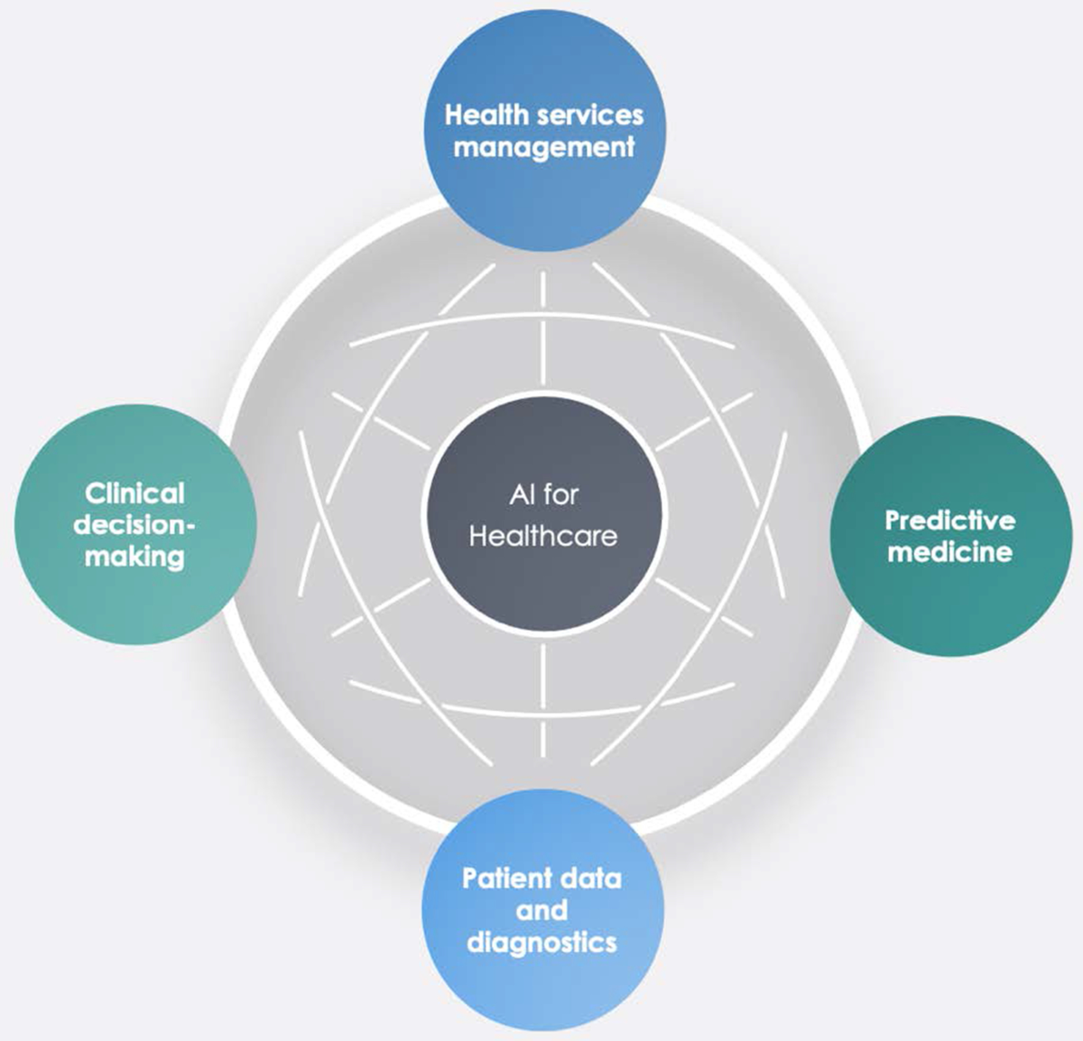

CONTENT:

Introduction
- Brief overview of AI in healthcare
- Focus on AI in diagnostics
- Importance and potential impact

Understanding AI in Diagnostics
- Basic concepts of AI and machine learning
- Types of AI used in diagnostics (e.g., deep learning, computer vision)
- How AI analyzes medical data (images, signals, etc.)

Applications of AI in Diagnostics
- Image analysis (X-rays, MRIs, CT scans, etc.)
- Disease detection and classification
- Early detection and screening
- Assisting in clinical decision-making
- Personalized medicine
- Drug discovery and development

Benefits of AI in Diagnostics
- Improved diagnostic accuracy
- Faster diagnosis and treatment
- Enhanced patient outcomes
- Increased efficiency and productivity
- Cost reduction
- Expanded access to healthcare

Challenges and Considerations
- Data quality and availability
- Ethical implications (privacy, bias, accountability)
- Regulatory and legal frameworks
- Integration into healthcare systems
- Human-AI collaboration

Case Studies and Real-world Examples
- Successful AI applications in diagnostics
- Lessons learned and best practices

Future Trends and Outlook
- Advancements in AI technology
- Emerging applications (e.g., AI-powered wearables, genomics)
- The role of AI in precision medicine
- Challenges and opportunities

Conclusion
- Summary of key points
- Emphasize the potential of AI to transform healthcare diagnostics
- Call to action for further research and development.



