**Assignment 1**

1. What is JDK? JRE? JVM?

JDK is a software development environment used for applications and applets.

JRE is an installation package that provides an environment to only run (not develop) the java program (or application) onto your machine.

JVM is an engine that provides a runtime environment to drive the Java Code or applications. It converts Java bytecode into machine language.

JVM is a part of JRE. Java compiler produces code for a virtual machine which is called as JVM.

1. What is java compiler?

A java compiler is a program that takes the text file work of a developer and compiles it into a platform-independent Java file(bytecode). Like javac(java Programming Language Compiler), the GCJ, ECJ.

1. Why is java platform independent?

Java is platform-independent because it does not depend on any type of platform. Hence, Java is platform-independent language.

The meaning of platform-independent is that the java compiled code(byte code) can run on all operating systems.

1. What is IDE? Why is it important for developers?

IDE is an integrated development environment. It enables programmers to consolidate the different aspects of writing a computer program.

IDEs increase programmer productivity by combining common activities of writing software into a single application: editing source code, building executables, and debugging.

1. Is java case sensitive?

Yes, java is case sensitive. (count does not equal Count)

1. What do the following key words do?  
   static, final, public, private, void, null, package, Class, new

static:

In the Java programming language, the keyword static means that the particular member belongs to a type itself, rather than to an instance of that type.

final:

Java final keyword is a non-access specifier that is used to restrict a class, variable, and method.

public:

access by global

private:

access only by the elements of it belonged.

void:

represent a return type means nothing return.

null:

in Java, null is a reserved word (keyword) for literal values. It seems like a keyword, but actually, it is a literal similar to true and false.

Package:

A package in Java is used to group related classes

Class:

class is a template for object

New:

be used to create a new instance in heap

1. What is primitive type and reference type?
2. Is parameter passed by value or reference?

all parameters pass by value in Java

1. What is the output: System.out.println(1 > 0 : “A”:”B”);

Print: A

1. How to define constants in java?

First, a constant is a variable whose value cannot change once it has been assigned.

Using "final" key word to define a constant.

Syntax: final int e = 10;

1. What is String? Is it primitive type?

Strings are a sequence of characters.

Strings are objects.

1. How to check if a String is representing a number?

1. Write a program to implement the following activity diagram:

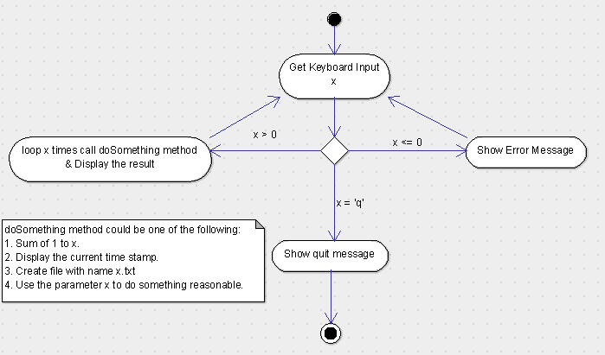

1. Write a program to merge two array of int.

Clarify: are the two arrays need to be sorted?

1. Write a program to find the second largest number inside an array of int.

public static Integer secondMinNumber(int[] array) {  
 // sanity check  
 if (array.length < 2 ) {  
 return null;  
 }  
 PriorityQueue<Integer> minPQ = new PriorityQueue<>(2, new Comparator<Integer>() {  
 @Override  
 public int compare(Integer o1, Integer o2) {  
 if (o1.equals(o2)) {  
 return 0;  
 }  
 return o1 < o2 ? -1 : 1;  
 }  
 });  
 minPQ.offer(array[0]);  
 minPQ.offer(array[1]);  
 for (int i = 2; i < array.length; i++) {  
 int tmp = minPQ.peek();  
 if (array[i] > tmp) {  
 minPQ.poll();  
 minPQ.offer(array[i]);  
 }  
 }  
 return minPQ.peek();  
}