|  |
| --- |
| 代码 |
| # Import socket module  from socket import *  # Create a TCP server socket  #(AF_INET is used for IPv4 protocols)  #(SOCK_STREAM is used for TCP)  serverSocket = socket(AF_INET, SOCK_STREAM)  # Assign a port number  serverPort = 3000  # Bind the socket to server address and server port  serverSocket.bind(("", serverPort))  # Listen to at most 1 connection at a time  serverSocket.listen(1)  # Server should be up and running and listening to the incoming connections  while True:  print('Ready to serve...')    # Set up a new connection from the client  connectionSocket, addr = serverSocket.accept()  print(connectionSocket)    # If an exception occurs during the execution of try clause  # the rest of the clause is skipped  # If the exception type matches the word after except  # the except clause is executed  try:  # Receives the request message from the client  message = connectionSocket.recv(1024)  # Extract the path of the requested object from the message  # The path is the second part of HTTP header, identified by [1]  filename = message.split()[1]  # Because the extracted path of the HTTP request includes  # a character '\', we read the path from the second character  f = open(filename[1:])  # Store the entire contenet of the requested file in a temporary buffer  outputdata = bytes(f.read(), encoding='utf-8')  # Send the HTTP response header line to the connection socket  connectionSocket.send(b"HTTP/1.1 200 OK\r\n\r\n")    # Send the content of the requested file to the connection socket  for i in range(0, len(outputdata)):  connectionSocket.send(outputdata)  connectionSocket.send(b"\r\n")    # Close the client connection socket  connectionSocket.close()  except IOError:  # Send HTTP response message for file not found  connectionSocket.send(b"HTTP/1.1 404 Not Found\r\n\r\n")  connectionSocket.send(b"<html><head></head><body><h1>404 Not Found</h1></body></html>\r\n")  # Close the client connection socket  connectionSocket.close()  serverSocket.close() |

文件夹目录：

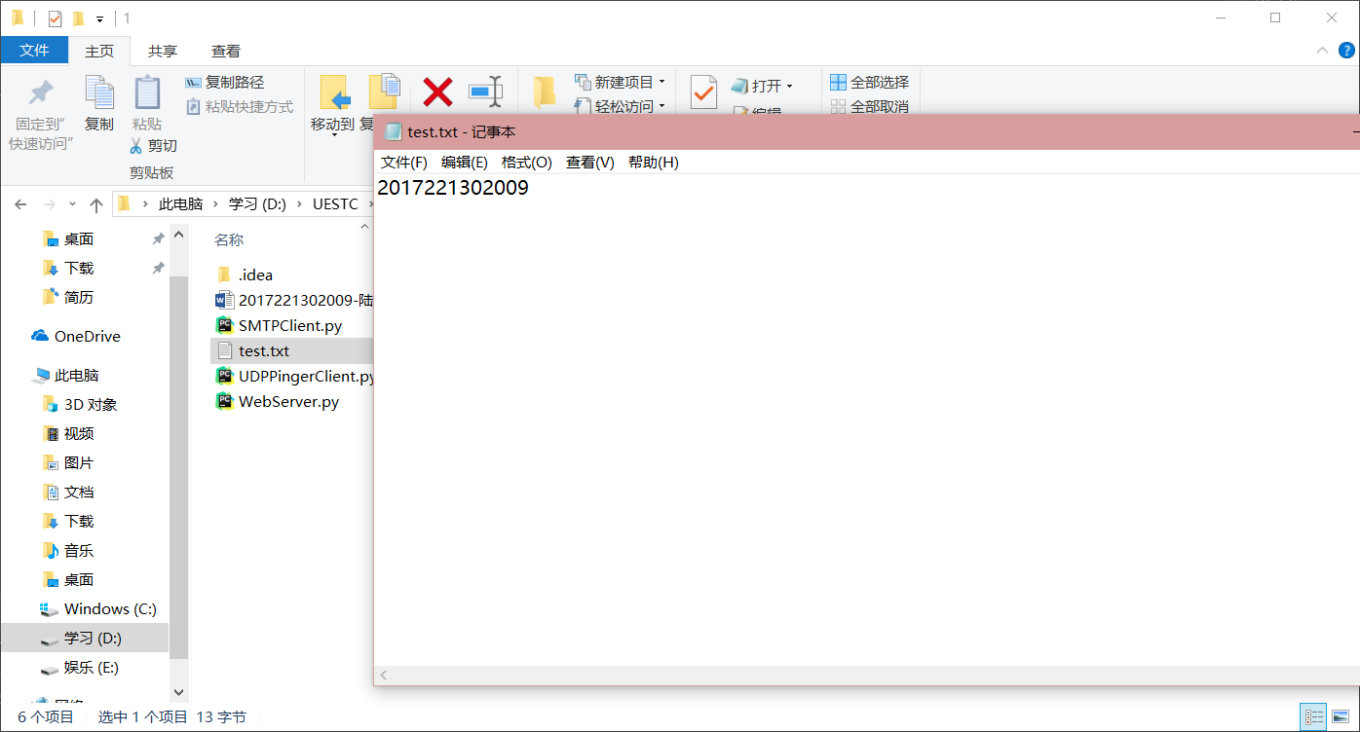

程序运行截图：

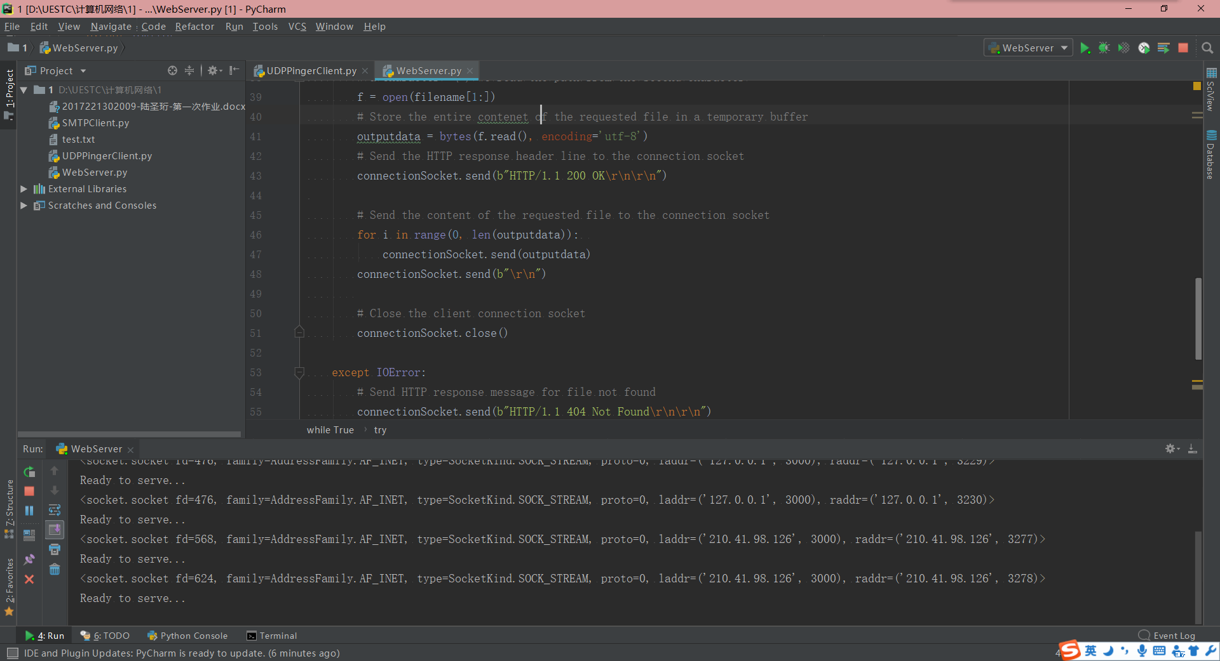

运行结果截图：

