**Express.js**

1. Display name in browser on port 3000

* CODE

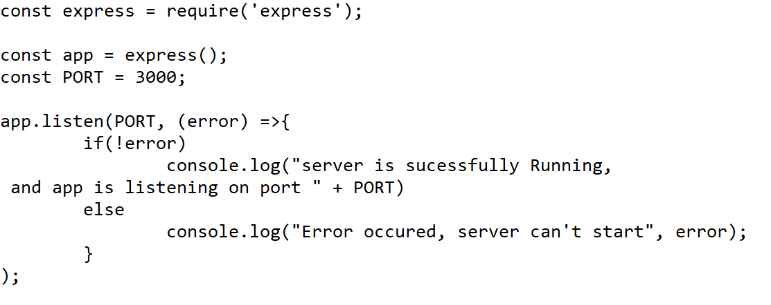

* OUTPUT



1. Display name in browser on port 3000 use get and post to execute the request

* CODE

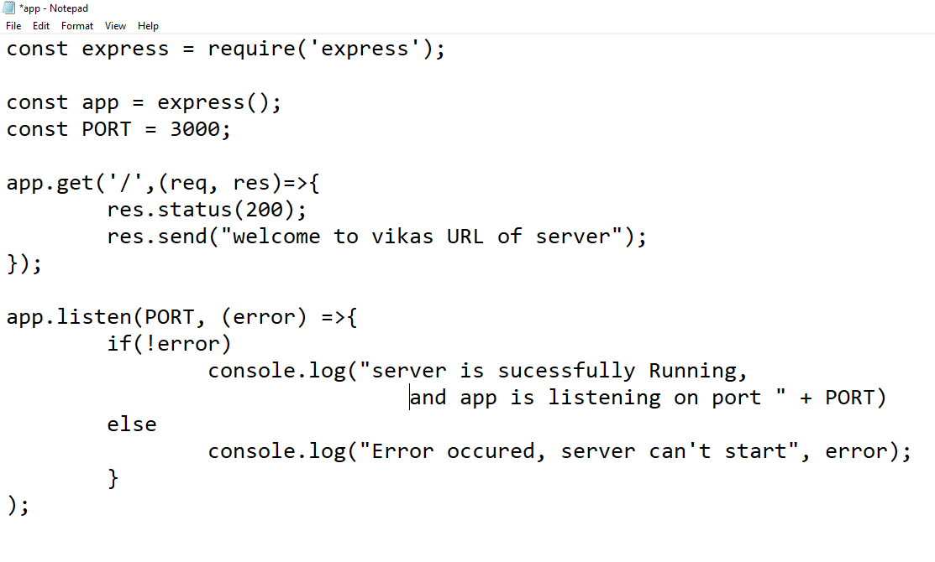

* OUTPUT

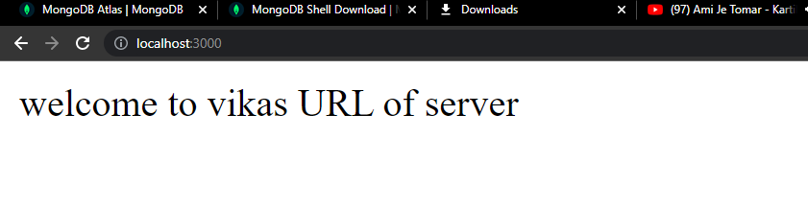

1. Define Router and use it in index.js file before app.listen function

* CODE

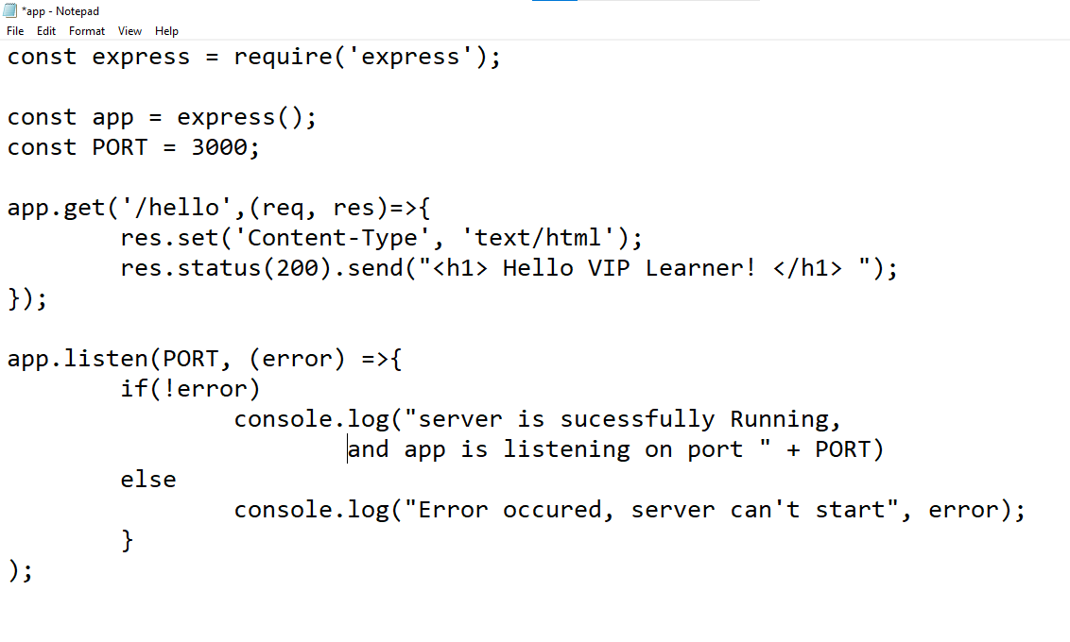

* OUTPUT

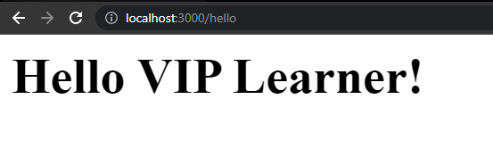

1. Use a dynamic route on port 3000 where you pass the parameters and process based on them to enter ID

* CODE

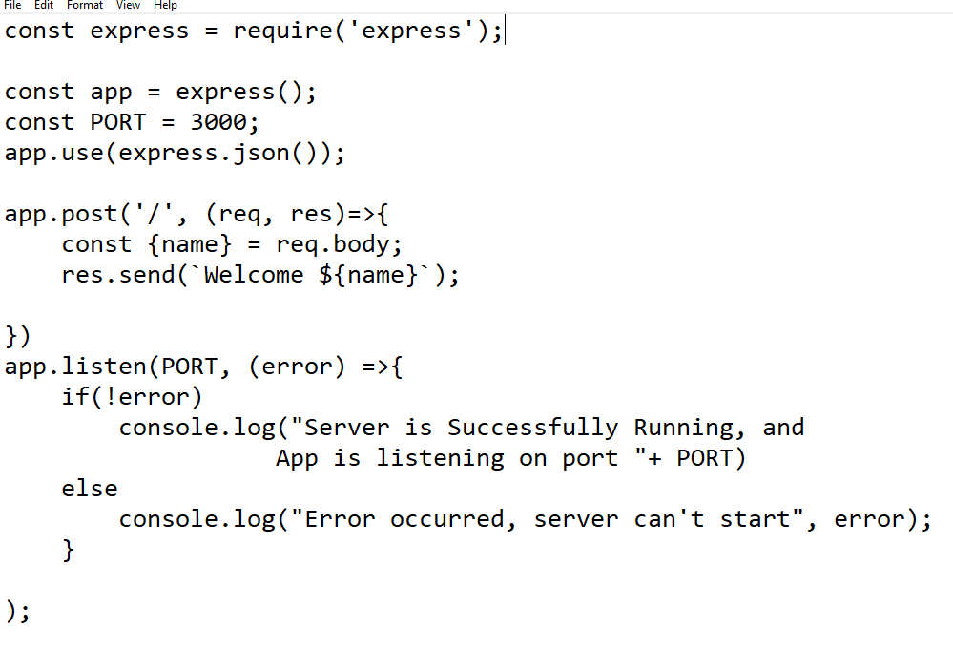

* OUTPUT

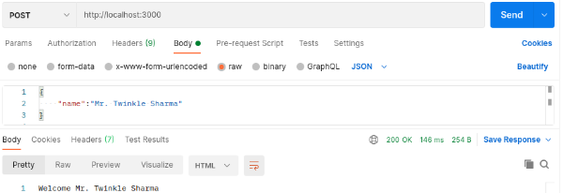

1. Use a dynamic route on port 3000 where you pass the parameters and process based on them to enter ID and “generate that it is invalid”

* CODE

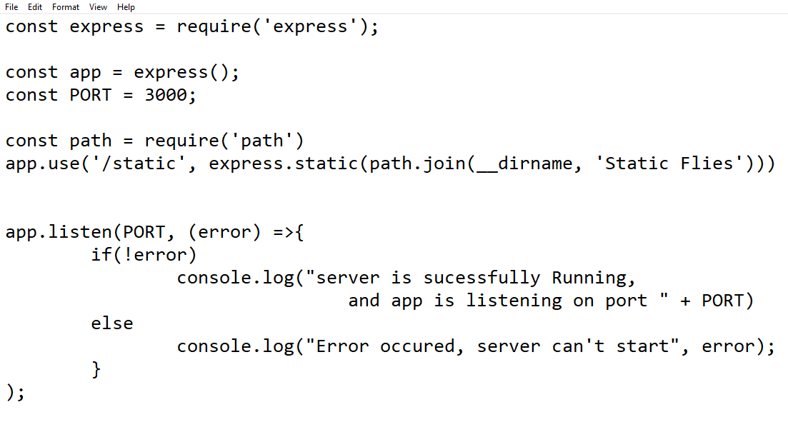

* OUTPUT



1. Write a code to use Middleware functions to access the request and respond object

* CODE

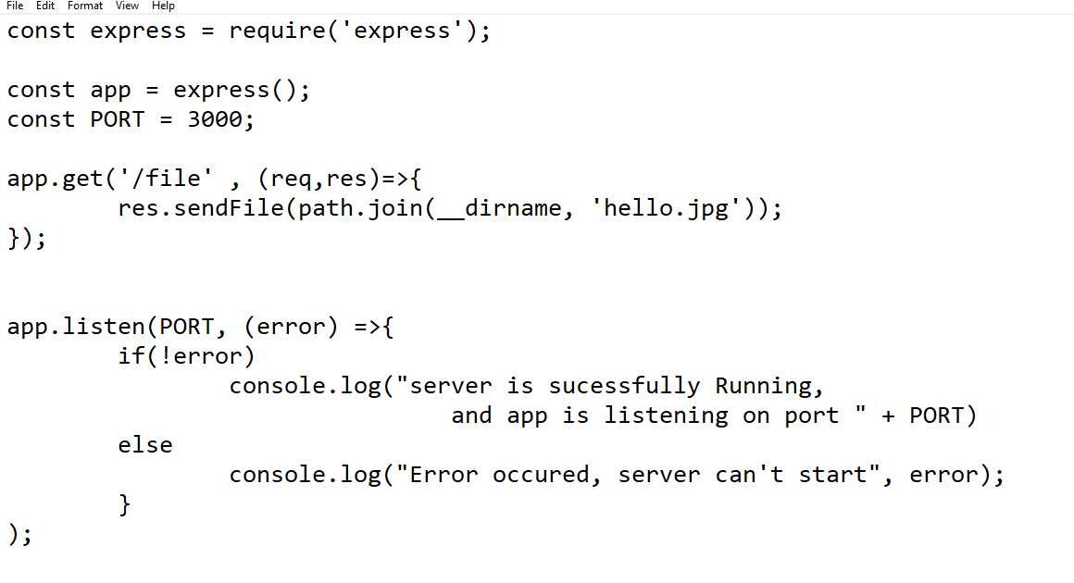

* OUTPUT

