**MongoDB**

1. Create, Insert , find, logical operation, update, update many remove, remove all

* CREATE DATABASE

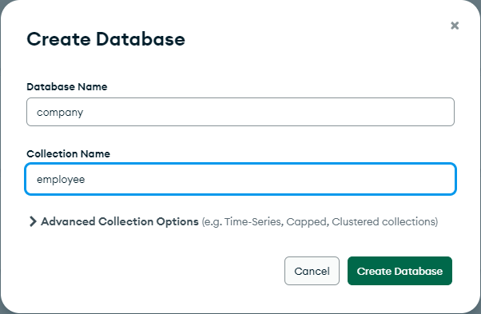

* INSERT VALUE

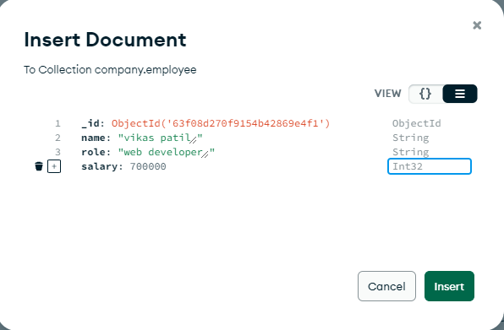

* FIND VALUE

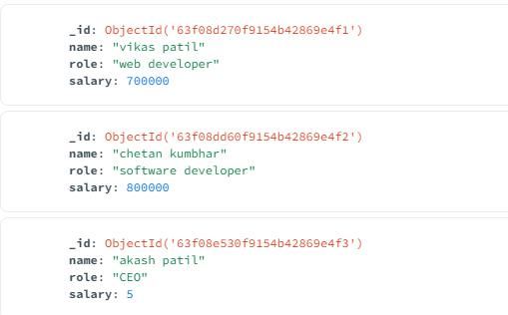

* UPDATE

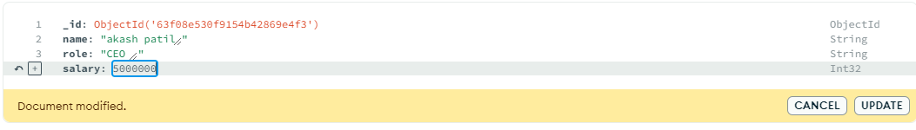

* DELETE RECORD

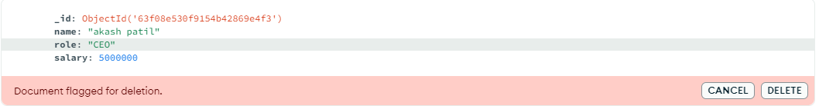

* DELETE COLLECTION

