**OSERVE: A WEB-BASED STUDENT INFORMATION MANAGEMENT SYSTEM WITH INTEGRATED CLEARANCE AND COMPLIANCE TRACKING FOR CAVITE STATE UNIVERSITY - CARMONA CAMPUS**

Undergraduate Capstone Project

Submitted to the Faculty of the

Cavite State University - Carmona Campus

Carmona, Cavite

In partial fulfillment

of the requirements for the degree of

Bachelor of Science in Information Technology

**FAIRY ROSS M. NARITO**

**CHRIZEL ANN V. SOLOMON**

**MARK LESTER L. TAAS**

**ALYSSA Y. TORRES**

January 2025

**BIOGRAPHICAL DATA**

**Fairy Ross M. Narito** was born on December 12, 1997 in Trece Martires, Cavite. He currently resides in Blk 6 Lot 8, Barangay Macario Dacon, General Mariano Alvarez, Cavite. He is the eldest among the seven children of Mr. Fernando Narito and Ms, Rosalie Narito.

He finished his primary education in Sitio Sto. Toribio Elementary School, Lipa City, Batangas in 2010. He completed his secondary education at Bulihan National High School, Silang, Cavite.

Currently, he is studying at Cavite State University – Carmona Campus, Carmona, Cavite pursuing a degree in (BSIT)

**Chrizel Ann V. Solomon** wasborn on October 8, 2002. She resides in Mabuhay Carmona, Cavite with her parents Ms. Gelinda K. Valenzuela and Mr. Ramizon L. Solomon, and siblings namely, Zyra, Jaimie, and Justine.

She graduated from Mabuhay Elementary School, Carmona, Cavite in 2015 with an award*.* She completed her junior high education in Carmona National High School, Carmona, Cavite in 2019. She graduated in Angelo Levardo Loyola Senior High School, Carmona, Cavite in 2021 with honors for her senior high education.

She is currently studying in CVSU – Carmona Campus, Carmona, Cavite under the BSIT program.

**Mark Lester L. Taas** was born on July 21, 2000 in Biñan, Laguna and currently living in Barangay Malaban, Biñan, Laguna. He is the youngest among the five children of Ms. Leticia Taas and Mr. Carlito Taas.

He finished his primary education in Malaban Elementary School, Biñan, Laguna in 2014. Moreover, he completed his junior high education at Nereo R Joquian National High School, Biñan, Laguna in 2018. For his senior high education, he graduated from Biñan City Senior High School in San Antonio, Biñan, Laguna in 2020. He is currently pursuing a degree in BSIT at CVS – Carmona Campus, Carmona, Cavite.

**Alyssa Y. Torres** was born on December 21, 2001 in Silang, Cavite and currently resides in Barangay Yakal Silang, Cavite. She is the youngest among the eight children of Mr. Conrado S. Torres and Ms. Alona Y. Torres.

She finished her primary education in Bulihan Sites and Services Project Elementary School, Silang, Cavite in 2015. She was awarded as the *Pinaka Masipag* student in Grades 4 and 5. Moreover, she completed her junior high education in General Mariano Alvarez Technical High School (GMA), Cavite in 2019. She finished senior high education at My Messiah School of Cavite GMA, Cavite in 2021.

Currently, she is studying BSIT at CVSU - Carmona Campus, Carmona, Cavite.

**ACKNOWLEDGMENT**

The proponents would like to express the sincerest gratitude to all who have contributed to the completion of this study;

The Almighty God, for the grace, inspiration, and resilience provided throughout this journey;

Ms. Janine B. Bacosmo, thesis adviser and program research coordinator, for giving knowledge and ideas about the study;

Mr. Jose Rizaldo D. Alingod, technical critic, for guidance, and shared support and knowledge;

Prof. Richard L. Hernandez, department research coordinator, for his guidance and advice throughout the capstone project;

Dr. Regene G. Hernandez, department chairperson of the Industrial and Information Technology, for her guidance and support;

Prof. Carlo Emil B. Mañabo, campus research coordinator, for his support, guidance, and sharing his expertise;

Dr. Cristina M. Signo, campus administrator, for providing support and motivation;

Their parents and families, for always being there and for the support financially, morally, and sacrifices; and

Cavite State University – Carmona Campus, the opportunity to develop and educate themselves without spending too much.

**THE PROPONENTS**

**TABLE OF CONTENTS**

**Page**

**BIOGRAPHICAL DATA**…………………………………………........................... iii

**ACKNOWLEDGMENT**…………………………………………………………….... iv

**LIST OF FIGURES**…………………………………………………………………. xii

**LIST OF APPENDICES**…………...………………………………………………... xiii

**INTRODUCTION**……………………………………………………………………. 1

Project Context…………………………………………………………….. 1

Objectives of the Study……………………………………………………. 2

Purpose and Description………………………………………………….. 3

Time and Place of the Study……………………………………………… 4

Scope and Limitation of the Study……………………………………….. 4

Conceptual Framework……………………………………………………. 6

Definition of Terms…………………………………………………………. 7

**REVIEW OF RELATED LITERATURE**…………..……………………………... 9

Related Literature/Studies………………………………………………... 9

Student information management……………………..……… 9

School records………………………………………………….. 11

School attendance……………………………………………… 13

Students violation ………..…………………………………..… 14

Disciplinary action………………………………………………. 15

Student counseling……………………………………………... 15

System Technical Background………………………………………….. 16

Synthesis…………………………………………………………………... 18

**METHODOLOGY**………………………………………………………………….. 20

Design of Software, Systems, Product, and/or Processes…………… 20

Requirement analysis………………………………………….… 26

*Operational feasibility*………………………………………………. 27

*Technical feasibility*…………………………………………………. 27

*Economic feasibility*………………………………………………... 28

*Schedule feasibility*………………………………………………… 28

Requirements documentation……………..……………..……….. 28

System Development…………………………………………………….. …. 29

Analysis……………...…………………………………..…. 30

Design…..…………………………………………….…….. 30

Implementation……………………..…………………….. 33

Testing…..…………………………..…………………….. 34

Maintenance………………………..…………………….. 34

System Testing…..…………………………………………………………… 35

System Evaluation…..……………..……………………….……………….. 36

Implementation Plan………………..………………………………………. 37

**REFERENCES**………………………………………………………….…………. 40

**APPENDICES**……………………………………………………………………… 43

**LIST OF FIGURES**

**Figure Page**

1 Conceptual framework……………………………………………………. 6

2 Wireframe of login form of Oserve………………………………………. 20

3 Wireframe of student records of Oserve……………………….………. 21

4 Wireframe of attendance record of Oserve……………………………. 21

5 Wireframe of counseling list of Oserve…………………………………. 22

6 Wireframe of violation list of Oserve……………………………………. 22

7 Wireframe of user list of Oserve…………………………………………. 23

8 System architecture………………………………...,…………………….. 23

9 Flowchart diagram.…..........................................….………………….. 24

10 Entity relationship diagram………………………………..……………... 25

11 Fishbone diagram……………………………….……..……………...….. 27

12 Modified waterfall model of Saravanos and Curinga (2023)….………. 29

13 Activity diagram of reporting module……………...,……………….….….. 34

14 Activity diagram of configuration module..………...,……………………... 35

15 Operational feasibility diagram……………….………...,………………… 37

16 Modified waterfall model (Dennis, Wixom, & Tegarden, 2015)………… 40

17 Use case diagram of student management module..…..………………. 31

….

18 Use case diagram of requirement management module………………. 31

19 Use case diagram of report management module..………………….… 31

20 Use case diagram of counseling management module………….…… 33

**LIST OF APPENDICES**

**Appendix Page**

1 Technical feasibility assessment……………………………………. 43

2 Budgetary requirement……………………………………………..… 46

3 Gantt chart………………………………………………………….…. 47

4 Evaluation instrument for system testing………………………..…. 48

5 Evaluation instrument product quality………………………….…… 52

6 Evaluation instrument quality in use……………………………….... 56

**OSERVE: A WEB-BASED STUDENT INFORMATION MANAGEMENT SYSTEM WITH INTEGRATED CLEARANCE AND COMPLIANCE TRACKING FOR CAVITE**

**STATE UNIVERSITY-CARMONA CAMPUS**

**Fairy Ross M. Narito**

**Chrizel Ann V. Solomon**

**Mark Lester L. Taas**

**Alyssa Y. Torres**

An undergraduate thesis proposal submitted to the faculty of the Department of Industrial and Information Technology, Cavite State University, Carmona Campus, Carmona, Cavite in partial fulfillment of the requirements for the degree Bachelor of Science in Information Technology. Prepared under the supervision of Ms. Janine B. Bacosmo.

**INTRODUCTION**

State University and Colleges are any public institution of higher learning that was created by an Act passed by the Congress of the Philippines. These university and colleges are fully subsidized by the national government (Commission on Higher Education, 2018).

**Project Context**

Cavite State University (CVSU) - Carmona Campus was established on December 10, 2001, and is located at J.M Loyola 4116 Carmona, Cavite. The campus is committed to providing quality education. With a variety of programs designed to student's needs, the university creates a supportive environment for learning and success. The University offers a wide range of programs for students such as Bachelor of Secondary Education, BS Business Management, BS Computer Engineering, BS Computer Science, BS Hospitality Management (formerly BS Hotel and Restaurant Management), BS Industrial Technology, and BS Information Technology. There are more than 4,000 students enrolled at CVSU.

 On the other hand, OSAS plays a vital role and is responsible for the development and implementation of various programs and services that focus on the nonacademic aspects of the student’s life in the university. However, they have problems in managing student information, they are struggling due to each student's information manually. This process is very time-consuming due to the large number of students. Another issue is monitoring student attendance at events, which is also done manually using attendance sheets with student’s information and it is difficult to encode all of the data due to the high number of students attending. The way student files and records are now managed is manual, complicated, and prone to mistakes or inaccuracy. Additionally, students with violations need counseling to clear the sanction graduate, enroll, and get clearance to avoid further violations. Keeping track of these students and ensuring they receive the necessary counseling is challenging because we know that we are still struggling and coping from the past pandemic that has affected our university throughout the past years. Managing student compliance with clearance requirements is another problem. Some students were able to complete their clearance even though they have missing requirements or unresolved violations. Generating reports related to student information, clearance, and compliance is also problematic. The OSAS has difficulty generating accurate and timely reports, mainly because of the number.

        In improving the efficiency and accessibility of student information management, simplifying the access, updating, and organization of student data. Additionally, it will make it easier to monitor clearance and compliance standards, guaranteeing that students fulfill every requirement or needs. The study aligns with the Sustainable Development Goal (SDG) Goal 4: Quality Education. Efficient record-keeping and compliance tracking can contribute to better monitoring of student progress and timely completion of educational requirements.

**Objectives of the Study**

The general objective of the study is to develop a system to manage student information, clearance, and compliance tracking.

Specifically, it aims to:

1. design a Oserve: A Web-Based Student Information Management System with Integrated Clearance and Compliance Tracking for Cavite State University, Carmona Campus that:
   1. manages the student information;
   2. monitors the attendance of students at OSAS-hosted events;
   3. manages the compliance of the students to clearance;
   4. monitors the students' clearance status;
   5. generates reports related to student information, clearance, and compliance;
   6. modifies the system’s contents;
2. develop the application/system using the following:
   1. My Structured Query Language (MySQL) for database of the system;
   2. Hypertext Preprocessor (PHP) for back-end development;
   3. Hypertext Markup Language 5 (HTML5) for front-end development;
   4. Cascading Style Sheets (CSS) for the layout and appearance;
   5. Javascript (JS) for dynamic functionality and interactivity;
   6. Visual Studio Code for code editing;
3. test the system in terms of unit, integration, and system testing;
4. evaluate the system using the adopted International Organization for Standardization 25010 evaluation instrument; and
5. prepare an implementation plan.

**Purpose and Description**

The purpose of the study is to develop a Web-Based Student Information Management System with Integrated Clearance and Compliance Tracking for OSAS at Cavite State University is crucial for several reasons. The current system of managing student files and records is manual, time-consuming, and prone to errors or misplacement. A web-based system will process the information, making it easier to organize, access, and update student information. It will also facilitate the tracking of clearance and compliance requirements, ensuring that students meet all necessary criteria before graduation or requirement.

The benefits from this study include improved efficiency in managing student records, reducing the time and effort required for administrative tasks. It also offers enhanced data security and integrity, as digital records are less susceptible to physical damage or loss. Additionally, it provides better accessibility for authorized personnel to access student information, and improved tracking of student clearance and compliance, ensuring that requirements are met on time. The proposed system will have a direct practical application in the management of student records and clearance processes at CVSU and it can potentially be adapted or replicated by other educational institutions facing similar challenges in managing student information.

The Sustainable Development Goal (SDG) that the study is connected is the SDG Goal 4: Quality Education. This goal focuses on providing students’ knowledge, skills, and values. Quality education is a making sure everyone has a chance to learn and grow, no matter who they are. This has to do with ensuring that everyone has a fair chance to education and the resources they require for success. A quality education teaches students how to think, feel, and interact with others in addition to helping them learn facts.

**Time and Place of the Study**

The study will be conducted at Cavite State University - Carmona Campus, Carmona, Cavite, from March 2024 to January 2025.

**Scope and Limitation of the Study**

The proposed system are composed of six major function. The manage student information, monitors the attendance of students at OSAS-hosted events, manages the compliance of the students to clearance, monitors the student's clearance status, generates reports to student information, clearance, and compliance, and modifies the system’s contents.

The first one is Manage student information this function will store and maintain all relevant student information, including personal details, academic records, and contact information. By managing this data, the system keeps student records up-to-date and easily accessible. This allows for efficient data retrieval and management, supporting various administrative processes. It also facilitates quick access to student profiles for academic purposes, administrative staff, and other authorized personnel, enhancing the efficiency of student services. The system also supports data integrity and security measures, ensuring that sensitive information is protected and only accessible to those with appropriate permissions.

The monitors the attendance of students at OSAS-hosted events this function will track student attendance at events organized by the Office of Student Affairs Services (OSAS). It will log attendance data via Qr code, generate attendance reports, and identify students who present or miss the participation of the event. This ensures accurate attendance monitoring and helps in managing student involvement in OSAS events.

The manages the compliance of the students to clearance this function manages student data related to academic requirements, including seminar completion and clearance status. It ensures students meet all necessary requirements for graduation or program completion by tracking their progress and handling any outstanding tasks or documents.

The monitors the student's clearance status this function manages student data related to academic requirements, including seminar completion and clearance status. It ensures students meet all necessary requirements for graduation or program completion by tracking their progress and handling any outstanding tasks or documents.

The generates reports to student information, clearance, and compliance this function is designed to handle and generate reports for students based on their current status, whether they are active, inactive, or graduates. It provides administrators and staff with the ability to create detailed reports that summarize the academic progress and status of students within the system. These reports show if students have fulfilled their clearance requirements and complied with necessary conditions. This helps in efficiently managing and monitoring student progress and ensuring all requirements are met.

The modifies the system’s contents this function is designed to handle and generate reports for students based on their current status, whether they are active, inactive, or graduates. It provides administrators and staff with the ability to create detailed reports that summarize the academic progress and status of students within the system. These reports show if students have fulfilled their clearance requirements and complied with necessary conditions. This helps in efficiently managing and monitoring student progress and ensuring all requirements are met.

However, the system will only focus mainly in collecting the feedback from administrators and staff of the Office of Student Affairs Services, without direct input from students using the system. The system will not connect with any other existing systems or databases outside of the Carmona Campus. Additionally, this system does not upload copies of files.

**Conceptual Framework**

The conceptual framework of the study contains input, process and output for the development of Oserve.

Figure 1 shows the conceptual framework of the study.

**INPUT PROCESS OUTPUT**

Knowledge Requirements

1. Student information management
2. Attendance Monitoring
3. Compliance Monitoring
4. Violation and Counselling
5. Data Privacy Act of 2012

Software Requirements

1. CSS
2. HTML5
3. PHP
4. JavaScript
5. MySQL
6. Visual Studio Code

Hardware Requirements

a. Computer Set Dual – Core processor 4GB RAM 500 GB HDD Windows 10

b. Laptop

OServe: A Web-Based Student Information Management System with Integrated Clearance and Compliance Tracking for Cavite State University- Carmona, Campus

Requirement Analysis

1. Operational Feasibility
2. Technical Feasibility
3. Economic Feasibility
4. Schedule Feasibility

Requirement Documentation

Software Design

1. Database Design
2. User Interface Design

Development and Testing

1. Database Programming
2. Program Coding
3. Functionality Test
4. Efficiency Test
5. Portability Test

Implementation Plan

Figure 1. Conceptual framework of the study

The conceptual framework involves the input, process, and output of the study. The knowledge requirement consists of information that the proponents should have in developing the study. Information about managing student information management, attendance monitoring, compliance monitoring, and violation and counseling while adhering to data privacy regulations like the Data Privacy Act of 2012 and quality standards like International Organization Standardization (ISO) 25010. To develop the software, tools like Visual Studio Code for coding, PHP for developing on the server front, HTML5 for web structure, CSS for styling, JavaScript for interactivity, and MySQL for database management are necessary. The hardware needed includes a laptop or computer with specific specifications. Before proceeding, the development feasibility in terms of operations, technology, economics, and schedule needs to be analyzed. Following this, the software architecture and user interface must be designed, and then the actual development and testing can take place. Finally, an implementation plan outlining deployment steps is essential for successful integration into the existing system.

**Definition of Terms**

The study operationally defined the following terms:

**Counseling with Violation** isa talking therapy that helps students with issues of violating rules on the CVSU-Carmona Campus.

**Role-Based Access Control** limits network access according to an individual's position within an organization and is now used as an essential technique for advanced access control (Zhang, 2023).

System Analysis is the process of examining a technical system such as a software program for the aim of development, troubleshooting, or improvement.

**REVIEW OF RELATED LITERATURE**

This chapter discussed the different related literature and studies for Oserve: A Web Based Student Information Management System with Integrated Clearance and Compliance Tracking for Cavite State University - Carmona Campus.

**Related Literature/Studies**

**Student information management.** According to Gomathy (2022), The main purpose of this Student Information Management System (SIMS), is a management information system for education establishments to manage student data. In the currently system, all the activities are done manually. It is very time-consuming and costly. For every college, the important task of the people administration department is to manage student data information and the details in a procedure-oriented system manner with of latest information updates that must be available for every year.

Moreover, Student Information Management System (SIMS) provides a simple interface for maintenance of student Information. Colleges and other educational institutions can use it to easily maintain student records. The creation of the management is to accurate, up-to-date information regarding a student's academic career is critically important in the university as well as colleges. Student information system deals with all kinds of student details, faculty details, and college details (Akiwate et al, 2016).

According to the recent research of Devi *et al* (2016), Student information management system covers a wide range, including educational administration management systems, teaching arrangement systems, performance management systems, and other subsystems. The various educational institutions manage these subsystems. The system is relatively independent, and the information resources cannot be shared, confusing management and waste of resources due to insufficient utilization of information (Cheng, 2022).

According to Lubanga *et al.* (2018), Over the past few decades, universities all over the world have been experiencing new paradigms in the way they handle and manage students’ information due to the proliferation of ICTs and their applications such as web-based student information systems. With the adoption of such systems as the Online Student Information System (OSIS) in academic institutions, the experience is that it has now become easy to use and fast-track all students’ records in one centralized database by the internet technology.

Wu *et al*(2020), the continuous development of information technology, and the means of information technology in the student management system continue to popularize and promote. It can make management efficient, fast, and convenient. In otherwise, the intelligent campus student information management system based on a cloud platform is an intelligent information technology that can be used in universities, colleges, schools, and other educational institutions. The Intelligent Campus Student Information Management System is a web-based application, which can be used to manage students and their academic records. Users of this application include university administration, faculty, staff, and students.

This application also helps for maintain a database of all registered students at any given time. It also helps to manage various other details related to each student, such as enrollment date, attendance record, etc (Zhou et al, 2023).

According to Ikhwan *et al.* (2019), Stated that Student management is an important part that must be considered by schools. The government has made standardized rules for how schools can manage students so that they are by National Education Standards. Student management activities start from registration, until student services that have been arranged neatly, may not run optimally, if schools are still manual in tidying student data collection. To him, the role of the student management information systems is very important for every school to have.

In addition, in existing college data management systems there are plenty of activities that are handled manually. All these activities are paper-based which is expensive and time-consuming. Various activities are handled by various departments. This lead is to major problems in interlinking data and avoiding duplicates. It will become a very hard and prolonged process for students to access information from management. In the proposed system, a better solution is to defined for all these activities which are paperless, cost-effective, and time-saving. In the 21st century with the latest technology the world is moving towards cloud computing (Jain et al, 2018).

According to the report of Andollo and Aseey (2020), Student Management Information Systems provide efficient, effective, and easier access to student information in educational institutions. In Kenya, 90% of the universities rely on the use of this system to support teacher training programs. This necessitated an investigation into how the availability of Information Communication and Technology infrastructure influences the use of Student Management Information Systems.

**Attendance Monitoring**. Every school’s they have a attendance monitoring for events to ensure their students who attended in events. According to Raj *et al* (2021) The smart attendance monitoring system which will use the concept of face recognition to identify students. On the basis of this a database will be created containing the information of attendance date wise. Apart from reducing time it will also help in replacing the laborious conventional method of using logbooks. The system also has the feature to send emails to the administrator about the student ‘s attendance status at the time of recognition itself. At the time of closing of the camera absentees’ names will be called out.

According to recent research by Evans and Mendez Acosta (2023), Student attendance at school is a necessary condition for learning and other schooling benefits, yet absenteeism is a significant issue for students in many countries. Policies, programs, and research seeking to reduce absenteeism need to be measured accurately. Moreover, the study of school attendance/problems has a rich history but one that has bifurcated into detached systemic and analytic approaches (Kearney, 2021). Also, School attendance and school completion are important benchmarks of successful development (Kearney & Graczyk, 2020).

Maeda (2022) stated that the number of students with school attendance problems into compulsory education schools has been the highest since the government introduced the current data collection format in 1991. All the Japanese compulsory education schools collect data on the attendance and the absence each day.

One potential coordinated, integrated approach is to ameliorate SAPs and boost school attendance is to leverage existing school-based systems already designed to address multiple individual domains of functioning in students. (Kearney & Graczyk, 2022).

According to De Azevedo et al. (2022), that most of the records of attendance of students in educational institutions are made manually, thus making the process quite laborious and repetitive for teachers, added to this, the system does not present to be fully reliable, because the method used shows itself vulnerable to is human error. Furthermore, Class teachers need to take students' daily attendance for every school day and analyze attendance data. It is a hassle for teachers to make an analysis of attendance data manually and ensure no error-prone in that process (Hawa Apandi *et al.*, 2022). In Addition, in the world of education, there is still a lot of data management that is done manually, one of which is the management of attendance data (Yuliadi *et al.*, 2022).

Additionally, student attendance is written in the attendance book that has been provided by the school management. The student attendance will be filled in by the subject teacher who will then report once a month to the school principal (Bangun, 2022).

**Compliance Monitoring.** Stated by Logachev (2021) the information system for monitoring and managing compliance the quality of educational programs has been developed. They allow for the quantitative evaluation of the educational program content and unambiguous interpretation of the obtained result. For this, the authors have developed an objective system for assessing the quality of educational programs.

According to Drapkina (2022) the Monitoring the quality of educational programs is determined by the compliance of their content with the requirements of professional standards, federal educational standards, healthcare delivery procedures and clinical guidelines.

According to recent research (Goswami *et al* 2021) the neonates admitted to neurocritical care units frequently undergo continuous bedside cerebral function monitoring (CFM). Documentation of CFM findings that are complete and accurate can augment the quality of care through improved communication. We aimed to increase the compliance with and quality of CFM documentation in the electronic medical records by 50% in our neonatal intensive care unit over 6 months. Methods: We used the Plan-Do-Study-Act methodology, process mapping, and fishbone analysis. We implemented interventions, including the development of standardized EMR templates, face-to-face reminders at staff meetings and clinical handover sessions, and teaching on CFM interpretation. Results: We evaluated 50 and 161 charts pre (August-October 2018) and postintervention (December 2018-July 2019), respectively.

**Violation and Counseling.** Students who violate the behavioral norms set by the Code, as well as any local, state, and federal laws, and engage in activities such as cheating and plagiarism, will be subject to counseling. Such students may also be referred for prosecution for violating the Security Policies & Procedures for Acceptable Use of the Campus Network. In Canada, a quantitative survey of faculty members' views and actions about academic integrity and dishonesty, as well as a qualitative evaluation of 17 institutions' rules for academic integrity and dishonesty, were used to determine student breaches of academic integrity (MacLeod *et al*., 2020). According to Albuquerque Public Schools (2024), students may need interventions for disruptive behavior, regardless of whether they receive special education or general education services. To ensure the safety and security of all individuals in the school, administrators have the power to enforce penalties. In case a student breaks any rules, the teacher will handle the situation and document the infraction in the respective instructor's violation note, as stated by (Arisandi *et al*., 2021). However, creating a comprehensive list of all the violations that students have committed can be difficult if their infraction records are scattered across multiple teachers' notebooks.

According to Millacci (2021), Counseling's primary goals are to help students grow socially, improve their attendance and conduct, and improve their academic success. School counselors are mental health professionals who work in school settings as teachers and counselors. They must hold a master's degree or higher. Full-time counselors are employed by many schools to assist students with academic or personal challenges, career and college planning, and behavioral, physical, or mental health concerns.

According to McGrew (2018) that the full understanding of one's self-worth, self-assurance, self-assuredness, and self-competence in the specific subject of study is known as academic self-concept. As per SAGE OPEN, school counselors are indispensable employees in an educational environment, as they play a crucial role in fostering student achievement by offering important services throughout the implementation of a complete school counseling program (Larberg *et al.*, 2021). School mental health promotion may be accomplished through the use of contemporary communication tools and life skills training (Chaitra *et al.*, 2020).

**Systems Technical Background**

Hypertext Preprocessor **(PHP.)** According to Nadhira *et al* (2022), the idea that the development of web-based information systems is growing very rapidly, one of which can help the process of processing information and data, to improve the performance in various fields, including in the academic. In making a system using the Hypertext Preprocessor (PHP) programming language, MySQL as a database and framework, and Visual Studio Code as a medium for writing coding. The system was debugged to troubleshoot and avoid problems during the testing phase. This process aimed to identify the interactions and issues faced by clients within the domain system.

Hypertext Markup Language 5 (HTML5).As found by Tabarés (2021), HTML (Hypertext Markup Language) has experienced a major transformation during the last decade before releasing its latest version known as HTML5 (Hypertext Markup Language 5). Several elements conceived around HTML during this period introduced significant problems in the development of the standard due to increasing fragmentation and complexity in protocols, platforms, devices, and systems. This language is compatible with the system and is used to create and design web pages for Oserve. It serves as a framework for the system, providing the structure for content such as text and images. HTML is utilized for tags and elements to define different parts of a webpage, including headings, paragraphs, and lists.

Cascading Style Sheets (CSS). Cascading Style Sheets (CSS) is used for front-end development and is used to define and customize the styles and layouts for your web pages. This means proponents can create a style sheet to alter the design, layout, and responsiveness to different screen sizes on various devices, including computers (Wilson, 2023). The proponents utilized the style and layout of the web pages. Additionally, CSS enhances the visual appeal and controls the colors, fonts, spacing, and overall layout of the system's content. CSS can also change the background color of the webpage, adjust the size and style of the text, create margins and padding elements, and arrange content in a specific way on the page. Moreover, by separating the content of HTML and the design of CSS, developers can easily maintain and update the look of a website without changing its structure.

**My Structure Query Language (MySQL).** The performance of MySQL, a well-known open-source relational database management system used in a variety of sectors, including student records, finance, and healthcare, that can be improved through the use of physical programming and data tuning. While data tuning involves refining the database to increase efficiency, physical programming involves optimizing the physical storage of data (Ranisavljevic & Suster, 2023). The database is a management system used to store and manage data for developing the system. It acts like a digital filing cabinet where data is organized into tables, making it easy to retrieve, update, and manage the information of the students at Cavite State University Carmona Campus. MySQL is popular because it is reliable, fast, and can handle large amounts of data.

**JavaScript*.***JavaScript works both on the front end the part you see and interact with on your browser and the back end the part that does all the behind-the-scenes work (Mesirov, 2023). JavaScript is a programming language used by the proponents to make a system interactive and responsive to user actions. It allows web pages to update dynamically without needing to reload. Additionally, JavaScript runs in the web browser, working alongside HTML and CSS to enhance the user experience by making a web page more engaging and functional.

**Visual Studio Code.** Is a lightweight but powerful source code editor that runs on your desktop and is available for Windows It comes with built-in support for JavaScript (Microsoft, 2020). The Visual Codes help the proponents to develop a system to easily understand the code and be readable.

Synthesis

According to Gomathy (2022) the use of the student information management system is to manage the information of all students. It is important to have a system that is administered by the admin in managing student information. Additionally, the student information management system is a great help in providing maintenance and making sure that the information is up-to-date (Akiwate et al, 2016). Over the past years, universities are adapting to the new technological advancement in terms of handling and managing students' information. It made the tracking of student records more centralized (Lubanga et al, 2018). Such development helps to maintain all registered students' data and information stored properly in a database. Managing other details such as enrollment and attendance record of a student (Zhou et al, 2023).

Ikhwan et al (2019) stated that schools in today’s era should consider applying a student management system. With this, it streamlines the registration and information of the students. Moreover, challenges arise when activities and information of the students are handled manually. It is time consuming and expensive unlike developing a system (Jain et al, 2018). Andorra and Assey (2020) stated that student management information systems provide efficiency and easier access to student information.

Every academic institution should give efforts in handling the information of the students (Manikas, 2015). By having good and efficient record management in schools, the administrator can have more comprehensive and easy handling of records that contain all information (Odeniyi & Adeyanju, 2020). Keeping the records of information is not enough, making sure that the records are properly stored is important too (Oluwole & Vagherm 2015).

Monitoring attendance is important in a student's academic life. It is essential for learning and other school benefits (Acosta, 2023). Maeda (2022) stated that the student school attendance becomes a problem in a student’s academic life. It is required to attend classes to make sure that students can learn proper knowledge. Students' behavior that results in school violations are subjected to counseling. There are various violations such as cheating, plagiarism, and being engaged in activities that cause a problem in school (MacLeod et al, 2020).

Students should be held accountable in every action they do that is against the school services. This is to ensure that the safety and security of all individuals are protected. In case students break rules, it is essential to give them disciplinary actions (Arisandi et al, 2021). Having a counseling taken in every school rule violated motivates the students to not contradict the rules.

**METHODOLOGY**

This chapter discusses the methods and procedures of the development system of OSERVE: A Web-Based Student Information Management System with Integrated Clearance and Compliance Tracking for Cavite State University – Carmona Campus.

**Design of Software, Systems, Product, and/or Processes**

OSERVE: A Web-Based Student Information Management System with Integrated Clearance and Compliance Tracking for Cavite State University–Carmona Campus will be developed using different software and hardware tools. The proponents will use various diagrams to show the process of Oserve.

Figure 8 shows the system architecture of Oserve.

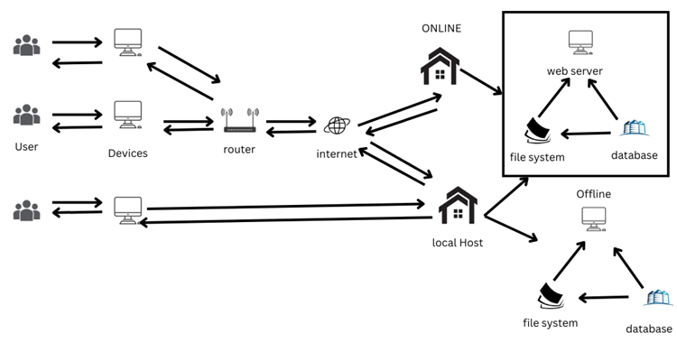

Figure 8. System architecture of Oserve

The system architecture represents the ideal between the user and Oserve. It will start with the user and device having a human and computer interaction where the user can input and is able to retrieve information. Devices connect to a router, facilitating the interaction of requesting and receiving data. The router then communicates to the internet, which routes to the system's frontend and backend. The frontend comprises the user interface of the application, linked to the backend. The backend includes a web server that handles the functionality connected to the frontend.

For online access, the system presents requested information retrieved from the web server's file system and database. For offline access, the device connects directly to a local host. This host, like its online counterpart, has its own file system and database. It can display and store information locally, allowing users to work even without internet connectivity. This dual setup ensures seamless user experience, whether online or offline.

Wireframe is a visual representation of a web page. It is a skeletal overview of what the system will look like. The wireframe is the user interface that focuses on styling the colors and graphics of the website (Hannah, 2024).

Figure 2 shows the wireframe of login form of Oserve.

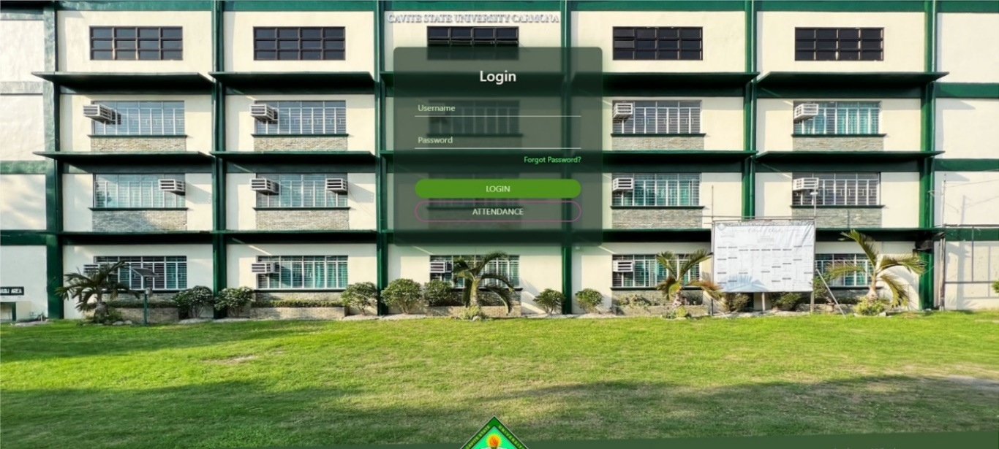

Figure 2. Wireframe of login form of Oserve

In the login module, the user is required to enter his username and password to log in to the system.

Figure 3 shows the wireframe of student records of Oserve

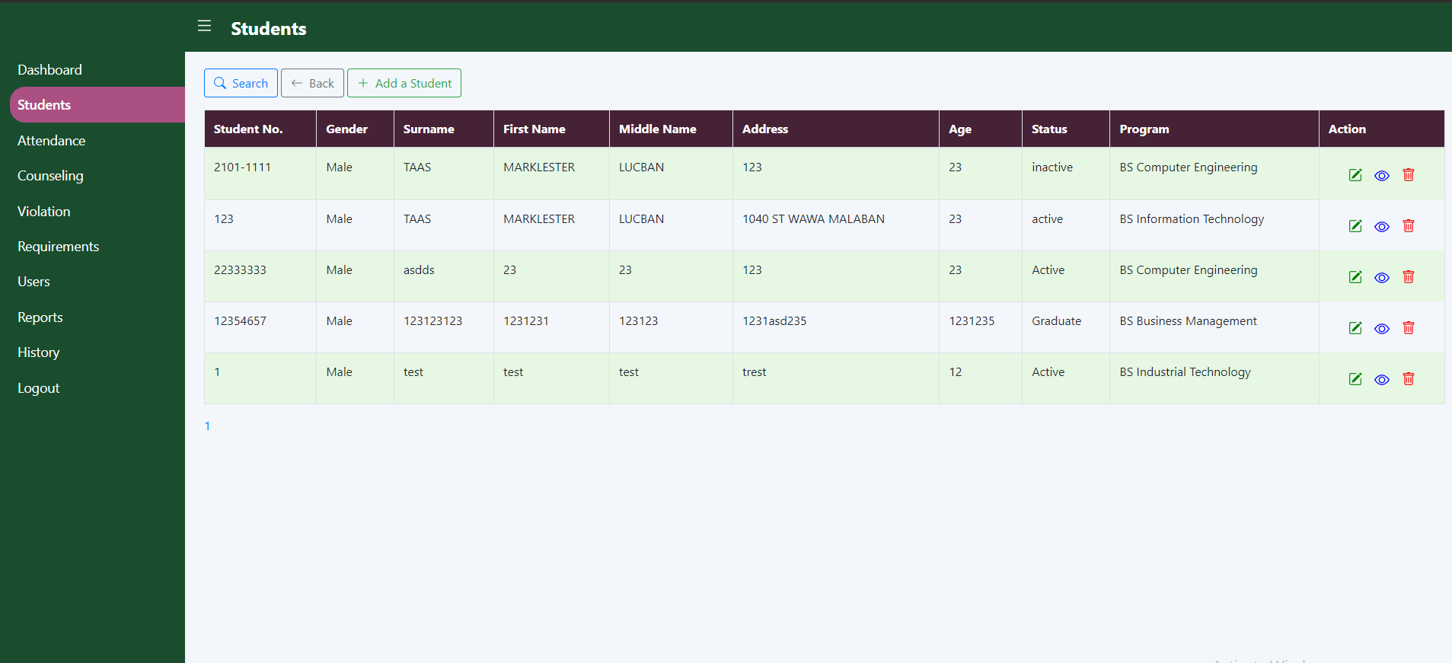

Figure 3. Wireframe of student records of Oserve

The student list wireframe shows the information of students including their first name, last name, middle name, age, gender, address, student number, and program.

Figure 4 shows the wireframe of attendance record of Oserve

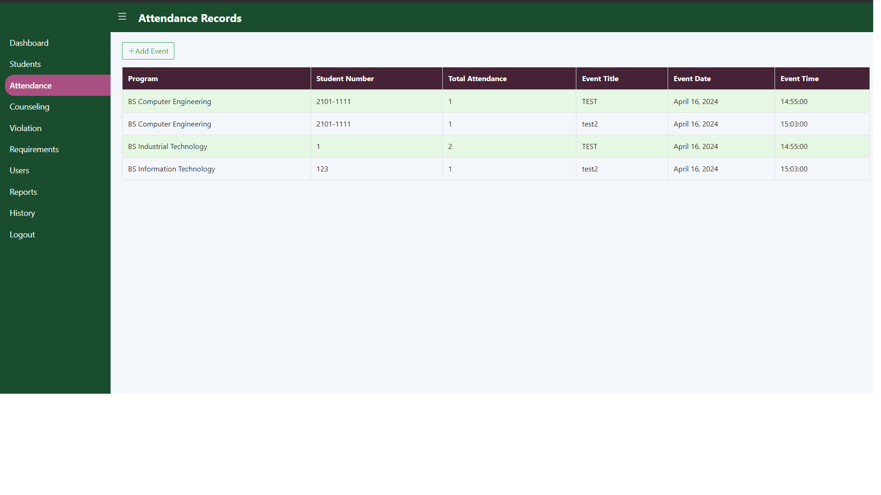

Figure 4. Wireframe of attendance record of Oserve

It displays the attendance of the students. The administrator can plan the event and utilize it to track the attendance.

Figure 5 shows the wireframe of counseling list of Oserve

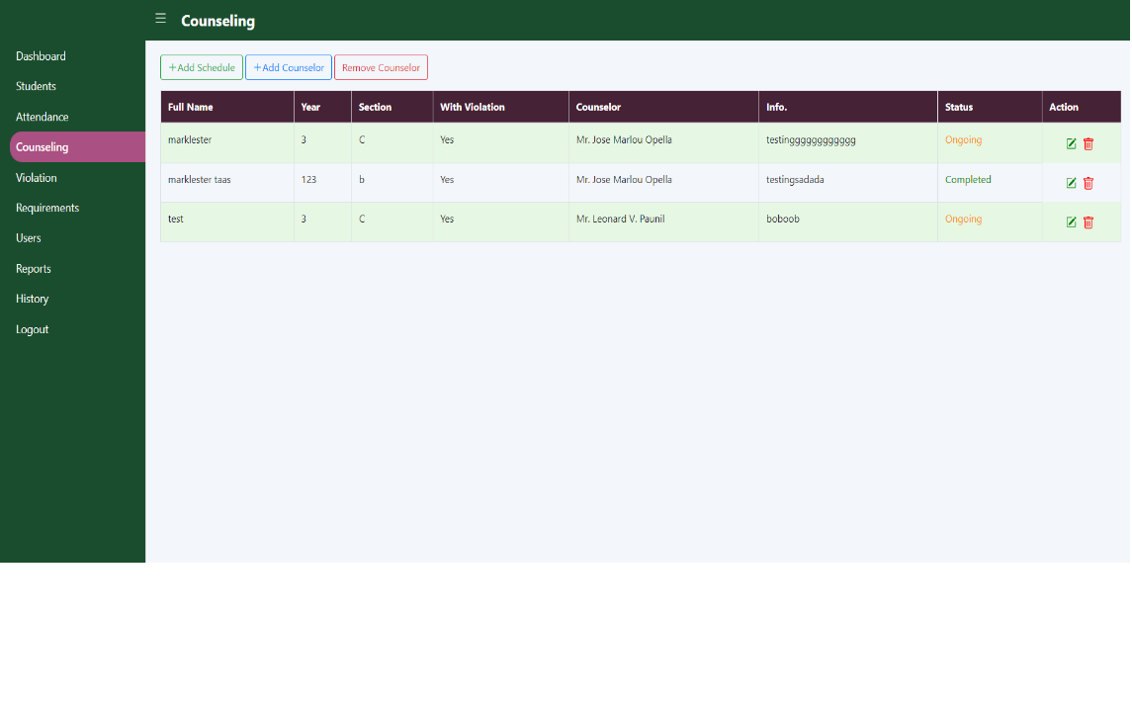

Figure 5. Wireframe of counseling list of Oserve

It displays the records of the students who attended their counseling. If the administrator makes a mistake in submitting the student’s information, they can change it by the edit button.

Figure 6 shows the wireframe of violation list of Oserve

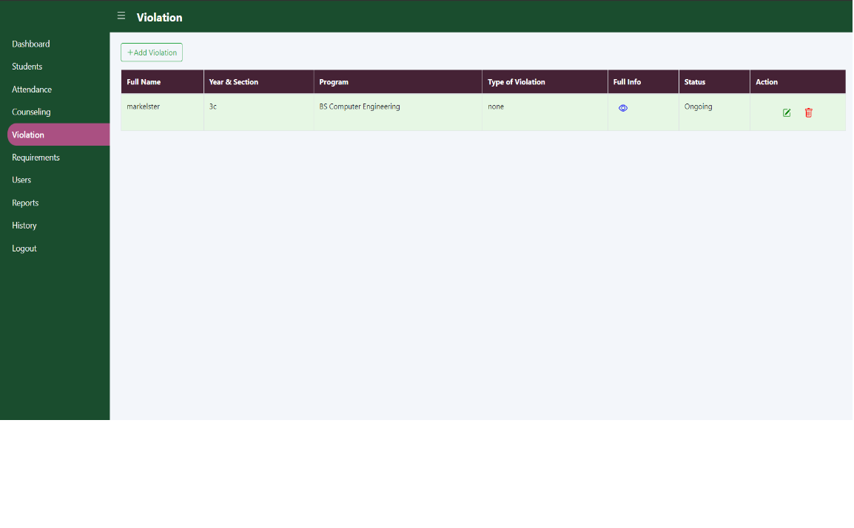

Figure 6. Wireframe of violation list of Oserve

The students records and their violation will be displayed in this list. Only the administrator can examine the reason for the violation. However, Staff can also see the current status of the students.

Figure 7 shows the wireframe of user list of Oserve.

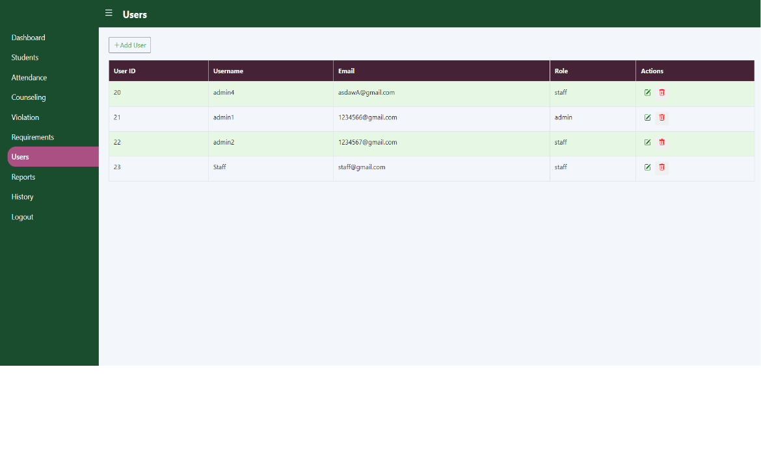

Figure 7. Wireframe of user list of Oserve

In this list, the administrator can see accounts of all users and its roles. The admin can create an account for another user since it is responsible of creating the account.

Figure 9 shows the flowchart diagram of Oserve.

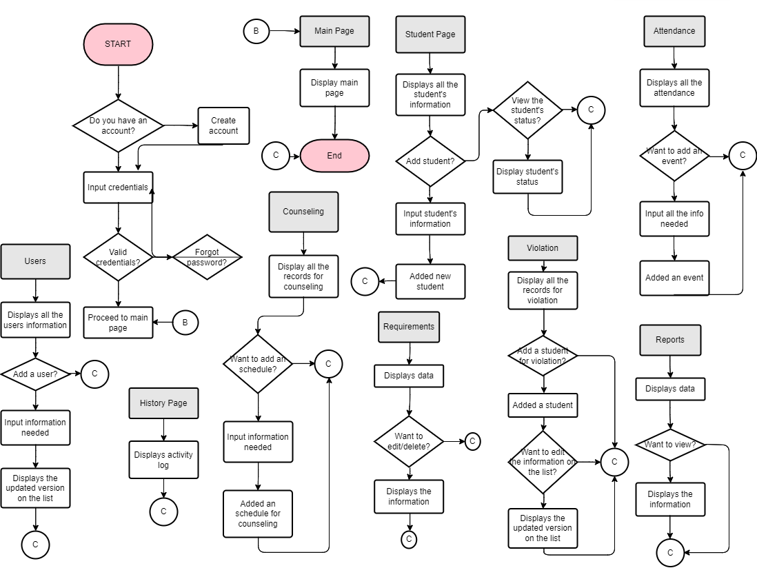

Figure 9. Flowchart diagram of Oserve

The figure displays the possible view of an administrator, which consists of an organized menu. Upon logging in, the administrator has access to manage students (adding, viewing, and editing), manage attendance (adding events, viewing by program or section), access counseling records, create violation reports (the type of violation committed by the student), also the manage reports (displays the summary of the entire system’s information) and lastly, manage users (adding, editing, and deletion of account for access control).

Figure 10 shows the entity relationship diagram of Oserve

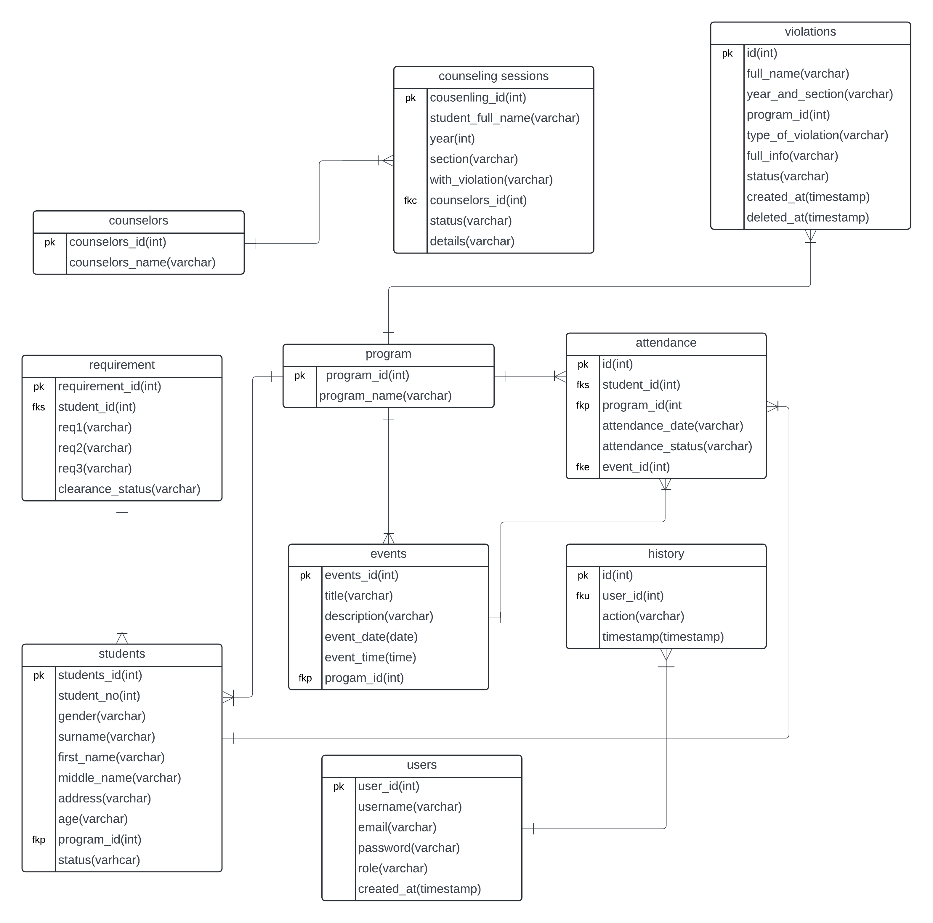

Figure 10. Entity relationship diagram of Oserve

The ERD for a Web-Based Student Information Management System with Integrated Clearance and Compliance Tracking comprises ten interconnected tables that effectively capture the complexities of student data. At the core is the "program" table, which has a one-to-many relationship with several other tables, indicating that each program can have multiple students, events, attendance records, and violations. The "students" table is central to the system, maintaining a many-to-one relationship with "program," a one-to-many link with "attendance," and a unique one-to-one connection with "requirements." This structure ensures that each student's academic program, attendance history, and individual requirements are accurately tracked.

Events and attendance are closely tied, with the "events" table having a one-to-many relationship to "attendance," while "attendance" itself connects many-to-one with students, programs, and events, enabling detailed tracking of student participation. The system also manages personal development through the "counseling sessions" table, which relates many-to-one with both "counselors" and "students," facilitating comprehensive counseling records. Additionally, student discipline is monitored via the "violations" table's many-to-one relationship with "program." To maintain system integrity and track changes, the "users" table has a one-to-many relationship with "history." This well-structured ERD ensures data consistency and enables the SIMS to handle a wide range of student-related data, from academic progress and event participation to personal development and disciplinary matters.

**Requirement analysis.** The requirements analysis is an important part in developing the system. This includes collecting information and interviewing the client based on their problems and needs. The people that are involved in the development of OSERVE is Office Students Affair Services (OSAS). They are a crucial part of the development on this study, they are the one who will provide the information that is needed in the process. The data that is gathered from OSAS will be then used as a guide to the development of the system. Proponents will then develop system to solve the problem, they make it easier to track the student file and compliance for clearance. The proponents ensure that all the data is secured and reliable for the user. Also, to avoid data leakage and loss especially since this data is a record of all students and is confidential.

Figure 11 shows the fishbone diagram of the study.

*Operational feasibility.* The fishbone diagram consists of eight parts; landing management, student management, attendance management, events management, counseling management, violation management, user management, and report management showcase the cause and effect of the operational inefficiency of handling the records of the students for counseling and violation. This diagram represents the actions that needs to be implemented to properly handle all records of students.

Figure 11 shows the fishbone diagram of the study.

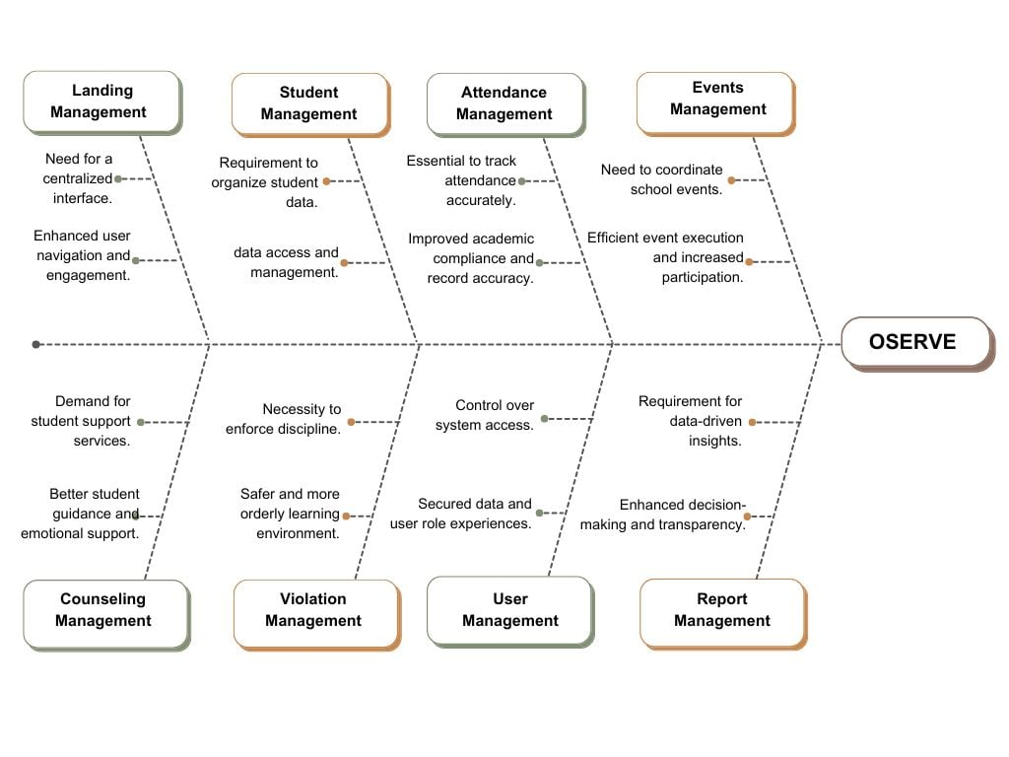

Figure 11. Fishbone diagram of the study

*Technical feasibility*. The main purpose of the system is to make the operations of OSAS more efficient and organized. Assessing of the factors such as risk and mitigation once the system is being developed as shown in Appendix 1.

*Economic feasibility*. The system will be implemented at Cavite State University – Carmona Campus, Carmona, Cavite. The system will be developed to meet the needs of Office of Student Affairs and Services. With this, the budgetary requirement of the system is expected to reach 4,500.00 pesos (Appendix 2).

*Schedule feasibility*. The estimated time of the development of the system will be 5 months. The first month is for the requirements gathering and the remaining four months will be spent for designing and development of the system (Appendix 3).

**Requirements documentation.** The OSERVE system is a comprehensive and user-friendly platform designed to streamline student information management at Cavite State University-Carmona Campus. It offers a range of modules accessible to both administrators and staff, each tailored to specific functions.

*Student management module*. This module manages the entire student information from admission to graduation, ensuring that all necessary details are accurately recorded and easily accessible.

*Student management module*. This module manages the entire student information from admission to graduation, ensuring that all necessary details are accurately recorded and easily accessible.

*Violation and counseling management module*. The Violation and Counseling Management Module integrates the functionalities of managing student violations and counseling sessions in a unified system. It tracks each student's violations, allowing for accurate and detailed records over time. The module supports CRUD (Create, Read, Update, Delete) operations, enabling the addition, editing, updating, and deletion of violation records to ensure that information remains current and accurate. Additionally, the module handles counseling sessions by allowing the scheduling, modification, and deletion of session details. It also tracks the status of each session.

*compliance management module*. It manages the student information and the status of a specific student. This module manages the student’s information and monitor the status of their clearance.

*Report module*. In this module, handling of reports of the students that is active, inactive, and graduated.

*Setting module*. The Setting Module allows you to edit and customize the system's features. It handles all the functions that can be changed to fit your needs. You can easily update settings, change configurations, and adjust options to make the system work the way you want. This module gives you control over how the system looks and behaves, making it more flexible and user-friendly.

**System Development**

The proponents used Modified Waterfall Model Saravanos and Curinga (2023) for developing the system that includes several phases such as requirements analysis, Design, Development, Testing, Implementation, and Maintenance.

Figure 12 shows the Modified Waterfall Model of Saravanos and Curinga (2023).

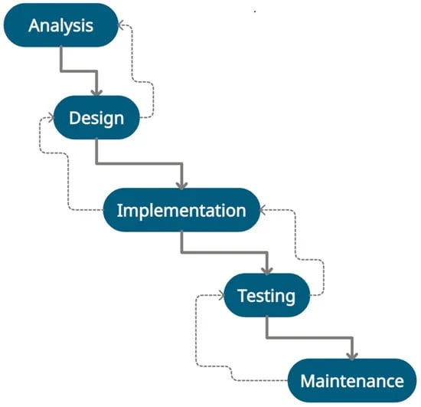

Figure 12. Modified Waterfall Model of Saravanos and Curinga (2023)

The Modified Waterfall Model will be used to propose a system for OSERVE: A Web-Based Student Information Management System with Integrated Clearance and Compliance Tracking for Cavite State University–Carmona Campus. This model is appropriate for proposed a web system.

**Analysis**. This phase, the proponents’ main job is to understand what the project is about, what it needs to achieve, and what limits it has. This starts with figuring out who is involved, like clients and users. The proponents talk to these people face-to-face, asking them questions in a way that is organized but also lets them share their thoughts freely. The goal is to gather detailed information about what the software needs to do, both in terms of specific functions and how it should work. This information is written down clearly. They also create examples to show how people will use the software, so everyone can understand how it will work visually. In this stage, the proponents look for problems like not having the right technology, not enough resources, or things that could go wrong. They also look for ways to do things better or more efficiently. They check if the project is possible from a technical, operational, and financial point of view. Once the requirements are gathered, they are checked with the client to make sure they are correct and match what the client wants. This makes sure everyone is on the same page about what needs to be done.

**Design.** During the design phase, all the requirements gathered earlier are turned into a detailed plan. The developer must define exactly how the system will look and function. This includes creating wireframes, which are like blueprints showing the layout of the screens and how they connect. The system interface is also designed, which is how users will interact with the software. This includes things like buttons, menus, and forms. Sketches are often used to visualize these interfaces before they are built.In simpler terms, this phase is like drawing a map of the software. It shows where everything will go and how people will use it. This step is crucial because it ensures that everyone involved understands how the software will work before any actual coding begins.

Figure 13 shows the use case diagram of thestudent management module.

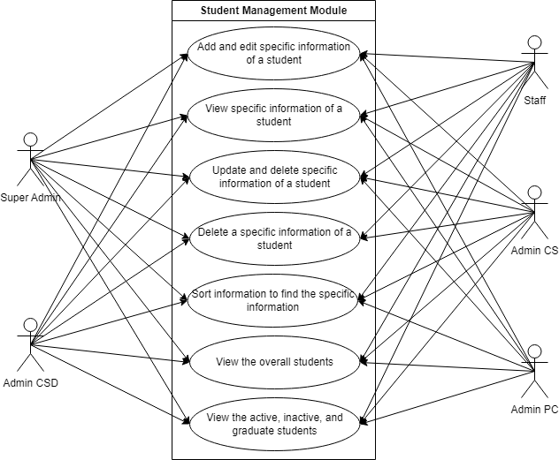

Figure 13. Use case diagram of the student management module

This use case diagram of the student management module illustrates the student management module, which allows both Admin and Staff to access and manage student information. Admin and Staff can edit, add, delete, update, and sort student information. They can also view all students in the table, including details on whether a student is active, inactive, or graduated.

Figure 14 shows the use case diagram of the compliance management module.

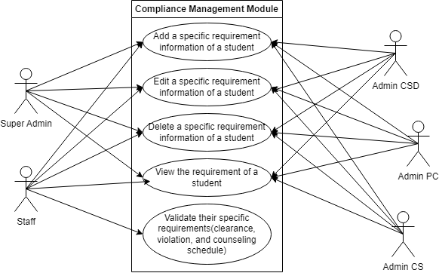

Figure 14. Use case diagram of compliance management module

The compliance management module illustrates the compliance that is needed in every student. It manages the student information and monitors the status of the clearance of students which can be accessed by both Admin and Staff. In this module, both Admin and Staff can add specific compliance, update existing requirements, and delete requirements as needed.

Figure 15 shows the use case diagram of the report management module.

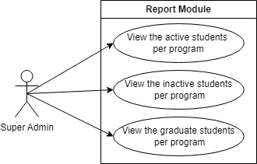

Figure 15. Use case diagram of report module

This use case diagram illustrates the report module, accessible only to Admin. In this module, Admin can view reports containing information on active students, inactive students, and graduates.

Figure 16 shows the use case diagram of violation management module.

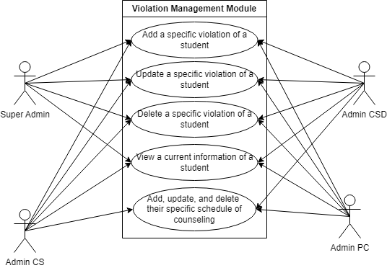

Figure 16. Use case diagram for violation management module

The violation management module is accessible by both Admin and Staff. In this module, Admin and Staff can add specific violations. They can also update or delete these violations as necessary. Additionally, both roles can view the overall violations of students, providing a comprehensive view of student disciplinary records.

Figure 17 shows the use case diagram of the counseling management module.

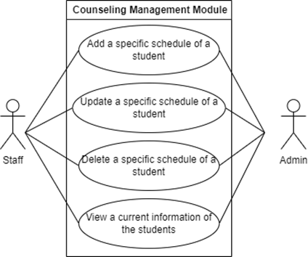

Figure 17. Use case diagram for counseling management module

Within this module, Admin and Staff can add specific schedules for students, update existing schedules, and delete schedules as needed. They can also view comprehensive student information related to counseling sessions, aiding in effective student support and management.

**Implementation.** In this phase, the proponents take the detailed design specifications and start building the actual software system. This phase involves several key activities. Firstly, developers write the code according to the design specifications, programming the functionality of the software, create algorithms, and implementing the user interface. Database developers concurrently work on creating the database structure based on the design specifications, defining tables, relationships, and data storage mechanisms. Simultaneously, user interface designers and developers focus on creating the graphical user interfaces (GUIs) that users will interact with, designing layouts, buttons, forms, and other elements to make the software easy to use. As these components are developed, they are integrated to work together. This involves connecting the user interface with the underlying code, integrating third-party libraries or services, and ensuring effective communication between all parts of the software.

**Testing.** The primary goal is to verify that the system functions correctly according to its requirements. There are three main types of testing performed: user acceptance testing, unit testing, and system testing.User acceptance testing involves the potential users of the system testing it to ensure it meets their needs and expectations. This testing is crucial as it confirms that the system is usable and acceptable to those who will be using it.

Unit testing is conducted by developers early in the development process to identify and fix bugs and errors in the system's individual components or units. This helps ensure that each part of the system works as intended before integrating them into the larger system.

System testing is performed to validate that the integrated system functions correctly as a whole. IT experts and domain experts test the system to ensure that it meets all specified requirements and performs as expected in its intended environment.

The testing phase is essential for identifying and fixing any issues with the system before it is deployed to users. It helps ensure that the system meets its objectives and delivers a high level of quality and performance.

**Maintenance.** In this phase, the software is released for use after thorough testing and approval. This phase begins with deployment planning, where a detailed schedule is created, outlining when and how the software will be deployed. Necessary preparations follow, such as setting up servers, databases, and ensuring that all required hardware and software components are ready. The software is then installed and configured on the target systems, involving steps like copying files to the appropriate directories and setting up configuration files to meet system requirements. Once deployed, the software undergoes post-deployment testing in the real environment to ensure it functions correctly. Users are trained on how to use the software, and a gradual rollout to end-users takes place. During this period, the software is closely monitored, and support is provided to address any issues that arise. Feedback from users is collected to identify and implement any necessary improvements. Regular maintenance is carried out to update the code, address troubleshooting issues, and ensure optimal system performance. This phase also involves making any necessary enhancements or modifications to meet changing user needs or technological requirements.

**System Testing**

The system will undergo testing using tools and checklists outlined in System Testing (Appendix 4), with the primary objective of identifying any bugs. Testers will utilize a questionnaire paired with a checklist to ensure that the system aligns with all requirements. In system testing, it also details the minimum hardware specifications necessary for testing. The questionnaire is designed to verify the suitability of the test environment The system's functionalities will be thoroughly tested to validate their proper operation. Testers will provide feedback and request changes as necessary. Additionally, compatibility tests will be conducted to ensure the system works seamlessly across different devices, operating systems, RAM capacities, and screen resolutions. The testing process aims to ascertain that the OSERVE functions correctly, achieves its intended objectives, and can be effectively automated. This includes bug identification, confirmation of feature functionality, and verification of compatibility with various hardware and software configurations.

The student management module will be tested to make sure all its functions are working properly. Testers will check for bugs, verify that features perform as expected, and confirm that the system is easy to use and reliable. They will also ensure that it can accurately track and display information about specific students. The counseling management module should be designed to handle scheduling and related issues. It will facilitate appointment scheduling and tracking by allowing students to book counseling sessions and get sessions to sync and remind about upcoming appointments. The violation management module will facilitate the reporting process by allowing students, staff, and administrators to submit violation reports. The report management module will track the status of each student who is active, inactive and graduate. The requirement management module allows both Admin and Staff to view the overall requirements of the students, promoting transparency and enabling better collaboration This functionality enhances the efficiency of requirement management processes.

**System Evaluation**

The system evaluation will be divided into two parts of ISO 25010: product quality and quality in use. Evaluation instrument ISO 25010 for product quality is tested based on different criterion and its indicator. Functional suitability criterion will be tested by its indicator that consist of functional completeness, functional correctness, and functional appropriateness. Performance efficiency criterion consists of testing the system based on its time behavior, resource utilization, and capacity. Moreover, Compatibility criterion will be tested based on its co-existence and interoperability indicator. Usability is consisting of six indicators namely appropriateness recognizability, learnability, operability, user protection error, user interface aesthetics, and accessibility. Testing of the maintainability criterion also consist of different indicators, modularity, reusability, analysability, modifiability, and testability. Criterion portability will be tested based on its indicator adaptability, installability, and replaceability. The respondents of the evaluation for product quality in use will consist of 10 IT experts, 5 domain experts, and 65 secondary users to complete the minimum requirement of 80 respondents for product quality.

Quality in use of ISO 25010 is tested based on different criterion and indicators (Appendix 6). Effectiveness and Efficiency will be tested to see if the degree of accuracy and degree of resources is also accurate which help users to achieve goals. Satisfaction criterion is divided into usefulness, trust, pleasure, and comfort. Freedom from risk will be tested based on its criterion such as economic risk mitigation, health and safety risk mitigation, and environmental risk mitigation. Context coverage will be tested based on its context completeness and flexibility. Respondents of the evaluation for quality in use will consist of 4 Admin user of Oserve. With indicators of numerical rating interpreted as 1 for poor, 2 for fair, 3 for good, 4 for very good, and 4 for excellent.

Frequency count, on one hand is a fundamental statistical concept used to quantify the occurrence of specific values or categories within a dataset. It is particularly useful for analyzing categorical data, where values represent distinct categories or groups. By tallying the frequency of each category, researchers can gain insights into the distribution and prevalence of different characteristics within the dataset.

Percentage, on the other hand, is a proportion of a whole expressed in parts per hundred. It is calculated by dividing the frequency of a particular value by the total number of values in the dataset and then multiplying by 100. This gives the percentage of times that value occurs in the dataset.

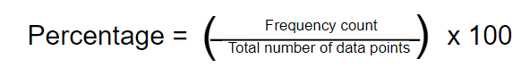In calculating the percentage based on the frequency count, the following formula is:

To assess how the participants interpreted their evaluation of the system, the indicators were scored using a scale of 1 to 5. The rating scale was categorized as follows: 1.00 to 1.80 was considered poor, 1.81 to 2.60 as fair, 2.61 to 3.40 as good, 3.41 to 4.20 as very good, and 4.21 to 5.00 as excellent

**Implementation Plan**

The implementation plan for the Web-Based Student Information Management System with Integrated Clearance and Compliance Tracking for Cavite State University – Carmona Campus involves several key activities to perform for the successful implementation of the system.

Table 1 shows the Implementation plan of the study.

Table 1. Implementation plan

|  |  |  |  |
| --- | --- | --- | --- |
| STRATEGY | ACTIVITIES | PERSONS  INVOLVED | DURATION |
| Obtain approval from  the administrator | Working on all necessary documents such as clearance | Proponents,  Administrator | 1 day |
| System’s  Deployment | Deployment n of the system and required software and hardware | Proponents,  Administrator | 1 to 2 days |
| Information  distribution | Create and distribution of flyers and manuals | Proponents, Administrator,  Faculty, and Students | 1 days |
| Three-day training | Conduct of hands-on system tutorial for the end user | Administrator and end user | 3 days |

The implementation plan shows the steps involved in getting approval, deploying the system, Distributing the information, and providing training. Initially, the administrator approval is necessary, involving the completion of essential documents such as clearance forms. This process typically takes one day and requires input from both proponents and the administrator. Following approval, the system is deployed, requiring the setup of necessary software and hardware components. This stage may duration is one to two days and requires collaboration between proponents and the administrator. Following that efforts are made to distribute the information, involving the creation and distribution of promotional materials such as flyers and manuals. This task generally requires one day to complete and involves coordination between the administrator and individuals within the school community. Finally, a three-day training session is conducted to provide hands-on tutorials for end-users. Both the administrator and end-users contribute to this training initiative.

**REFERENCES**

Akiwate, B. Patel, A., Nabiwale, T., Naik, N., & Patil, S. (2016). Web Based Student Information Management System using MEAN Stack. *International Journal of Advanced Research in Computer Science and Software Engineering (2016) 6(5) 357-362.* Retrieved from <https://www.mendeley.com/catalogue/ecaee525-f6cb-335e-b05d-ac2a9e0b298b/>

Andollo, A., Aseey, A. A. A., & Rambo, C. M. (2020). Influence of Availability of Information Communication and Technology Infrastructure on the Use of Student Management Information System in Teacher Training Programmes by Distance Learning in Universities in Kenya. *International Journal of Arts and Social Science*, *3*(4), 334–347. Retrieved from https://www.ijassjournal.com/2020/V3I4/4146575870.pdf

Bangun, M. H. (2022). STUDENT ABSENCE INFORMATION SYSTEM AT PANCUR IDO ELEMENTARY SCHOOL USING RAPID APPLICATION DEVELOPMENT METHOD. *Instal : Jurnal Komputer*, *14*(02), 52–56. <https://doi.org/10.54209/jurnalkomputer.v14i02.47>

Chinyere, A., & Love, O. (2019). School Records in Basic Schools. *IAA Journal of Applied Sciences*, *5*(1), 41–52. Retrieved from [www.iaajournals.org](http://www.iaajournals.org)

de Azevedo, Y. C. A., de Jesus, L. R., de Araújo, W. F., Costa, F. F. da S., Smith, E., & de Lima, A. A. (2022). SCHOOL ATTENDANCE MANAGEMENT SYSTEM FOR STUDENTS THROUGH FACIAL RECOGNITION. *Journal of Engineering and Technology for Industrial Applications*, *8*(38), 15–23. https://doi.org/10.5935/jetia.v8i38.838

Baindoor, S., Adhira Devi, S. P., M, S. K., & Ranjan, A. (2016). Enhanced Model of Student Information Management System. *International Journal of Engineering Applied Sciences and Technology*, *1*(7), 23–25. Retrieved from <http://www.ijeast.com>

Dahiru, A. S. & Yahaya, N. (2023). School records-keeping culture among public and private schools in Nigeria. Retrieved from <https://www.school-records-keeping-culture-among-public-and-private-schools-in-nigeria.pdf>

Drapkina, O. M., Astanina, S. Y., & Shepel, R. N. (2022). Monitoring the quality of training programs for internists and general practitioners. *Cardiovascular Therapy and Prevention (Russian Federation)*, *21*, 7–16. <https://www.mendeley.com/catalogue/81b742a8-659c-3d84-9d09-8318afd9ee14/>

Evans, D. K., & Mendez Acosta, A. (2023). How to measure student absenteeism in low- and middle-income countries. *Economics of Education Review*, *96*. <https://doi.org/10.1016/j.econedurev.2023.102454>

Ikhwan, S., Mukhtar, M., & Wahyudi, M. (2019). Development of Information Systems Models Management for Students. *International Journal for Educational and Vocational Studies*, *1*(7). <https://doi.org/10.29103/ijevs.v1i7.1775>

Jain, S., Garg, R., Bhosle, V., & Sah, L. (2018). Smart university-student information management system. In *Proceedings of the 2017 International Conference On Smart Technology for Smart Nation, SmartTechCon 2017* (pp. 1183–1188). Institute of Electrical and Electronics Engineers Inc. <https://doi.org/10.1109/SmartTechCon.2017.8358555>

Junaidi, N. H, Richard, L. & Busrah, N. H. (2021). Youth perception and the effects of disciplinary action implemented in school. Retrieved from <https://www.researchgate.net/publication/348932754_Youth_Perception_and_the_Effects_of_Disciplinary_Action_Implemented_in_School>

Kashyap, D. (2015). Educational Administration: Meaning, Nature and Other Details. Retrieved from https://www.yourarticlelibrary.com/educational-management/educational%20administration/educational-administration-meaning-nature-and-other-details/63730

Kearney, C. A., & Graczyk, P. A. (2020, September 1). A Multidimensional, Multi-tiered System of Supports Model to Promote School Attendance and Address School Absenteeism. *Clinical Child and Family Psychology Review*. Springer. <https://doi.org/10.1007/s10567-020-00317-1>

Kearney, C. A. (2021, August 1). Integrating Systemic and Analytic Approaches to School Attendance Problems: Synergistic Frameworks for Research and Policy Directions. *Child and Youth Care Forum*. Springer. <https://doi.org/10.1007/s10566-020-09591-0>

Logachev, M. S., Orekhovskaya, N. A., Seregina, T. N., Shishov, S., & Volvak, S. F. (2021). Information system for monitoring and managing the quality of educational programs. Journal of Open Innovation: Technology, Market, and Complexity, 7(1).<https://www.mendeley.com/catalogue/5fd90535-7c36-3617-a3da-cc7ff688b940/>

Lubanga, S. C., Chawinga, W. D., Majawa, F., & Kapondera, S. (2018). Web-based Student Information Management System in Universities: Experiences from Mzuzu University. *Standing Conference of Eastern, Central and Southern Africa Library and Information Associations (SCESCAL)*, (May), 655–669.

Nadhira, F., Wahyuddin, Moh. I., & Sari, R. T. K. (2022). Penerapan Metode Agile Scrum Pada Rancangan SisIAM4. *JURNAL MEDIA INFORMATIKA BUDIDARMA*, *6*(1), 560. https://doi.org/10.30865/mib.v6i1.3525

Odeniyi, O. A., & Adeyanju, A. S. (2020). ASSESSMENT OF SCHOOL RECORD MANAGEMENT IN SECONDARY SCHOOLS IN FEDERAL CAPITAL TERRITORY. *Open Journal of Educational Development (ISSN: 2734-2050)*, *1*(1), 54–65. <https://doi.org/10.52417/ojed.v1i1.63>

Raj, A., Raj, A., & Ahmad, I. (2021). Smart Attendance Monitoring System with Computer Vision Using IOT. *Journal of Mobile Multimedia* <https://www.mendeley.com/catalogue/2caba4b7-ad9b-3663-8deb-36c27d1d90fa/>

Robinson, J. T., Thorvaldsdottir, H., Turner, D., & Mesirov, J. P. (2023). igv.js: an embeddable JavaScript implementation of the Integrative Genomics Viewer (IGV). *Bioinformatics*, *39*(1). <https://doi.org/10.1093/bioinformatics/btac830>

Sergeeva, M. G., Latipova, L. N., Rekhtina, I. V., Sannikova, N. I., Zemliakov, D. N., & Shvedov, L. A. (2019). Organization of monitoring in the quality management system of the educational process when training of specialists. *Humanities and Social Sciences Reviews*, *7*(6), 227–232.<https://www.mendeley.com/catalogue/af209bf9-7ab5-3bba-a695-af01b237073b/>

Šušter, I., & Ranisavljević, T. (2023). Optimization of MySQL database. *Journal of Process Management and New Technologies*, *11*(1–2), 141–151. <https://doi.org/10.5937/jouproman2301141q>

Tabarés, R. (2021). HTML5 and the evolution of HTML; tracing the origins of digital platforms. *Technology in Society*, *65*. https://doi.org/10.1016/j.techsoc.2021.101529

Wilson, K. (2023). Cascading Style Sheets. In *The Absolute Beginner’s Guide to HTML and CSS* (pp. 75–126). Apress. https://doi.org/10.1007/978-1-4842-9250-1_4

Wu, X., Feng, B., & Qi, W. (2020). Design and Implementation of a Novel Student Information Management System. In *Proceedings of 2020 IEEE 3rd International Conference on Information Systems and Computer Aided Education, ICISCAE 2020* (pp. 637–639). Institute of Electrical and Electronics Engineers Inc. https://doi.org/10.1109/ICISCAE51034.2020.9236801

Yuliadi, Y., Zaen, M. T. A., Sofya, N. D., & Sonia, S. (2022). Rekayasa Sistem Informasi Absensi Siswa Sekolah Berbasis Internet. *Journal of Information System Research (JOSH)*, *3*(4), 636–643. <https://doi.org/10.47065/josh.v3i3.1522>

Zhou, Y., & Hou, L. (2023). Intelligent Campus Student Information Management System Based on Cloud Platform. In *2023 2nd International Conference for Innovation in Technology, INOCON 2023*. Institute of Electrical and Electronics Engineers Inc. <https://doi.org/10.1109/INOCON57975.2023.10101285>

**APPENDICES**

**Appendix 1**

Technical Feasibility Assessment

Republic of the Philippines

**CAVITE STATE UNIVERSITY**

**Carmona Campus**

Market Road, Carmona, Cavite

🕾 (046) 487-6328/cvsucarmona@cvsu.edu.ph

www.cvsu.edu.ph

**DEPARTMENT OF INDUSTRIAL AND INFORMATION TECHNOLOGY**

|  |  |  |
| --- | --- | --- |
| Name of Researchers | : | **FAIRY ROSS M. NARITO, CHRIZEL ANN V. SOLOMON, MARK LESTER L. TAAS, and ALYSSA Y. TORRES** |
| Program | : | **BACHELOR OF SCIENCE IN INFORMATION TECHNOLOGY** |
| Title of Study: | : | **OSERVE: A WEB-BASED STUDENT INFORMATION MANAGEMENT SYSTEM WITH INTEGRATED CLEARANCE AND COMPLIANCE TRACKING FOR CAVITE STATE UNIVERSITY - CARMONA CAMPUS** |

|  |
| --- |
| **Project Overview** |
| The study aims to develop a web-based student information management system with integrated clearance and compliance tracking for Cavite State University Carmona Campus. The Administrator faces difficulties with manual processes, particularly in tracking student files with incomplete requirements. This tracking is crucial as students without clearance cannot be marked as enrolled. To address this, a request was made for a system that can manage student information and track clearance and compliance. The key functional requirements include Student Management, Counseling Management, Violation Management, Report Management, and Requirement Management modules. Admin will have full access, while Staff will have limited access for specific tasks like updating and searching student information. The system should generate reports to ensure transparency. For non-functional requirements, the system must comply with security standards to protect data and prevent unauthorized access. The timeline includes phases such as requirement analysis, design, coding, testing, operation, and maintenance. |
| **Technology Assessment** |
| Existing Technologies:   1. List the existing technologies currently used in the organization or relevant to the project.   - Currently, the organization, particularly the Campus, relies heavily on manual processes for its operations. This is evident in the manual handling of student information management, indicating a lack of digital systems or technologies in use.   1. Evaluate the suitability and maturity of these technologies for the project's requirements.   - The current manual processes for student information management at the university are not efficient. To effectively meet project requirements, it is necessary to transition to a digital student information management system. This system should include integrated clearance and compliance tracking, improve efficiency, and ensure data security.  - Effective for the Administrator and student because the administrator can see what the student lack on the documents and the student can bring it if the administrator say so. |
| Emerging Technologies:   1. Identify any emerging technologies that could potentially address the project's requirements.   - the technology that is featured can be access even in offline also this can be use in event for the attendance, tracking the current status of the student.   1. Assess the maturity and adoption level of these emerging technologies.   - The technologies for offline-capable student information management are mature and widely adopted due to their reliability, functionality and speed. |
| **Resource Assessment** |
| Hardware:   1. Identify the hardware requirements for the project, such as servers, workstations, and network infrastructure.   - The main device will be used in the development of the web-based student information management system with integrated clearance and compliance tracking is dell latitude 3520 it has specification of intel i5 with 16gb of ram and 512 ssd.   1. Evaluate the availability and adequacy of the existing hardware.   - This specific device is suitable for the development for the web-based student information management system with integrated clearance and compliance tracking and it meets the hardware requirement that capable of building the testing. |
| Software:   1. Identify the software requirements for the project, including operating systems, programming languages, and development tools.   - the operation system will be use for the development is windows 10.  - for the programming language is the developers will use the javascript, php  - the developers will also use the html, css and bootstrap for the design.   1. Assess the availability and compatibility of the existing software.   - Windows 10 for the stable operating system and this can carer the latest tools for development  - Php and javascript is compatible with operating system.  - Html and css are usually standard for web development. |
| Personnel:   1. Identify the technical skills and expertise required for the project.  * the technical skill is need to acquire to development of the system.   1. Proficiency in software development, including programming languages.  2. Proficiency in database management, particularly with storing data in MySQL.  3. Experience in web development.  4. Understanding of security threats.  5. Project management skills.  6. Ability to provide support and training in technical aspects for the OSAS.  b. Evaluate the availability and expertise of the existing team members.  - The team members possess the technical skills, time management abilities, and project management traits necessary to complete the web-based student information management system with integrated clearance and compliance tracking. |
| **Risk Assessment** |
| Identify potential technical risks that could impact the project's success.   1. System integration from manual processes to a digital system can be time-consuming and prone to information errors. 2. Scalability challenges may arise when handling increased data and user loads. lack of technical expertise, leading to insufficient knowledge and skills to effectively use and manage the system assess the likelihood and severity of risk   Assess the likelihood and severity of each risk.   1. System integration - Manual to system this will be taking a lot of time and prone to human error, can be error on name or id. 2. Scalability challenges - Managing the growing volume of data that a system accumulates over time can become challenging. As data increases, it becomes more difficult to store, process, and retrieve efficiently. This can result in slower performance and increased storage requirements   This may not be immediate impact. However, this left unaddressed this can lead to hindering the system.  Develop mitigation strategies to address the identified risks.   1. System integration issues.   - conduct a checking per batch to resolve the issues  - Identify and make some notes to the unreadable files   1. scalability challenges issues.   - maintain the data need as possible  - get a much bigger data storage  - also check the unnecessary data and delete it. |
| **Overall Technical Feasibility Assessment** |
| The assessment shows that making a web-based student information management system with integrated clearance and compliance tracking for Cavite State University Carmona Campus is doable. Even though there are challenges and risks, there are plans in place to handle them. Also, there is the right software, hardware, and skilled people available, suggesting the project can be done well within the project's limits. |

**Appendix 2**

Budgetary Requirements

Republic of the Philippines

**CAVITE STATE UNIVERSITY**

**Carmona Campus**

Market Road, Carmona, Cavite

🕾 (046) 487-6328/cvsucarmona@cvsu.edu.ph

www.cvsu.edu.ph

**DEPARTMENT OF INDUSTRIAL AND INFORMATION TECHNOLOGY**

|  |  |  |
| --- | --- | --- |
| Name of Researchers | : | **FAIRY ROSS M. NARITO, CHRIZEL ANN V. SOLOMON, MARK LESTER L. TAAS, and ALYSSA Y. TORRES** |
| Program | : | **BACHELOR OF SCIENCE IN INFORMATION TECHNOLOGY** |
| Title of Study: | : | **OSERVE: A WEB-BASED STUDENT INFORMATION MANAGEMENT SYSTEM WITH INTEGRATED CLEARANCE AND COMPLIANCE TRACKING FOR CAVITE STATE UNIVERSITY - CARMONA CAMPUS** |

|  |  |
| --- | --- |
| **PARTICULARS** | **AMOUNT (P)** |
| 1. Domain Hosting | 2,500.00 |
| 1. Web Hosting | 2,000.00 |
| **TOTAL** | **4,500.00** |

**Appendix 3**

Gantt Chart

Republic of the Philippines

**CAVITE STATE UNIVERSITY**

**Carmona Campus**

Market Road, Carmona, Cavite

🕾 (046) 487-6328/cvsucarmona@cvsu.edu.ph

www.cvsu.edu.ph

**DEPARTMENT OF INDUSTRIAL AND INFORMATION TECHNOLOGY**

|  |  |  |
| --- | --- | --- |
| Name of Researchers | : | **FAIRY ROSS M. NARITO, CHRIZEL ANN V. SOLOMON, MARK LESTER L. TAAS, and ALYSSA Y. TORRES** |
| Program | : | **BACHELOR OF SCIENCE IN INFORMATION TECHNOLOGY** |
| Title of Study: | : | **OSERVE: A WEB-BASED STUDENT INFORMATION MANAGEMENT SYSTEM WITH INTEGRATED CLEARANCE AND COMPLIANCE TRACKING FOR CAVITE STATE UNIVERSITY - CARMONA CAMPUS** |

|  |  |  |  |  |  |  |  |  |  |  |  |
| --- | --- | --- | --- | --- | --- | --- | --- | --- | --- | --- | --- |
| **ACTIVITY** | **2024** | | | | | | | | | | **2025** |
| **Mar** | **Apr** | **May** | **Jun** | **Jul** | **Aug** | **Sep** | **Oct** | **Nov** | **Dec** | **Jan** |
| Proposal drafting |  |  |  |  |  |  |  |  |  |  |  |
| Proposal defense |  |  |  |  |  |  |  |  |  |  |  |
| System design |  |  |  |  |  |  |  |  |  |  |  |
| System development |  |  |  |  |  |  |  |  |  |  |  |
| System testing |  |  |  |  |  |  |  |  |  |  |  |
| System evaluation |  |  |  |  |  |  |  |  |  |  |  |
| System implementation |  |  |  |  |  |  |  |  |  |  |  |
| Manuscript preparation |  |  |  |  |  |  |  |  |  |  |  |
| Final oral defense |  |  |  |  |  |  |  |  |  |  |  |
| Manuscript review |  |  |  |  |  |  |  |  |  |  |  |

**Appendix 4**

Evaluation Instrument for System Testing

Republic of the Philippines

**CAVITE STATE UNIVERSITY**

**Carmona Campus**

Market Road, Carmona, Cavite

🕾 (046) 487-6328/cvsucarmona@cvsu.edu.ph

www.cvsu.edu.ph

**OSERVE: A WEB-BASED STUDENT INFORMATION MANAGEMENT SYSTEM WITH INTEGRATED CLEARANCE AND COMPLIANCE TRACKING FOR CAVITE STATE UNIVERSITY - CARMONA CAMPUS**

1. **INTRODUCTION**

A web based student information management system with integrated clearance and compliance tracking for the cavite state university carmona campus will be developed to efficiently track the students information, manage and track the clearance and compliance of the student. it also allocate a materials and others for the project. this will be efficient to Office Students Affair Service(OSAS) as the information will be handle efficient and less time consuming.

1. **OBJECTIVES**

The main objective of the study is this test document is to discover the bugs and fix the issues before the user evaluation.

This project will help the proponents to

Specifically, it aims to:

1. develop test cases for the testers (IT experts);
2. test the system in terms of usability, functionality, performance, and portability.
3. gather feedback from the testers.
4. **TASKS**

The testers were provided a questionnaire which includes a checklist of attributes that the proposed system should comply with. A column for the tester’s comments or recommendations is also provided.

The bugs discovered in this tool were addressed by the developer if deemed necessary and/or within the requirements and specifications of this project.

1. **HARDWARE REQUIREMENTS**

The following hardware specifications ensure that the system runs. Before the start of the software testing, the minimum hardware requirements as stated below is compared to the actual specification used by the tester.

Table 1. Minimum hardware specification

|  |  |
| --- | --- |
| **HARDWARE SPECIFICATION** | **MINIMUM** |
| RAM  Hard disk drive  Screen resolution | 1 GB  400 MB  480x800 |

**V. SOFTWARE TESTING QUESTIONNAIRE**

Table 2. Test environments

|  |  |  |
| --- | --- | --- |
| **ITEM(S) FOR CHECKING** | **COMPLIANCE** | **REMARKS (IF ANY)** |
| 1. The role of the tester had been clearly defined. |  |  |
| 1. The tester used the project in Android version:    1. 7.0    2. 6.0    3. 5.1    4. 5.0    5. 4.4 |  |  |
| 1. The tester used the project in the following screen resolutions:    1. 1080x1920    2. 480x800    3. 720x1280 |  |  |

**Test Scenarios:**

Table 3. Functionality

|  |  |  |
| --- | --- | --- |
| **CRITERION** | **COMPLIANCE** | **REMARKS/ REQUEST FOR CHANGE (IF ANY)** |
| 1. **Student Management Module** |  |  |
| 1. Admin and staff can add a specific information of a student |  |  |
| 1. Admin and staff can edit specific information of a student |  |  |
| 1. Admin and staff can update specific information of a student |  |  |
| 1. Admin and staff can delete specific information of a student |  |  |
| 1. Admin and staff can sort information to find the specific information |  |  |
| 1. Admin and staff can view the overall students |  |  |
| 1. Admin and staff can view the active, inactive, and graduate students |  |  |
| **B. Requirement Management Module** |  |  |
| 1. Staff and Admin can add a specific information of a student |  |  |
| 1. Staff and Admin can edit a specific information of a student |  |  |
| 1. Staff and Admin can delete a specific information of a student |  |  |
| 1. Staff and Admin can view the requirement of a student |  |  |
| **C. Report Management Module** |  |  |
| 12. Admin can view the active student per program |  |  |
| 13. Admin can view the inactive student per program |  |  |
| 14. Admin can view the graduate student per program |  |  |
| **CRITERION** | **COMPLIANCE** | **REMARKS/ REQUEST FOR CHANGE (IF ANY)** |
| **D. Violation Management Module** |  |  |
| 15. Staff and admin can add a specific violation of a student |  |  |
| 16. Staff and admin can update a specific violation of a student |  |  |
| 17. Staff and admin can delete a specific violation of a student |  |  |
| 18. Staff and admin can view information of a student |  |  |
| **E. Counseling Management Module** |  |  |
| 19. Staff and admin can add schedule of a student |  |  |
| 20. Staff and admin can update schedule of a student |  |  |
| 21. Staff and admin can delete schedule of a student |  |  |
| 22. Staff and admin can view a current information of a student |  |  |

Table 4. Portability

|  |  |  |  |  |
| --- | --- | --- | --- | --- |
| **SPECIFICATIONS (MODEL, OS, RAM, RESOLUTION)** | **INSTALLED** | **WORKED PROPERLY** | **ACTIONS** | **RESPONSE TIME(S)** |
| Huawei D15, 512gb, Windows 11, 15.6 inches |  |  |  |  |
| Huawei D15, 256gb, Windows 11, 15.6 inches |  |  |  |  |

Prepared:

**FAIRY ROSS M. NARITO**

**CHRIZEL ANN V. SOLOMON**

**MARK LESTER L. TAAS**

**ALYSSA Y. TORRES**

**Appendix 5**

Evaluation Instrument ISO 25010 for Product Quality

Republic of the Philippines

**CAVITE STATE UNIVERSITY**

**Carmona Campus**

Market Road, Carmona, Cavite

🕾 (046) 487-6328/cvsucarmona@cvsu.edu.ph

www.cvsu.edu.ph

**EVALUATION INSTRUMENT FOR**

**OSERVE: A WEB-BASED STUDENT INFORMATION MANAGEMENT SYSTEM WITH INTEGRATED CLEARANCE AND COMPLIANCE TRACKING FOR CAVITE STATE UNIVERSITY - CARMONA CAMPUS**

|  |
| --- |
| Dear Participant,  Good day! We are currently conducting a research entitled “**OSERVE: A WEB-BASED STUDENT INFORMATION MANAGEMENT SYSTEM WITH INTEGRATED CLEARANCE AND COMPLIANCE TRACKING FOR CAVITE STATE UNIVERSITY - CARMONA CAMPUS”.** In line with this, we are respectfully request your assistance in filling out this evaluation form. It will not be a problem if you wish not to participate, but your responses will be highly valued. The evaluation form can be completed anonymously. Responses from completed questionnaires will be collated for analysis; once complete, the original questionnaires will be kept electronically. Rest assured that all information indicated therein will be treated with utmost confidentiality under the Data Privacy Law of 2012 and strictly used only for the above purpose. All the gathered information/data will also be retained in the system and used as a part of the historical data for further analysis. If you wish to learn more about the results of the research, please send an email to cc.marklester.taas@cvsu.edu.ph  We are hoping for your kind consideration and support. Thank you very much. |

Name (Optional): ______________________________________ Date: _________

Address (Optional): ___________________________________________________

Profession: _____________________________ Specialization: ________________

▢ IT experts ▢Domain experts ▢Secondary users

**Instructions:** Please evaluate using the given scale and placing a checkmark (✓) on the appropriate column corresponding to your response.

**Numerical Rating:**

5 – Excellent 4 – Very Good 3 – Good 2 – Fair 1 – Poor

| **INDICATOR** | **5** | **4** | **3** | **2** | **1** |
| --- | --- | --- | --- | --- | --- |
| **Functional Suitability** |  |  |  |  |  |
| 1. **Functional completeness -** Degree to which the set of functions covers all the specified tasks and user objectives. |  |  |  |  |  |
| 1. **Functional correctness** - Degree to which a product or system provides the correct results with the needed degree of precision. |  |  |  |  |  |
| 1. **Functional appropriateness** - Degree to which the functions facilitate the accomplishment of specified tasks and objectives. |  |  |  |  |  |
| **Performance Efficiency** |  |  |  |  |  |
| 1. **Time behaviour** - Degree to which the response and processing times and throughput rates of a product or system, when performing its functions, meet requirements. |  |  |  |  |  |
| 1. **Resource utilization** - Degree to which the amounts and types of resources used by a product or system, when performing its functions, meet requirements. |  |  |  |  |  |
| 1. **Capacity** - Degree to which the maximum limits of a product or system parameter meet requirements. |  |  |  |  |  |
| **Compatibility** |  |  |  |  |  |
| 1. **Co-existence** - Degree to which a product can perform its required functions efficiently while sharing a common environment and resources with other products, without detrimental impact on any other product. |  |  |  |  |  |
| 1. **Interoperability** - Degree to which two or more systems, products or components can exchange information and use the information that has been exchanged. |  |  |  |  |  |
| **Usability** |  |  |  |  |  |
| 1. **Appropriateness recognizability** - Degree to which users can recognize whether a product or system is appropriate for their needs. |  |  |  |  |  |
| 1. **Learnability** - Degree to which a product or system can be used by specified users to achieve specified goals of learning to use the product or system with effectiveness, efficiency, freedom from risk and satisfaction in a specified context of use. |  |  |  |  |  |
| 1. **Operability** - Degree to which a product or system has attributes that make it easy to operate and control. |  |  |  |  |  |
| 1. **User error protection** - Degree to which a system protects users against making errors. |  |  |  |  |  |
| 1. **User interface aesthetics** - Degree to which a user interface enables pleasing and satisfying interaction for the user. |  |  |  |  |  |
| 1. **Accessibility** - Degree to which a product or system can be used by people with the widest range of characteristics and capabilities to achieve a specified goal in a specified context of use. |  |  |  |  |  |
| **Reliability** |  |  |  |  |  |
| 1. **Maturity** - Degree to which a system, product or component meets needs for reliability under normal operation. |  |  |  |  |  |
| 1. **Availability** - Degree to which a system, product or component is operational and accessible when required for use. |  |  |  |  |  |
| 1. **Fault tolerance** - Degree to which a system, product or component operates as intended despite the presence of hardware or software faults. |  |  |  |  |  |
| 1. **Recoverability** - Degree to which, in the event of an interruption or a failure, a product or system can recover the data directly affected and re-establish the desired state of the system. |  |  |  |  |  |
| **Security** |  |  |  |  |  |
| 1. **Confidentiality** - Degree to which a product or system ensures that data are accessible only to those authorized to have access. |  |  |  |  |  |
| 1. **Integrity** - Degree to which a system, product or component prevents unauthorized access to, or modification of, computer programs or data. |  |  |  |  |  |
| 1. **Non-repudiation** - Degree to which actions or events can be proven to have taken place so that the events or actions cannot be repudiated later. |  |  |  |  |  |
| 1. **Accountability** - Degree to which the actions of an entity can be traced uniquely to the entity. |  |  |  |  |  |
| 1. **Authenticity** - Degree to which the identity of a subject or resource can be proved to be the one claimed. |  |  |  |  |  |
| **Maintainability** |  |  |  |  |  |
| 1. **Modularity** - Degree to which a system or computer program is composed of discrete components such that a change to one component has minimal impact on other components. |  |  |  |  |  |
| 1. **Reusability** - Degree to which an asset can be used in more than one system, or in building other assets. |  |  |  |  |  |
| 1. **Analysability** - Degree of effectiveness and efficiency with which it is possible to assess the impact on a product or system of an intended change to one or more of its parts, or to diagnose a product for deficiencies or causes of failures, or to identify parts to be modified. |  |  |  |  |  |
| 1. **Modifiability** - Degree to which a product or system can be effectively and efficiently modified without introducing defects or degrading existing product quality. |  |  |  |  |  |
| 1. **Testability** - Degree of effectiveness and efficiency with which test criteria can be established for a system, product or component and tests can be performed to determine whether those criteria have been met. |  |  |  |  |  |
| **Portability** |  |  |  |  |  |
| 1. **Adaptability** - Degree to which a product or system can effectively and efficiently be adapted for different or evolving hardware, software or other operational or usage environments. |  |  |  |  |  |
| 1. **Installability** - Degree of effectiveness and efficiency with which a product or system can be successfully installed and/or uninstalled in a specified environment. |  |  |  |  |  |
| 1. **Replaceability** - Degree to which a product can replace another specified software product for the same purpose in the same environment. |  |  |  |  |  |

*Adopted from the International Organization for Standardization (ISO) 25010 for product quality*

**Remarks/Comments/Suggestions:**

__________________________________________________________________________________________________________________________________________________________________________________________________________________________________________________________________________________________________________________________________________________________________________________________________________________

_____________________

Signature of Respondent

**Appendix 6**

Evaluation Instrument ISO 25010 for Quality in Use

Republic of the Philippines

**CAVITE STATE UNIVERSITY**

**Carmona Campus**

Market Road, Carmona, Cavite

🕾 (046) 487-6328/cvsucarmona@cvsu.edu.ph

www.cvsu.edu.ph

**EVALUATION INSTRUMENT FOR**

**OSERVE: A WEB-BASED STUDENT INFORMATION MANAGEMENT SYSTEM WITH INTEGRATED CLEARANCE AND COMPLIANCE TRACKING FOR CAVITE STATE UNIVERSITY - CARMONA CAMPUS**

|  |
| --- |
| Dear Participant,  Good day! We are currently conducting a research entitled “**OSERVE: A WEB-BASED STUDENT INFORMATION MANAGEMENT SYSTEM WITH INTEGRATED CLEARANCE AND COMPLIANCE TRACKING FOR CAVITE STATE UNIVERSITY - CARMONA CAMPUS”.** In line with this, we are respectfully request your assistance in filling out this evaluation form. It will not be a problem if you wish not to participate, but your responses will be highly valued. The evaluation form can be completed anonymously. Responses from completed questionnaires will be collated for analysis; once complete, the original questionnaires will be kept electronically. Rest assured that all information indicated therein will be treated with utmost confidentiality under the Data Privacy Law of 2012 and strictly used only for the above purpose. All the gathered information/data will also be retained in the system and used as a part of the historical data for further analysis. If you wish to learn more about the results of the research, please send an email to [cc.marklester.taas@cvsu.edu.ph](mailto:cc.marklester.taas@cvsu.edu.ph).  We are hoping for your kind consideration and support. Thank you very much. |

Name (Optional): ______________________________________ Date: _________

Address (Optional): ___________________________________________________

Profession: _____________________________ Specialization: ________________

**Instructions:** Please evaluate using the given scale and placing a checkmark (✓) on the appropriate column corresponding to your response.

**Numerical Rating:**

5 – Excellent 4 – Very Good 3 – Good 2 – Fair 1 – Poor

| **INDICATOR** | **5** | **4** | **3** | **2** | **1** |
| --- | --- | --- | --- | --- | --- |
| **Effectiveness** |  |  |  |  |  |
| 1. **Effectiveness** - Degree of accuracy and completeness with which users achieve specified goals. |  |  |  |  |  |
| **Efficiency** |  |  |  |  |  |
| 1. **Efficiency** - Degree of resources expended in relation to the accuracy and completeness with which users achieve goals. |  |  |  |  |  |
| **Satisfaction** |  |  |  |  |  |
| 1. **Usefulness** - Degree to which a user is satisfied with their perceived achievement of pragmatic goals, including the results of use and the consequences of use. |  |  |  |  |  |
| 1. **Trust** - Degree to which a user or other stakeholder has confidence that a product or system will behave as intended. |  |  |  |  |  |
| 1. **Pleasure** - Degree to which a user obtains pleasure from fulfilling their personal needs. |  |  |  |  |  |
| 1. **Comfort** - Degree to which the user is satisfied with physical comfort. |  |  |  |  |  |
| **Freedom from Risk** |  |  |  |  |  |
| 1. **Economic Risk Mitigation** - Degree to which a product or system mitigates the potential risk to financial status, efficient operation, commercial property, reputation or other resources in the intended contexts of use. |  |  |  |  |  |
| 1. **Health and Safety Risk Mitigation** - Degree to which a product or system mitigates the potential risk to people in the intended contexts of use. |  |  |  |  |  |
| 1. **Environmental Risk Mitigation**- Degree to which a product or system mitigates the potential risk to property or the environment in the intended contexts of use. |  |  |  |  |  |
| **Context coverage** |  |  |  |  |  |
| 1. **Context Completeness**- Degree to which a product or system can be used with effectiveness, efficiency, freedom from risk, and satisfaction in all the specified contexts of use. |  |  |  |  |  |
| 1. **Flexibility**- Degree to which a product or system can be used with effectiveness, efficiency, freedom from risk and satisfaction in contexts beyond those initially specified in the requirements. |  |  |  |  |  |

*Adopted from the International Organization for Standardization (ISO) 25010 for quality in use*

**Remarks/Comments/Suggestions:**

_________________________________________________________________________________________

Signature of Respondent