
School of InfoComm Technology

Distributed Data Pipelines
Diploma in Data Science (DS) 2025 Apr Semester

INDIVIDUAL ASSIGNMENT

(40% of Distributed Data Pipelines Module)
Released on 30 Jun 2025

Deadline for Submission:
02 Aug 2025 (Saturday), 2359 Hours

Student Name | : | Tiffany Loy
Student Number | : | S10266970K

Penalty for late submission:
10% of the marks will be deducted every day after the deadline.
NO submission will be accepted after 10 Aug 2025, 23:59.

Contents
1. Introduction 3
Problem Statement: 3
Proposed Solution: 3
2. Alteryx Flow 1 5
Importing into Alteryx 5
Preparing Model and API Call 6
Data Preparation 8
Data Output 12
3. Alteryx Flow 2 13
Input and API Call 13
Data Preparation 14
Data Output 17
4. Alteryx Flow 3 18
Input and API Call 18
Data Preparation 18
Data Output 20
5. Enhancement: Frontend Display 21
Frontend Display 21
PowerBI to Alteryx Connection 22
6. Summary 24
7. Reflection 25
Areas for Improvement 25
Overall Process 25
Skills Learnt 26

Introduction

How can operators optimize off-peak bus intervals using real-time and scheduled frequencies to reduce clustering and hence overcrowding of buses?

Problem Statement:
In Singapore, one of the most common methods of transportation is public transport. Individuals going to work, school or simply doing their daily task all utilize Singapore’s bus system. However, a major issue currently faced during off-peak hours is the unpredictability of bus intervals. Buses often arrive in clusters, and if a someone misses one, they may have to wait a long time for the next. This also results in the next bus to be overcrowded. This inconsistency frequently disrupts people’s schedules and travel plans.

To dive down further, students attending off-peak or evening classes at Ngee Ann Polytechnic often experience unexpectedly long wait times for buses, despite published schedules promising regular intervals. This is due to the bus skipping many previous stops during low demand periods, leading to unintentional bunching or clustering of the same bus services. This causes inconsistent wait times, resulting in it being hard for students to plan their journey to school and home efficiently.

Proposed Solution:
This project uses Alteryx Designer to create a data pipeline that combines real-time bus arrival data from the LTA Bus Arrival API and frequency data from the LTA Bus Services API. Using these 2 datasets, the pipeline identifies irregularities, detecting clustering or long gaps between arrivals during non-peak hours. Based on these insights, we can recommend bus frequencies during off-peak periods, stagger dispatches more effectively to prevent buses from arriving in clusters unnecessarily.

This assignment is aimed to reduce clustering of buses and missed buses for students, improving their daily commuting experience. With more consistent service, students can better plan their commutes, improving punctuality and satisfaction. Transport authorities like LTA can use this data to optimize route planning and bus frequencies and timings. This type of data pipeline can also be used in other various ways. For example, just the bus tracking part of it alone can be used by app developers to create an app for commuters to check their bus arrival timings, load of the buses and type of buses.

Overall, I hope to show how real-time data and automation can support smarter transport decision-making. By improving the efficiency and predictability of bus services, Singapore can continue to build a commuter-centric transport system that responds dynamically to public needs.

Alteryx Flow 1
Flow 1 is the main flow that requires the user input. It is used to eventually get details of the incoming buses at the bus stop. This includes the bus number, arrival timing, load and type of the next 3 buses. This can be used to see the current gap of the incoming buses and by comparing it with the load and type one can determine if the gap timings affect the how packed a bus is.

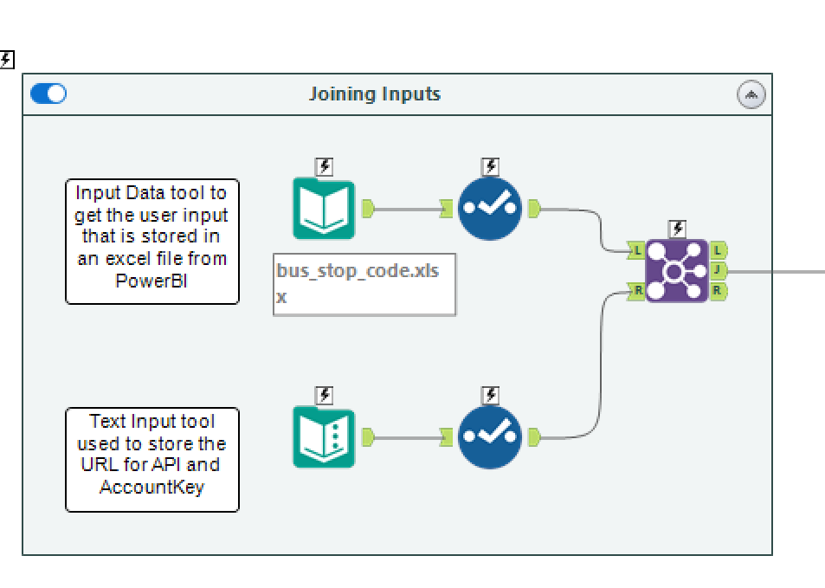
Importing into Alteryx
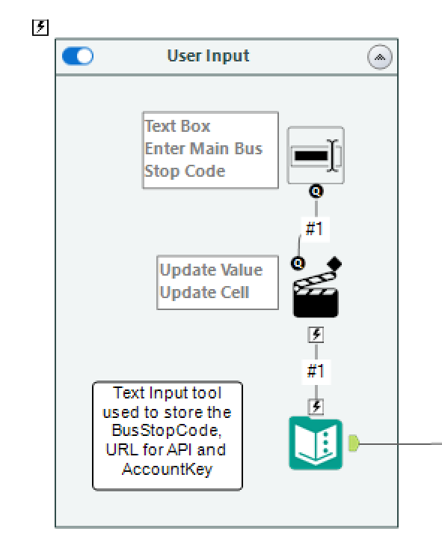

In order to import the BusStopCode into alteryx, the user would first need to input the code for the bus stop they are looking for.
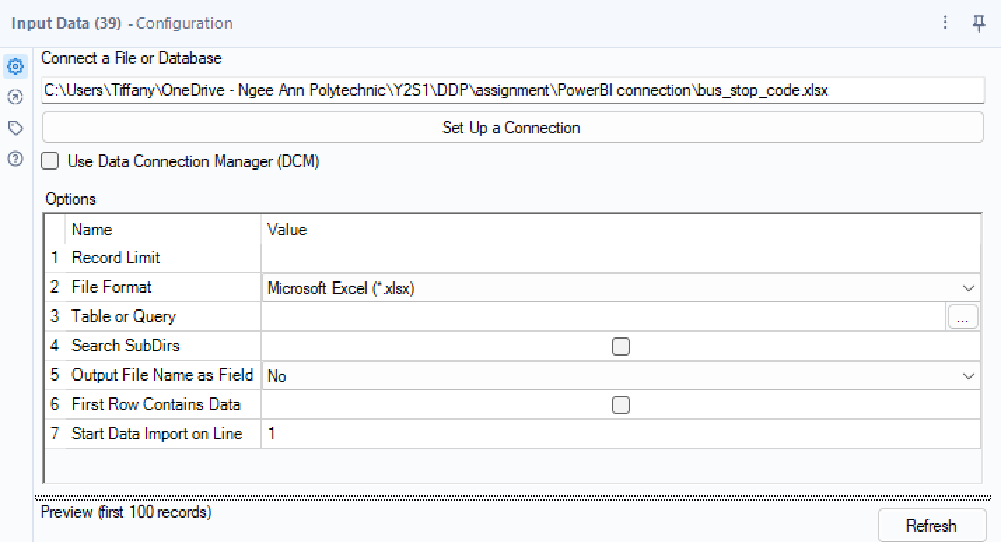

The file would then be imported into Alteryx from PowerBI using the ‘Input Data’ tool in a xlsx format. The ‘Text Input’ tool is also used to store the URL and AccountKey to retrieve the necessary data.

The ‘Join’ tool is then used to combine the BusStopCode, URL and AccountKey together.

Preparing Model and API Call
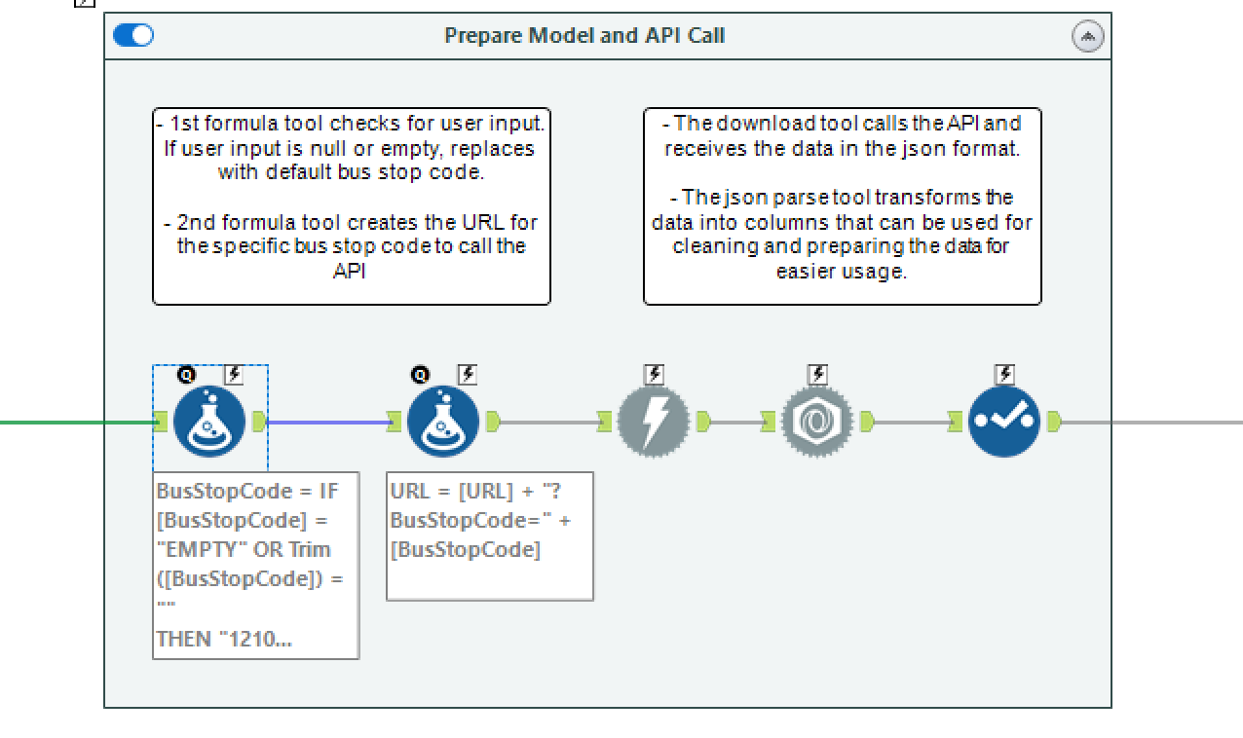

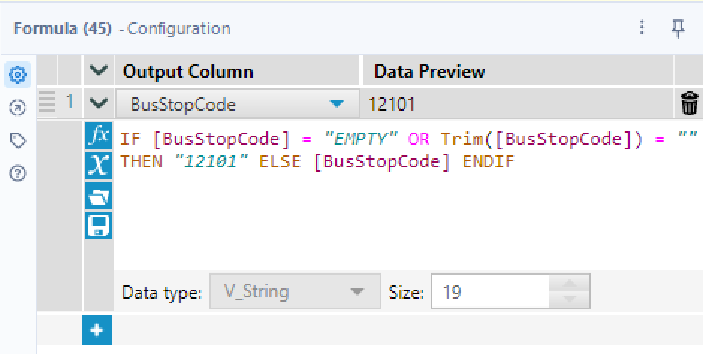
After getting the data input, the ‘Formula’ tool is first used to check if there is a user input where if it is “EMPTY” (In the front end, if there is no user input it updates the xlsx as EMPTY), it will auto fill in “12101” which is the bus stop code for Ngee Ann Poly.

Using another ‘Formula’ tool, the URL and BusStopCode is then combined into one string to create a valid API call link for the specific bus stop.
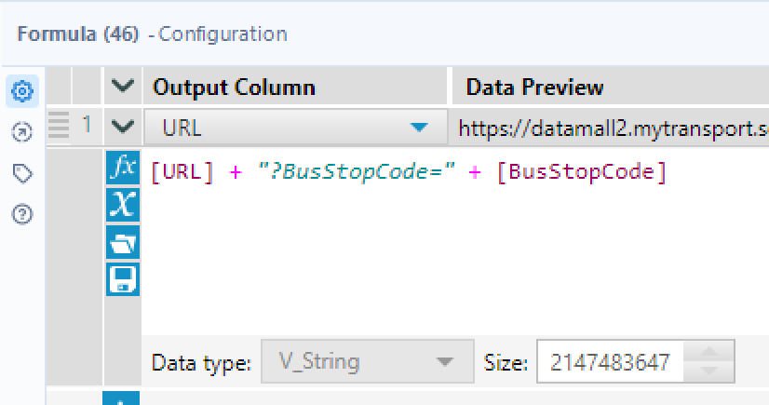
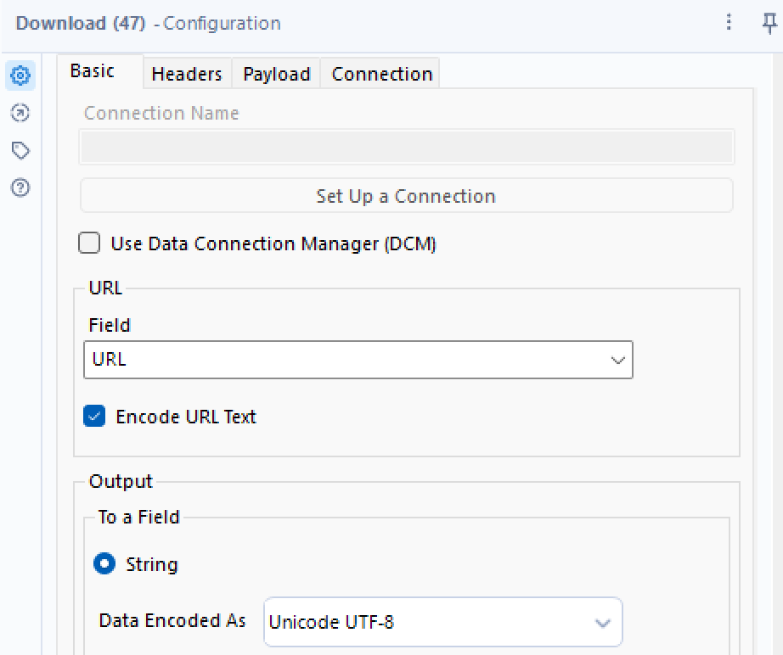
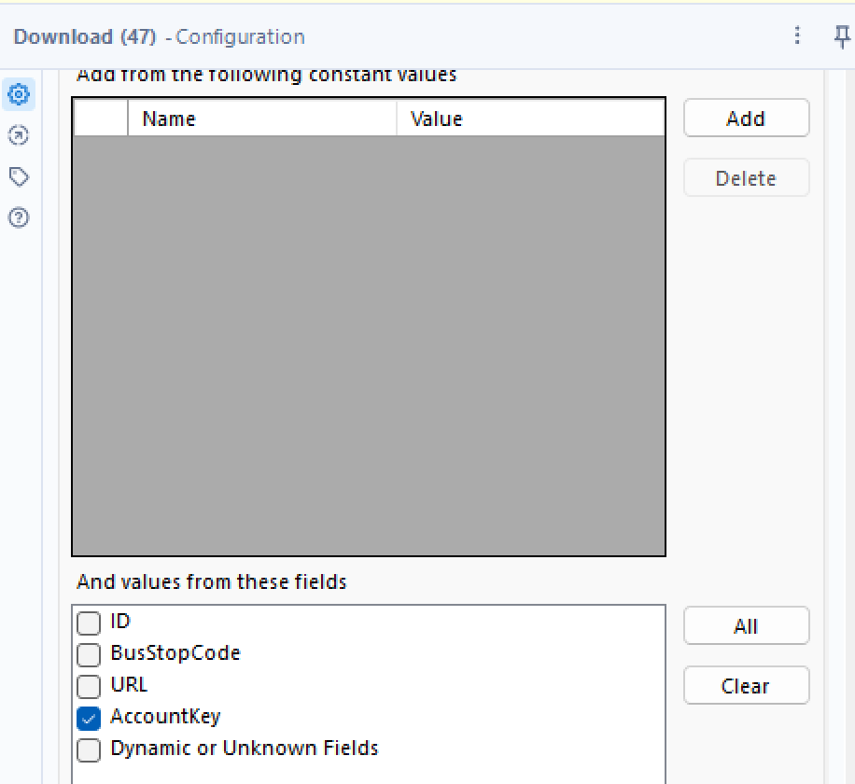
After preparing the URL for API calling, the ‘Download’ tool is then used to get the data. By using the AccountKey, on the URL, it was then able to download all the associated data in a JSON format. Since the data is in a JSON format, the ‘JSON Parse’ tool is then used to break down the JSON structure, parse and hence convert the data into a table format. This will then allow us to get the exact value of the data.

The ‘select’ tool was then used to select the necessary data including JSON_Name and JSON_ValueString as the URL, AccountKey and BusStopCode is not needed anymore.

Data Preparation
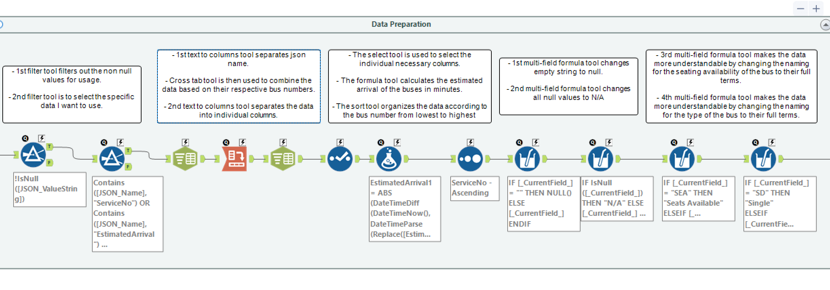
The above has transformed the data into a tabular representation, addressing the hierarchical nature of JSON. However, further fine tuning and data preparation is needed in other to get the data into the necessary format for analysis.
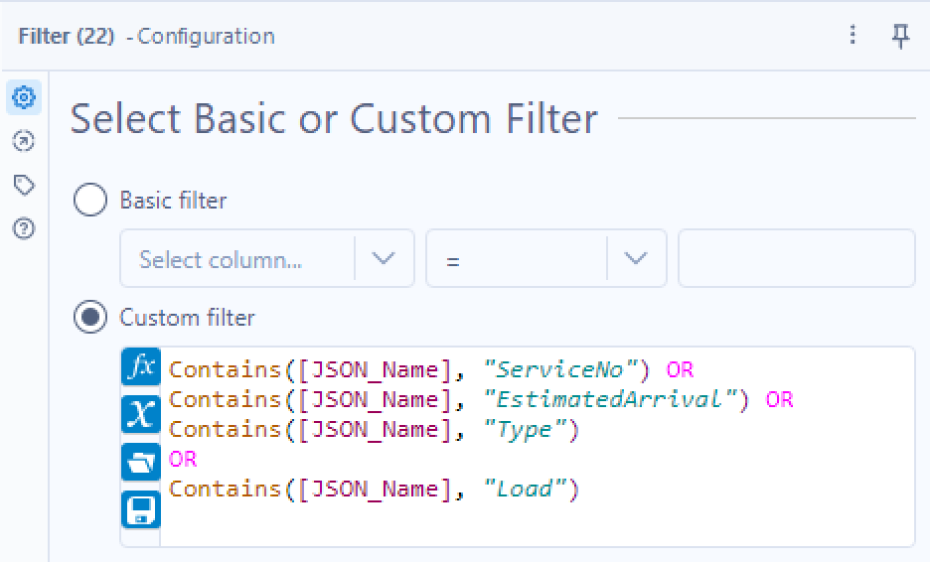

The first ‘filter’ tool uses a basic filter to get the non-null values for usage. The second ‘filter’ tool then uses a custom filter to extract only the relevant information from the JSON_Name field, excluding unnecessary data from the API response. The selected fields will be the data fields included in the final data. This included the following:
- ServiceNo: the service number of the buses, which is needed to know the available bus services at the bus stop
- EstimatedArrival: the estimated arrival time of the respective bus services in date time
- Type: the bus vehicle type which can show the more common bus types used during Peak and Non-Peak
- Load: the crowd of the bus
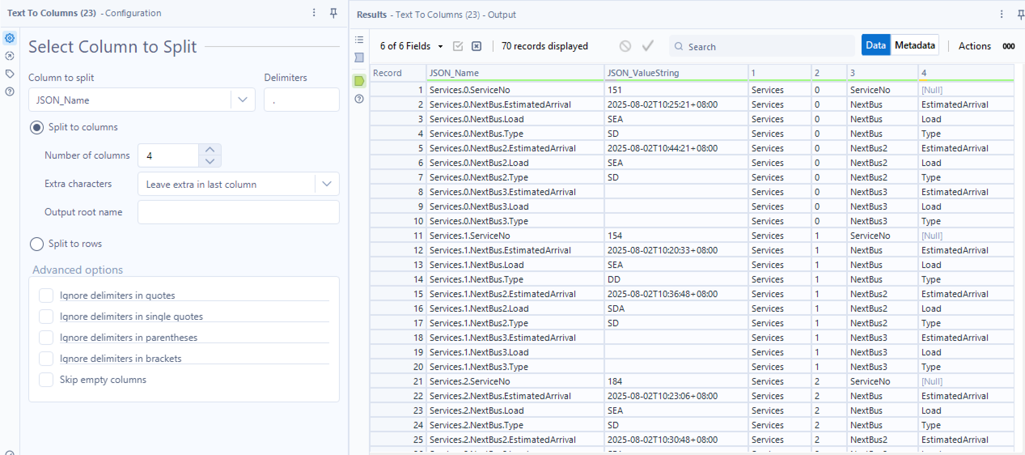
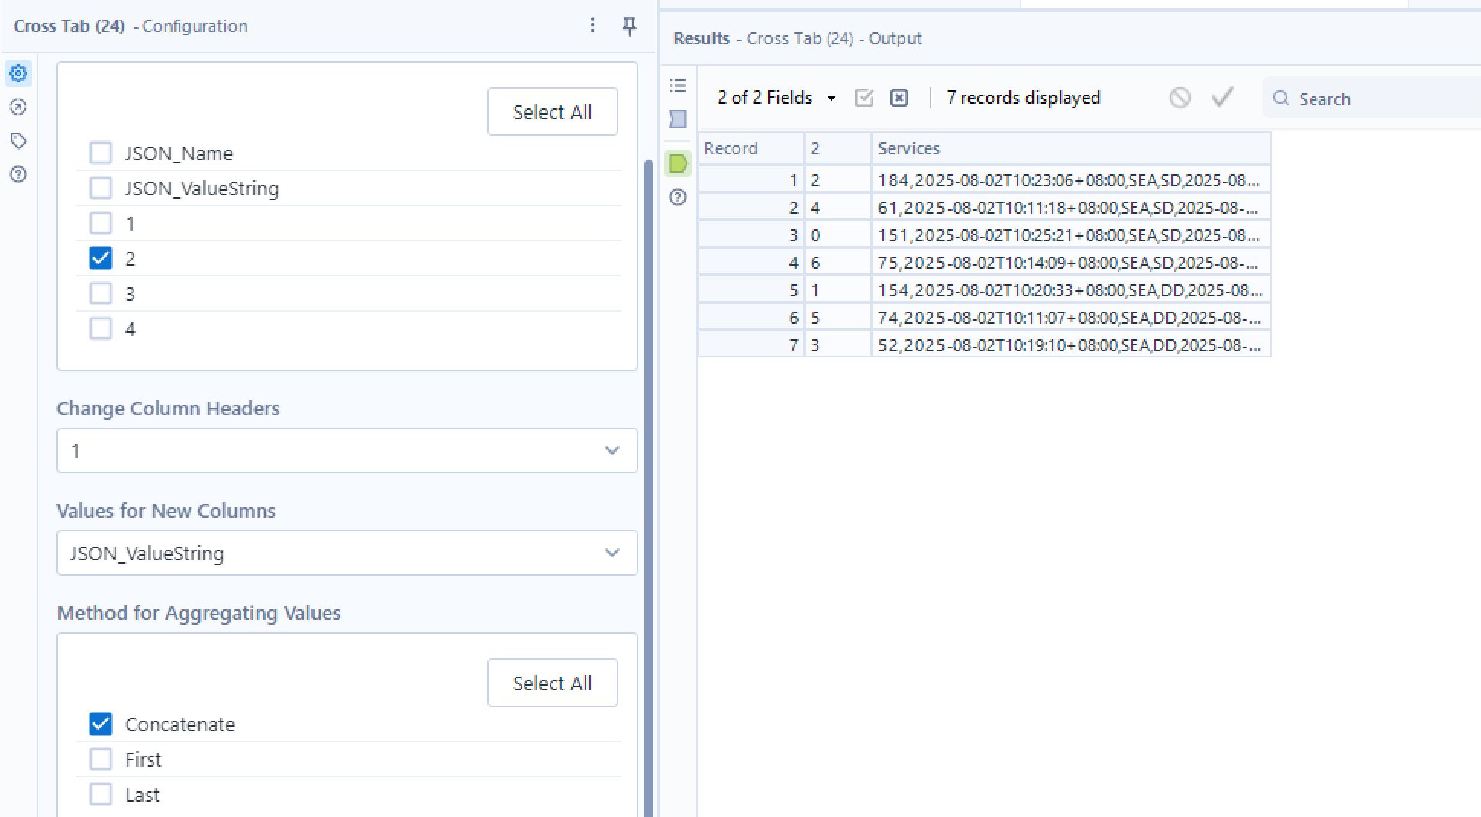
Currently under JSON_Name, it is structured in the format “Services.[Number].[Column Name] as shown above. Hence to improve the presentation of the data, a ‘Text to Column’ tool is using to separate the columns by their specified delimiter ‘.’ . The string was split into 4 columns. ‘1’ is the services, ‘2’ is the number of that service, ‘3’ is the bus number and bus count and ‘4’ is the details of the bus number.

Next, the ‘Cross Tab’ tool is used to transform the data from a long format to a wide format where the table will change to columns representing the respective bus numbers.

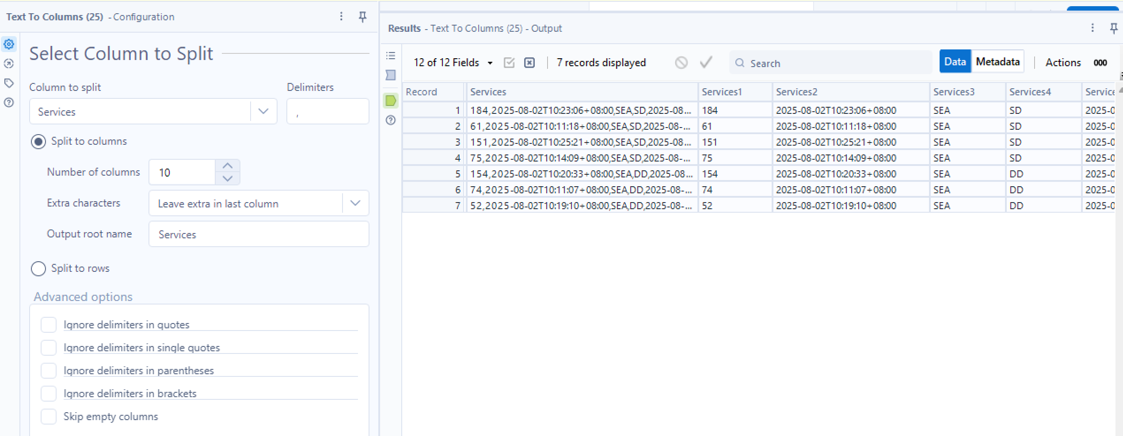
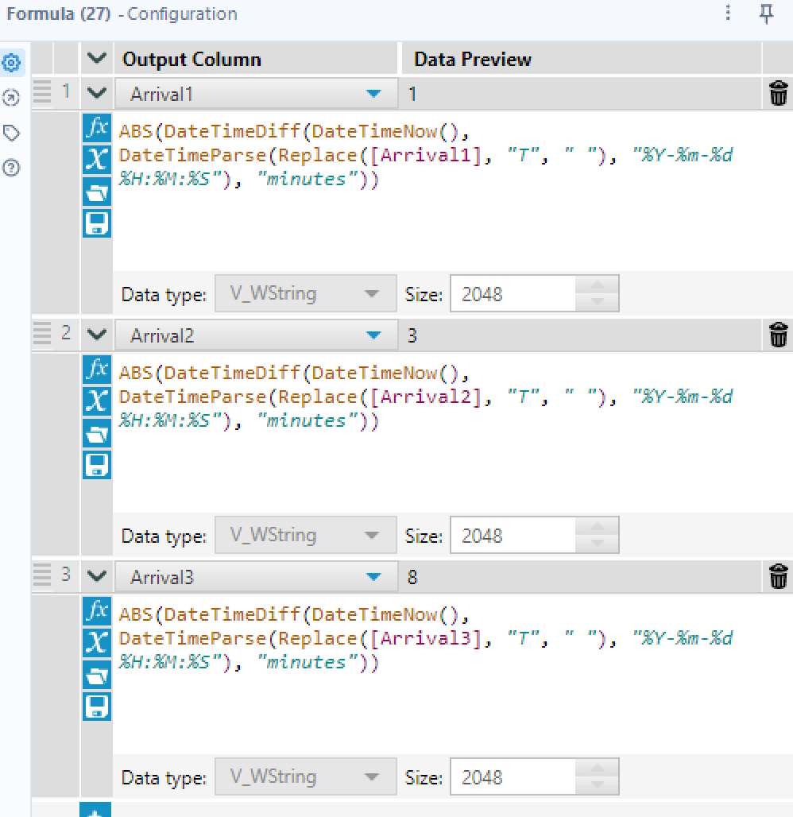
Another ‘Text to Columns’ tool is then used split the data up into the bus number followed by details of the next 3 buses for the respective bus numbers. After doing this, the data appears in a more clear and understandable format.
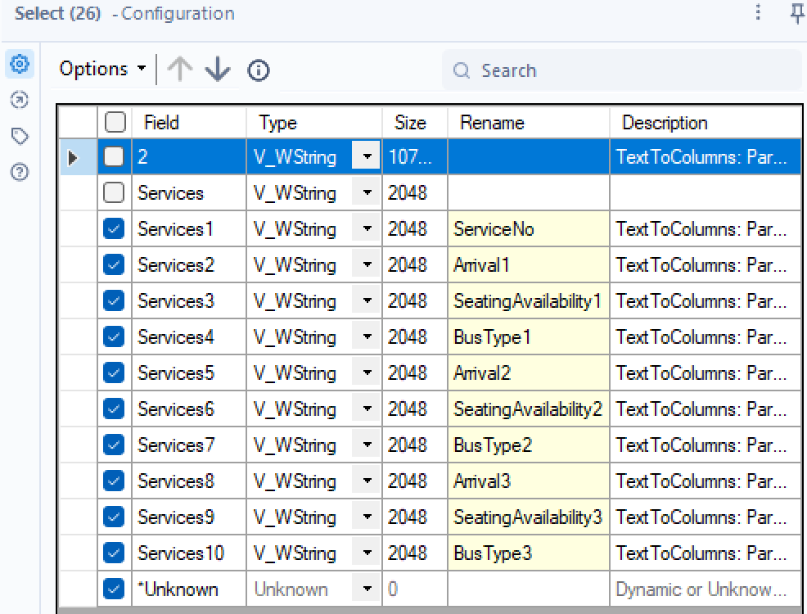

A ‘Select’ tool is then used to select the bus number and bus details columns while also renaming them to what each columns data is. This ensures that the data heading is more understandable and readable for frontend application.

A ‘Formula’ tool is used to change the format of the arrival columns from DateTime to the number of minutes it will be from the current time before the bus arrives at the bus stop. This is for easier readability.

Next, a ‘Sort’ tool is used to sort the buses according to their bus number from lowest to highest to make it more organised.

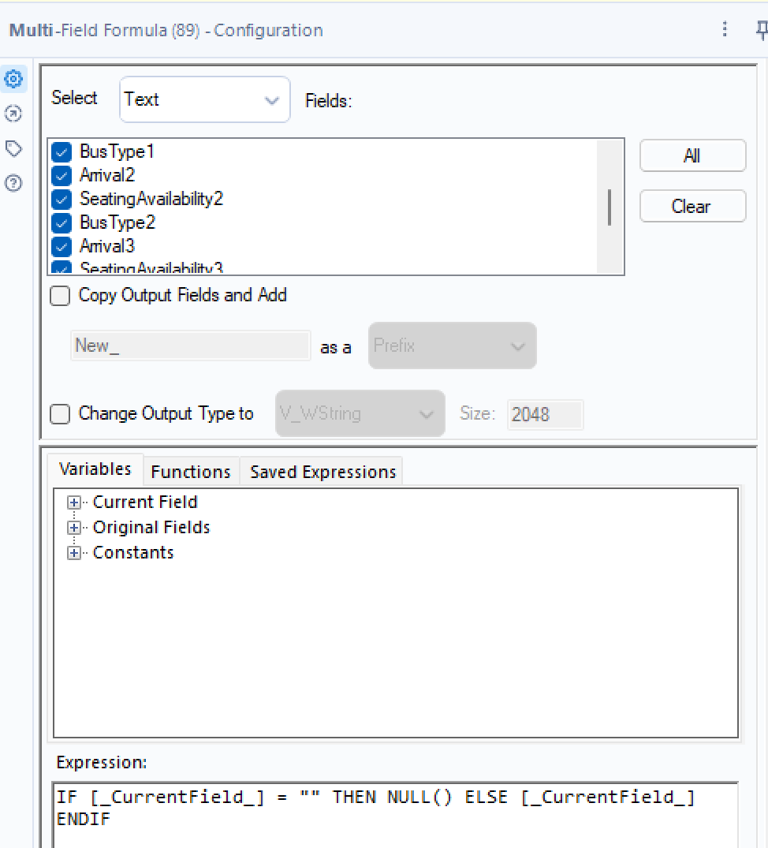
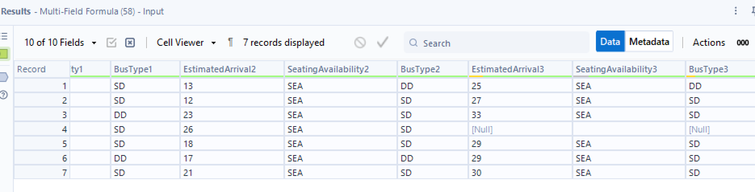
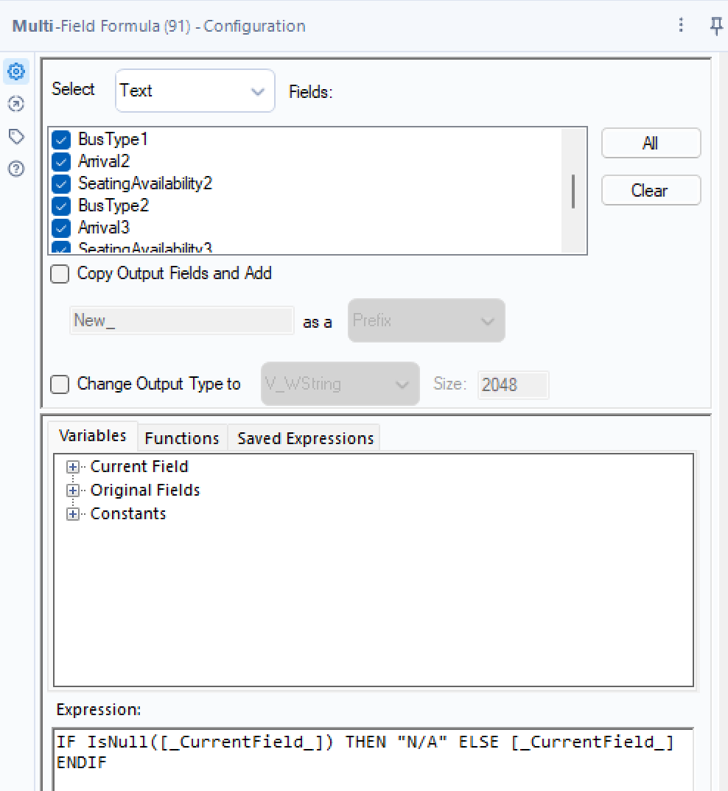

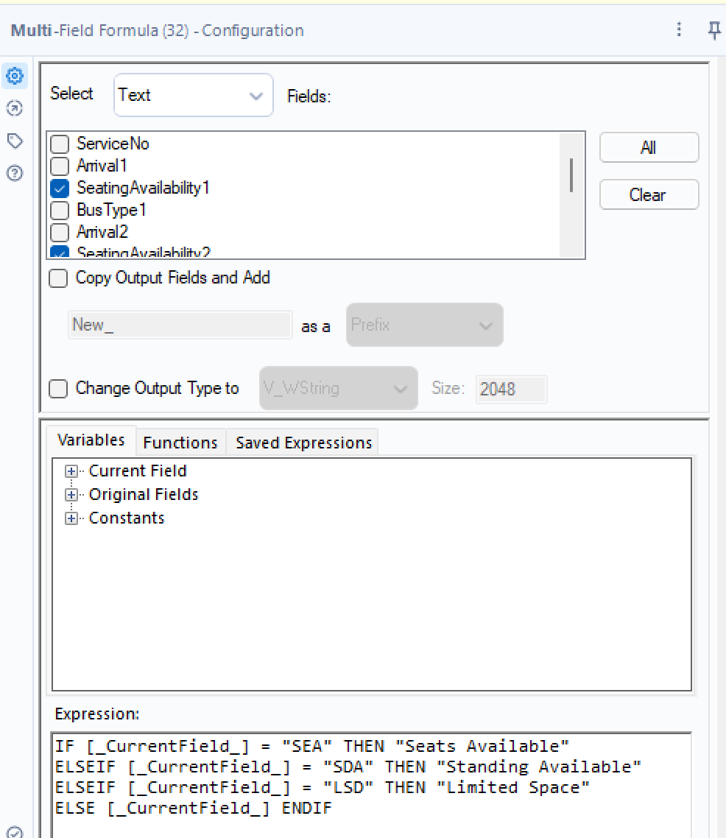
Currently, not all empty fields are set to NULL as shown above. Hence, the first ‘Multi-Field Formula’ tool is used to change all empty fields to NULL. Next for easier readability, another ‘Multi-Field Formula’ tool is used to change all the empty fields to ‘N/A’.
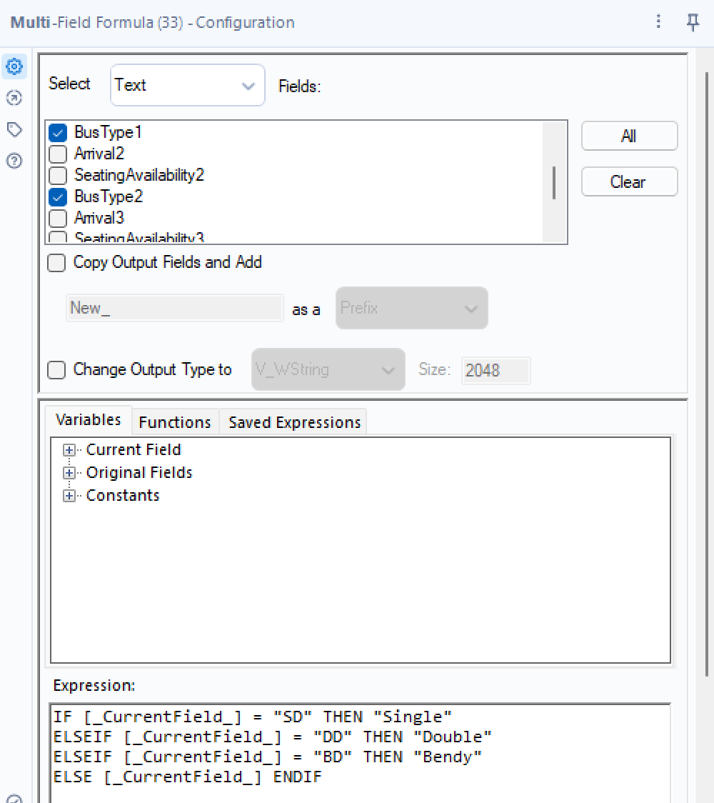

The next 2 ‘Multi-Field Formula’ tools help convert the current short forms into their full terms for easier readability and understanding as not everyone will know what the short forms stand for.

Data Output
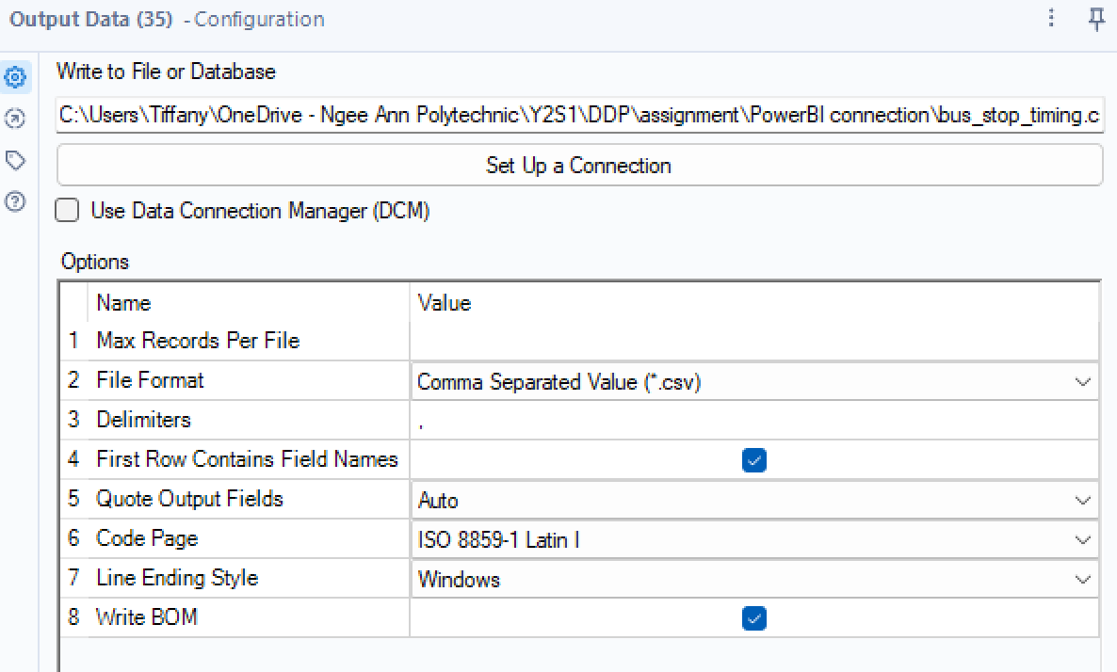
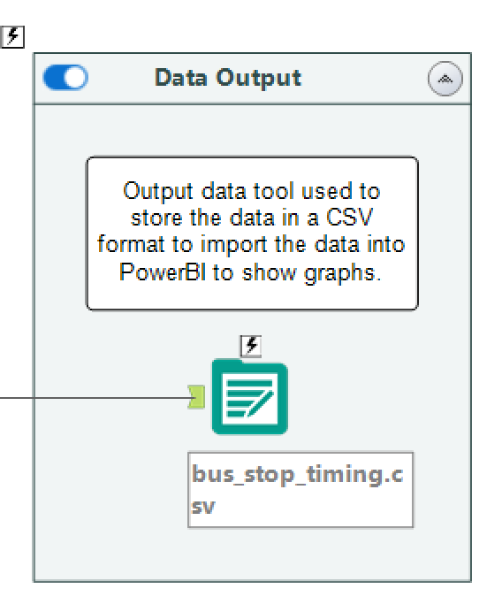

After all of the above, the data is now in a fully readable and understandable format for frontend use. Hence, the data is not exported using the ‘Output’ tool in a csv format to be able to import the data into PowerBI.

Alteryx Flow 2
Flow 2 is used to get the data of the expected bus frequencies for the different time periods for all the possible bus services.

Input and API Call
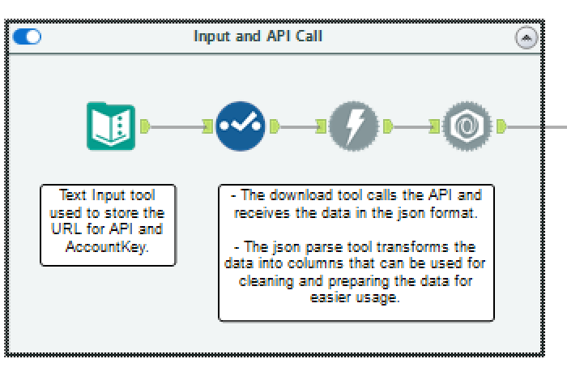
The ‘Text Input’ tool similar to above is used to store a different URL as before and the AccountKey. The ‘Download’ and ‘JSON Parse’ tool like above calls the API and gets the data before converts the data into a table format.

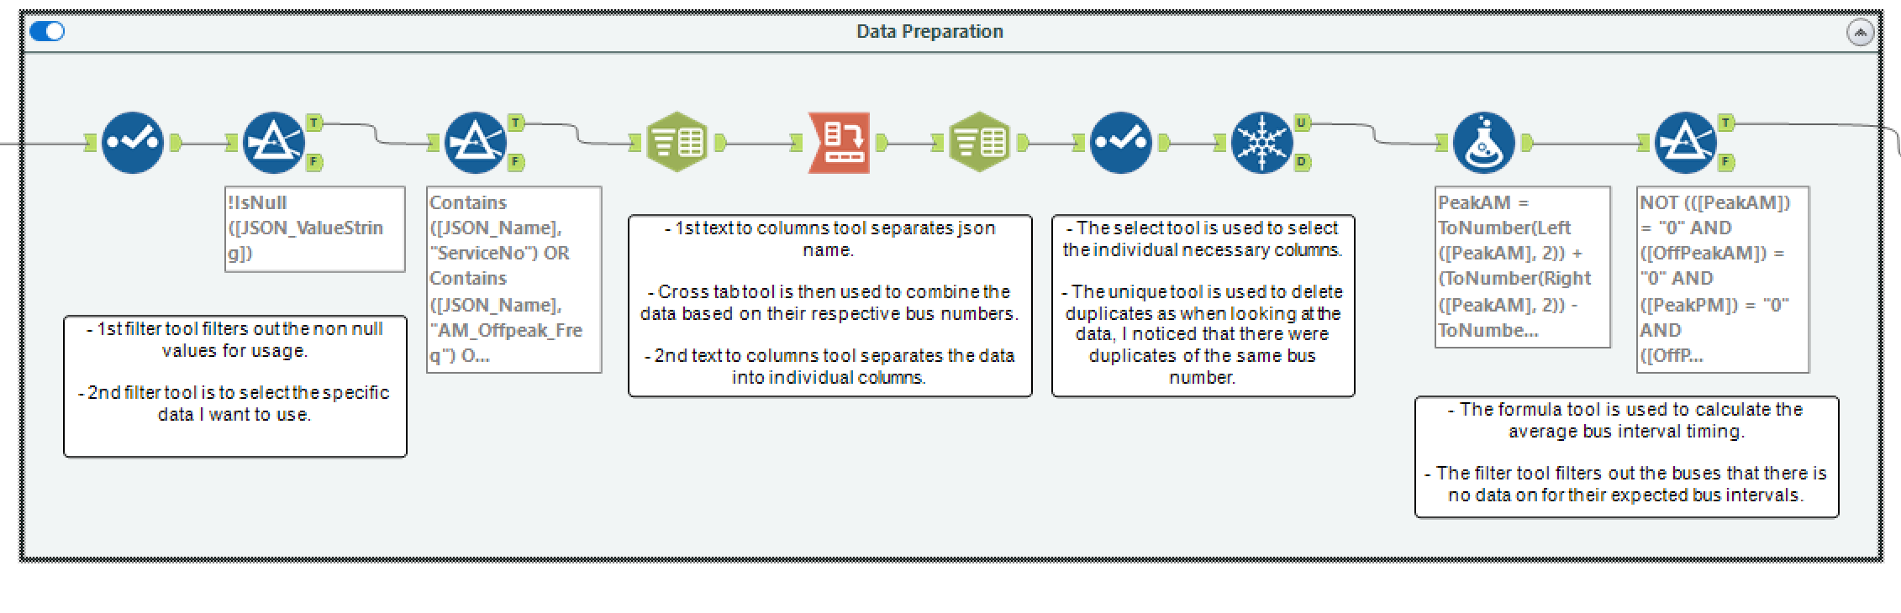
Data Preparation

The first ‘filter’ tool uses a basic filter to get the non-null values for usage. The second ‘filter’ tool then uses a custom filter to extract only the relevant information from the JSON_Name field, excluding unnecessary data from the API response. The selected fields will be the data fields included in the final data. This included the following:
- ServiceNo: the service number of the buses, which is needed to combine with the other dataset to filter to specific buses
- AM_Peak_Freq: expected frequency of bus during morning peak hours (0630H-0830H)
- AM_OffPeak_Freq: expected frequency of bus during morning off peak hours (0831H-1659H)
- PM_Peak_Freq: expected frequency of bus during night peak hours (1700H-1900H)
- PM_OffPeak_Freq: expected frequency of bus during night off peak hours (0630H-0830H)

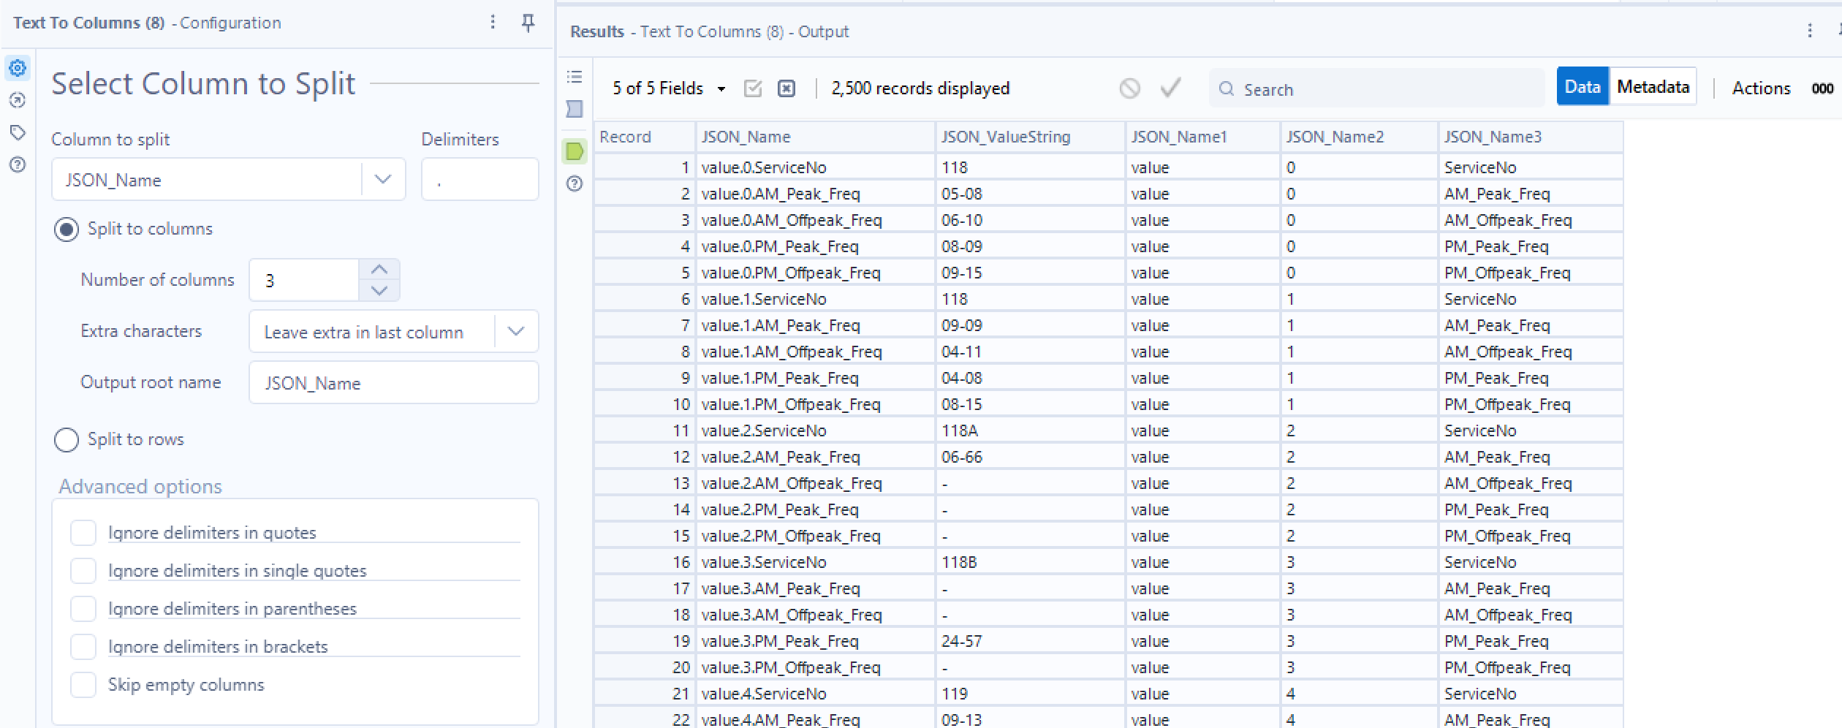
Currently under JSON_Name, it is structured in the format “value.[Number].[Column Name] as shown above. Hence to improve the presentation of the data, a ‘Text to Column’ tool is using to separate the columns by their specified delimiter ‘.’ . The string was split into 3 columns. ‘1’ is the value, ‘2’ is the number of that service, ‘3’ is the bus number and the bus interval timings.
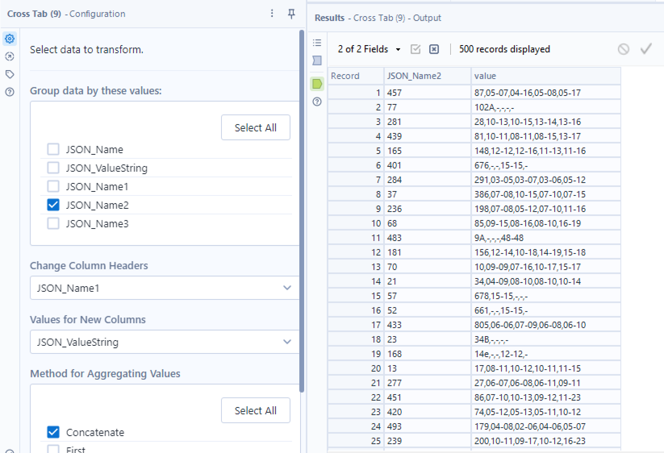

Next, the ‘Cross Tab’ tool is used to transform the data from a long format to a wide format where the table will change to columns representing the respective bus numbers.

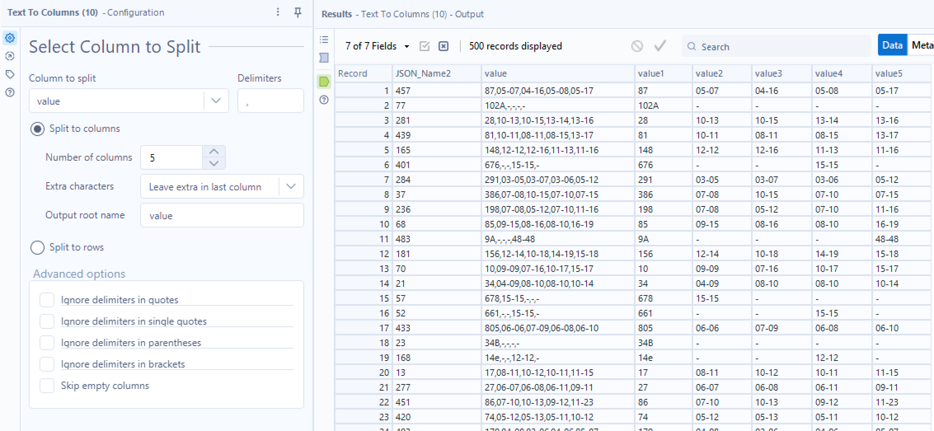
Another ‘Text to Columns’ tool is then used to split the data up into the bus number followed by its expected frequency time for the different time periods. After doing this, the data appears in a more clear and understandable format.
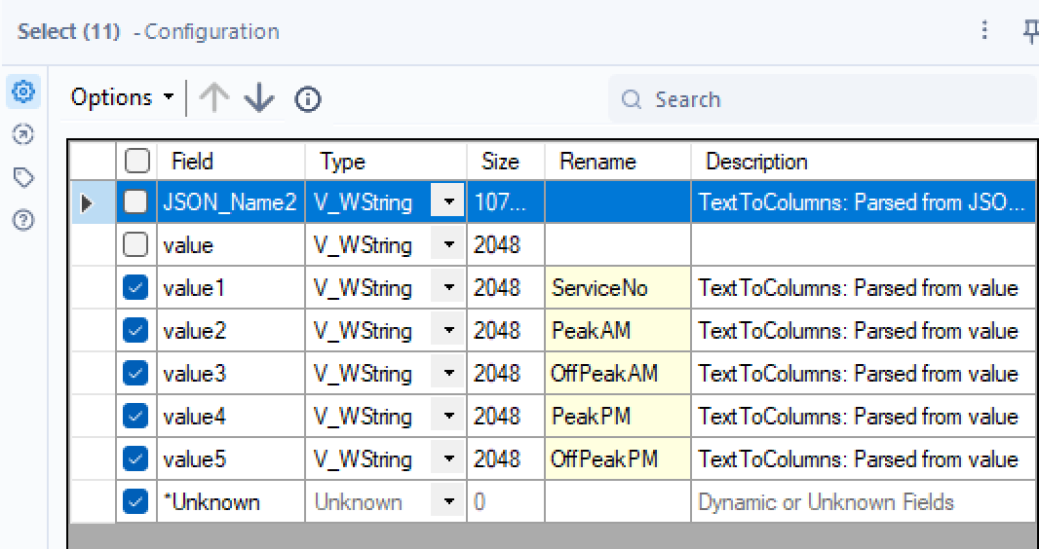
A ‘Select’ tool is then used to select the bus number and frequency timing columns while also renaming them to what each columns data is. This ensures that the data heading is more understandable and readable for frontend application.

A ‘Unique’ tool is then used as when looking at the data there were repeated of the same bus services. The tool was set to ServiceNo to ensure there were no repeated data.
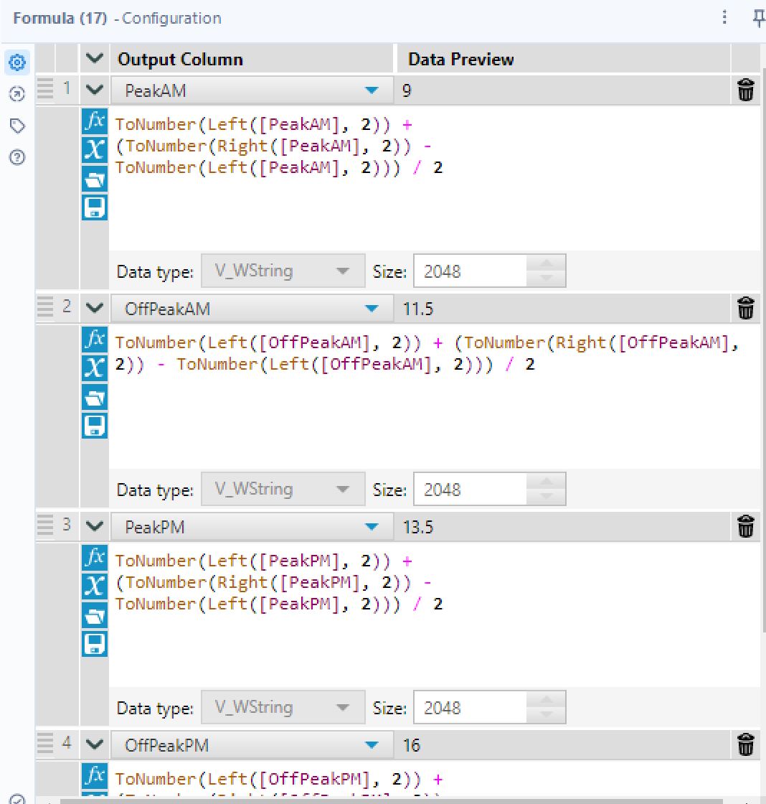
A ‘Formula’ tool is used to change the values from a range to an average expected interval time.

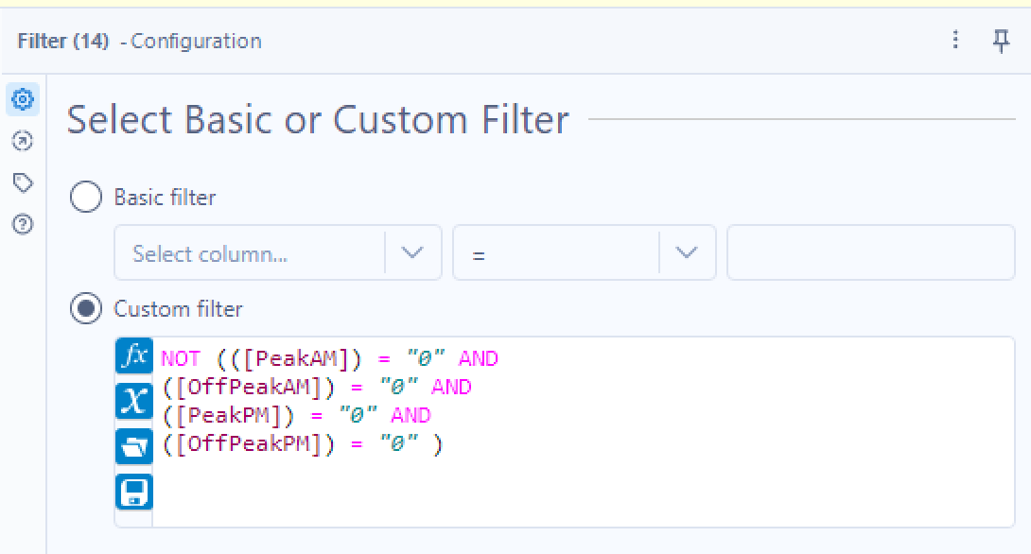
Finally, a ‘Filter’ tool is used to filter out the data where there is no expected interval time for all 4 time periods.

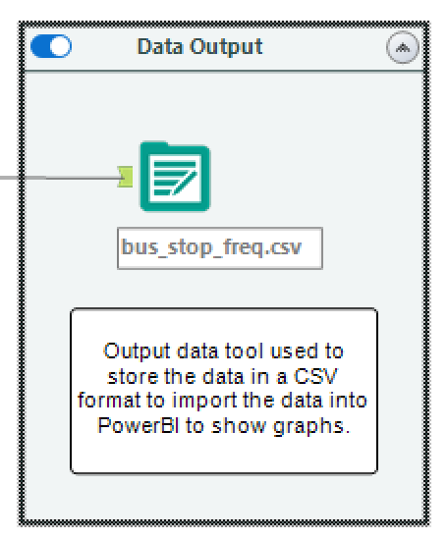
Data Output

After all of the above, the data is now in a fully readable and understandable format for frontend use. Hence, the data is not exported using the ‘Output’ tool in a csv format to be able to import the data into PowerBI.

Alteryx Flow 3
Flow 3 is used to get the bus stop code of all the bus stops in Singapore to be able to check if the user input exists in the front end.

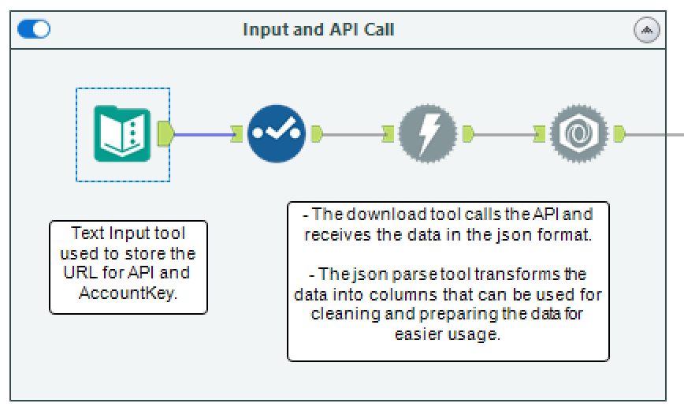
Input and API Call

The ‘Text Input’, ‘Select’, ‘Download’ and ‘JSON Parse’ tools are the same as flow 2 where the only difference is the URL.

Data Preparation
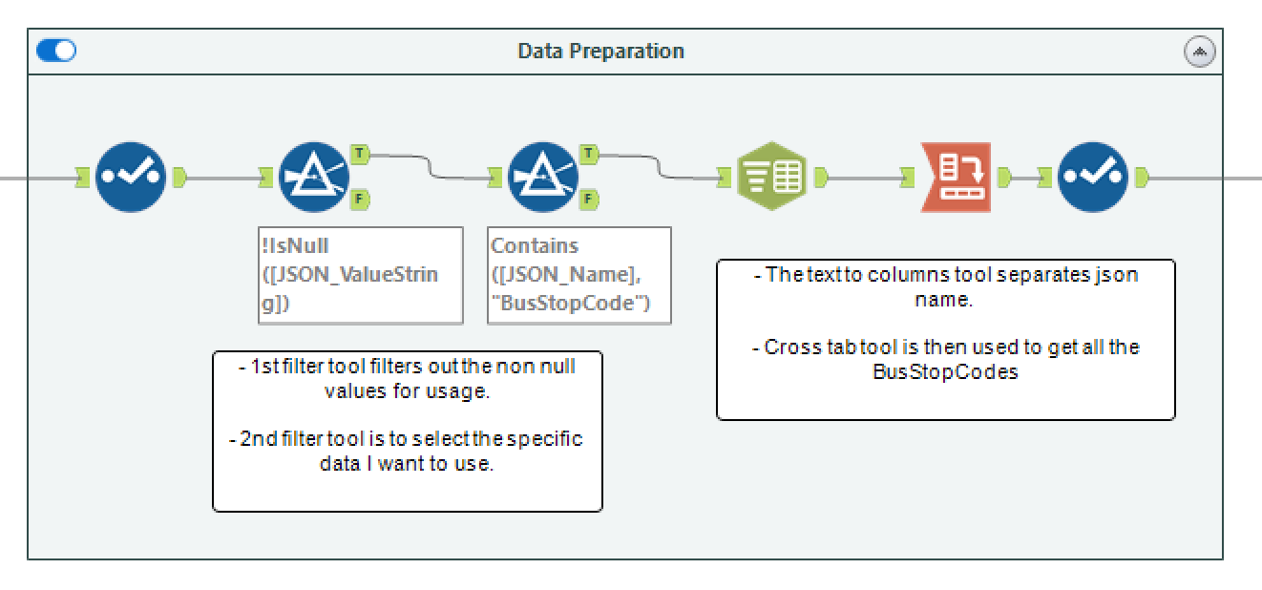
The first ‘filter’ tool uses a basic filter to get the non-null values for usage. The second ‘filter’ tool then uses a custom filter to extract only the relevant information from the JSON_Name field, excluding unnecessary data from the API response. In this case it is just the BusStopCodes.
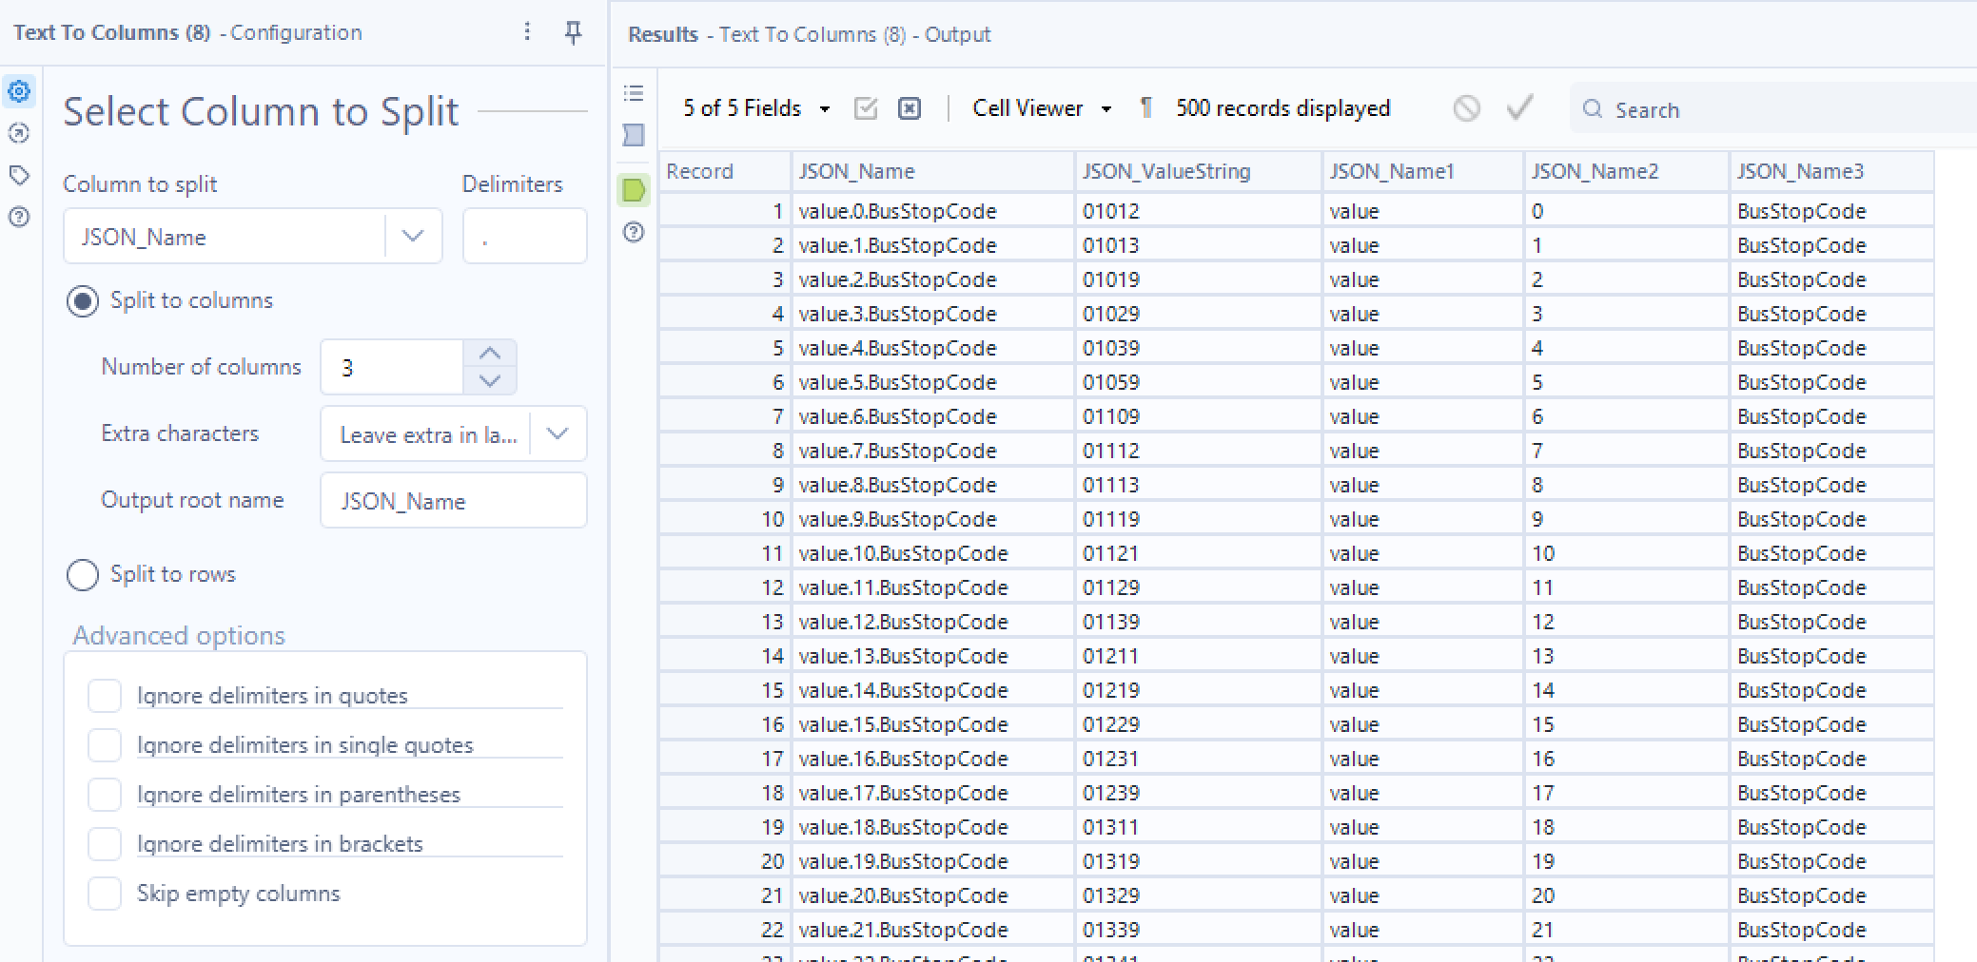

Currently under JSON_Name, it is structured in the format “value.[Number].BusStopCode as shown above. Hence to improve the presentation of the data, a ‘Text to Column’ tool is using to separate the columns by their specified delimiter ‘.’ . The string was split into 3 columns. ‘1’ is the value, ‘2’ is the number of that service, ‘3’ is the bus stop code.
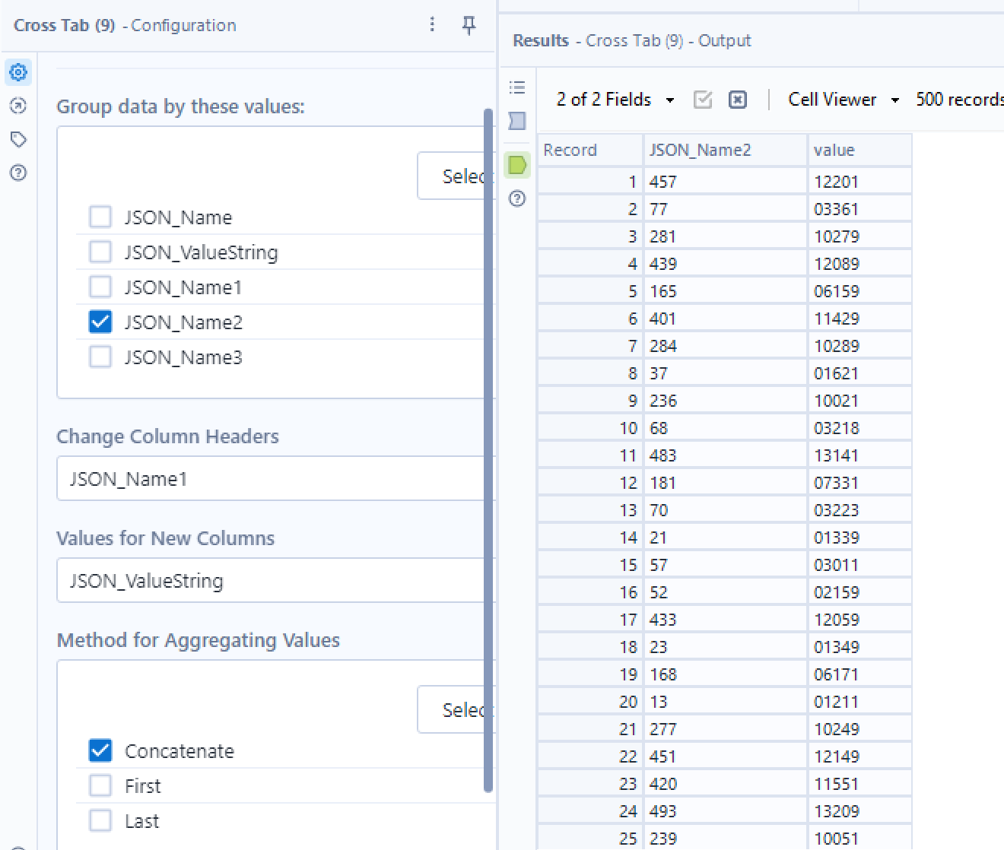

Next, the ‘Cross Tab’ tool is used to transform the data from a long format to a wide format where the table will change to columns representing the respective bus numbers.

Data Output
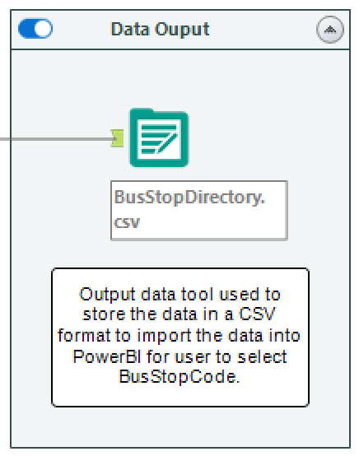
After all of the above, the data is now in a fully readable and understandable format for frontend use. Hence, the data is not exported using the ‘Output’ tool in a csv format to be able to import the data into PowerBI.

Enhancement: Frontend Display

Frontend Display

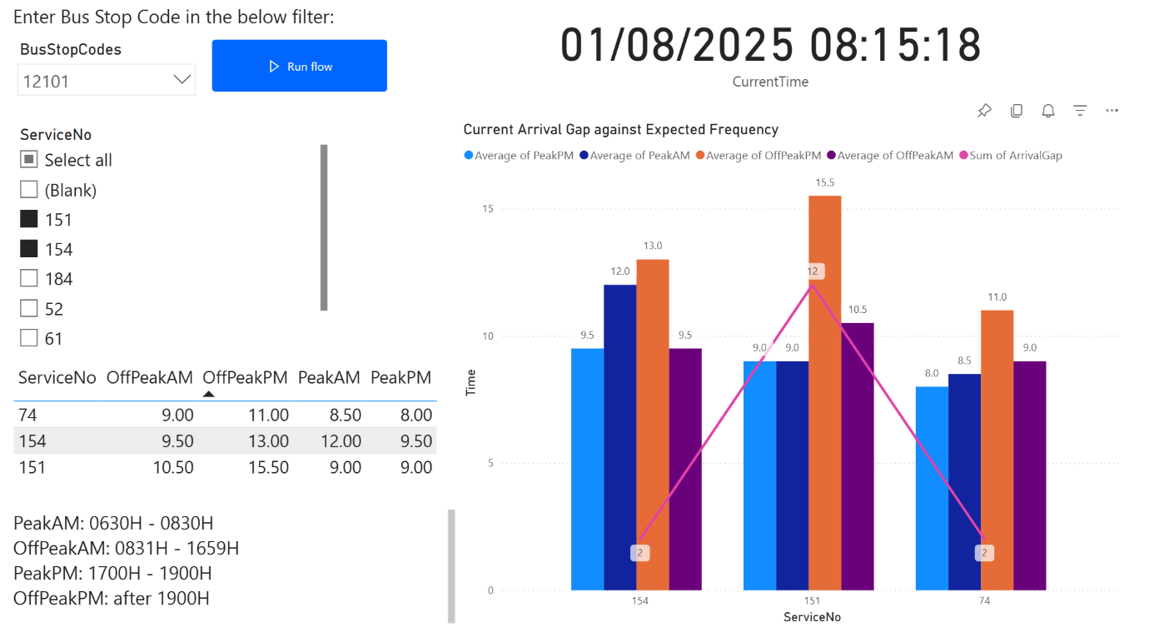

This dashboard provides an interactive overview of bus arrival patterns at a selected bus stop, focusing on key bus services used by students commuting to King Albert Park MRT.
At the top left, users can input a specific bus stop code using the slicer, followed by clicking the “Run Flow” button to refresh and filter the data accordingly. Below that, the user can select the bus service numbers they wish to analyse. In this case, buses 74, 151, and 154 have been selected as they are frequently used by students heading home after classes.
Directly beneath the slicers, a table displays the expected arrival intervals (in minutes) for each selected bus service during different periods of the day: Peak AM (0630H–0830H), Off-Peak AM (0831H–1659H), Peak PM (1700H–1900H), and Off-Peak PM (after 1900H). A text box also explains the definitions of these time periods to help users better understand the breakdown.
To the right side of the dashboard, a live date and time component shows the current system time. This gives the user immediate context when comparing actual arrival gaps to scheduled timings, which is particularly useful when determining if a service is currently delayed or clustered.
Below the clock, a clustered bar and line chart visualises the key comparison between scheduled frequencies and real-time performance. The bars represent the expected average frequency of bus arrivals during each time band. Overlaid on top is a pink line graph indicating the actual arrival gap (calculated using a quick measure in Power BI). Data labels have been enabled to show the exact value of each current arrival gap. This makes it easy to spot which buses are underperforming or arriving too closely together, potentially leading to service clustering or longer-than-expected wait times.

PowerBI to Alteryx Connection

In order to connect the User Input from PowerBI to Alteryx, I used Microsoft power automate to create a flow. Each time the run flow button is pressed in PowerBI, the Update a row task will run where it automatically changes the BusStopCode value to the users input. If the user did not enter a single bus stop code, it will fill “EMPTY”.
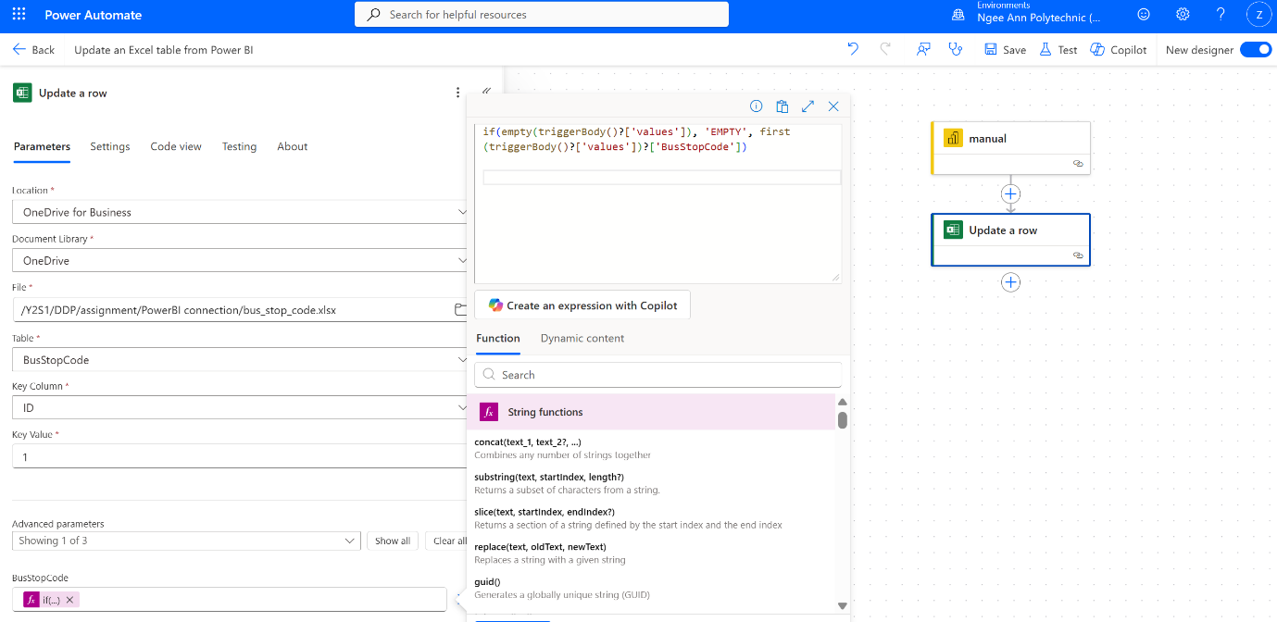
After running the power automate flow, the alteryx Flow 1 will then run to get the bus information for the buses at that bus stop. Afterwards, on the PowerBI page, the user just needs to press data refresh for the updated bus timings.

PowerBI is able to receive the data without importing again as it is already linked to my OneDrive where I have created a folder to hold all the excel files. The bus_stop_code file is saved as an excel workbook as the power automate can only update excel workbooks and not csv files.
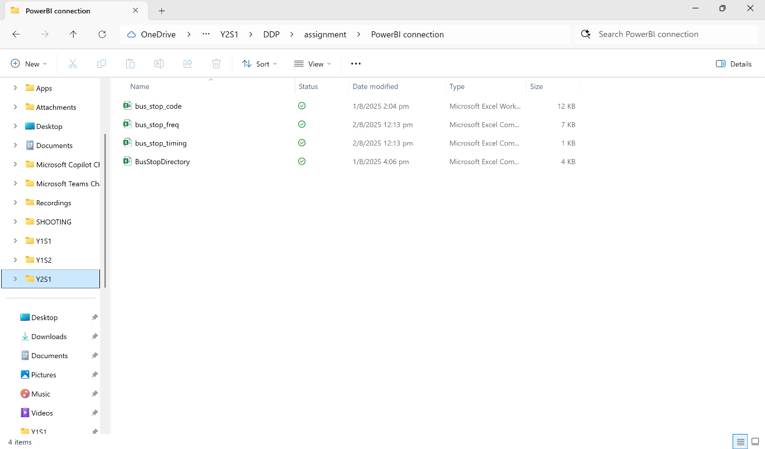

Summary
This assignment explores how real-time and scheduled bus frequency data can be combined to improve off-peak public transport efficiency. During off-peak hours, people often face long, unpredictable waits due to bus clustering and inconsistencies between scheduled and actual arrival intervals. To address this, a data pipeline was created using Alteryx Designer, using APIs from LTA DataMall, specifically the Bus Arrival API, Bus Services API and Bus Stops API.

The pipeline consisted of 3 main flows. Flow 1 pulls real-time data based on the user-input bus stop code and processes it into a readable csv that shows the next 3 bus arrival timings, vehicle types and seating availability for the different bus services. Flow 2 obtained the scheduled frequency data during different time periods for all services. Flow 3 retrieves all valid bus stop codes to validate user input.

On the frontend, PowerBI was used to create an interactive dashboard. Users input a bus stop code and run a Power Automate flow to update the backend excel data. Right now, the dashboard displays scheduled vs real-time gaps in arrival intervals using a combined bar and line chart. This is just one of the ways they can use the data. After determining if the bus are clustering, they can also look at the bus load to determine the effect of the current frequency timing.

The overall result is a dynamic system that provides LTA with clear, data-driven insights into how buses are performing in real time compared to scheduled intervals. By highlighting inconsistencies, especially during off-peak hours, this solution enables LTA to identify services that are frequently delayed or bunched and take proactive steps to optimise dispatch intervals and route planning. In doing so, there will be a more efficient and commuter-centric transport system for users. Furthermore, the pipeline and dashboard can be extended into mobile apps or internal monitoring tools, making it a versatile asset for ongoing transport planning and decision-making.

Reflection

Areas for Improvement

One major area for improvement in my project was the connection between Power BI and Alteryx. Initially, I intended to use Snowflake to link the two platforms, with the goal of enabling a DirectQuery connection in Power BI. This would have allowed for real-time auto-refresh of the dashboard without doing it manually. However, due to the complexity of the setup and time constraints, I was unable to implement it successfully. As a result, users currently need to manually refresh the data in Power BI after triggering the flow via Power Automate, which affects the user experience.

Another enhancement I had planned was to include the Passenger Volume by Bus Stops API. Unfortunately, I encountered issues with my AccountKey which prevented me from successfully calling this API. If implemented, it would have allowed users especially transport authorities like LTA to visualise historical crowd data by location and improve bus dispatch timings accordingly. This would have greatly strengthened the decision-making value of the dashboard.

Overall Process

At the start of the assignment, I found the assignment quite interesting and was very excited to get started. I jumped right in with making a problem statement without checking what data I had at hand. I wanted to use crowd analysis of bus stops to redirect certain bus services during peak hours to ensure that the bus is not always fully packed by the time it reached Ngee Ann.

Upon starting, I realised a problem with my AccountKey which resulted in me having problems calling the API. At first, I tried to contact LTA, but they did not reply to me in time. They only replied once I had finished my workflow and did not have time to restart. I realised that I could only use the Bus Arrival, Bus Services Bus Routes and Bus Stops API. This limited my options significantly causing me to change my problem statement.

I also faced technical limitations with combining data from multiple API endpoints within a single Alteryx workflow. Because of this, I had to split my logic across three separate flows and combine the results only at the frontend using Power BI. This meant that I couldn’t fully achieve the backend integration objective of the assignment, which is something I hope to improve in future projects.

Additionally, when learning how to use the Power Automate tool on PowerBI, I encountered a lot of problems. Most of the YouTube videos I saw online used a SharePoint. However, I wanted to update a specific excel file in my current drive. I tool a few hours figuring out the connection for just this tool alone.

Skills Learnt

This module has significantly deepened my understanding of the data pipelining process, especially in the context of real-time data. I gained hands-on experience in designing workflows using Alteryx Designer, learning how to build end-to-end pipelines that include API calls, JSON parsing, data cleansing, and transformation. I applied tools like Filter, Cross Tab, and Multi-Field Formula, which helped me understand how to structure and format complex datasets.

In addition, I learned how to integrate backend workflows with frontend visualisations through Power BI and Power Automate. Before this, I had never used Power Automate, so setting up a flow that updates an Excel file based on user input in Power BI was a valuable new experience. It taught me how different tools can be used together to create an interactive, user-responsive dashboard.

The module also covered theoretical concepts like Hadoop and PySpark, which helped me appreciate how large-scale data processing works in industry. Even though these technologies weren’t directly used in the assignment, the theory helped me understand the importance of scalable and distributed data pipelines.

Overall, this has been one of the most engaging and practical modules I’ve taken. It allowed me to apply both technical tools and theoretical knowledge through Hadoop, PySpark and Alteryx. I feel more confident in building real-world data solutions and look forward to exploring more advanced integrations and automation in future projects.

