<project_name>

Analysis and Design Document : Assignment 1

Student: <Student_name>
Group: 30435

Table of Contents
Contents
1. Requirements Analysis 3
1.1 Assignment Specification 3
1.2 Functional Requirements 3
1.3 Non-functional Requirements 3
2. Use-Case Model 4
3. System Architectural Design 4

1. Requirements Analysis

Assignment Specification
The objective of this project is to ….

Functional Requirements
The application has the following functional requirements:
….

Non-functional Requirements

The application has the following non-functional requirements:
….

EXAMPLE:
The application has the following functional requirements:
- Allow users to create new entries with a short description, set of tags, and sleep metrics (duration, energy level, and stress).
- Allow users to view all their entries and filter them by category and tags.
- Allow users to view a daily chart for each sleep metric given a requested category and date range.
The application has the following non-functional requirements:
- Implement validation to ensure that all inputs are valid and adhere to the specified format.
- Use an ORM to handle database interactions.
- Use a DI container for dependency injection.
- Use a layered architecture for better organization and separation of concerns.
- Use the factory pattern for creating the various metric-driven reports/charts.
- Use a database to store all the data.

Use-Case Model

Example content:
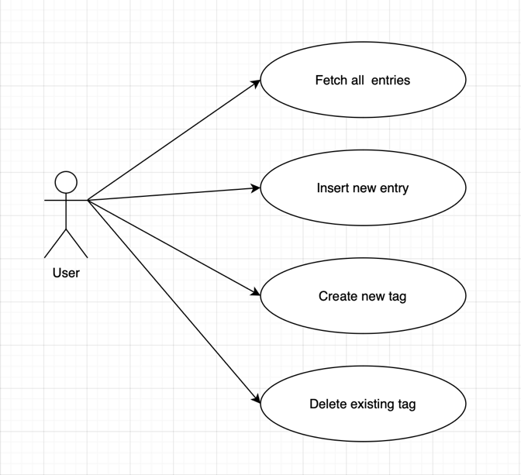
Description of the “Fetch all entries” use-case:
Use case goal: Fetching all of the recent entries and displaying them on screen using a graph representation
Primaray actor: The user of the application
Main succes scenario: Database connection succeeds, data is fetched correctly and is displayed in an intuitive manner within graphs
Extensions:
- Alternate scenario of success: Database connection succeeds, data is fetched correctly, but no entries are contained in the response due to the user never having inserted one, the home screen displays a message suggesting that user should insert his first entry
- Failure: Either the database connection fails, the request times out, the data is corrupt, the graph is unreadable or does not populate with data or the Android app crashes unexpectedly. The user will get a corresponding message in the frontend.

System Architectural Design

Architectural Pattern Description

For assignment 1, your architecture should be 3 tier application
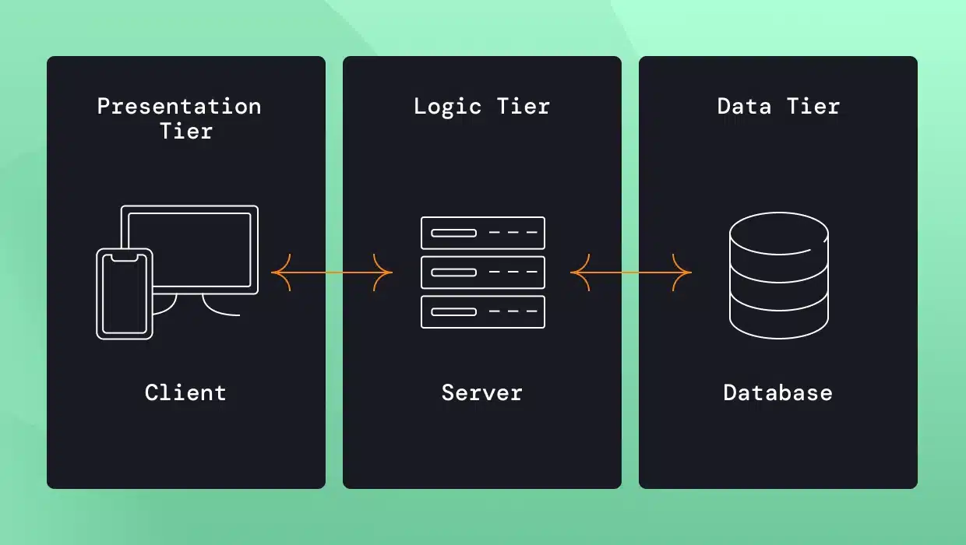

Describe what implementation you used for each tier.

Diagrams

And architecture should be layered:

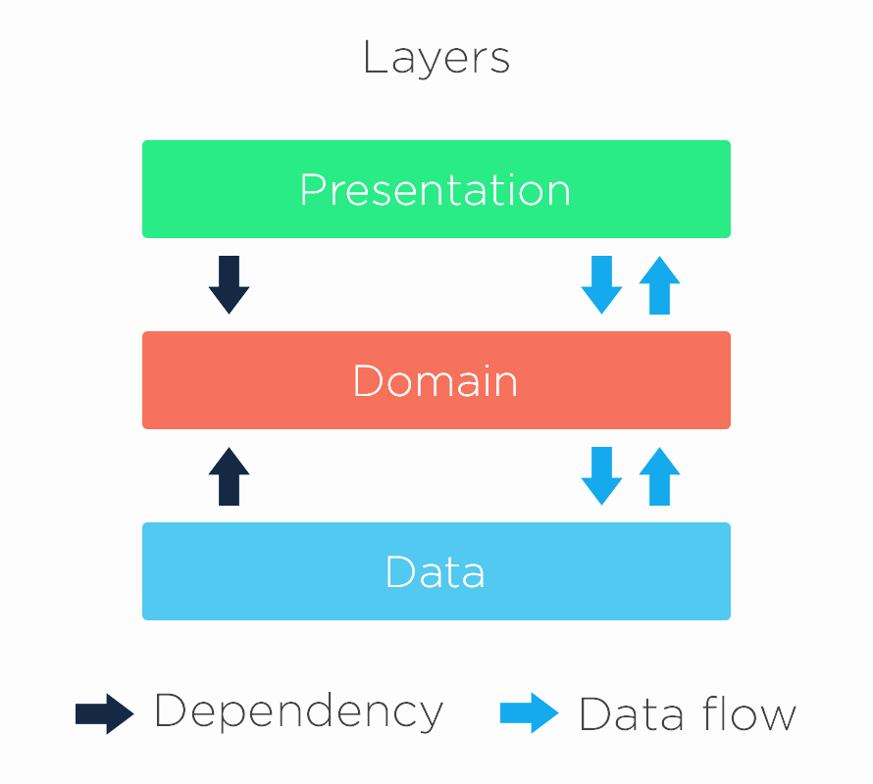

Make a diagram with YOUR OWN layers and say what they are and why.

Class Design

Package + Class Diagram
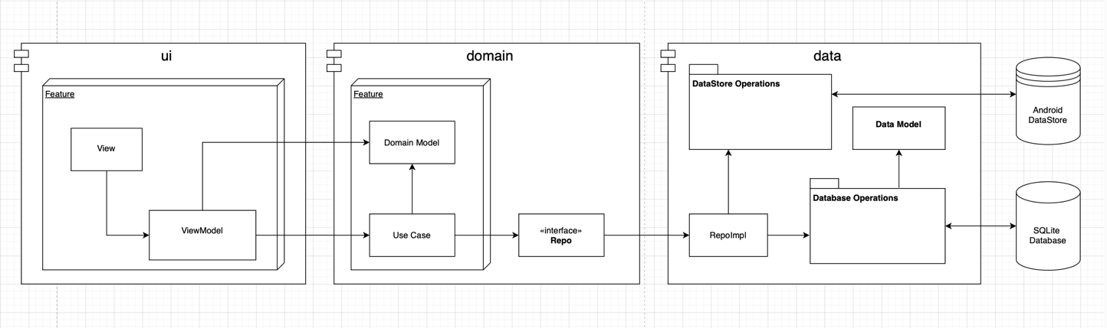

The diagram should contain the modules and high level classes, as seen above.

Data Model

Describe your data model, alongside a diagram of the database (entity – relationship). You can probably generate it straight from IntelliJ.

